Bardia Mojra – 1000766739

07/24/2022 – Assignment 04

Q1. This is a shared memory C implementation.

typedef struct {

double value;

int outNode;

} ScanNodePair;

void c_Scan(ScanNodePair *inNode, ScanNodePair *inoutNode)

{

int i;

ScanNodePair scan;

for (i = 0; i < 8; ++i) {

if (inNode->outNode == inoutNode->outNode)

scan.value = inNode->value + inoutNode->value;

else

scan.value = inoutNode->value;

scan.outNode = inout->outNode;

*inout = scan;

inNode++;

inoutNode++;

}

}

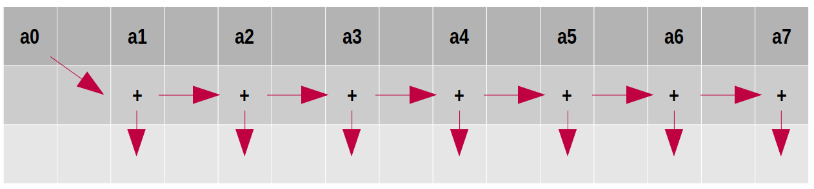

Q2.

Row-wise partitioning efficiency:

On a hypercube communication network, the row-wise algorithm has an overall communication time of $t_{s}log p +t_{w} n (p-1)/p$, where $t_{s}$ is the communication startup time and $t_{w}$ is the per word communication time. The efficiency is E = $\frac{p}{1+\frac{t_{s}p log p + t_{w} np}{t_{c}n^{2}}}$, where $t_{s}p log p + t_{w} np$ is the communication overhead, n is the dimension length of the matrix, p is the number of processors, and $t_{c}$ is unit computation time. The isoefficiency is obtained by $θ(p^{2})$. For checkerboard partitioning, parallel time is approximated by $T_{p}=t_{c} (n^{2}/p) + t_{s} log p+(3/2)t_{w}(n/\sqrt{p})logp$, so isoefficiency is $θ(p \log^{2}p)$ as it is the dominant term as p gets larger. Given the two isoefficiency, we conclude the checkerboard algorithm is more stable as its time complexity grows at a much lower rate as you increase the processor count. Nonetheless, it is important to note that this only applies to a well-balanced hypercube parallel computing system. For a hypercube communication topology, the overall isoefficiency is heavily dependent on the ratio of per-word communication time and compute time as defined by $E/(1-E)=t_{c}/t_{w}$. The lower E ratio (generally less than .5) results in higher isoefficiency rates, given enough communication bandwidth by hardware.

Q3. Time for sequential process is given by $T_{1}=cN^{3}$ and a parallel time of $T_{n}=(cN^{3})/n + bN^{2}/\sqrt{n}$.

1. Fixed-workload speedup analysis is based on Ahmdal’s law,

speedup = $\frac{sequential exec time}{parallel exec time}=\frac{T_{1}}{T_{n}}=\frac{cN^{3}}{(cN^{3})/n + bN^{2}/\sqrt{n}}=\frac{W}{(W)/n + bN^{2}/\sqrt{n}}=\frac{Wn}{αW + (1-α)W/n^{2}}$

Thus, we can factor out W (fixed workload) and efficiency becomes purely dependant on communication time $\frac{T_{1}}{T_{n}}=\frac{n}{α + (1-α)/n^{2}}$. For very large processor count, speed up approaches 1/ $α$ where $α$ is between 0 and 1.

1. Fixed-time speedup is based on Gustafson's law which assumes a fixed execution time for all processes. Now, we have,

speedup = $\frac{single processor exec time}{n-processor exec time}=\frac{T_{1}}{T_{n}}=\frac{{cN}^{3}+ bN^{2}/\sqrt{n}}{(cN^{3})/n + bN^{2}/\sqrt{n}}=\frac{αW+(1-α)nW}{αW + (1-α)nW/n}=\frac{α+(1-α)n}{α + (1-α)}$

Which becomes $S_{n}^{'}=α+(1-α)n$ which indicates that the speedup increases as workload increases for an increased number of processors with a fixed computation time.

Q4. E=.25, B is more scalable than A. b,c>0 and $b=4c$, $W(A)={1.33}^{3}n^{1.5}$ and $W(B)=n^{1.5}$

1. ${T_{n }= cN}^{3}+ bN^{2}/\sqrt{n }$, $E(A)=\frac{1}{1+(b\sqrt{n})/cN}$
2. ${T_{n }= 2cN}^{3}/n+ bN^{2}/2\sqrt{n }$, $E(B)=\frac{1}{2+(b\sqrt{n})/(2cN)}$

Since the iso-efficiency functions are given, we obtain B scalability factor over A by,

$\frac{W(B)}{W(A)} = \frac{n^{1.5}}{{(1.33)}^{3} n^{1.5}} = \frac{1}{{(1.33)}^{3}}$, Since lower W implies higher scalability factor, we conclude B scalability factor over A is ${(1.33)}^{3}$.

${T_{n }(A)= cN}^{3}+ bN^{2}/\sqrt{n }, E(A)=\frac{1}{1+(b\sqrt{n})/cN}$

${T_{n }(B)= 2cN}^{3}/n+ bN^{2}/2\sqrt{n }$, $E(B)=\frac{1}{2+(b\sqrt{n})/(2cN)}$

${E(A)=\frac{{ T}_{1 }(A)}{n{ T}_{n }(A)} => { T}_{n }(A) = \frac{{ T}_{1 }(A)}{n E(A)}}^{}$

$\frac{{ T}_{n }(B)}{{ T}_{n }(A)} = \frac{\frac{{ T}_{1 }(B)}{n E(B)}}{\frac{{ T}_{1 }(A)}{n E(A)}} = \frac{\frac{2cN^{3}}{ E(B)}}{\frac{cN^{3}}{ E(A)}} = \frac{(2cN^{3})(2+(b\sqrt{n})/(2cN))}{(cN^{3})(1+(b\sqrt{n})/cN)}$

For E=¼:

For A,

$E(A)=\frac{1}{1+(b\sqrt{n})/cN}=1/4 =>1+(b\sqrt{n})/cN =4 => (b\sqrt{n})/cN =3$

$W(A)= {(b/3c)}^{3}n^{1.5}$

And for B,

$W(B)= {(b/4c)}^{3}n^{1.5}$

Now if we consider b=4c, we will have,

$W(A)= {(4c/3c)}^{3}n^{1.5}= {(4/3)}^{3}n^{1.5}$

$W(B)= {(4c/4c)}^{3}n^{1.5}= n^{1.5}$

Thus, $\frac{T_{n}(B)}{T_{n}(A)}={(4/3)}^{3}=\frac{{(b/4c)}^{3}n^{1.5}}{{(b/3c)}^{3}n^{1.5}}=\frac{{(b/4c)}^{3}}{{(b/3c)}^{3}}$, under the given condition, system B is more scalable and to maintain the same isoefficiency the workload has to increase by a factor of (2.82)^(-1), which is ${(1.33)}^{3}$.

Yes, B becomes slower if E increases to .5 and beyond.

Q5.

1. 1.71
2. 4
3. 10
4. 1.93
5. 34
6. 100