Bardia Mojra – 1000766739

06/8/2022 – Assignment 05

Q1.

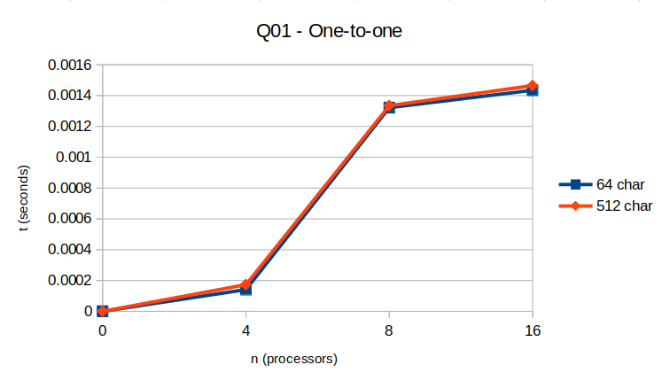

Q2.

