Bardia Mojra – 1000766739

07/15/2022 – Assignment 06

Q1.

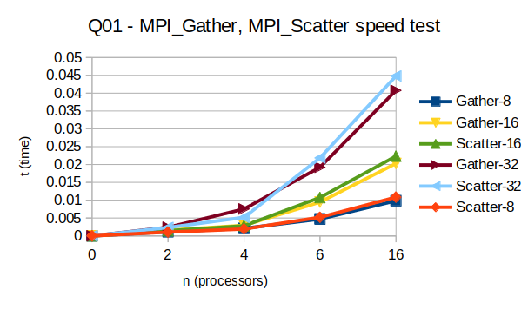

Q2. Please refer to q2.out for output sample.

Q3. Please refer to q3.out for output sample.

