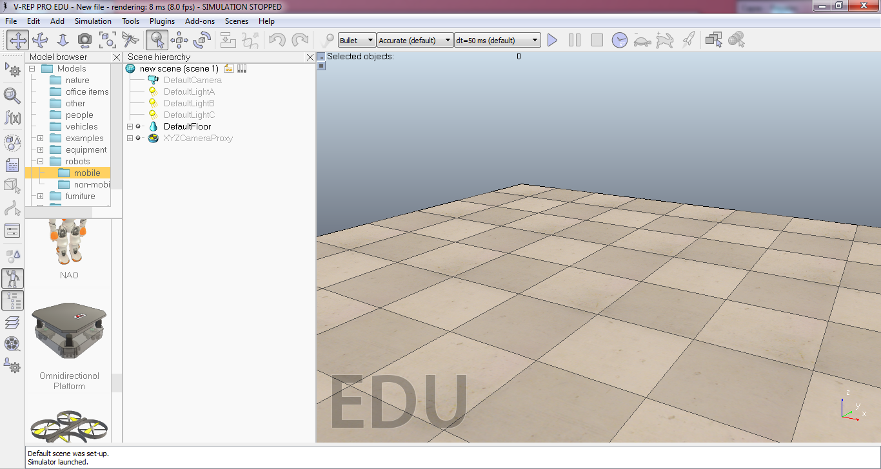

**Other Options**

**Simulation Buttons**

**Scene**

**Edit Buttons**

**Camera Buttons**

**Predefined models**

**Objects hierachy**