Module 12 Final Database Project
Inventory Management System in C#
Project Option: Inventory System
Technology: C# WinForms, SQLite, Microsoft.Data.Sqlite

1. System Overview
The Inventory Management System is a desktop database application designed to track products, suppliers, categories, stock movements, and sales order records. It supports product CRUD operations, stock-in/stock-out transactions, low stock monitoring, and reporting.

2. Main Features
- Dashboard with total products, low stock count, and inventory value
- Product management with SKU, category, supplier, price, and quantity
- Stock-in and stock-out transaction recording
- Low stock detection based on reorder level
- Transaction report and SQL query report

3. ER Diagram
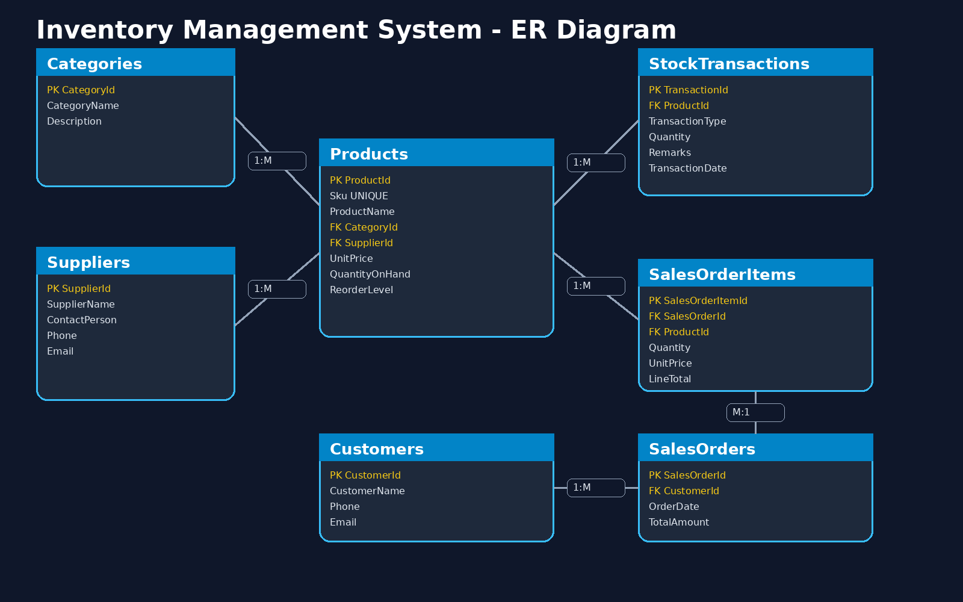

4. Normalized Tables
Table | Primary Key | Purpose
Categories | CategoryId | Stores product classifications
Suppliers | SupplierId | Stores supplier contact information
Products | ProductId | Stores inventory items and stock levels
Customers | CustomerId | Stores customer information
StockTransactions | TransactionId | Records stock-in and stock-out
SalesOrders | SalesOrderId | Stores sales order header
SalesOrderItems | SalesOrderItemId | Stores sales order product lines

5. Normalization Summary
The design follows third normal form. Each table has a primary key, repeating groups were removed, non-key attributes depend on the whole key, and transitive dependencies were separated into lookup tables such as Categories and Suppliers.

6. SQL Queries Report
- Product master list with category and supplier
- Low stock report
- Inventory valuation report
- Stock movement history
- Product count per category

7. User Interface
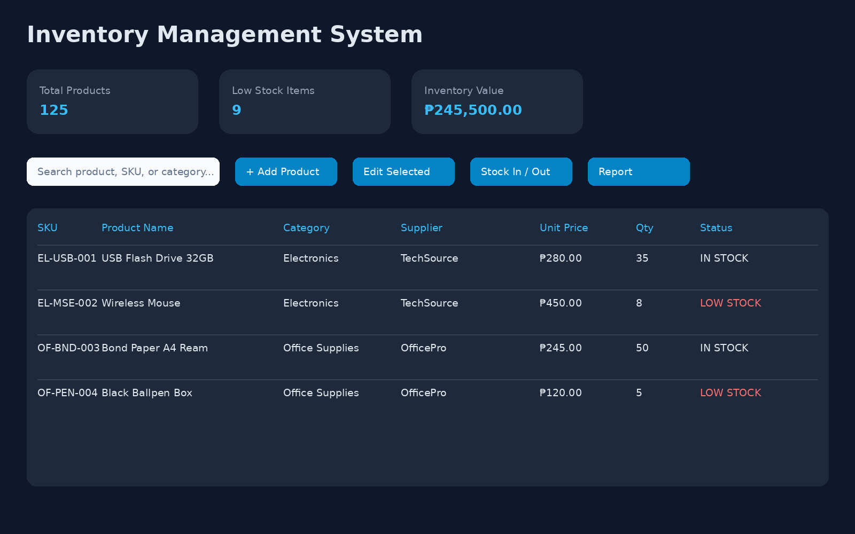

8. Conclusion
This project demonstrates database design, normalization, SQL scripting, reporting, and a working C# user interface connected to a relational database.

