RA23E01 – ROBOT OPERATING SYSTEM

8 LEGGED ROBOT INSPIRED BY SPIDER

Submitted By

BARGAVAN R (2023511001)
NAVINKRISHNA K (2023511013)

BACHELOR OF ENGINEERING
in
ROBOTICS AND AUTOMATION



DEPARTMENT OF PRODUCTION TECHNOLOGY
MADRAS INSTITUTE OF TECHNOLOGY
ANNA UNIVERSITY - CHENNAI 600044

BONAFIDE CERTIFICATE

Certified that this project report “8 LEGGED ROBOT INSPIRED BY SPIDER” is the Bonafide word of Bargavan R (2023511001) and Navinkrishna K (2023511013) who carried out the project work under my supervision.

SIGNATURE SIGNATURE

HEAD OF THE DEPARTMENT SUPERVISOR

ABSTRACT:
This project focuses on the design, simulation, and control of a 24-degree-of-freedom (DOF) octopod spider robot using ROS2 Humble and Ignition Gazebo. The robot is modeled in SolidWorks with 8 legs, each containing 3 joints (coxa, femur, tibia), and converted to a URDF/Xacro format for seamless integration with ROS2. The system leverages ros2_control to manage joint-level control, using a joint_state_broadcaster and position_controller to achieve stable multi-legged locomotion. The simulation is performed in Ignition Gazebo Fortress, providing a realistic physics environment to test kinematics, dynamics, gait patterns, and control strategies. Controller configurations are defined via YAML, allowing precise tuning of update rates, joint trajectories, and interface commands. A custom PyQt-based GUI enables interactive joint control and real-time trajectory visualization. The project demonstrates a modular and extensible approach to robot simulation, offering insights into spider-inspired locomotion, inverse kinematics for multi-legged systems, tripod gait implementation, and ROS2-based control frameworks. This work serves as a foundation for further research in bio-inspired robotics, terrain navigation, warehouse automation, and real-time robotic control.

TABLE OF CONTENTS:

CHAPTER NO. | TITLE | PAGE NO.
1 | INTRODUCTION | 1
2 | SOLIDWORKS DESIGNING PARTS | 4
3 | URDF CONVERSION EXPLANATION | 7
4 | ROS2 IMPLEMENTATION | 9
5 | FEATURES OF THE ROBOT | 10
6 | PACKAGE STRUCTURE | 12
7 | ARCHITECTURE | 13
8 | STEPS TO IMPORT IN IGNITION / GAZEBO | 18
9 | ERRORS AND DEBUGGING METHODS | 22
10 | STEPS TO CONTROL | 24
11 | STEPS TO CREATE ENVIRONMENT IN ROS2 | 30
12 | FABRICATION IDEAS AND FUTURE ENHANCEMENTS | 36
13 | RESULTS AND DISCUSSION | 43
14 | CONCLUSION | 44

INTRODUCTION:
The development of multi-legged robots has become a significant focus in robotics research due to their superior stability and ability to navigate complex, unstructured terrains where wheeled systems fail. Spider-inspired robots with eight legs offer unique advantages in terrain adaptability, load distribution, and fault tolerance. Unlike bipedal or quadrupedal systems, an octopod robot maintains static stability even when multiple legs are in swing phase, making it inherently more stable during locomotion.
This project presents an 8-legged spider robot implemented within the ROS2 Humble ecosystem. The robot's mechanical design is first created in SolidWorks and converted into a URDF/Xacro format, enabling seamless integration with ROS2 tools and Gazebo simulation. ROS2 provides a robust middleware for robot control, while ros2_control facilitates precise trajectory execution and real-time state feedback from all 24 joints (3 joints per leg × 8 legs). The joint_state_broadcaster publishes joint positions, and the position_controller executes trajectory commands to drive each joint, ensuring coordinated and stable multi-legged locomotion.
The project employs Ignition Gazebo as a high-fidelity simulation platform to validate the robot's kinematics, dynamics, and control strategies. YAML-based controller configurations allow tuning of update rates, joint interfaces, and monitoring parameters, ensuring responsive and predictable behavior. The system includes a custom PyQt-based GUI for interactive joint control, SLAM modules for autonomous mapping and localization, and warehouse navigation tasks demonstrating practical applications in industrial environments.
By combining mechanical design, software integration, and simulation, this project highlights a systematic methodology for developing advanced multi-legged robots. The insights gained form a foundation for future work in bio-inspired locomotion, autonomous navigation, search and rescue operations, and real-time robotic applications.

SOLIDWORKS DESIGNING PARTS:
Totally 9 Parts where the parts of the legs are same & can be duplicated in Assembly.
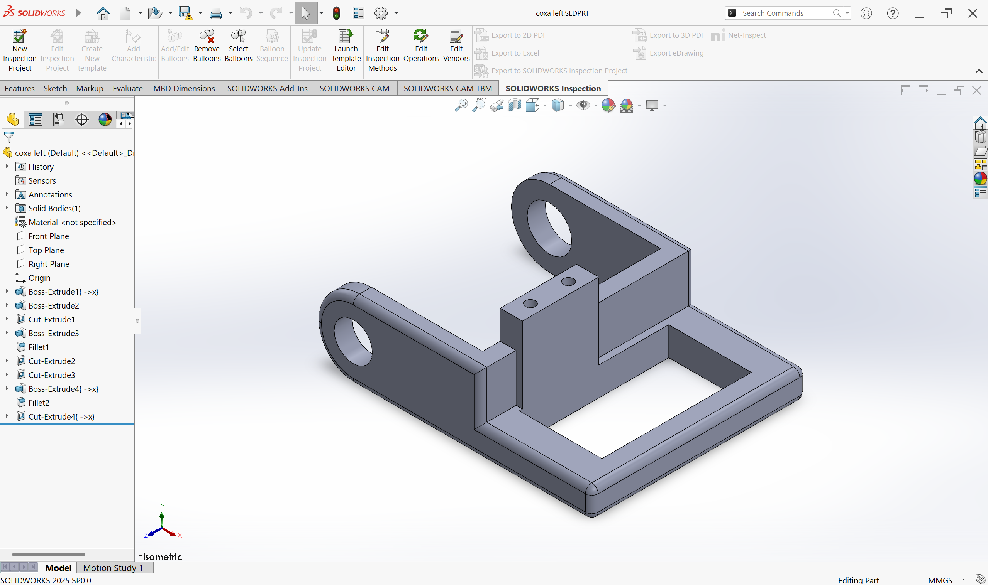
- Coxa-left

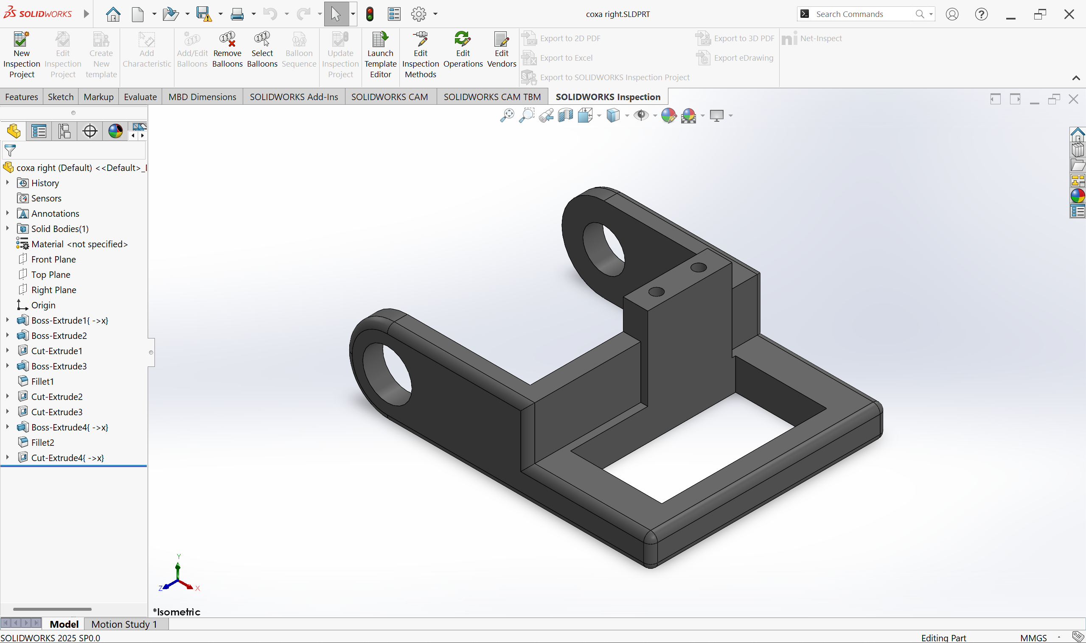
- Coxa-right
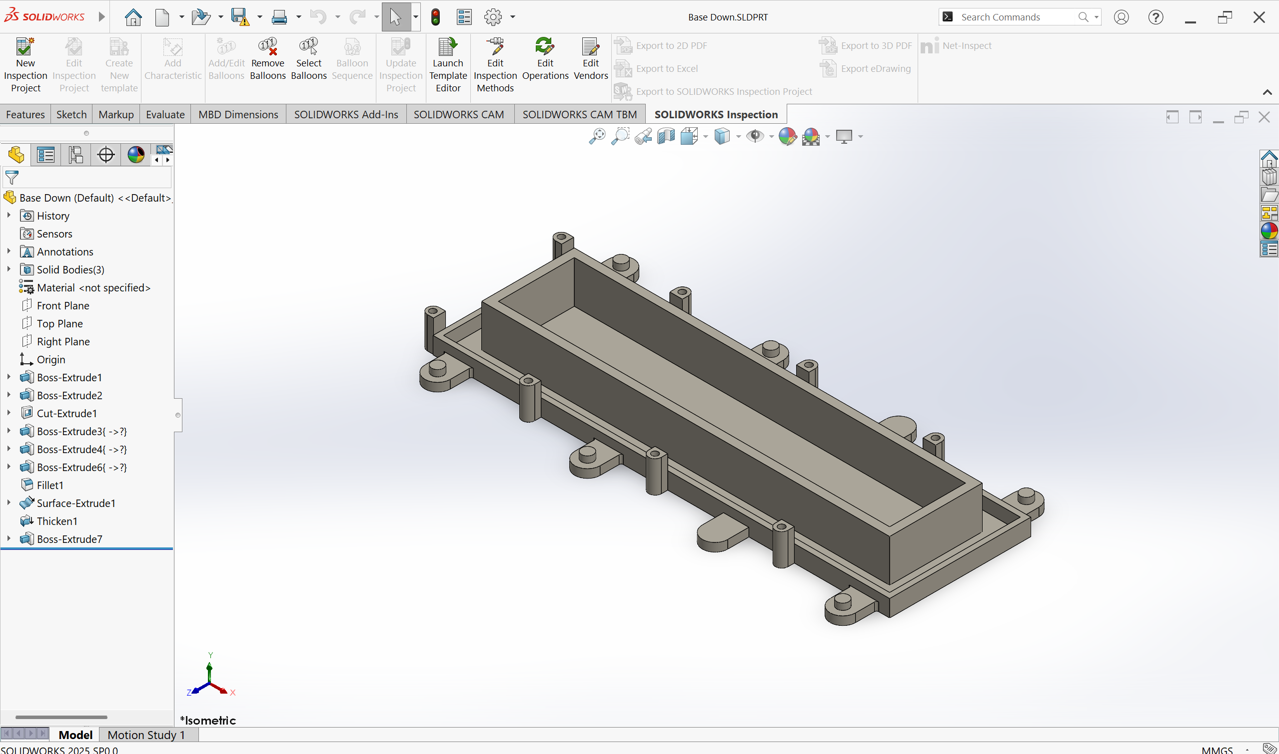
- Base-Down

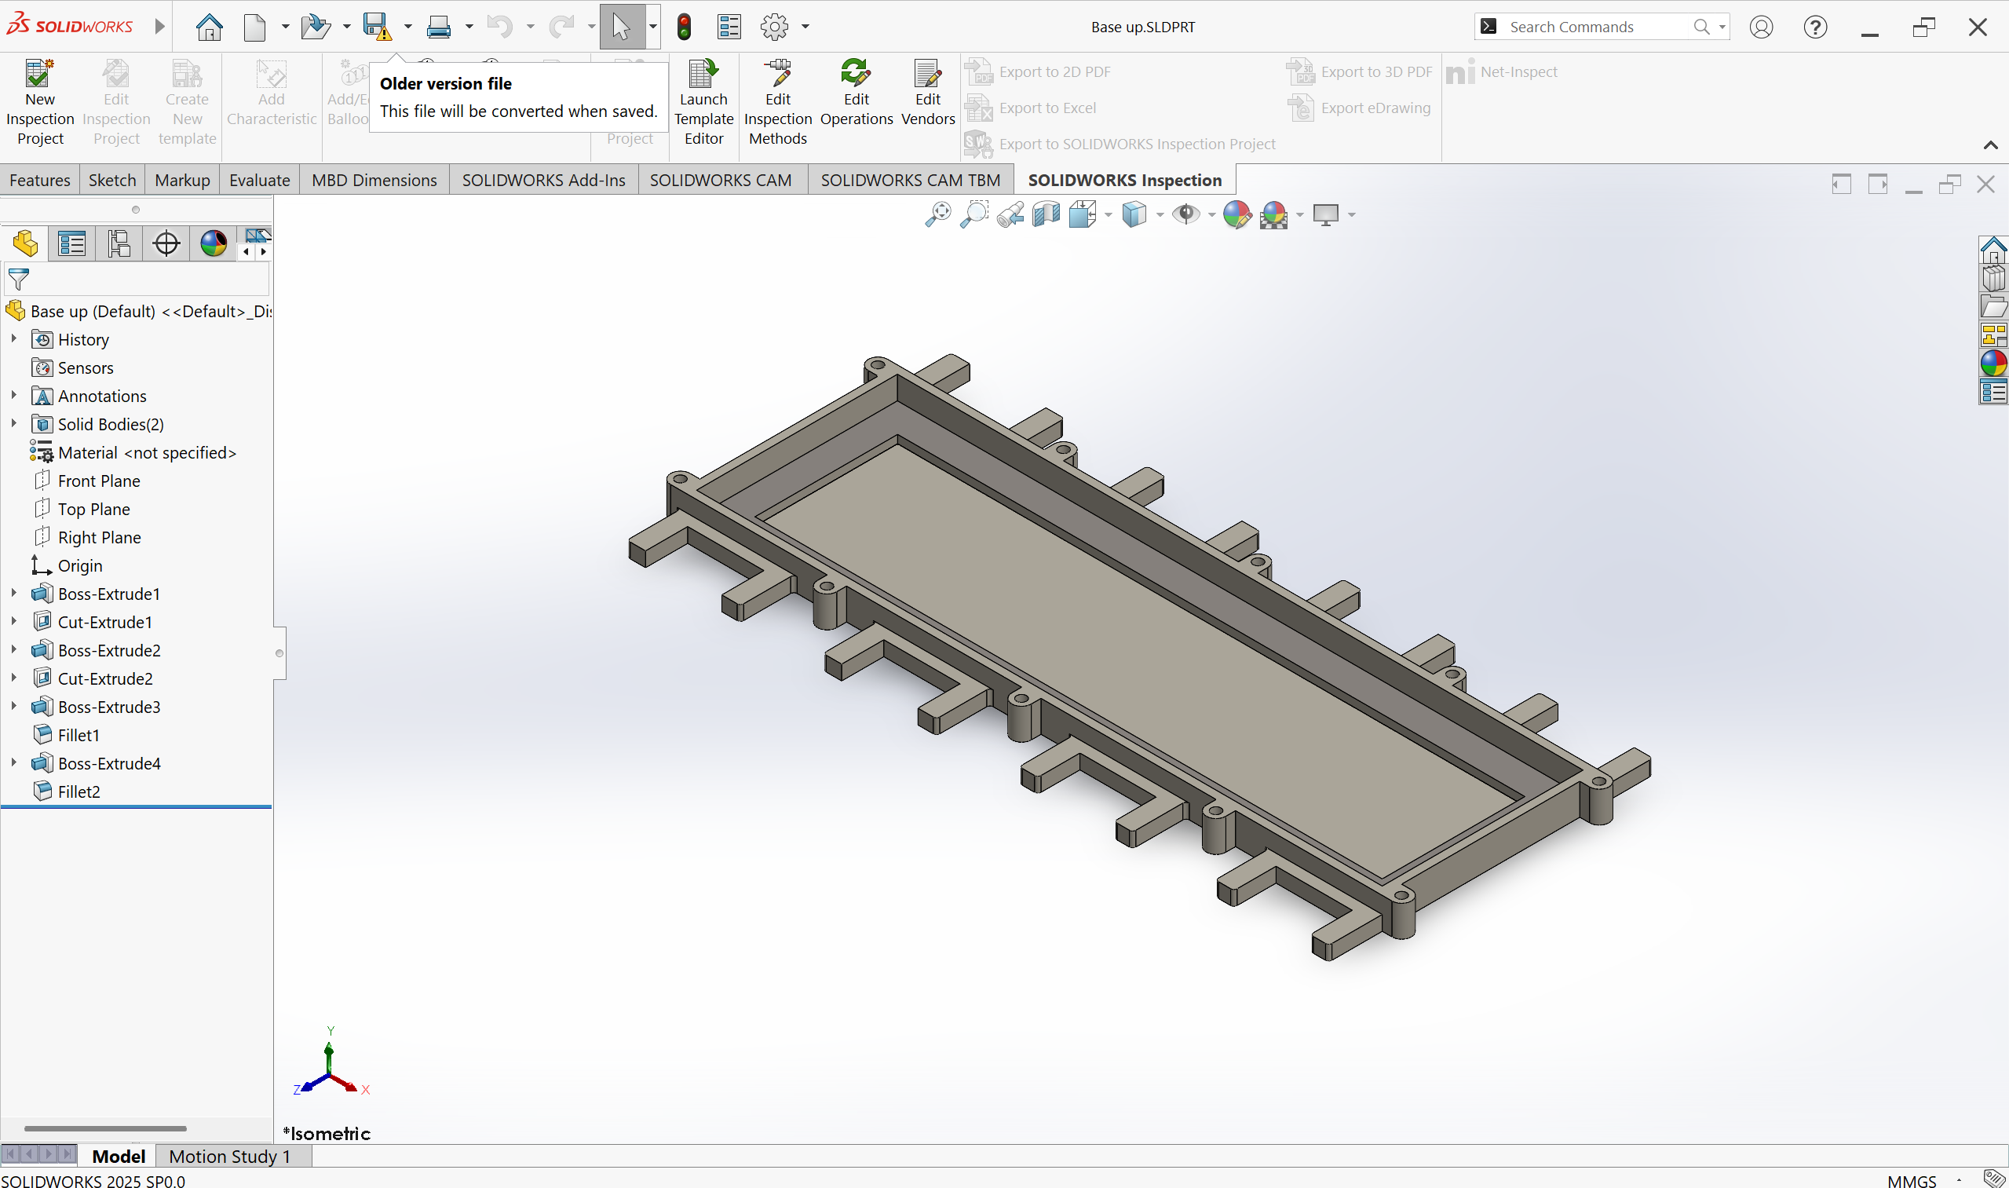
- Base-Up
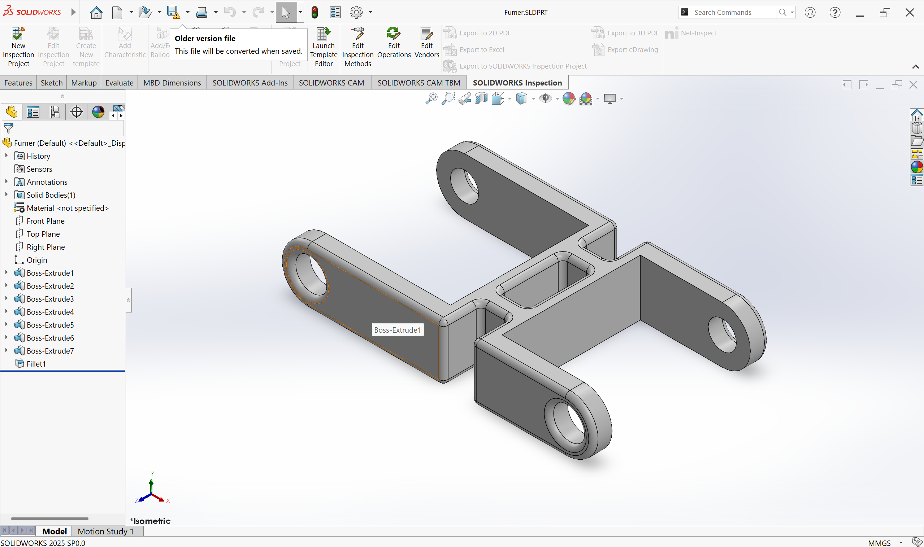
- Fumer

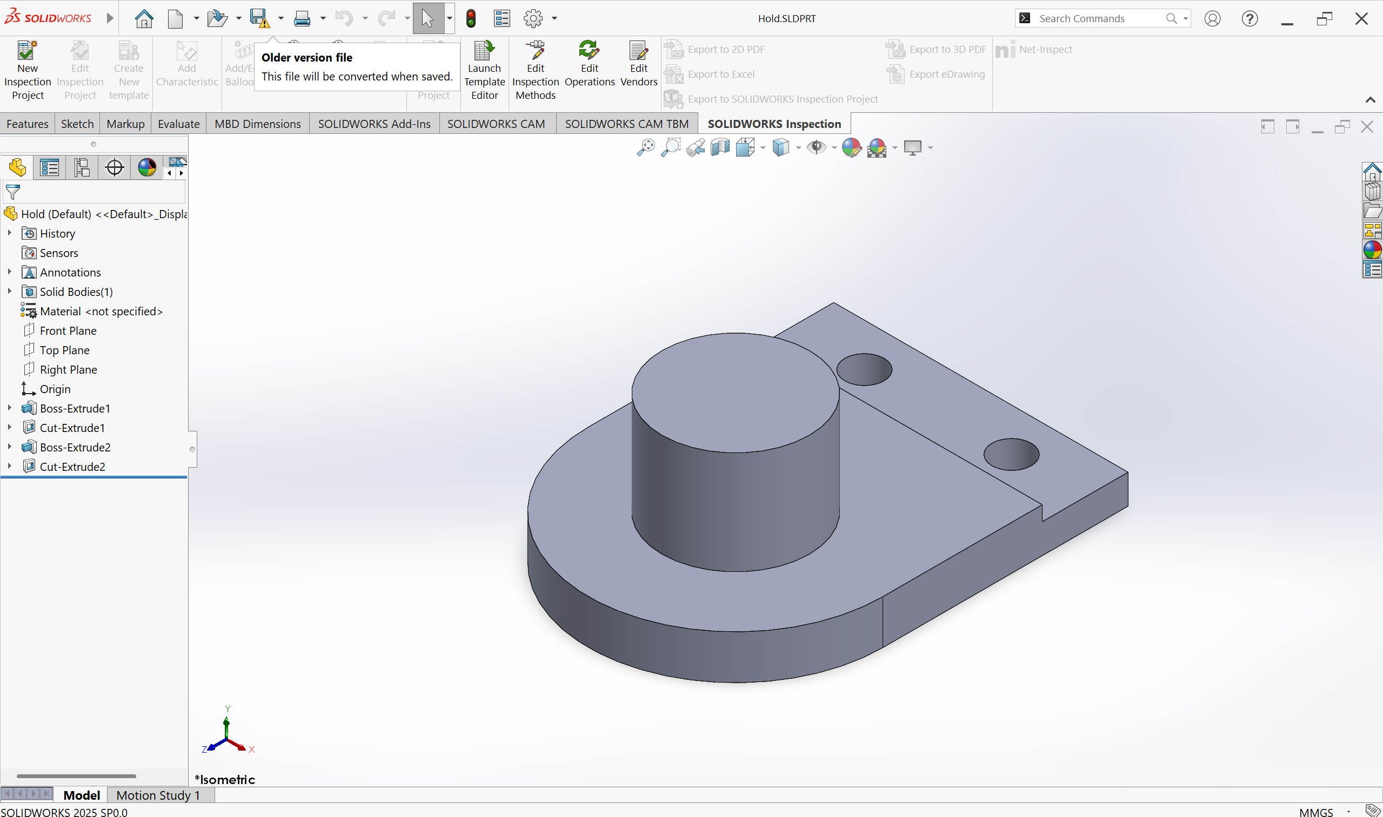
- Hold

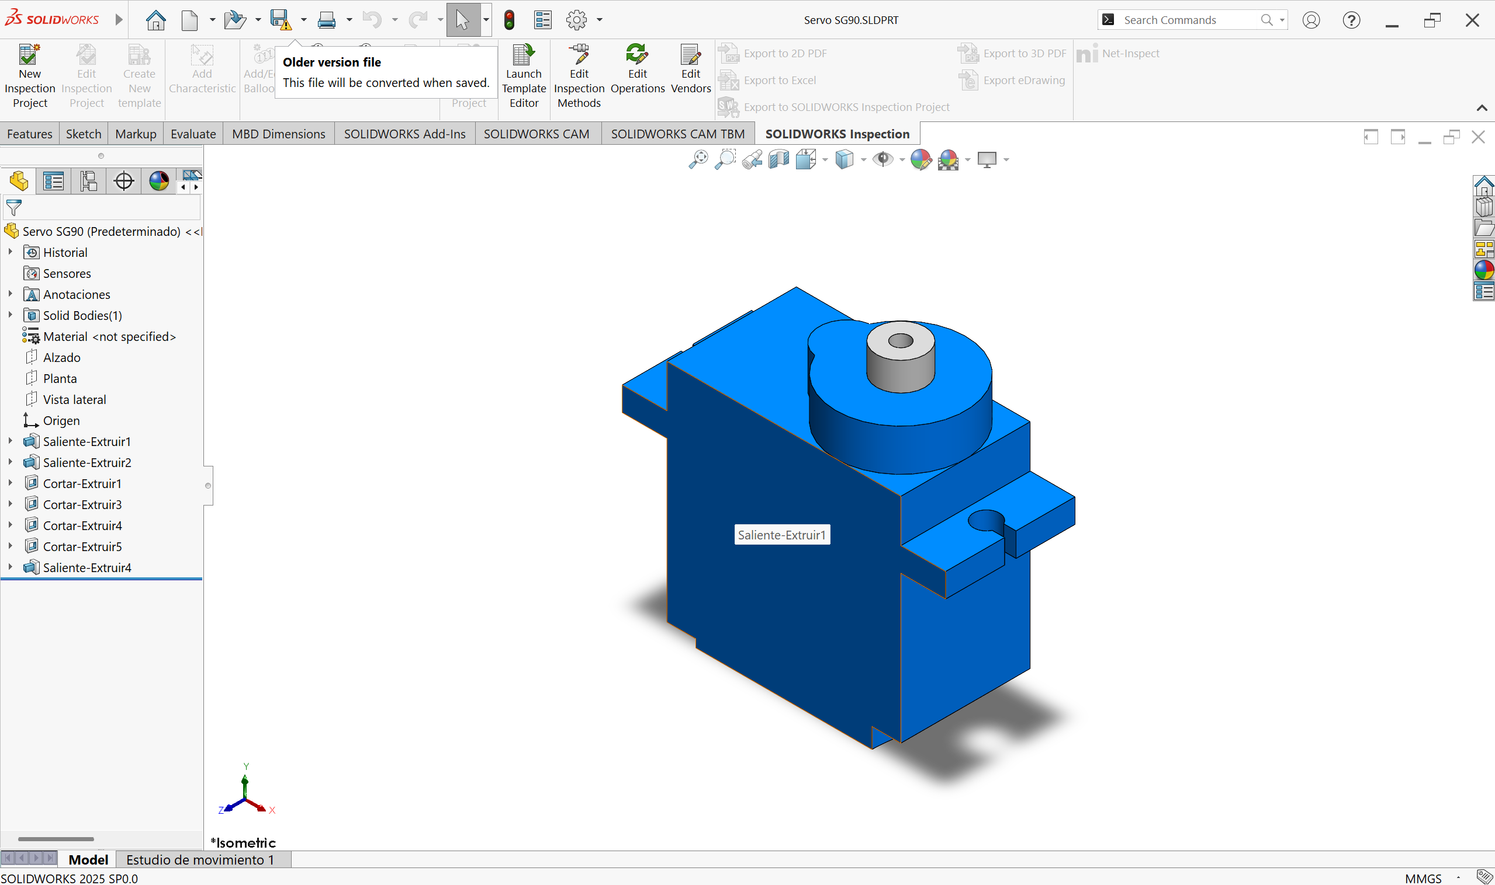
- Servo

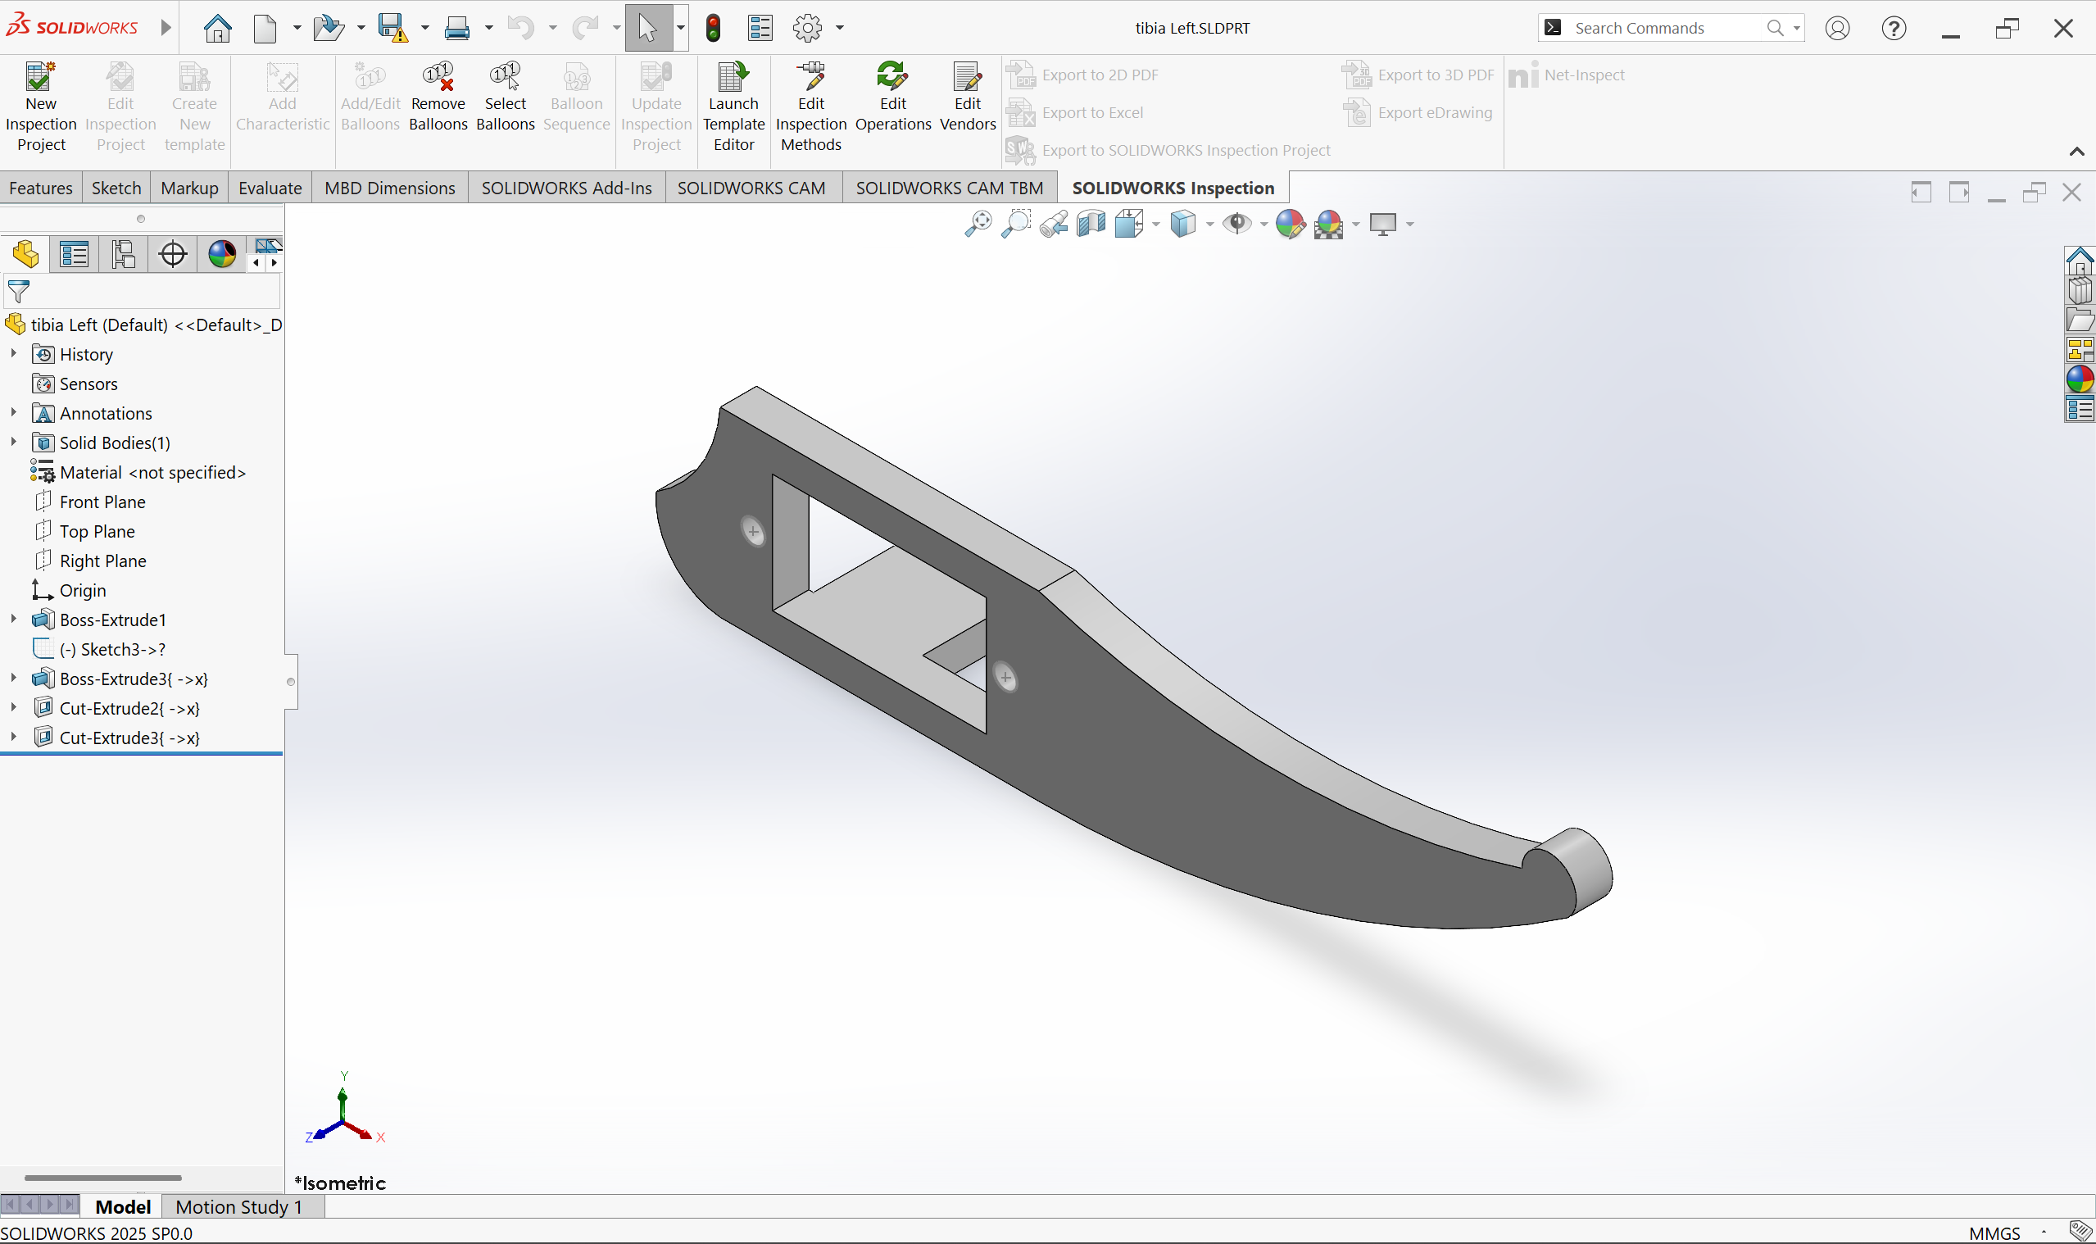
- Tibia-Left

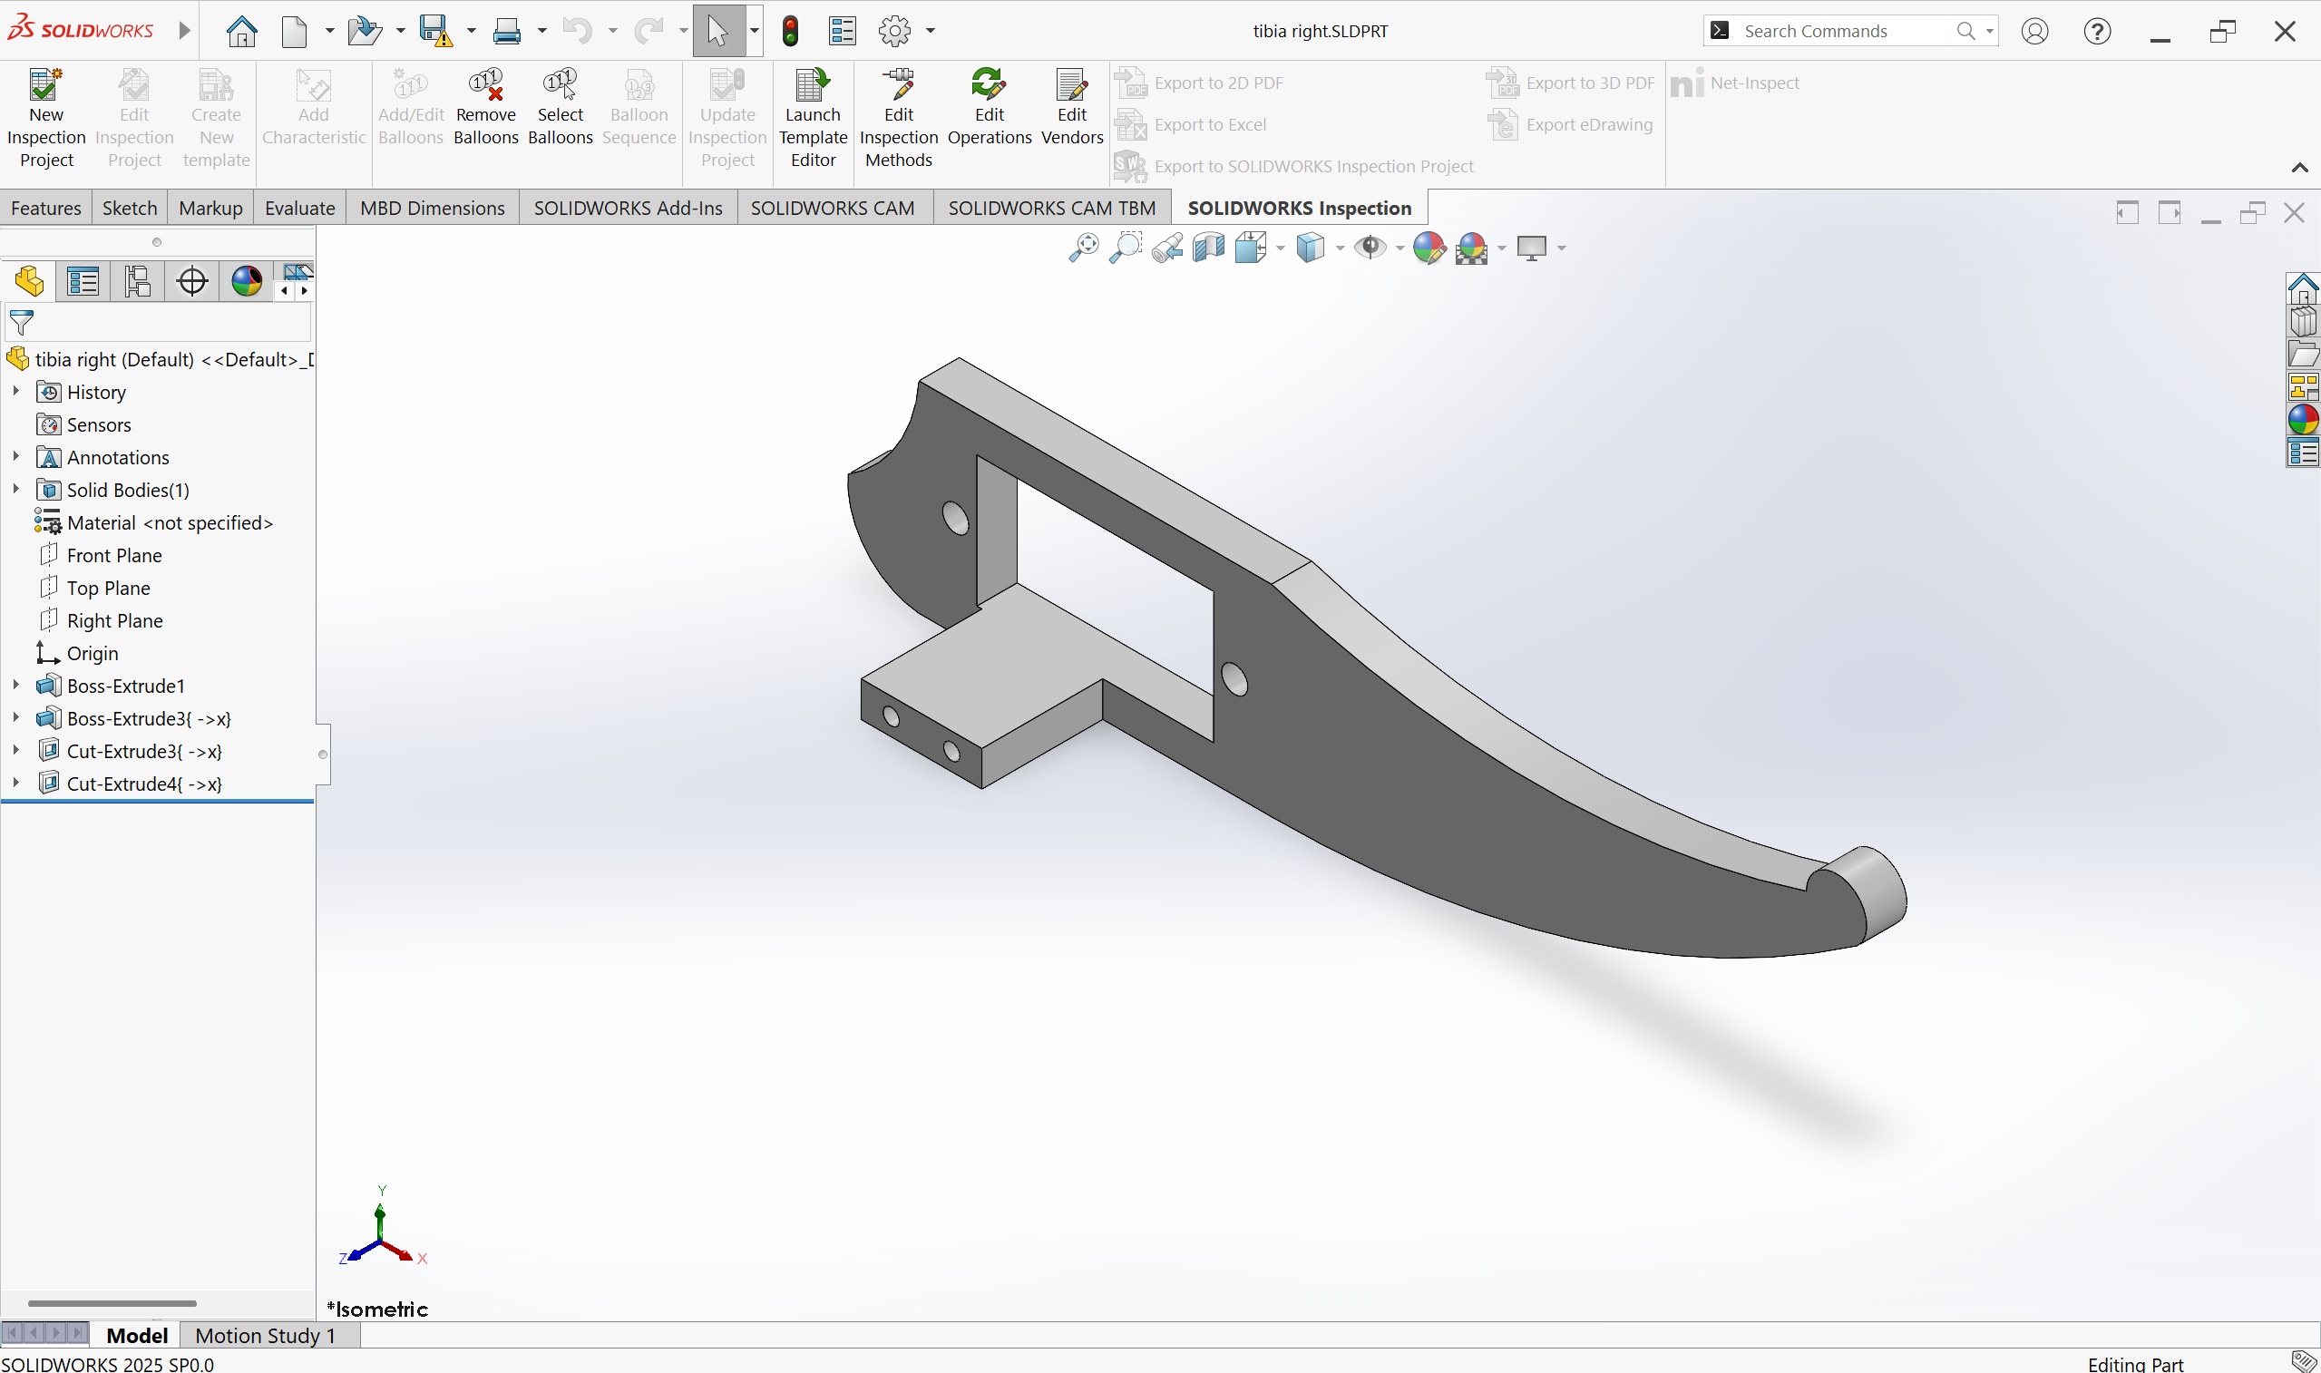
- Tibia-right
ASSEMBLY:
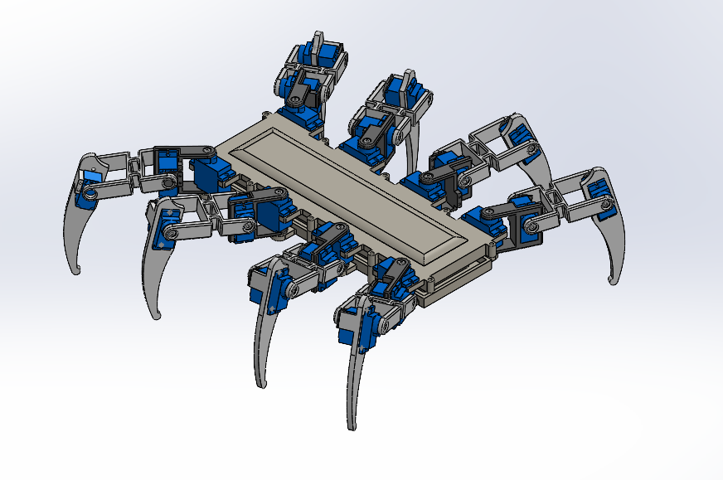
Mates Used: Concentric, Coincident mates for Joints & Limit Angle mate to restrict the rotation of the joints.
URDF CONVERSION EXPLANATION:
The mechanical design of the bipedal robot was initially modelled in SolidWorks using precise geometric and mass properties for each link and joint. To integrate this CAD model into the ROS simulation environment, the SW2URDF plugin was utilized. This plugin automatically exports the SolidWorks assembly into a URDF (Unified Robot Description Format) structure compatible with ROS1. The exported files include link meshes (in .stl or .dae format), joint definitions, inertial parameters, and a ROS1-style CMakeLists.txt and .launch files written in C++ XML format.
However, since this project is implemented in ROS2, the ROS1-style package structure and launch files are no longer directly compatible. ROS2 introduces several key differences:
- The build system is now based on ament rather than catkin.
- Python-based launch files (.launch.py) replace the older XML-style .launch files.
- The package.xml format and dependency declarations have been updated to support ROS2’s modular architecture.
- Node execution and parameter passing follow new conventions defined under launch_ros and rclpy.
To bridge this compatibility gap, the exported ROS1 URDF package was converted into a ROS2-compatible format using the online tool ROS2 URDF Web Converter.
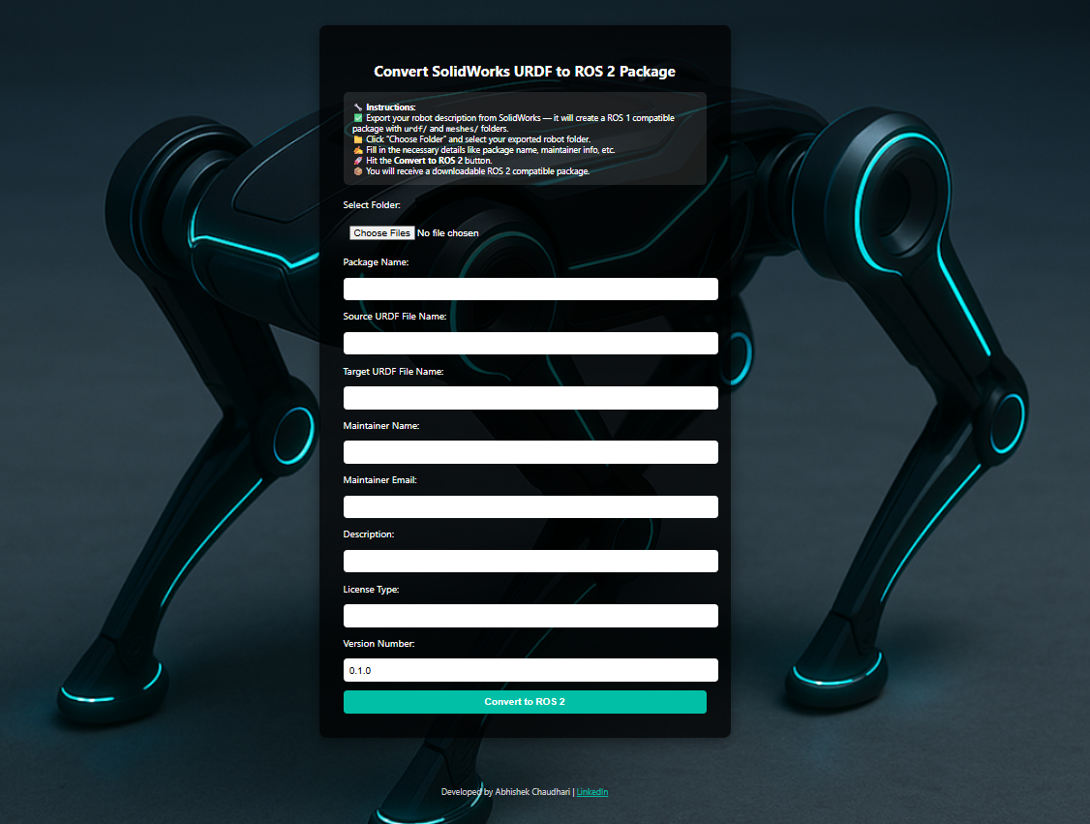
This web-based converter automates the following tasks:
- Converts CMakeLists.txt (ROS1 catkin) into setup.py (ROS2 ament Python).
- Generates a Python-based Gazebo launch file (gazebo.launch.py) for ROS2.
- Updates the package.xml to follow ROS2’s format version 3.
- Adjusts directory structures for urdf/, meshes/, launch/, and config/ folders.
- Ensures compatibility with ROS2-specific packages such as controller_manager, ros_gz_sim, and robot_state_publisher.
After conversion, the resulting ROS2 package contains:
- A URDF/Xacro file describing the robot’s structure.
- A Python-based launch file (gazebo.launch.py) to spawn and control the robot in Ignition Gazebo.
- A YAML configuration (legged_controllers.yaml) for joint controllers under ros2_control.
- A setup.py script for installation using colcon build.
This conversion process ensures that the robot model originally designed for ROS1 can now be fully simulated, visualized, and controlled within the ROS2 Foxy/Humble ecosystem using Gazebo or Ignition. It enables smooth interoperability with ROS2 control frameworks and provides a scalable foundation for further development in motion control, gait planning, and autonomous locomotion.

ROS2 IMPLEMENTATION:
The spider_description package integrates design, simulation, and control of an 8-Legged robot within the ROS2 framework. The system uses Ignition Gazebo for physics-based simulation, ros2_control for actuator-level control, and a custom PyQt GUI for real-time joint operation.
URDF/Xacro and Control Setup
The robot’s model, designed in SolidWorks, was converted to a ROS2-compatible Xacro file (spider_description.xacro). It defines all links, joints, and inertial properties and includes a <ros2_control> tag linking the robot to the Ignition ROS2 Control Plugin.
The ign_ros2_control::IgnitionROS2ControlPlugin bridges Gazebo’s physics engine with ROS2’s control system. When the robot is spawned, the plugin:
- Reads the robot’s joint interfaces (position/velocity/effort).
- Exposes them to ROS2 as hardware interfaces.
- Synchronizes Gazebo’s physics states with ROS2 control commands.
This allows direct execution of joint trajectories through standard ROS2 commands:
ros2 run controller_manager spawner joint_state_broadcaster
ros2 run controller_manager spawner position_controller
The joint_state_broadcaster publishes real-time joint states, while the position_controller executes incoming joint position commands to simulate walking or balancing.
Ignition Simulation & GUI Control
The simulation is launched via gazebo.launch.py, which starts Ignition Gazebo, loads the robot description, initializes controllers, and spawns the robot model.
A separate PyQt-based GUI package provides an interactive control panel. The GUI, built using rclpy and PyQt5, lets users adjust joint angles with sliders, send commands to the position_controller, and monitor feedback visually in Ignition Gazebo. This improves testing and debugging compared to command-line-only control.

FEATURES:
- 24-DOF Multi-Legged Locomotion – 8 legs with 3 joints each (hip, knee, ankle) providing independent position control for complex terrain navigation.
- IgnitionROS2Control Plugin – Real-time interface between Gazebo physics engine and ROS2 controllers for seamless simulation-to-hardware transition.
- PyQt Joint Control GUI – Interactive desktop application for manual control of all 24 joints via ROS2 topics with real-time feedback visualization.
- Modular ROS2 Package Architecture – Separate packages for robot description, control, GUI, and visualization ensuring scalability and maintainability.
- Realistic Physics Simulation – Joint dynamics, gravity, ground contact forces, and collision detection handled by Ignition Gazebo for accurate behavior modeling.
- ROS2 Control Integration – joint_state_broadcaster and position_controller enable smooth trajectory tracking and coordinated gait execution.
- Multiple Gait Pattern Support – Implementation of tripod, wave, and ripple gaits for different speed and stability requirements.
- Python-Based Launch System – Single-step startup for robot spawning, world loading, controller initialization, and visualization nodes.
- Easily Extensible Framework – Can integrate additional sensors (IMU, cameras, LiDAR), inverse kinematics solvers, path planning algorithms, or custom behaviors.
- RViz Visualization Support – Real-time monitoring of joint states, TF frames, sensor data, and robot pose for debugging and analysis.

PACKAGE STRUCTURE:
ros2_ws/
├── src/
│ ├── spider_description/
│ │ ├── package.xml
│ │ ├── CMakeLists.txt
│ │ ├── launch/
│ │ │ ├── spider_gazebo.launch.py
│ │ │ └── spider_gz_rviz.launch.py
│ │ ├── urdf/
│ │ │ ├── spider_description.xacro
│ │ │ └── spider.gazebo
│ │ ├── config/
│ │ │ ├── controller.yaml
│ │ │ ├── bridge.yaml
│ │ │ └── gaz_ros2_ctl_use_sim.yaml
│ │ ├── meshes/
│ │ │ ├── visual/
│ │ │ └── collision/
│ │ ├── worlds/empty.world
│ │ └── src/
│ │
│ ├── spider_control/
│ │ ├── package.xml
│ │ ├── CMakeLists.txt
│ │ └── src/
│ │ ├── Forward_perfect.py
│ │ ├── Backward_perfect.py
│ │ ├── Left_Turn.py
│ │ ├── Right_Turn.py
│ │ ├── Circle_C.py
│ │ ├── Circle_CC.py
│ │ ├── INVERSE_KINEMATICS.py
│ │ └── Dancer_spider.py
│ │
│ ├── spider_gui/
│ │ ├── package.xml
│ │ ├── CMakeLists.txt
│ │ └── src/
│ │ ├── joint_gui.py
│ │ └── joystick_control.py
│ │
│ ├── spider_rviz/
│ │ ├── package.xml
│ │ ├── CMakeLists.txt
│ │ ├── launch/launch.py
│ │ └── rviz/
│ │ ├── default.rviz
│ │ └── rviz_launch.rviz
│ │
│ └── spider_warehouse/
│ ├── package.xml
│ ├── CMakeLists.txt
│ ├── launch/warehouse.launch.py
│ ├── worlds/spider_warehouse.world
│ ├── models/
│ └── meshes/
ARCHITECTURE:
TIER 1: MECHANICAL DESIGN LAYER
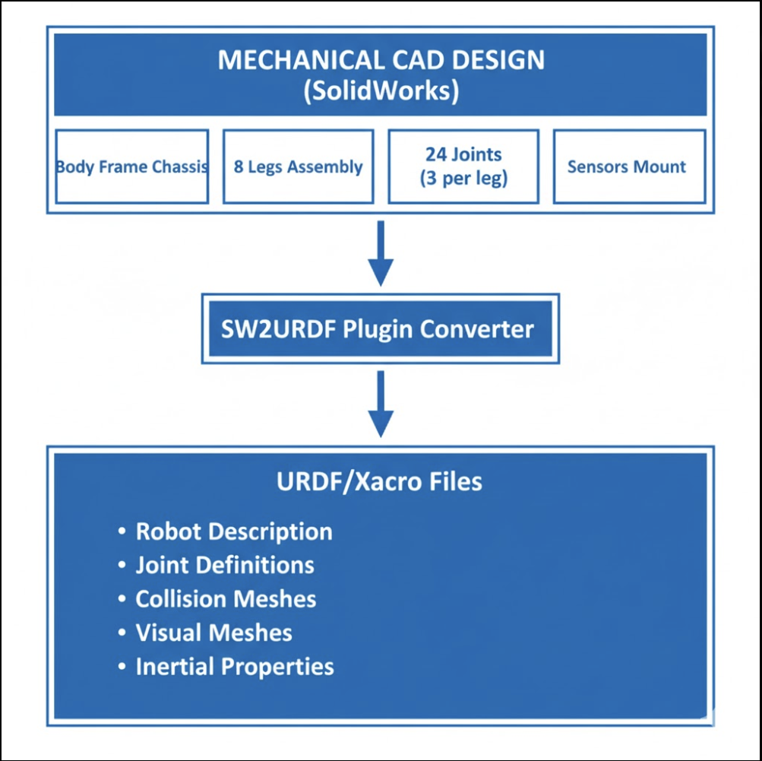

TIER 2: ROS2 PACKAGE ECOSYSTEM
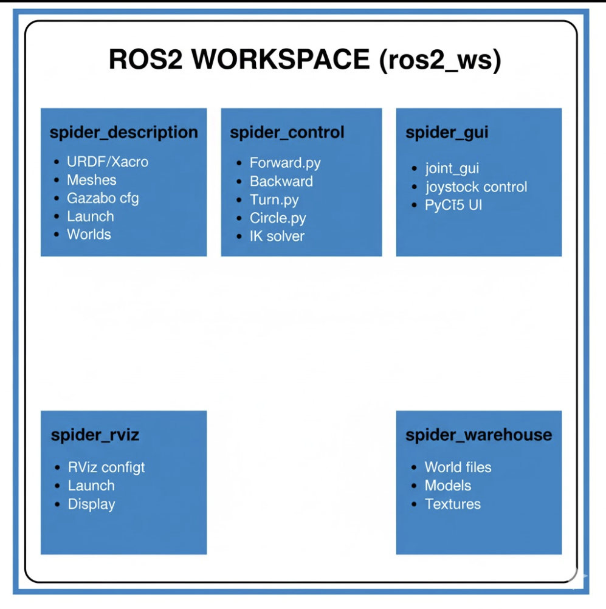

TIER 3: ROS2 MIDDLEWARE & CONTROL LAYER
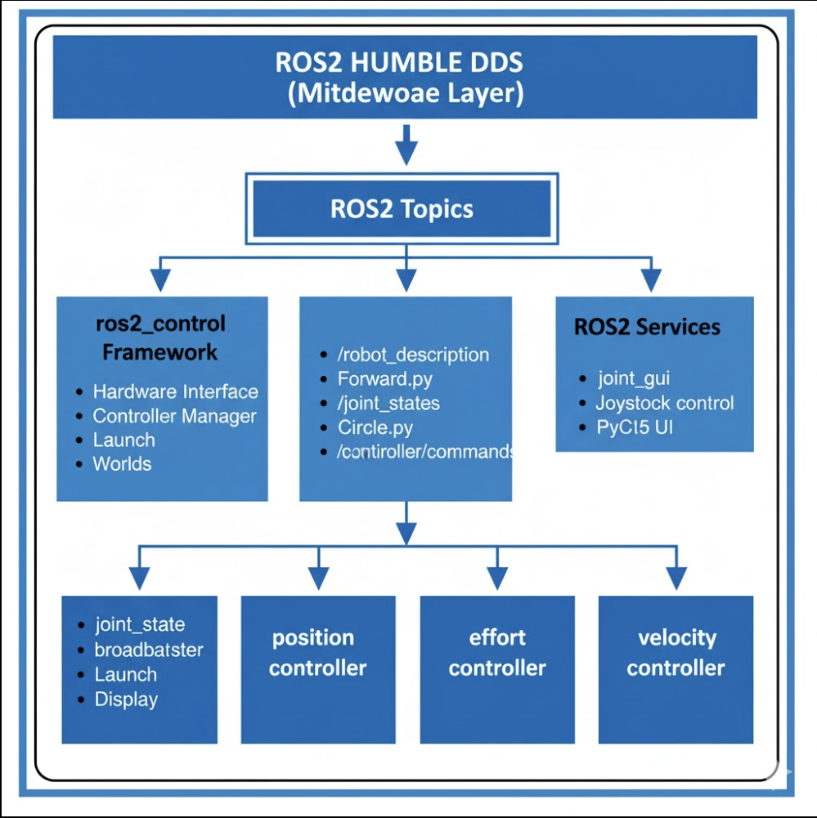
TIER 4: SIMULATION ENVIRONMENT
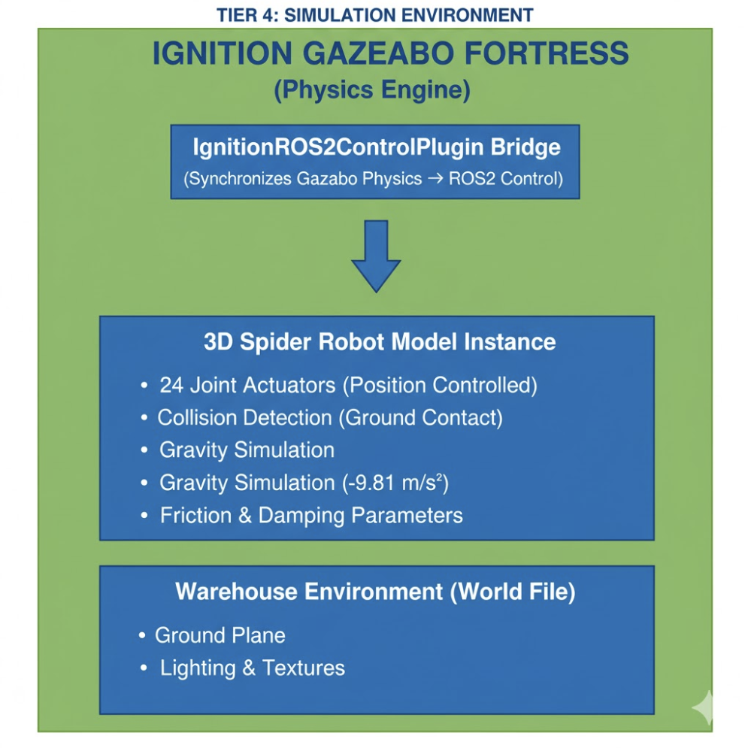

TIER 5: KINEMATICS & CONTROL ALGORITHMS
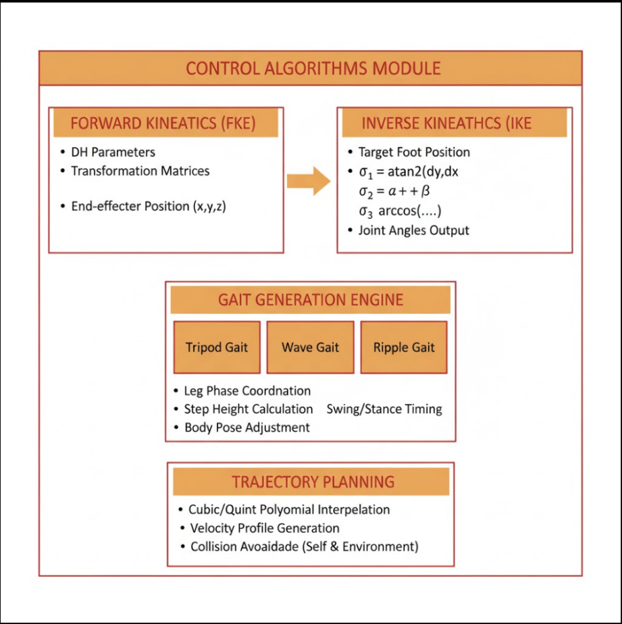
TIER 6: USER INTERFACE LAYER
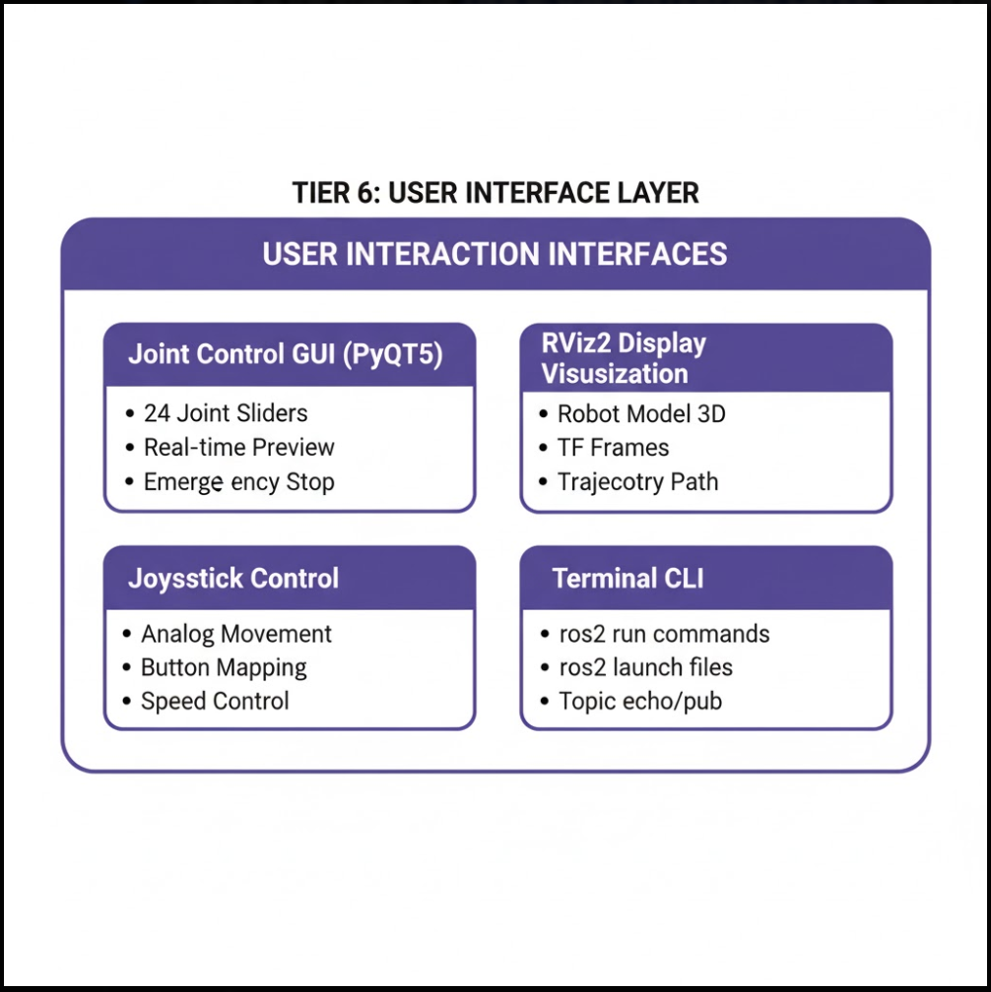

TIER 7: HARDWARE DEPLOYMENT
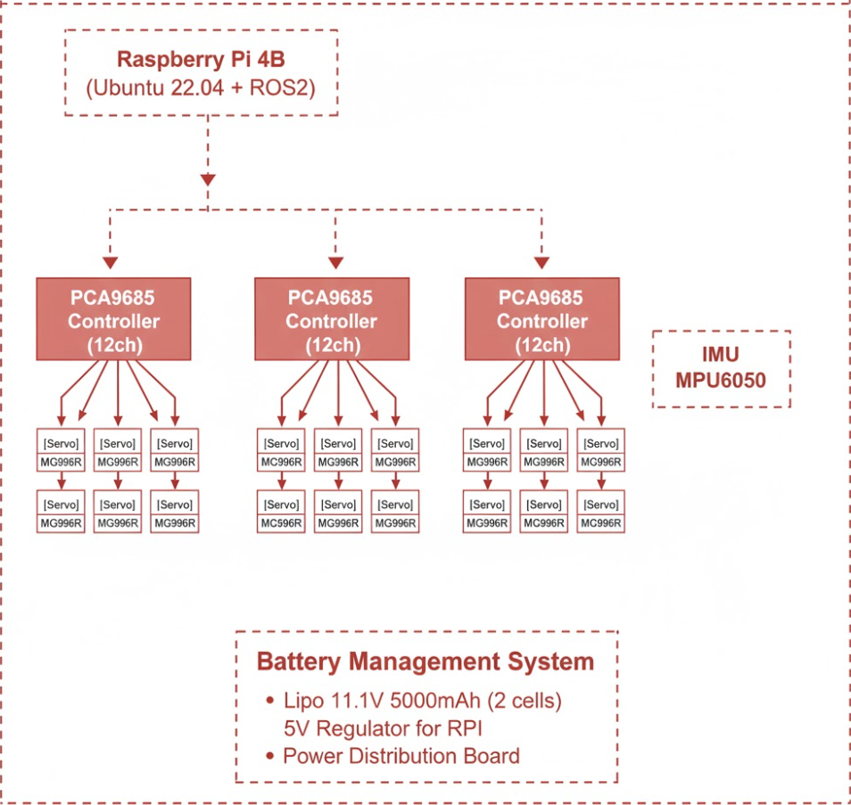
Data Flow Diagram:
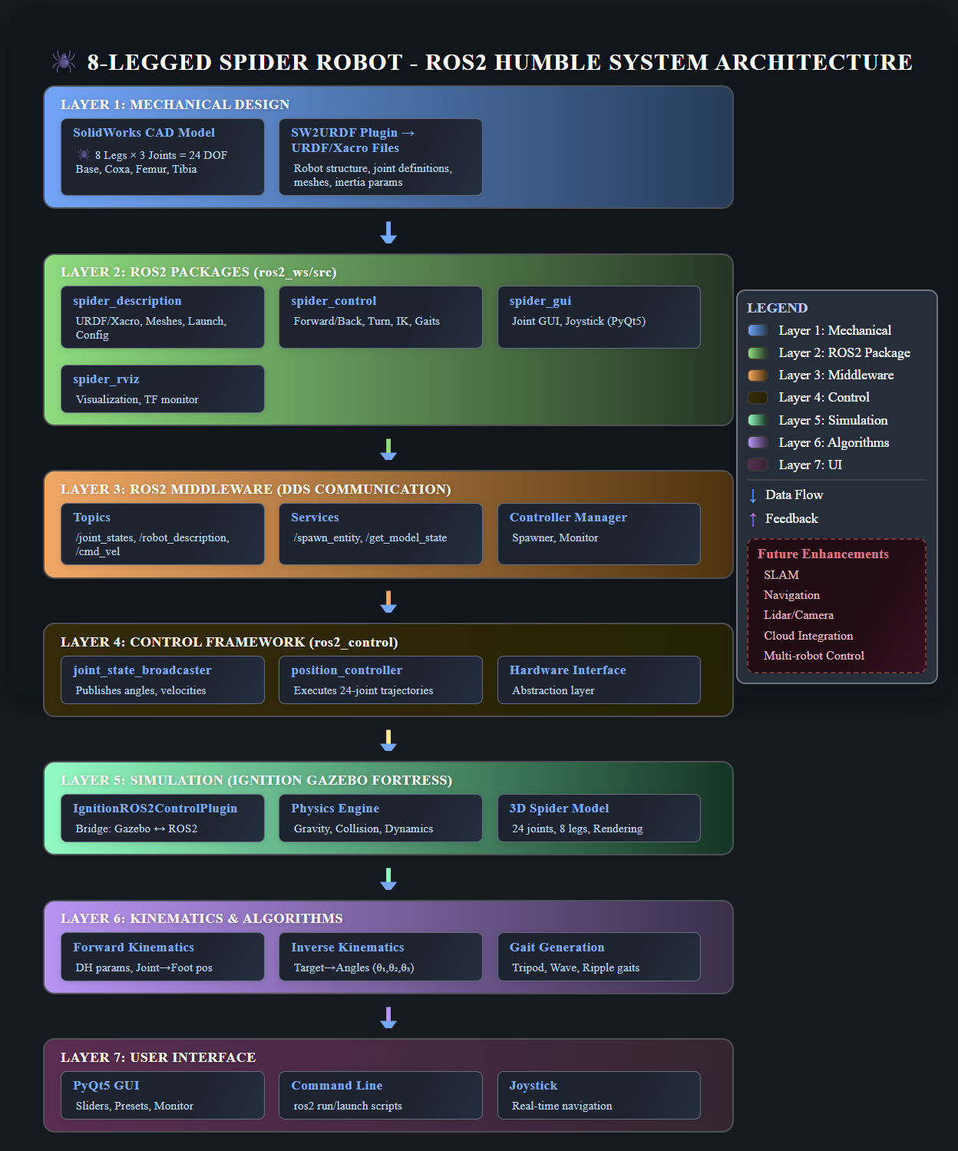

Prerequisites:
1. System Requirements
- Operating System: Ubuntu 22.04 LTS (required for ROS2 Humble)
- Processor: 64-bit CPU with at least 4 cores (Intel i5/AMD Ryzen 5 or higher recommended)
- RAM: Minimum 8 GB (16 GB recommended for Ignition Gazebo smooth performance)
- Graphics: GPU supporting OpenGL 4.2 or higher for visualisation
- Storage: At least 10 GB free disk space
2. Software Dependencies
Component | Recommended Version | Purpose
ROS2 Distribution | Humble | Core middleware for robot nodes and communication
Ignition Gazebo | Fortress | Physics simulation environment
colcon | Latest | ROS2 build system for Python-based packages
rosdep | Latest | Dependency manager for installing missing ROS packages
rviz2 (optional) | - | For visualizing robot states and TFs
python3-pyqt5 | - | Required for the PyQt-based Joint Control GUI
ros2_control | - | Hardware abstraction and controller framework
ros2_controllers | - | Controller implementations
xacro | - | URDF macro processing
gazebo_ros_pkgs | - | ROS2-Gazebo integration

3. Installation Commands
Install Build Tools:
sudo apt update
sudo apt install -y python3-colcon-common-extensions python3-pip build-essential
pip3 install -U setuptools
Install ROS Control & Common Packages:
sudo apt install -y \
ros-humble-rclpy \
ros-humble-ros2-control \
ros-humble-ros2-controllers \
ros-humble-xacro \
ros-humble-joint-state-controller \
ros-humble-controller-manager \
ros-humble-gazebo-ros-pkgs \
python3-pyqt5

STEPS TO IMPORT & CONTROL IN “IGNITION FORTRESS”
1. Setup the Workspace
Create a ROS2 workspace and place the project inside the src directory:
- mkdir -p ~/ros2_ws/src
- cd ~/ros2_ws/src
Then clone or copy the spider robot packages into this source directory.
Then build the workspace:
- cd ~/ros2_ws
- colcon build
- source install/setup.bash
2. Launch Ignition Gazebo
Run the main launch file to open Ignition Gazebo with the spider robot model:
- ros2 launch spider_description spider_gazebo.launch.py
This command performs the following:
- Starts Ignition Gazebo with an empty world or custom warehouse environment.
- Loads the spider_description.xacro file and publishes it as /robot_description.
- Spawns the 8-legged spider robot entity in the simulation environment.
- Launches the ros2_control_node with IgnitionROS2ControlPlugin for real-time control of all 24 joints.
You should now see the spider robot model appear in the Ignition GUI window with all 8 legs properly positioned.
3. Activate Controllers
In a new terminal (after sourcing your workspace again):
- source ~/ros2_ws/install/setup.bash
- ros2 run controller_manager spawner joint_state_broadcaster
- ros2 run controller_manager spawner position_controller
These commands:
- joint_state_broadcaster → Publishes all 24 joint angles and velocities in real-time.
- position_controller → Enables direct control of individual leg joints via ROS2 commands or GUI.
Once these controllers are active, the spider robot's joints can respond to trajectory commands and gait execution scripts in the simulation.
4. Control the Robot
Now you can control the robot using multiple methods:
Joint Control GUI:
- ros2 run spider_gui joint_gui.py
This opens the PyQt interface where you can manually adjust individual joint angles for testing and debugging.
Gait Execution Scripts:
- ros2 run spider_control Forward_perfect.py (Forward walking)
- ros2 run spider_control Backward_perfect.py (Backward walking)
- ros2 run spider_control Left_Turn.py (Turn left)
- ros2 run spider_control Right_Turn.py (Turn right)
- ros2 run spider_control Circle_C.py (Circular motion clockwise)
Joystick Control (Optional):
- ros2 run spider_gui joystick_control.py
This enables real-time control using a game controller for intuitive navigation.

ERRORS/DEBUGGING METHODS DURING IMPORT:
Can’t locate meshes error:
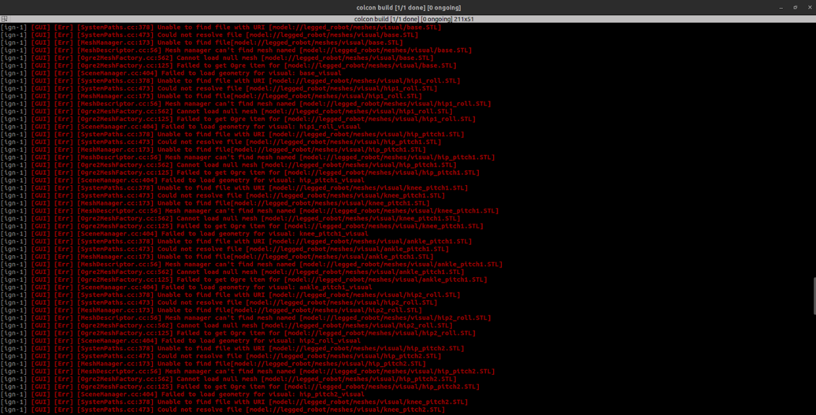
This error is due to that ignition can’t find your mesh files because the default resource path of ignition is different.
- Check in xacro file whether the path is like “<mesh filename="package://your_mesh_path" />” & not as “model” instead of package.
- Add this line at the end of .bashrc: “export IGN_GAZEBO_RESOURCE_PATH=~/your_ws/src:$IGN_GAZEBO_RESOURCE_PATH”.
- Then source and run.

Controllers are activated but doesn’t responding to Controller GUI
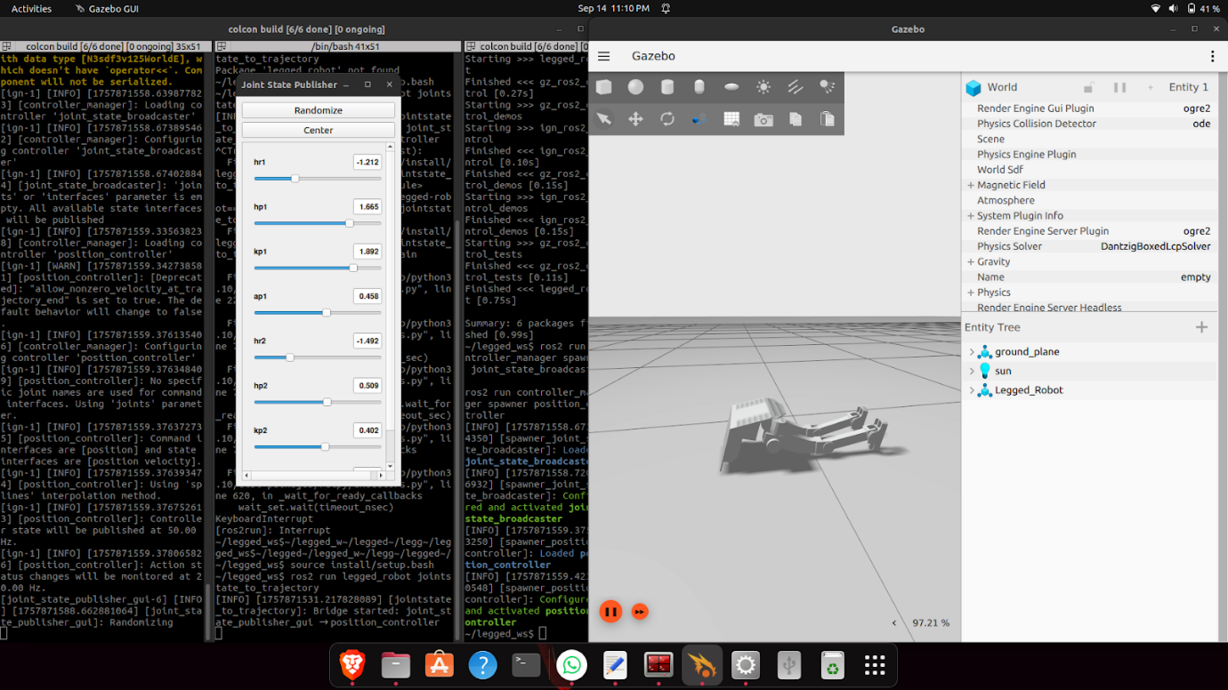
- This is due to unproper bridging or the topic is not published or not subscribed.
- Check whether the commands are published to this topic “ /position_controller/joint_trajectory trajectory_msgs/msg/JointTrajectory” (Here bridging is not used).

STEPS TO CONTROL:
1. Kinematic Configuration and Additional Bend (α)
Each leg of the spider robot consists of a hip joint (coxa), knee joint (femur), and ankle joint (tibia), giving three degrees of freedom per leg. However, the knee segment includes a bent link (as shown in the figure) that introduces an additional offset angle α between the upper and lower leg links
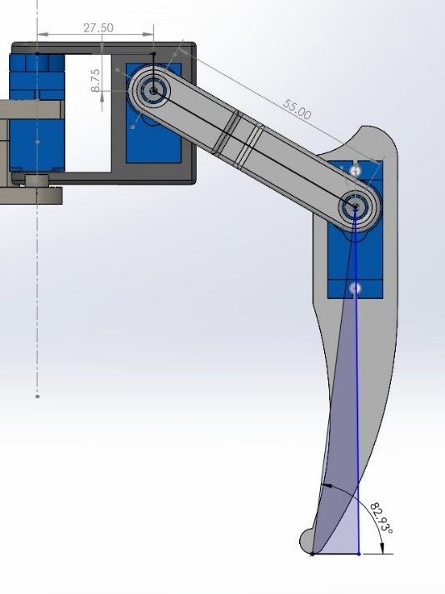

This geometric bend must be explicitly considered in both the IKE and FKE models; otherwise, the simulated foot will not align parallel to the ground plane during walking, causing instability and improper ground contact.
In the kinematic formulation:
- Let L1 = 55.00 mm = upper leg length (femur),
- L2 = 82.93 mm = lower leg length (tibia),
- L3 = foot offset or vertical foot link, and
- α = constant internal bend angle in the knee link (derived from geometry).
Thus, the effective position of the foot relative to the hip can be expressed as:
x = L1cos(θ₁ + α) + L2cos(θ₁ + θ₂ + α)
z = L1sin(θ₁ + α) + L2sin(θ₁ + θ₂ + α)
where θ1 and θ2 are the hip and knee joint angles, respectively.
Including α ensures that the virtual leg line used in inverse kinematics matches the physical leg posture, allowing all eight feet to maintain flat ground contact and proper center of mass (CoM) alignment during stepping.

2. Forward & Inverse Kinematics
The Forward Kinematics (FKE) module computes the end-effector (foot) position from known joint angles while the Inverse Kinematics (IKE) module determines the required joint angles to achieve a desired foot position or step trajectory.
Both solvers are implemented in Python and integrated with ROS2 topics. The computed joint trajectories are published to the position_controller, which sends commands through the IgnitionROS2ControlPlugin to actuate the virtual joints inside Ignition Gazebo.

Forward Kinematics Equations (FKE) using Your DH Table
For a 3R revolute robot, the Denavit-Hartenberg (DH) parameter matrix from your RoboAnalyzer window is as follows:
DH Table:
Link | Link Length (a) | Link Offset (d) | Twist Angle (⍶º) | Joint Angle (θº)
0 | 0.0415 | 0 | 90 | θ₁ (variable)
1 | 0.065 | 0 | 90 | θ₂ (variable)
2 | 0.10114 | 0 | 0 | θ₃ (variable)
*All dimensions are in “mm” & “degrees” respectively

For each joint $i$, the homogeneous transformation matrix using DH parameters is:
$$A_{i}=[\begin{matrix}\cos{θ_{i}} & -sin⁡θ_{i}cos⁡α_{i} & sin⁡θ_{i}sin⁡α_{i} & a_{i}cos⁡θ_{i} \\ \sin{θ_{i}} & cos⁡θ_{i}cos⁡α_{i} & -cos⁡θ_{i}sin⁡α_{i} & a_{i}sin⁡θ_{i} \\ 0 & \sin{α_{i}} & \cos{α_{i}} & d_{i} \\ 0 & 0 & 0 & 1\end{matrix}]$$
Now, plug in the values for each joint:

Joint 1:
$$A_{1}=[\begin{matrix}\cos{θ_{1}} & 0 & \sin{θ_{1}} & a_{1}cos⁡θ_{1} \\ \sin{θ_{1}} & 0 & -cos⁡θ_{1} & a_{1}sin⁡θ_{1} \\ 0 & 1 & 0 & 0 \\ 0 & 0 & 0 & 1\end{matrix}]$$
where $a_{1}=0.0415$, $α_{1}={90}^{∘}$.

Joint 2:
$$A_{2}=[\begin{matrix}\cos{θ_{2}} & -sin⁡θ_{2} & 0 & a_{2}cos⁡θ_{2} \\ \sin{θ_{2}} & \cos{θ_{2}} & 0 & a_{2}sin⁡θ_{2} \\ 0 & 0 & 1 & 0 \\ 0 & 0 & 0 & 1\end{matrix}]$$
where $a_{2}=0.065$, $α_{2}=0^{∘}$.

Joint 3:
$$A_{3}=[\begin{matrix}\cos{θ_{3}} & -sin⁡θ_{3} & 0 & a_{3}cos⁡θ_{3} \\ \sin{θ_{3}} & \cos{θ_{3}} & 0 & a_{3}sin⁡θ_{3} \\ 0 & 0 & 1 & 0 \\ 0 & 0 & 0 & 1\end{matrix}]$$
where $a_{3}=0.10114$, $α_{3}=0^{∘}$.
Total Transformation Matrix $T$ from base to end-effector:
$$T=[\begin{matrix}sin⁡θ_{1}sin⁡θ_{3}+cos⁡θ_{1}cos⁡θ_{2}cos⁡θ_{3} & sin⁡θ_{1}cos⁡θ_{3}-sin⁡θ_{3}cos⁡θ_{1}cos⁡θ_{2} & sin⁡θ_{2}cos⁡θ_{1} & X \\ sin⁡θ_{1}cos⁡θ_{2}cos⁡θ_{3}-sin⁡θ_{3}cos⁡θ_{1} & -sin⁡θ_{1}sin⁡θ_{3}cos⁡θ_{2}-cos⁡θ_{1}cos⁡θ_{3} & sin⁡θ_{1}sin⁡θ_{2} & Y \\ -sin⁡θ_{2}cos⁡θ_{3} & -sin⁡θ_{2}sin⁡θ_{3} & \cos{θ_{2}} & Z \\ 0 & 0 & 0 & 1\end{matrix}]$$
Where,
$$\begin{matrix}X & =0.10114sin⁡θ_{1}sin⁡θ_{3}+0.10114cos⁡θ_{1}cos⁡θ_{2}cos⁡θ_{3}+0.065sin⁡θ_{1}cos⁡θ_{2}+0.0415cos⁡θ_{1} \\ Y & =0.10114sin⁡θ_{1}cos⁡θ_{2}cos⁡θ_{3}+0.065sin⁡θ_{1}cos⁡θ_{2}+0.0415sin⁡θ_{1}+0.10114cos⁡θ_{3}cos⁡θ_{1}-0.10114sin⁡θ_{3}cos⁡θ_{1} \\ Z & =-0.065sin⁡θ_{2}+0.10114cos⁡θ_{3}sin⁡θ_{2}\end{matrix}$$This gives you the forward kinematic transformation $T$, which you can expand as needed for your robot to get the explicit equations for position and orientation.

Inverse Kinematics Equations (IKE)
Given your robot link lengths $L_{1},L_{2},L_{3}$ (Coxa, Femur, Tibia), and using the Python code you've provided, the equations for each joint (for a single leg, with target position $(x,y,z)$ and base position $(bx,by,bz)$) are:
- Coxa angle (θ₁):
$$θ_{1}=arctan⁡2(y-b_{y},x-b_{x})$$
- Planar distance r and s:
$$r=\sqrt{(x-b_{x})^{2}+(y-b_{y})^{2}}-L_{1} \\ s=z-b_{z} \\ D=\sqrt{r^{2}+s^{2}}$$
- Tibia angle (θ₃):
$$cos⁡(θ_{3})=\frac{L_{2}^{2}+L_{3}^{2}-D^{2}}{2L_{2}L_{3}} \\ θ_{3}=arccos⁡(\text{clip}(cos⁡(θ_{3}),-1,1))-\frac{π}{2}$$
- Femur angle (θ₂):
$$α=arctan⁡2(s,r) \\ β=arccos⁡(\text{clip}(\frac{L_{2}^{2}+D^{2}-L_{3}^{2}}{2L_{2}D},-1,1)) \\ θ_{2}=α+β$$
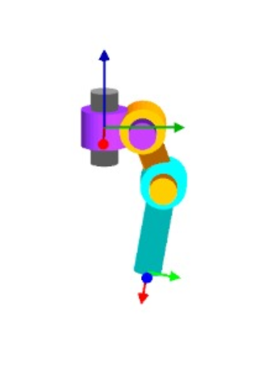
Joint frame representation using Robo Analyser software

4. Zero Moment Point (ZMP) and Center of Mass (CoM)
The ZMP is the point on the ground where the total moment of all forces (including gravity and inertia) is zero.
To maintain stability:
$$x_{ZMP}≤\text{support polygon (foot area)}$$
The Center of Mass (CoM) trajectory must therefore be planned so that the projected CoM always stays close to the ZMP line between the two feet.
In this project:
- The CoM trajectory is generated from the LIPM model.
- Foot placements are planned via IKE.
- Both are synchronized in the control loop to ensure balanced steps.

5. GAIT EXECUTION PROCESS
Each walking step for the 8-legged spider robot is executed using the following control sequence:
- Initialize: All 8 feet positioned flat on the ground at initial stance; body centered and balanced.
- Select Gait Pattern: Choose locomotion mode (Tripod, Wave, or Ripple gait) based on desired speed and stability requirements.
- Define Support and Swing Phases:
  - Tripod Gait: Legs 1, 3, 6, 8 move together while 2, 4, 5, 7 provide support, then alternate.
  - Wave Gait: Legs lift sequentially in a rippling pattern for maximum stability.
- Compute Swing Leg Trajectories: For each swing leg, use IKE to calculate joint angles (θ₁, θ₂, θ₃) for the desired foot position, incorporating the knee bend angle α for proper ground clearance.
- Generate Step Parameters:
  - Define step height (lift distance from ground)
  - Set forward/backward displacement (STEP_SIZE = 10 mm)
  - Calculate intermediate waypoints for smooth trajectory
- Publish Joint Commands: Send computed joint angles to the position_controller through ROS2 topics (/position_controller/commands) for all active legs simultaneously.
- Monitor Execution: Use feedback from joint_state_broadcaster (/joint_states) to confirm joint convergence and detect any trajectory errors.
- Cycle Phases: Alternate between swing and support phases. When swing legs complete motion and contact ground, switch roles with support legs.
- Coordinate Body Motion: Adjust body pose and center of mass position to maintain stability throughout the gait cycle, ensuring static stability margin.
This coordinated multi-leg cycle results in stable locomotion patterns. The spider robot maintains at least 5 legs on the ground during tripod gait (62.5% support polygon) or 7 legs during wave gait (87.5% support polygon), ensuring robust stability even on uneven terrain. The modular control scripts (Forward_perfect.py, Backward_perfect.py, Left_Turn.py, etc.) implement these sequences with precise timing and trajectory synchronization.

STEPS TO CREATE AN ENVIRONMENT IN ROS2
1. Create Workspace Directory Structure
mkdir -p ~/ros2_ws/src
cd ~/ros2_ws/src
This creates the standard ROS2 workspace with a src folder for all packages.
2. Clone or Copy Spider Robot Packages
cd ~/ros2_ws/src
git clone https://github.com/BargavanR/spider_8leg_ros2_humble.git
Or manually copy the spider packages into the src directory.
3. Install Dependencies
cd ~/ros2_ws
rosdep install --from-paths src --ignore-src -r -y
This automatically installs all missing ROS2 dependencies listed in package.xml files.
4. Source ROS2 Environment
source /opt/ros/humble/setup.bash
Note: This must be done in every new terminal before building or running ROS2 commands.
5. Build the Workspace
cd ~/ros2_ws
colcon build --symlink-install
The --symlink-install flag allows editing Python scripts without rebuilding.
6. Source the Workspace
source ~/ros2_ws/install/setup.bash
This makes your custom packages discoverable by ROS2.

7. Verify Package Installation
ros2 pkg list | grep spider
Expected output:
```
spider_control
spider_description
spider_gui
spider_rviz
spider_warehouse
8. Configure Gazebo Resource Path
Add this line to ~/.bashrc to help Ignition Gazebo locate mesh files:
echo"export IGN_GAZEBO_RESOURCE_PATH=~/ros2_ws/src:\$IGN_GAZEBO_RESOURCE_PATH" >> ~/.bashrc
source ~/.bashrc
9. Test Launch Files
ros2 launch spider_description spider_gazebo.launch.py
The spider robot should spawn in Ignition Gazebo without errors.

COMMON ERRORS AND PREVENTION

Error 1: Package Not Found
Symptom:
Package 'spider_description' not found

Cause: Workspace not sourced or build failed.

Solution:
cd ~/ros2_ws
colcon build --symlink-install
source install/setup.bash
---
Error 2: Mesh Files Not Loading
Symptom:

[Err] [SDFFeatures.cc:843] File or path does not exist
Cause: Ignition Gazebo cannot locate STL/mesh files.
Solution:
- Verify mesh paths in URDF use package:// prefix, not model://
- Ensure IGN_GAZEBO_RESOURCE_PATH is set in .bashrc
- Check mesh files exist in spider_description/meshes/ folder
export IGN_GAZEBO_RESOURCE_PATH=~/ros2_ws/src:$IGN_GAZEBO_RESOURCE_PATH

---
Error 3: Controller Manager Not Starting
Symptom:

[controller_manager]: Waiting for /controller_manager services...
Cause: ros2_control plugin not loaded or YAML configuration error.
Solution:
- Check spider_description.xacro includes <ros2_control> tag
- Verify controller.yaml syntax is correct
- Ensure gazebo_ros2_control plugin is installed:
sudo apt install ros-humble-gazebo-ros2-control

---
Error 4: Multiple Build Failures
Symptom:

CMake Error / setup.py error
Cause: Missing dependencies or incorrect package structure.
Solution:
# Clean build artifacts
cd ~/ros2_ws
rm -rf build/ install/ log/

# Reinstall dependencies
rosdep update
rosdep install --from-paths src --ignore-src -r -y

# Rebuild
colcon build --symlink-install

---
Error 5: Controllers Not Spawning
Symptom:

[spawner]: Failed to load controller
Cause: Controller name mismatch or joint names incorrect.
Solution:
- Verify controller names in controller.yaml match spawn commands
- Check joint names in URDF match those in controller configuration
- List available controllers:
ros2 control list_controllers

---
Error 6: Python Scripts Not Executable
Symptom:

Permission denied when running ros2 run
Cause: Script files lack execute permissions.
Solution:
chmod +x ~/ros2_ws/src/spider_8leg_ros2_humble/spider_control/src/*.py
chmod +x ~/ros2_ws/src/spider_8leg_ros2_humble/spider_gui/src/*.py
colcon build --symlink-install

---
Error 7: Gazebo Crash on Launch
Symptom:

Segmentation fault or Gazebo hangs
Cause: Insufficient GPU resources or conflicting plugins.
Solution:
- Close other GPU-intensive applications
- Reduce Gazebo quality settings
- Check GPU driver installation:
Command to run:
glxinfo | grep "OpenGL version"

Prevention Best Practices:
- Always source environments:
# Add to ~/.bashrc for persistence
echo "source /opt/ros/humble/setup.bash" >> ~/.bashrc
echo "source ~/ros2_ws/install/setup.bash" >> ~/.bashrc
- Use --symlink-install during development:

colcon build --symlink-install

- Clean rebuild when switching branches:

rm -rf build/ install/ log/
colcon build

- Verify dependencies before building:

rosdep check --from-paths src --ignore-src

- Test individual packages:

colcon build --packages-select spider_description

FABRICATION IDEAS AND FUTURE ENHANCEMENTS
1. Hardware Fabrication Plan
Mechanical Components
Component | Specification | Quantity | Estimated Cost (INR)
Body Frame | 3D printed PLA/ABS chassis | 1 | ₹800
Leg Segments | 3D printed coxa, femur, tibia | 24 (8 legs × 3) | ₹1,200
Servo Motors | MG996R or DS3218 (20kg-cm torque) | 24 | ₹12,000
Servo Brackets | Aluminum or 3D printed mounts | 24 | ₹600
Ball Bearings | 608ZZ (8mm ID) for joints | 24 | ₹480
Fasteners | M3/M4 screws, nuts, spacers | Set | ₹300
Foot Pads | Rubber or silicone grips | 8 | ₹200

Electronics & Control
Component | Specification | Quantity | Estimated Cost (INR)
Microcontroller | Raspberry Pi 4B (4GB/8GB) | 1 | ₹6,500
Servo Controller | PCA9685 16-channel PWM driver | 2 | ₹600
Power Supply | LiPo 11.1V 5000mAh 3S battery | 2 | ₹4,000
Voltage Regulator | 5V 10A step-down converter | 1 | ₹250
IMU Sensor | MPU6050 (gyroscope + accelerometer) | 1 | ₹150
LiDAR (Optional) | RPLidar A1 for SLAM | 1 | ₹18,000
Camera | Intel RealSense D435i depth camera | 1 | ₹25,000
Wiring | Jumper wires, connectors, heat shrink | Set | ₹500
Power Switch | Emergency stop button | 1 | ₹100

Total Estimated Budget
Category | Cost (INR)
Mechanical Components | ₹3,580
Electronics (Basic) | ₹12,100
Total (Basic Build) | ₹15,680
With LiDAR | ₹33,680
With RealSense Camera | ₹40,680
Full Featured Build | ₹58,680

2. Fabrication Process
Step 1: 3D Printing
- Export STL files from SolidWorks assembly
- Print body chassis and all 24 leg segments using PLA (220°C, 60°C bed)
- Post-process: sand rough edges, drill precise servo mount holes
Step 2: Assembly
- Install servo motors into leg segments with brackets
- Connect leg segments using ball bearings for smooth rotation
- Attach all 8 legs to the main body frame
- Mount Raspberry Pi, servo controllers, and battery inside chassis
Step 3: Wiring
- Connect all 24 servos to two PCA9685 controllers (12 servos each)
- Wire PCA9685 boards to Raspberry Pi via I2C bus
- Connect battery to voltage regulator and distribute 5V power
- Install emergency stop switch in series with battery
Step 4: Software Integration
- Install Ubuntu 22.04 and ROS2 Humble on Raspberry Pi
- Flash servo controller firmware and test individual joint movement
- Deploy spider_control package for gait execution
- Calibrate joint offsets and validate inverse kinematics

3. Future Enhancements
A. SLAM and Autonomous Navigation
Objective: Enable the spider robot to map unknown environments and navigate autonomously.
Implementation Plan:
- Integrate RPLidar A1 or Intel RealSense D435i for environment sensing
- Implement SLAM using slam_toolbox or cartographer_ros packages
- Deploy Nav2 stack for path planning and obstacle avoidance
- Use AMCL (Adaptive Monte Carlo Localization) for position estimation
Expected Capabilities:
- Real-time 2D/3D mapping of warehouse or indoor spaces
- Autonomous waypoint navigation with dynamic obstacle avoidance
- Multi-floor exploration using elevation mapping
B. Cloud-Based Remote Control
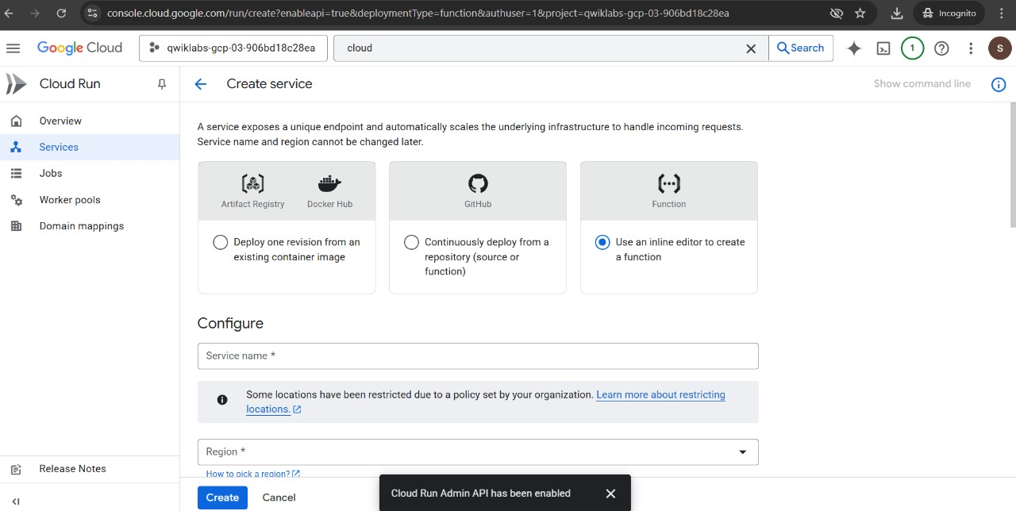
Objective: Deploy robot control and monitoring services on Google Cloud for remote operation and data analytics.
Implementation Platform: Google Cloud Run – A serverless execution environment for event-driven services on Google Cloud.
Architecture:
- Cloud Run Function Setup:
  - Deploy lightweight HTTP endpoints for receiving robot commands
  - Use Cloud Functions (Python/Node.js) to process control requests
  - Auto-scales based on incoming traffic with zero maintenance
- Real-Time Communication:
  - Robot publishes telemetry data (joint states, sensor readings, camera feed) to Cloud Pub/Sub
  - Cloud Run functions subscribe to topics and trigger actions
  - Low-latency command relay using WebSockets or gRPC
- Data Pipeline:
  - Store sensor logs in Cloud Storage for offline analysis
  - Use BigQuery for analyzing gait performance metrics
  - Visualize robot trajectory using Looker Studio dashboards
- Web Dashboard:
  - Build React/Angular frontend hosted on Cloud Run
  - Display live camera feed, joint angles, battery status
  - Remote joystick control interface accessible from any device
- Security:
  - Implement OAuth 2.0 authentication for user access
  - Use Cloud IAM roles to restrict command permissions
  - Encrypt all communication using TLS/SSL
Benefits:
- Remote operation from anywhere with internet connectivity
- Centralized logging and diagnostics for fleet management
- Scalable architecture supporting multiple robots simultaneously
- Cost-effective (pay only for actual compute time)
Cost Estimate:
- Cloud Run: ~₹500/month for moderate usage
- Cloud Storage: ~₹200/month for telemetry logs
- Pub/Sub: ~₹300/month for messaging
- Total Cloud Cost: ~₹1,000/month

C. Machine Learning Integration
Objective: Train neural networks for adaptive gait control and terrain classification.
Planned Features:
- Use TensorFlow Lite on Raspberry Pi for on-device inference
- Train reinforcement learning models for optimal gait selection
- Implement computer vision for object detection and manipulation tasks
- Deploy models via Cloud AI Platform for continuous improvement

D. Enhanced Sensor Suite
Additional Sensors:
- Force sensors on feet for ground contact detection
- Ultrasonic sensors for close-range obstacle detection
- GPS module for outdoor localization
- Temperature sensors for motor thermal monitoring

E. Multi-Robot Coordination
Objective: Enable swarm behavior for collaborative tasks.
Implementation:
- Deploy ROS2 DDS for inter-robot communication
- Implement formation control algorithms
- Coordinate warehouse tasks (inventory scanning, object transport)
- Use Fleet Management System for task allocation

F. Energy Optimization
Planned Improvements:
- Implement power-efficient gaits based on terrain analysis
- Add solar panel for extended outdoor operation
- Use sleep modes during idle periods
- Battery monitoring system with low-power alerts
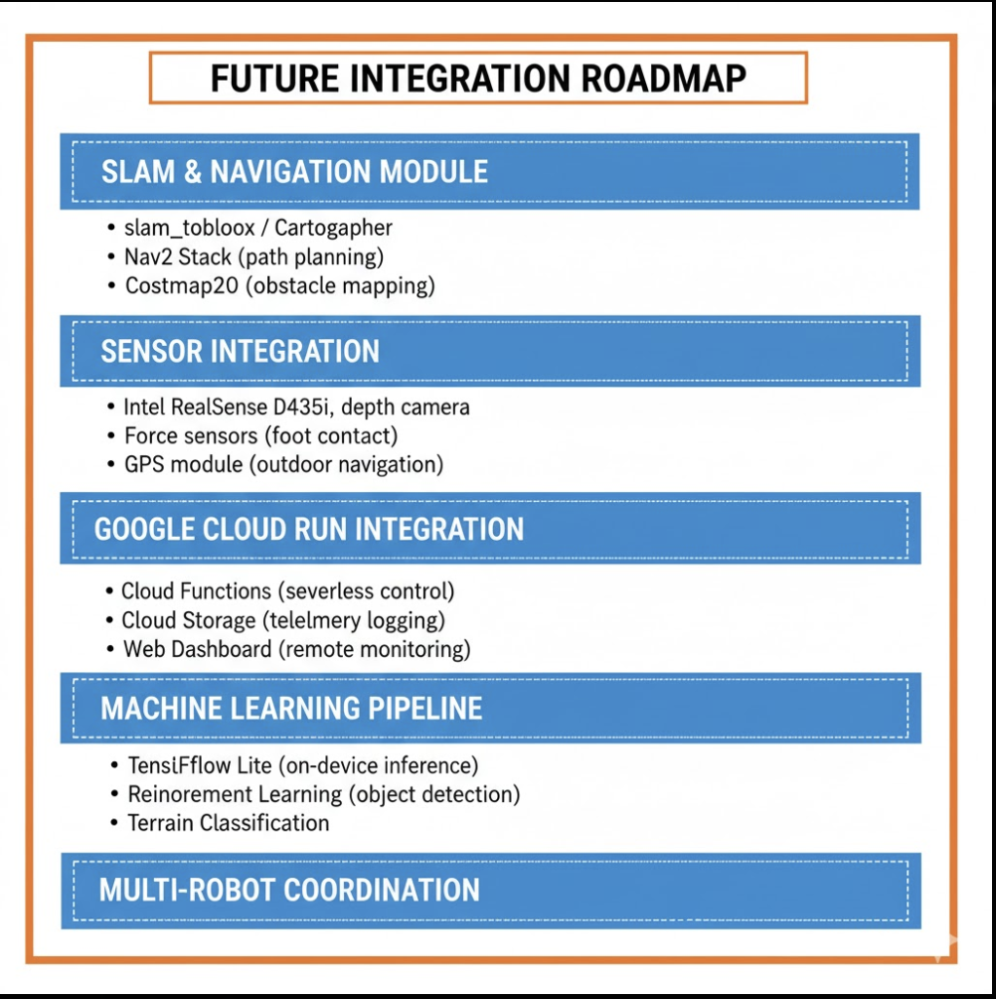

RESULTS AND DISCUSSION:
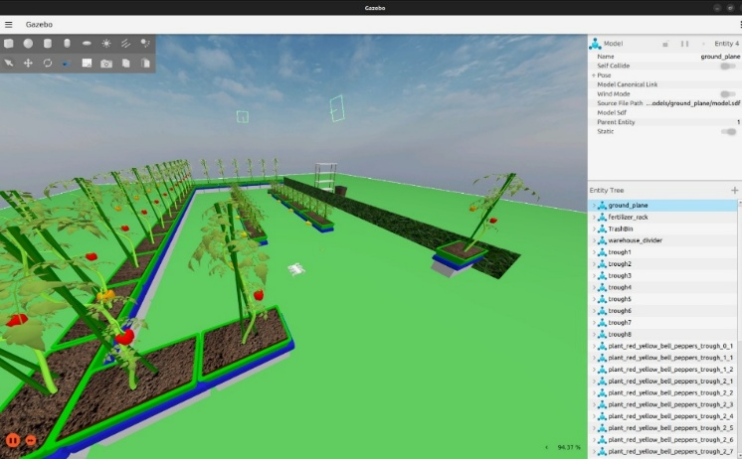
These are the results after executing the commands mentioned in Pg-no: 20 & 21

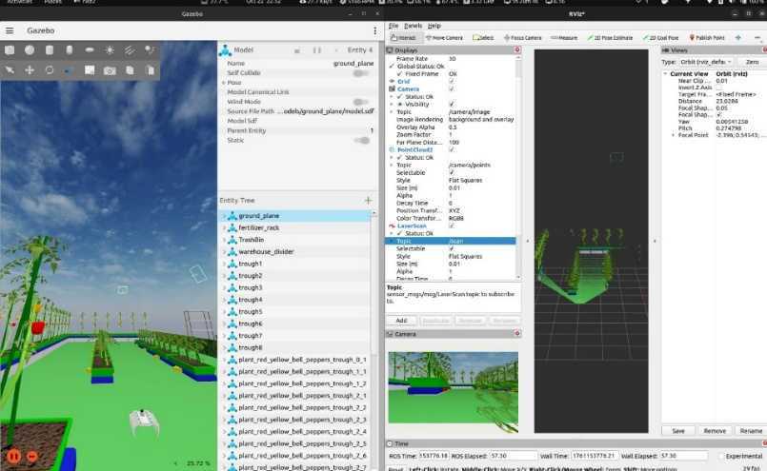

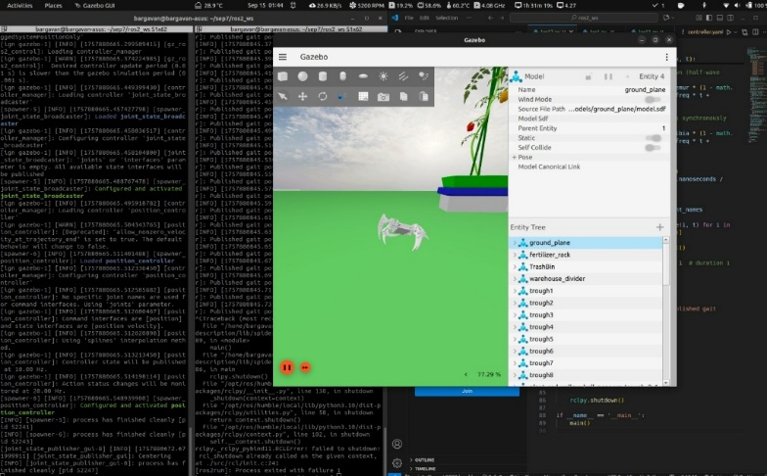

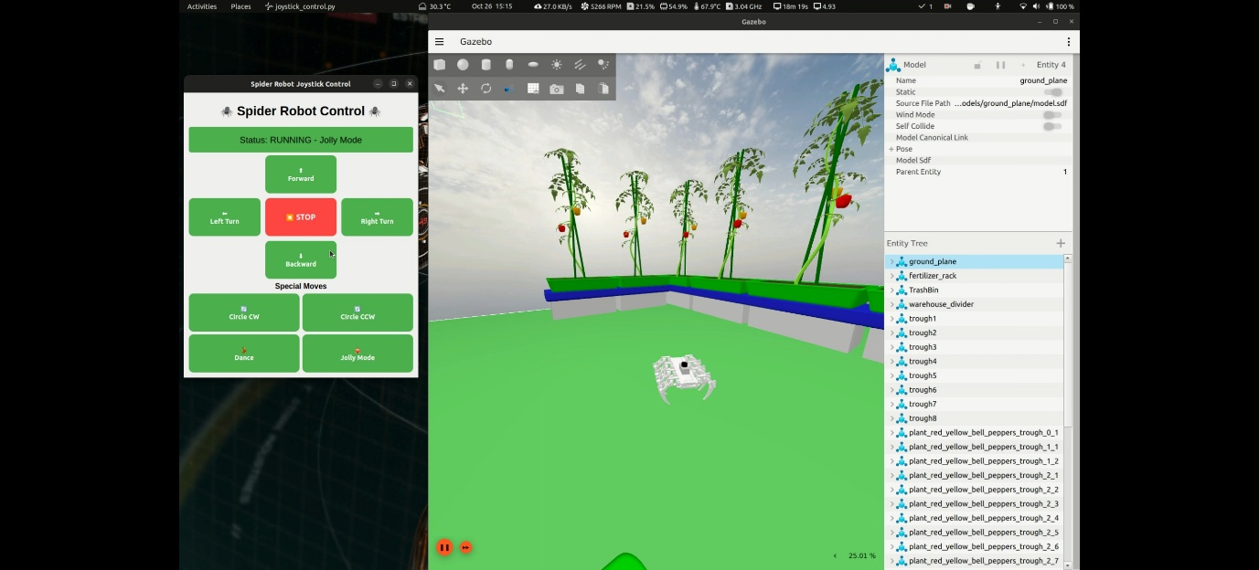

CONCLUSION
The development of the 8-legged spider-inspired robot successfully demonstrates the integration of mechanical design, control theory, and simulation technologies within the ROS2 ecosystem. From conceptual modelling in SolidWorks to real-time testing in Ignition Gazebo, the project provides a comprehensive workflow for designing and validating complex legged robots. Through the use of ROS2 control frameworks, inverse kinematics algorithms, and custom Python-based control scripts, the robot achieves stable locomotion and versatile gait patterns such as tripod and wave gait.
The modular structure of the system with separate packages for description, control, GUI, and visualization enables flexibility for further expansion, such as SLAM-based navigation, cloud integration, or machine learning-based gait optimization. The inclusion of fabrication ideas bridges the gap between simulation and real-world implementation, providing a clear roadmap for transitioning the project into a fully functional hardware prototype.
Overall, this project highlights the potential of bio-inspired robotics in addressing complex mobility challenges. It serves as a foundation for future research in terrain navigation, autonomous warehouse logistics, and swarm robotics. The successful execution of this work underscores the importance of combining mechanical design, control systems, and software integration in modern robotic innovation.

