Human-Centric Artificial Intelligence Project-3 Report
Name – Surname: Barış Kaplan
Matriculation Number: 669584
In this project, the following class mappings are used:
Class 0 => "World"
Class 1 => "Sports"
Class 2 => "Business"
Class 3 => "Sci/Tech"
Task 1:
Used Classification Model: Logistic Regression
Classifier Baseline Test Accuracy Achieved: 90.55%
# Split the imported data into train and test parts
self.X_train_raw = dataset['train']['text']
self.y_train = np.array(dataset['train']['label'])
self.X_test_raw = dataset['test']['text']
self.y_test = np.array(dataset['test']['label'])

# Text Feature Extraction
self.vectorizer = TfidfVectorizer(max_features=5000, stop_words='english')
self.X_train = self.vectorizer.fit_transform(self.X_train_raw).toarray()
self.X_test = self.vectorizer.transform(self.X_test_raw).toarray()

# Baseline Classifier
self.baseline_model = LogisticRegression(C=0.4, max_iter=200)
self.baseline_model.fit(self.X_train, self.y_train)
self.baseline_test_preds = self.baseline_model.predict(self.X_test)
self.baseline_acc = float(accuracy_score(self.y_test, self.baseline_test_preds))
Code used for train test splitting, text feature extraction, and baseline model training, and baseline model evaluation using accuracy score between the ground truth y_test data and baseline model test data predictions.
Task 2:
Simulated Expert’s Test Dataset Accuracy Achieved: 92.70% (Specialized expertise in Class 1 (Sports))
# Simulated Expert
self.expert_test_preds = self.simulate_expert_predict(self.y_test)
self.expert_acc = float(accuracy_score(self.y_test, self.expert_test_preds))

def simulate_expert_predict(self, y_true):
""" Simulates bounded human expert decisions."""
expert_preds = []
for label in y_true:
# Specific domain specialization
if label == 1:
expert_preds.append(label)
else:
if np.random.rand() < 0.90:
expert_preds.append(label)
else:
remaining_classes = [c for c in range(4) if c != label]
expert_preds.append(np.random.choice(remaining_classes))
return np.array(expert_preds)
Code implemented for the prediction of a simulated expert and evaluation of the expert using the accuracy score between the ground-truth y_test data and the expert predictions on the y_test data
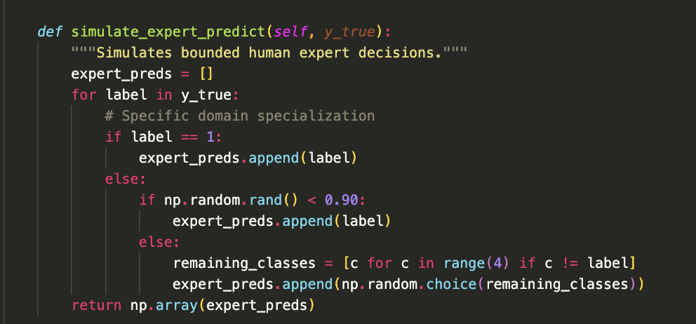

Code implemented for the predictions of the simulated expert
Strengths of the Simulated Expert on the Dataset
1. Domain Expertise in Specific Regions of the Input Space: This simulated expert exhibits a deterministic behavior for Class 1, which is the “Sports” field. It suitably mimics the knowledge of real-world human experts who possess deep knowledge in a specific field (Class 1: Sports), instead of holding a generalized and/or broad expertise. Therefore, it will serve as a realistic and resource-efficient proxy substitute to evaluate cost-efficient (efficient in terms of time, computational complexity, and financial budget) routing and decision delegation mechanisms within the learning-to-defer framework.
2. High Accuracy Achieved on the Test Dataset: The simulated expert has achieved a high test dataset accuracy of “92.70%”, which means it is a highly reliable ground-truth substitute.
3. Significant Reduction of Time, Effort, and Cost Needed for Manual Data Labeling: This simulated expert can serve as a highly reliable proxy for a manual domain expert workforce on the ground-truth dataset; as a result, this approach will significantly reduce the time, effort, and cost required for manual data labeling.

Weaknesses of the Simulated Expert on the Dataset
1. Uniform Error Distribution: The simulated expert makes mistakes %10 of his/her choices. A class for the given text is randomly and uniformly chosen from the remaining options, with equal probability for each class option. However, this is not the case for the decisions of real-life human experts. Human experts rarely guess uniformly and randomly. They are typically influenced by cognitive biases, systematic biases, patterned behavior, and social context, which makes them usually confuse specific classes sharing similar features.
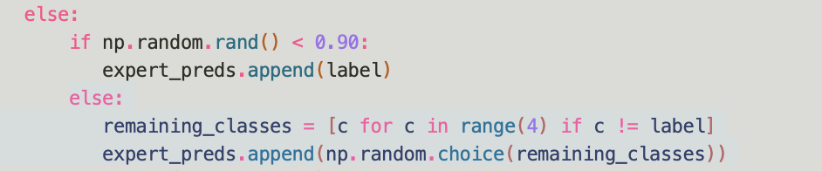

2. Class Imbalance Problem: When human experts encounter an unclear text, they will inherently develop a high level of prior bias towards the classes with more dominance than the others. However, my simulated expert cannot observe the frequencies of the classes (labels). Therefore, its guessing behavior and following prediction errors do not change based on which classes are seen more often, which means the simulated expert is not affected by the class distribution.
3. Static Error Ratio: The error ratio is static and 10% for all remaining classes except Class 1, which are Class 0, 2, and 3. However, the human experts' data labeling performance and errors made in this process change a lot based on several factors, such as tiredness level, daytime, and changing expertise levels for the remaining classes.
4. No Contextual Knowledge of the Input X Values: Even though the simulated expert knows the ground-truth class labels (Class 0 => "World", Class 1 => "Sports", Class 2 => "Business", Class 3 => "Sci/Tech"), it does not know how the features of the input values differ from each other in terms of the length, number, meaning, complexity, and structure of the words in each input text.

5. No “I am completely unsure” Option: This expert is forced to select from the available labels in the error case. However, our expert in real-life might not be able to classify the input into the provided categories and put it into a category like "Unknown".

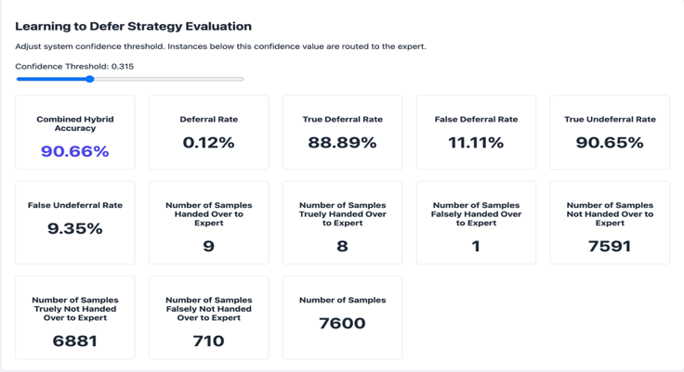
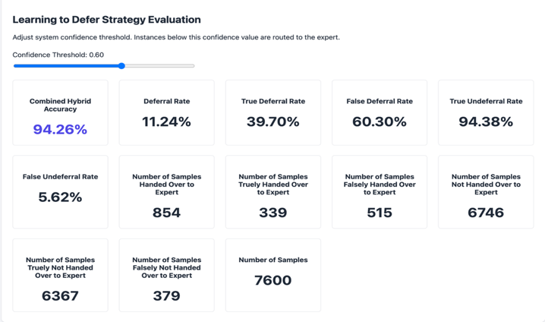
Task 3:

Figure 2: Learning to Defer Strategy Evaluation When Confidence Threshold is 0.315
Figure 1: Learning to Defer Strategy Evaluation When Confidence Threshold is 0.60
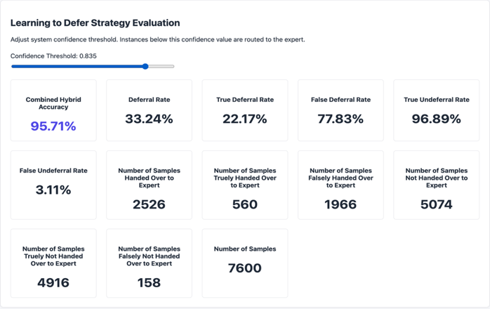
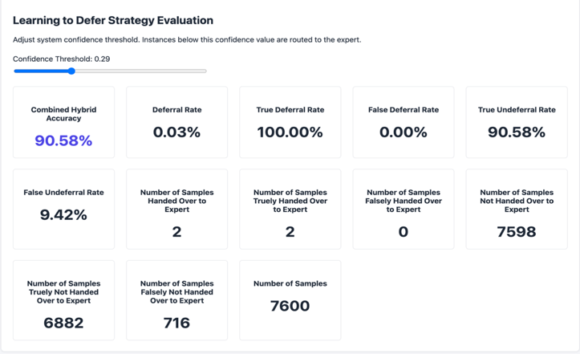

Figure 3: Learning to Defer Strategy Evaluation When Confidence Threshold is 0.835
Figure 4: Learning to Defer Strategy Evaluation When Confidence Threshold is 0.29
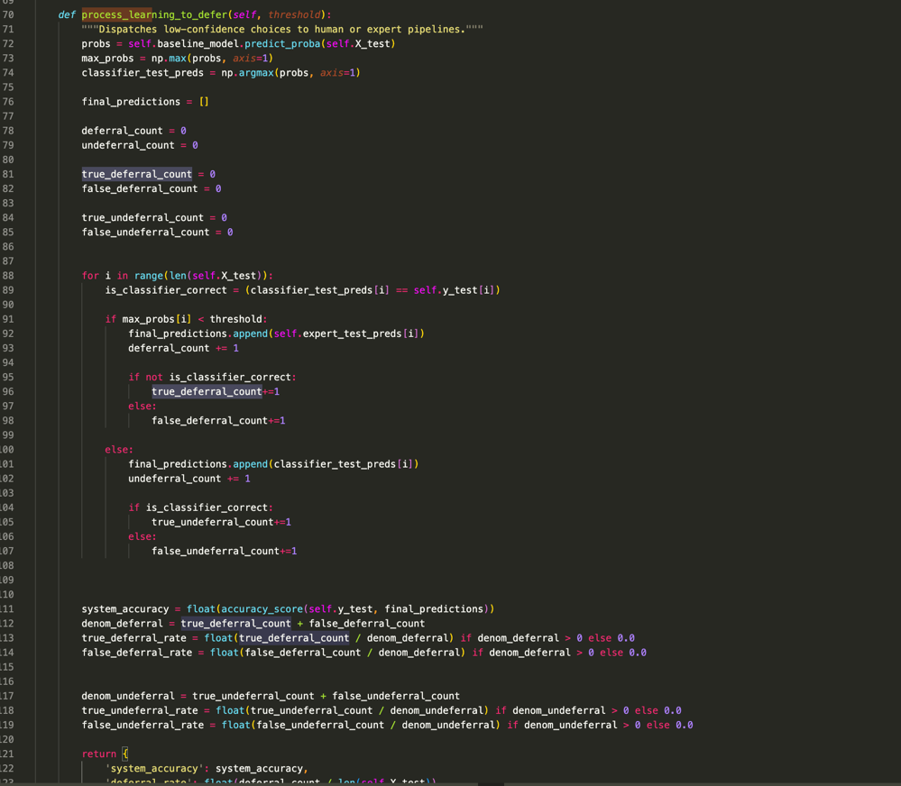

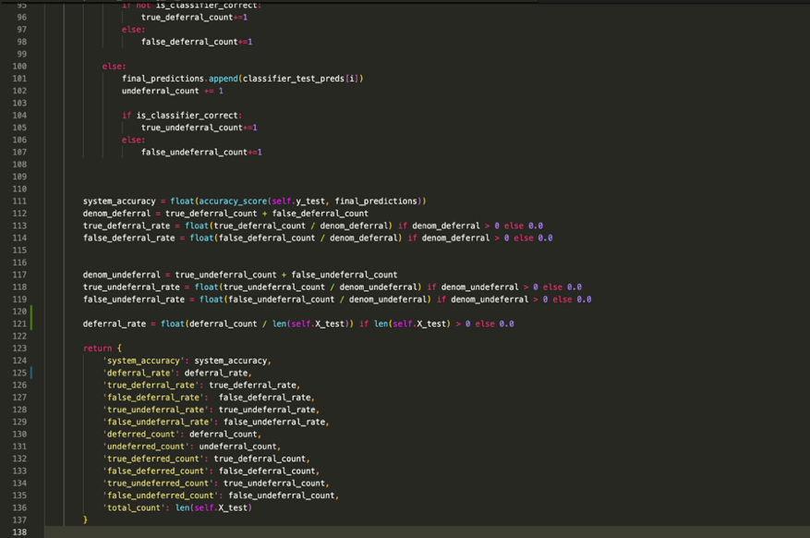

Code implemented for the learning-to-defer process

Here, the system accuracy calculated is a hybrid value. The accuracy value is calculated for the ground truth "y_test" values and final_predictions, which include both the expert predictions and baseline classifier predictions. To avoid a divide-by-zero error in the ratio values, we checked whether the denominator of each ratio value is greater than 0; if so, it is used as it is. Otherwise, the corresponding ratio value is taken as 0.0.
If the max probability coming from the baseline model trained on the X input test dataset is below the threshold (max_probs[i] < threshold), it means that we are deferring to the expert. However, in this scenario, if the baseline classifier is correct for the current index, it is a false deferral (false positive) of knowledge to the expert. Otherwise, it is a true deferral (true positive) case.
If the max probability coming from the baseline model trained on the X input test dataset is above the threshold (max_probs[i] >= threshold), it means that we do not defer to the expert, meaning the baseline model is confident enough in its prediction. However, in this scenario, if the baseline classifier is correct for the current index, it is a true undeferral (true negative) of knowledge to the expert. Otherwise, it is a false undeferral (false negative) case.
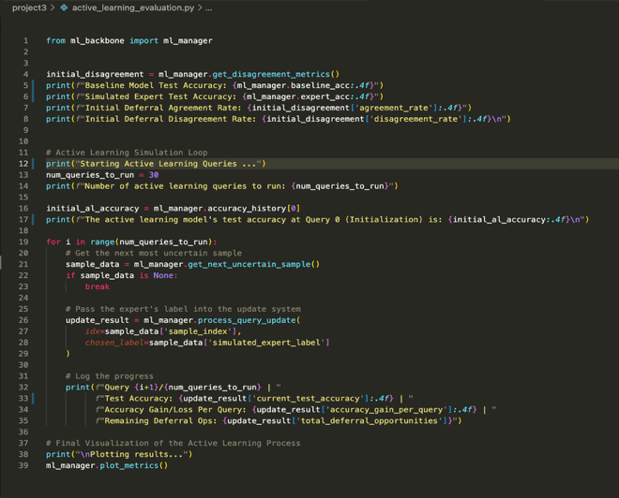
Task 4 & Task 5:
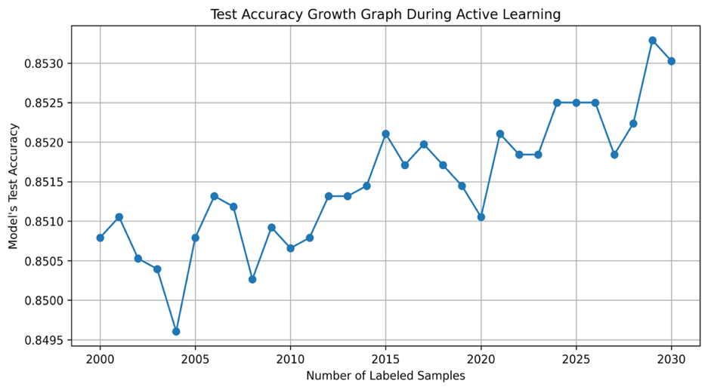

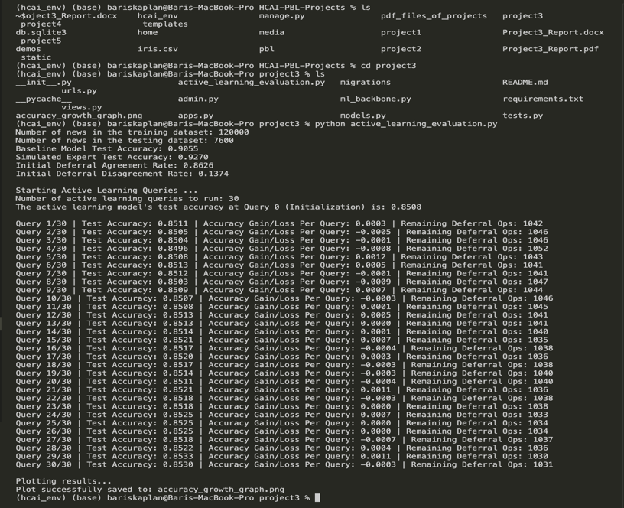
Figure 5: Number of Labeled Samples vs Model’s Test Accuracy Graph for 30 Active Learning Queries
Code implemented for the active learning evaluation and test accuracy change graph plotting during active learning process

Figure 6: Active Learning Evaluation Results and Progress for 30 Active Learning Queries
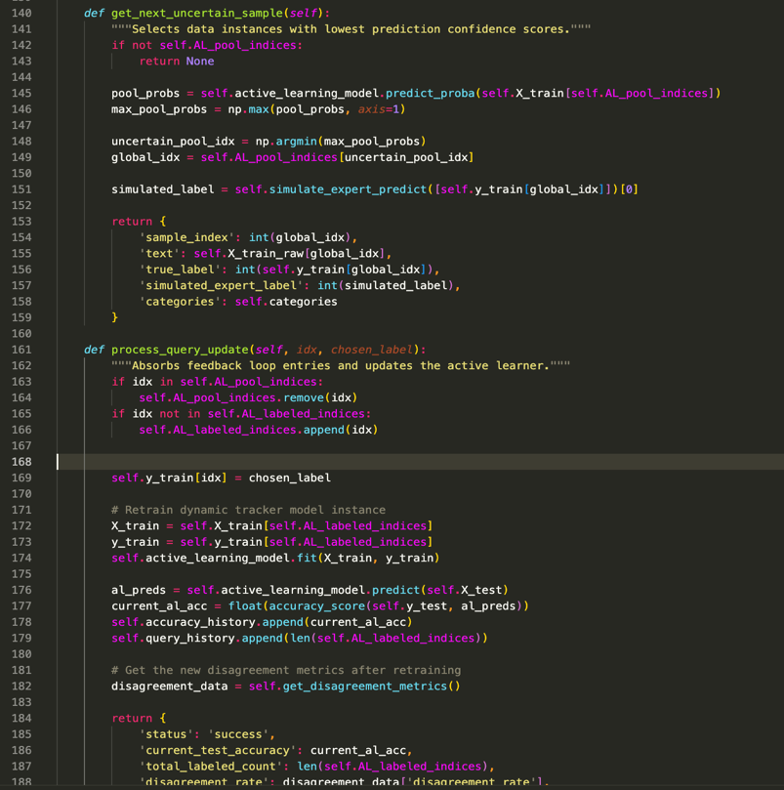

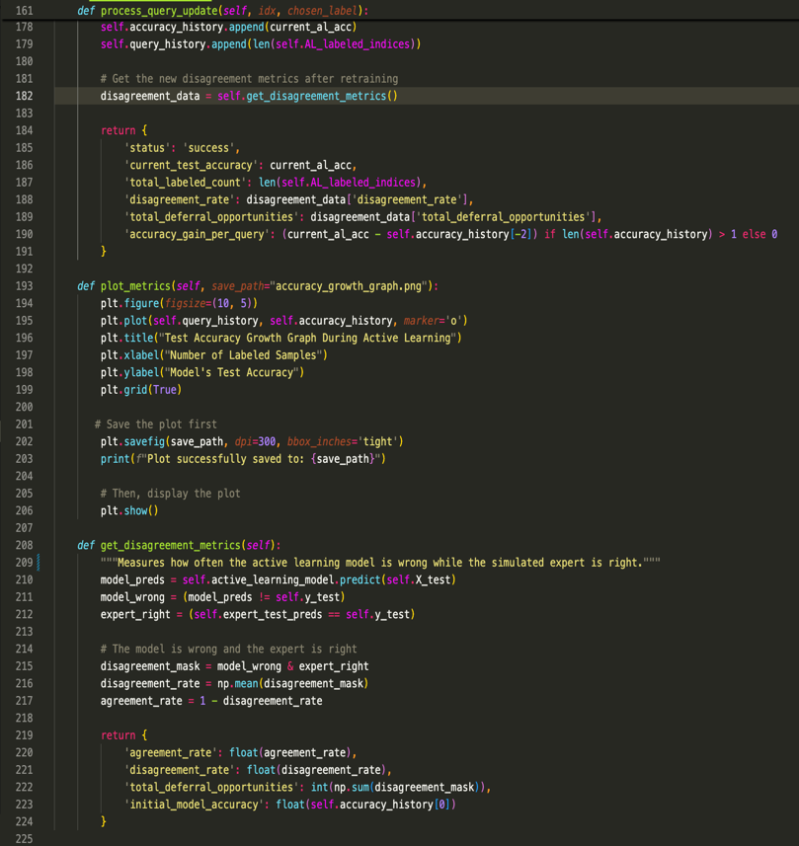

Code implemented for the active learning process and evaluation

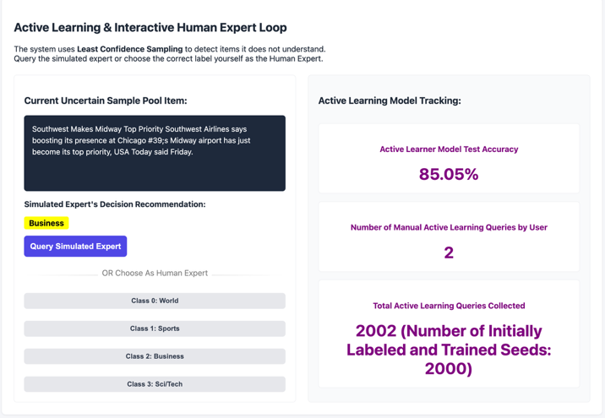
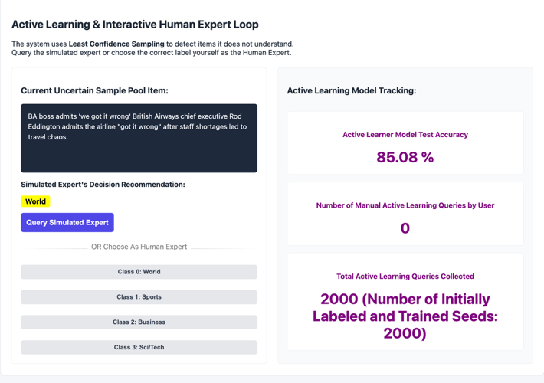
Figure 8: Active Learning Interface State After 2 User Queries
Figure 7: Initial Active Learning Interface State

In the active learning process, it is aimed to actively choose which text instance(s) should be presented/deferred to the expert in order to efficiently learn the expert’s competence area, the text classification task, and the case where the deferral of knowledge is beneficial, given no access to any expert label during training. In order to achieve this, I have used a sampling strategy named "Uncertainty-Based (Least-Confidence) Sampling" in the "get_next_uncertain_sample()" function. I have predicted the probability distribution for the unlabeled part of the X training data corresponding to the active learning pool indices. Then, I have selected the maximum value in each row of this probability distribution (using the "np.argmax(pool_probs, axis=1)" call) and created a maximum pool probabilities array. At this step, the benefit of deferral needs to be somehow increased. I have achieved this by selecting the global index where the active learning model is the least confident. Here, the least confident index from the pool is obtained by selecting the minimum index value (using the "np.argmin(values)" call) from the maximum pool probabilities array created. This suggests that the deferral is more useful because of the lower model confidence at that index.
In the “process_query_update” function, I am updating the AL_pool_indices (pool indices for active learning), and AL_labeled_indices (labeled indices for active learning) lists after labeling each text instance. When I label a text sample, I remove its index from the active learning pool indices and uniqely add it to the labeled indices. Then, I retrain the active learning model with the new list of labeled indices for active learning. After that, I am evaluating the retrained model to get the recent accuracy value of the active learning model trained with new query.
When we look at the test accuracy growth graph for 30 new queries, given in Figure 5, we can observe that the overall trend of test accuracy is upward as new queries are provided. However, when an active learner queries highly borderline samples, the decision boundary of the active learning classifier model aggressively changes, which often leads to performance stagnation or decreases on the test set before the self-correction and increase in accuracy.
I have kept track of the current test accuracies of the active learner in self.accuracy_history and the number of labeled samples in self.query_history. In addition to the graph plotted, I have used deferral agreement & disagreement rates, current test accuracy of the active learning model, and accuracy gain/loss per user query for evaluating the active learning model. They indicate high initial (0.8508) & last (0.8530) test accuracies, which means active learning performs well on the unseen test data. In order to calculate the disagreement rate between the active learning model and the simulated expert, I have first calculated the part where the active learning model predictions on the unseen ‘y_test’ data do not match the ground truth ‘y_test’ data. Then, I have calculated the part where the simulated expert predictions on the unseen ‘y_test’ data do match the ground truth ‘y_test’ data. After that, I get the “AND” mask of these parts. Finally, I have applied np.mean() on the created mask, which treats the true boolean value as 1 and the false boolean value as 0. The np.mean() call will then give the deferral disagreement rate, which indicates how often the active learning model is wrong while the simulated expert is right.

