**4 Bitlik Full Adder**

1306160048 Barış Yarar

Kod:

----------1 bitlik full adder--------

library IEEE;

use IEEE.STD_LOGIC_1164.ALL;

entity xor_kapisi is

port(xor_g1: in STD_LOGIC;

xor_g2: in STD_LOGIC;

xor_cikis: out STD_LOGIC);

end xor_kapisi;

architecture Behavioral of xor_kapisi is

begin

process(xor_g1, xor_g2)

begin

xor_cikis <= xor_g1 xor xor_g2;

end process;

end Behavioral;

------------------------------------------------------

library IEEE;

use IEEE.STD_LOGIC_1164.ALL;

entity and_kapisi is

port(and_g1: in STD_LOGIC;

and_g2: in STD_LOGIC;

and_cikis: out STD_LOGIC);

end and_kapisi;

architecture Behavioral of and_kapisi is

begin

process(and_g1, and_g2)

begin

and_cikis <= and_g1 and and_g2;

end process;

end Behavioral;

--------------------------------------------------------

library IEEE;

use IEEE.STD_LOGIC_1164.ALL;

entity or_kapisi is

port(or_g1: in STD_LOGIC;

or_g2: in STD_LOGIC;

or_cikis: out STD_LOGIC);

end or_kapisi;

architecture Behavioral of or_kapisi is

begin

process(or_g1, or_g2)

begin

or_cikis <= or_g1 or or_g2;

end process;

end Behavioral;

---------------------------------------------------------

library IEEE;

use IEEE.STD_LOGIC_1164.ALL;

entity FullAdder is

port(x: in STD_LOGIC;

y: in STD_LOGIC;

z: in STD_LOGIC;

S: out STD_LOGIC;

C: out STD_LOGIC);

end FullAdder;

architecture Behavioral of FullAdder is

component xor_kapisi is

port(xor_g1: in STD_LOGIC;

xor_g2: in STD_LOGIC;

xor_cikis: out STD_LOGIC);

end component;

component and_kapisi is

port(and_g1: in STD_LOGIC;

and_g2: in STD_LOGIC;

and_cikis: out STD_LOGIC);

end component;

component or_kapisi is

port(or_g1: in STD_LOGIC;

or_g2: in STD_LOGIC;

or_cikis: out STD_LOGIC);

end component;

signal ara1: STD_LOGIC;

signal ara2: STD_LOGIC;

signal ara3: STD_LOGIC;

begin

blok1: xor_kapisi port map(xor_g1=>x, xor_g2=>y, xor_cikis=>ara1);

blok2: xor_kapisi port map(xor_g1 =>ara1, xor_g2 =>z, xor_cikis => S);

blok3: and_kapisi port map(and_g1 =>ara1, and_g2 =>z, and_cikis => ara2);

blok4: and_kapisi port map(and_g1 =>x, and_g2 =>y, and_cikis => ara3);

blok5: or_kapisi port map(or_g1 =>ara2, or_g2 =>ara3, or_cikis => C);

end Behavioral;

--------------4 bitlik full adder----------------

library IEEE;

use IEEE.STD_LOGIC_1164.ALL;

entity fourbitFA is

port(A: in STD_LOGIC_VECTOR (3 downto 0);

B: in STD_LOGIC_VECTOR (3 downto 0);

S: out STD_LOGIC_VECTOR (3 downto 0);

C4: out STD_LOGIC);

end fourbitFA;

architecture Behavioral of fourbitFA is

COMPONENT FullAdder is

port(x: in STD_LOGIC;

y: in STD_LOGIC;

z: in STD_LOGIC;

S: out STD_LOGIC;

C: out STD_LOGIC);

end COMPONENT;

signal C1, C2, C3: std_logic;

begin

FA1: FullAdder port map(A(0),B(0),'0',S(0),C1);

FA2: FullAdder port map(A(1),B(1),C1,S(1),C2);

FA3: FullAdder port map(A(2),B(2),C2,S(2),C3);

FA4: FullAdder port map(A(3),B(3),C3,S(3),C4);

end Behavioral;

Full Adder’ın çalışıp çalışmadığını test etmek için örnek 1

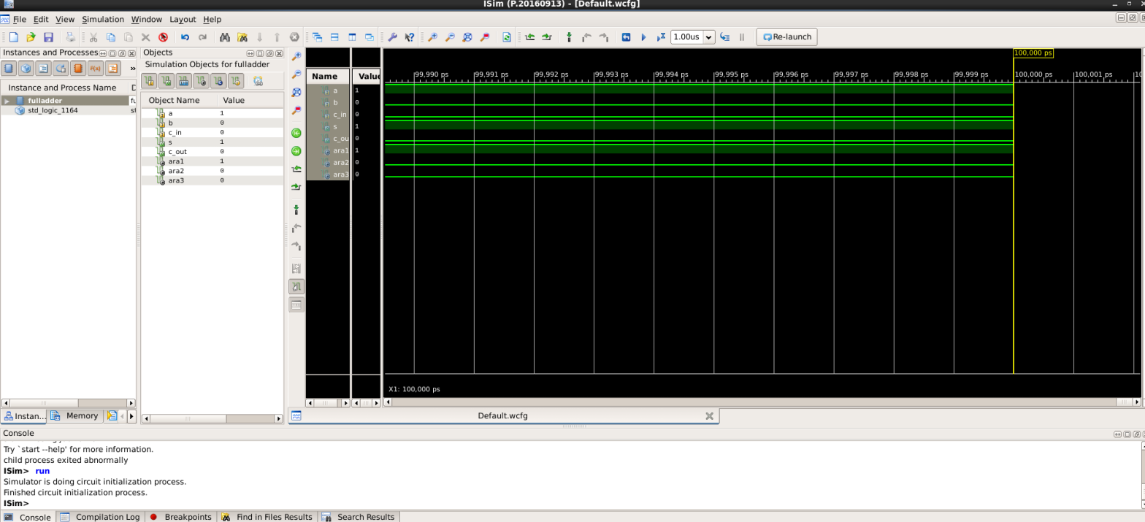

Örnek 2:

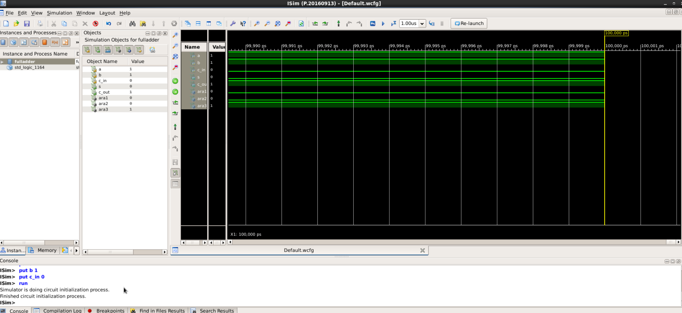

4 bitlik Full Adder Şeması

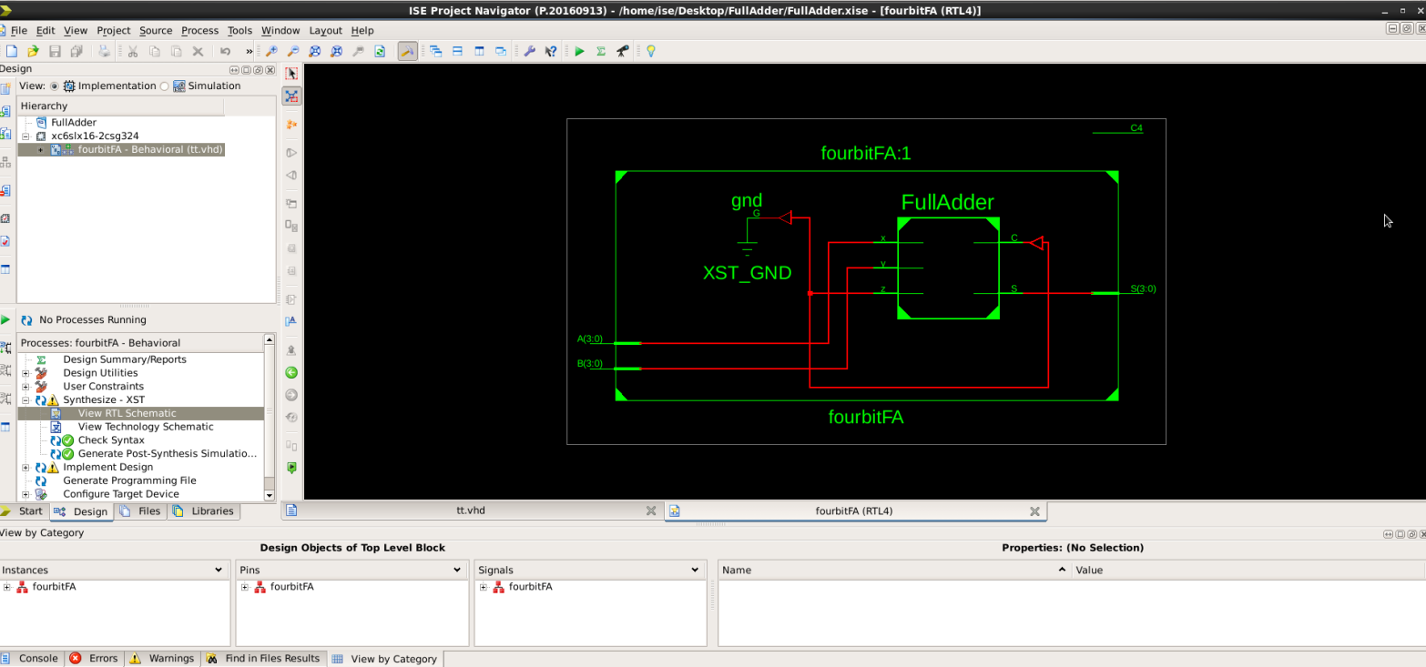

Açık versiyon:

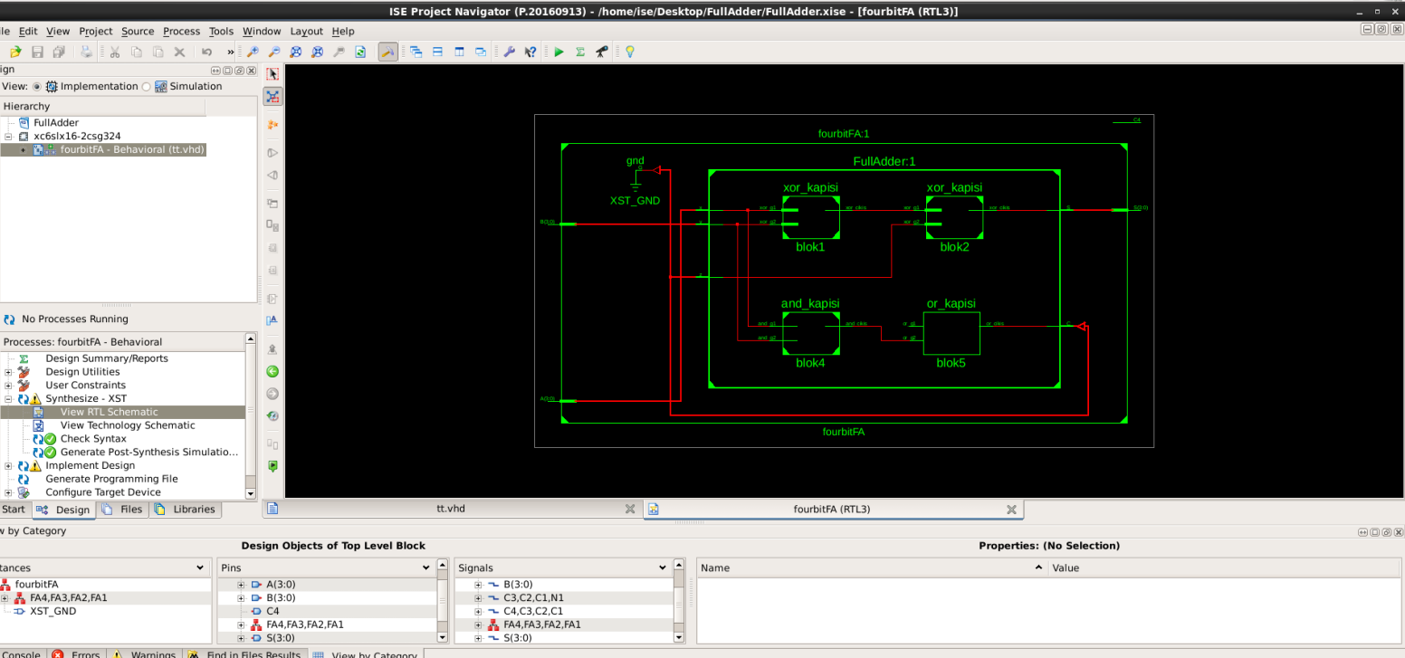

4 bitlik Full Adder örnekleri

Örnek 1:

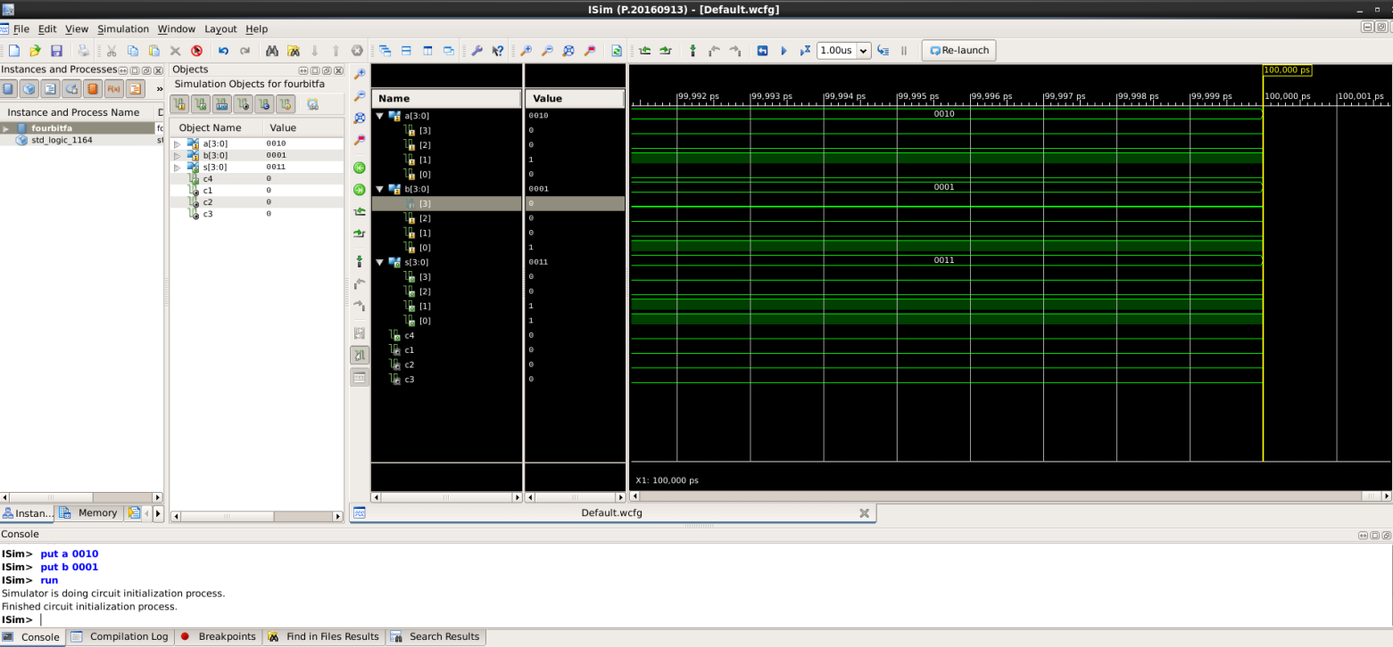

A: 0010 B: 0001 S: 0011

Örnek 2:

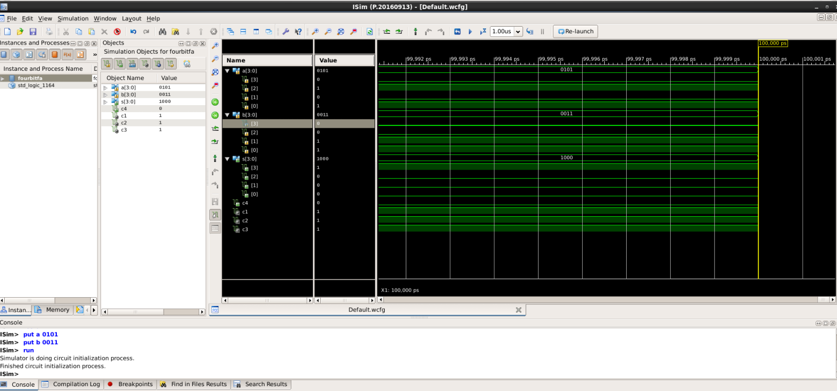

A: 0101 B: 0011 S:1000