**COMPUTER ARCHITECTURE**

**EXPERIMENT – 1**

**Implementation of Multiplexers**

**Aim:** In this experiment, students will be introduced to the operation of multiplexers and implement the full-adder circuit using multiplexers.

**Experimental Work:**

*Consider the Full-Adder circuit:*

$$S(x,y,z)=x⊕y⊕z \\ C(x,y,z)=x.y+(x⊕y).z$$

Implement the Full-Adder circuit by using the multiplexer 4539. Confirm that your multiplexer implementation is satisfying the truth table of Full-Adder.

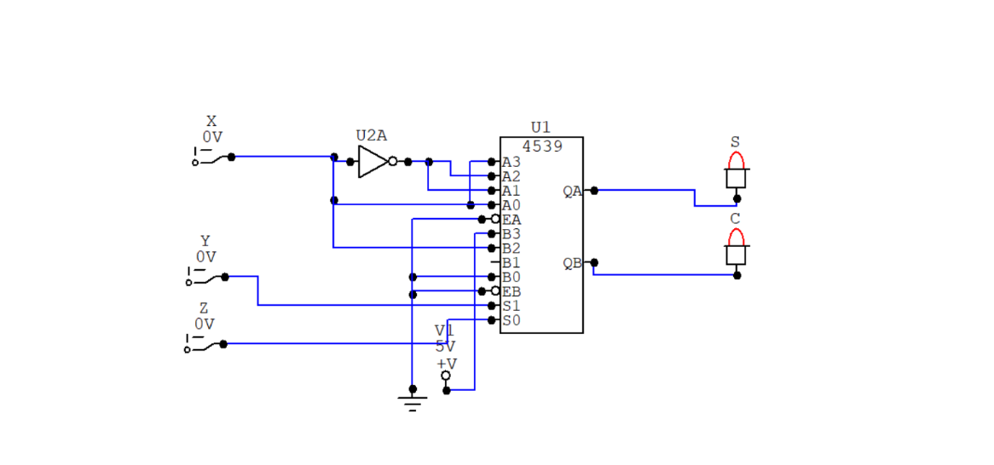

Multiplexer

|  |  |  |  |  |
| --- | --- | --- | --- | --- |
| **X** | **Y** | **Z** | **C S** | |
| **0** | **0** | **0** | **0** | **0** |
| **0** | **0** | **1** | **0** | **1** |
| **0** | **1** | **0** | **0** | **1** |
| **0** | **1** | **1** | **1** | **0** |
| **1** | **0** | **0** | **0** | **1** |
| **1** | **0** | **1** | **0** | **0** |
| **1** | **1** | **0** | **1** | **0** |
| **1** | **1** | **1** | **1** | **1** |