**CYPRUS INTERNATIONAL UNIVERSITY**

**CMPE344 Database Management Systems II**

**HW1 (Due Date: 05/04/2020)**

Q1- Display first name and last name of all employees together with their department name.

Q2- List all employees whose department is located in Tokyo.

Q3- Display the last_name of all employees with their managers’ name. List only those whose job_id is IT_PROG.

Q4- Display the department_id, department_name with its state_province from locations. Display those departments even if there is no state province assigned.

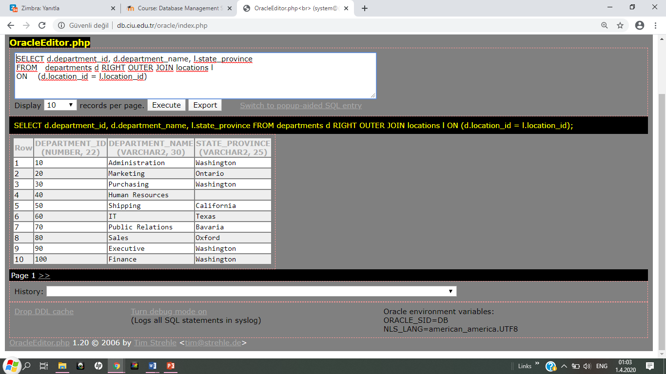

**Q1-Answer**

SELECT e.employee_id, e.last_name, d.department_name

FROM system.employees e

JOIN system.departments d

ON (e.department_id=d.department_id)

**Q2-Answer**

SELECT e.employee_id, e.last_name, d.department_name, x.city

FROM system.employees e

JOIN system.departments d

ON (e.department_id=d.department_id)

JOIN system.locations x

ON (d.location_id=x.location_id)

WHERE x.city='Tokyo'

**Q3-Answer**

SELECT a.last_name AS "Employee Last Name ",b.first_name AS "Manager Name"

FROM employee a, employee b

WHERE a.manager_id = b.employee_id AND a.job_id='IT_PROG'

**Q4-Answer**

SELECT d.department_id, d.department_name, l.state_province

FROM system.departments d J

OIN system.locations l

ON (d.location_id=l.location_id)