Recall results from last week:
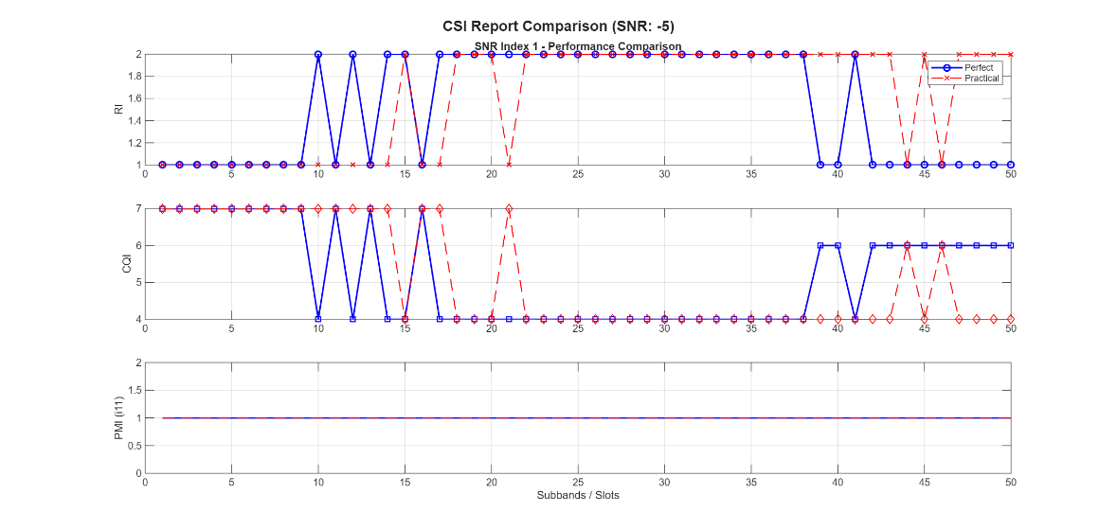 | 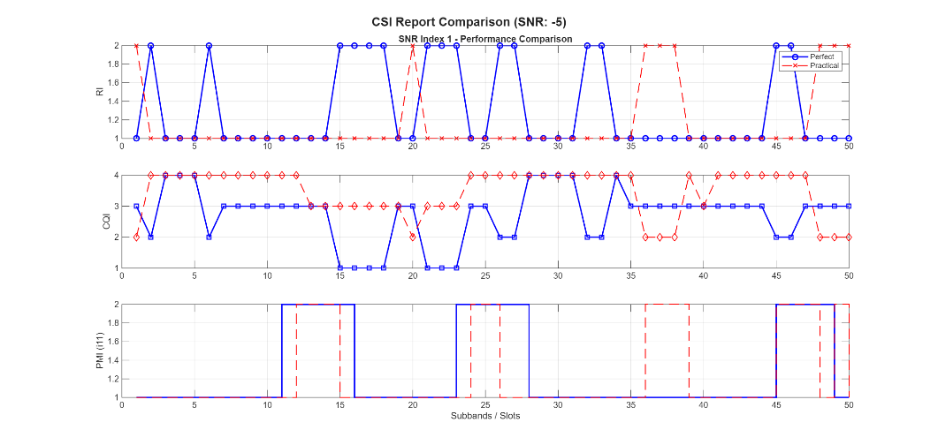

There has been a serious mistake in last week’s code, updated version:
CDL-C 10Hz: -5, 15dB; 200Hz: -5dB, 15dB
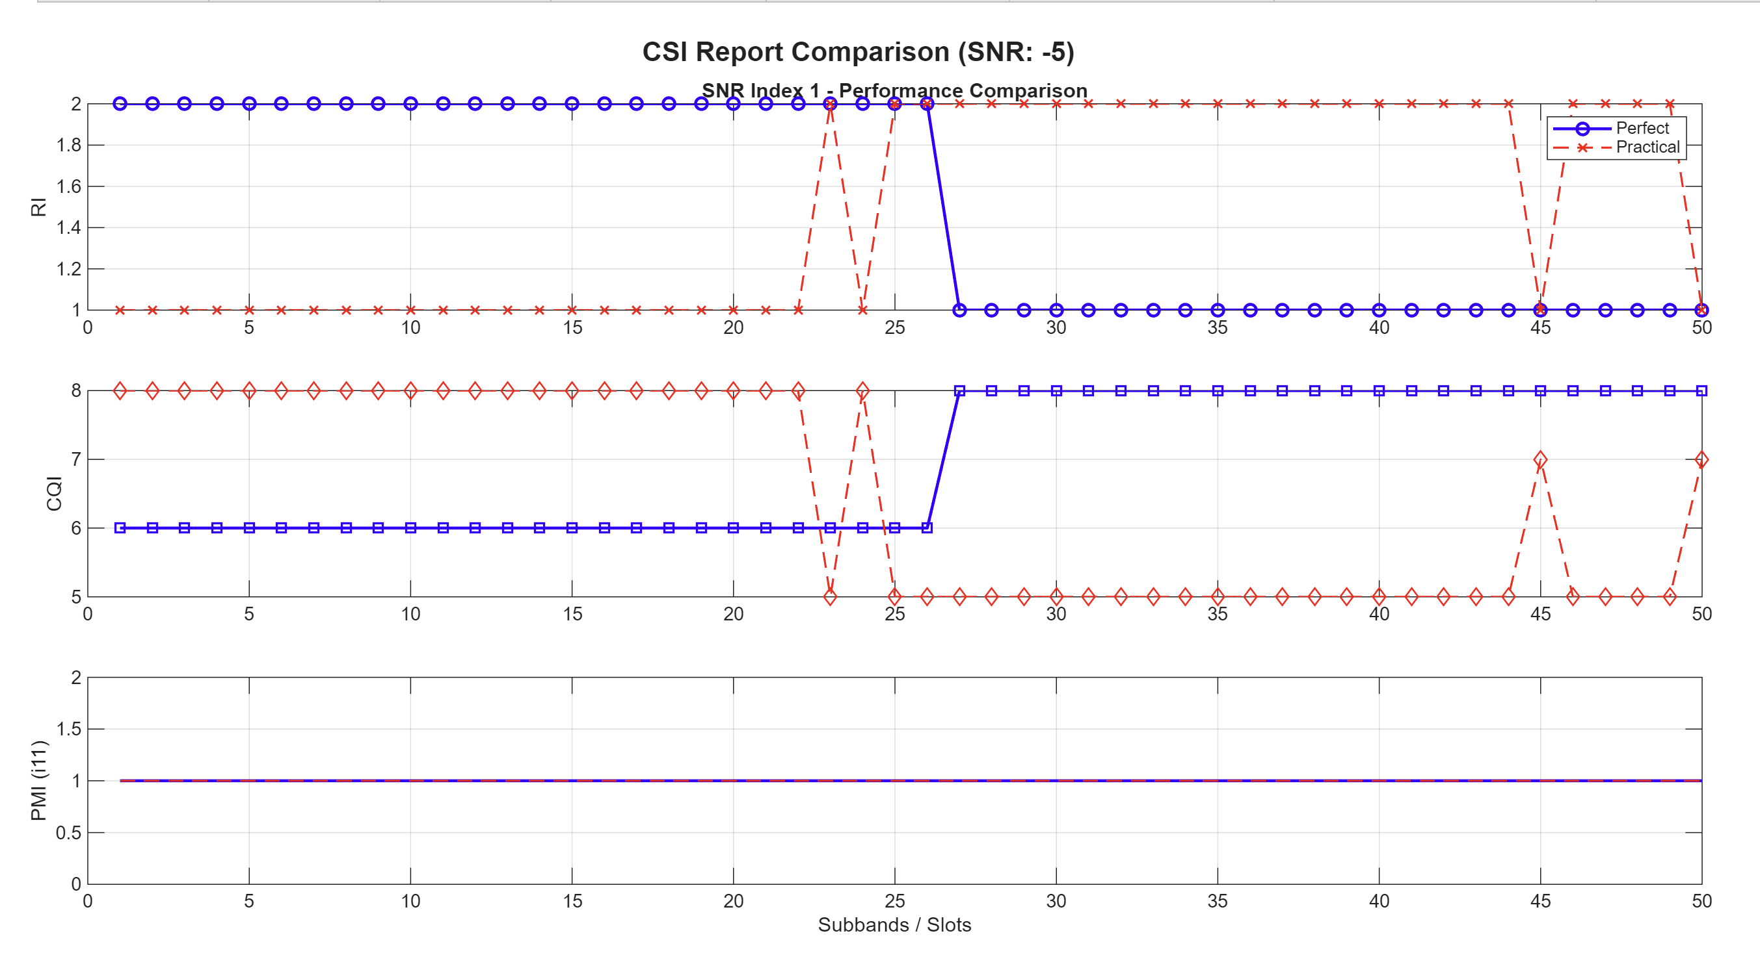 | 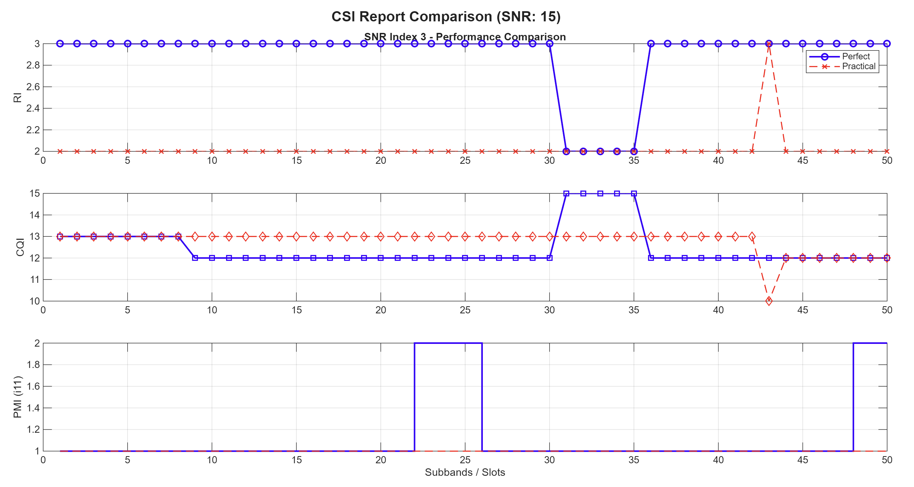
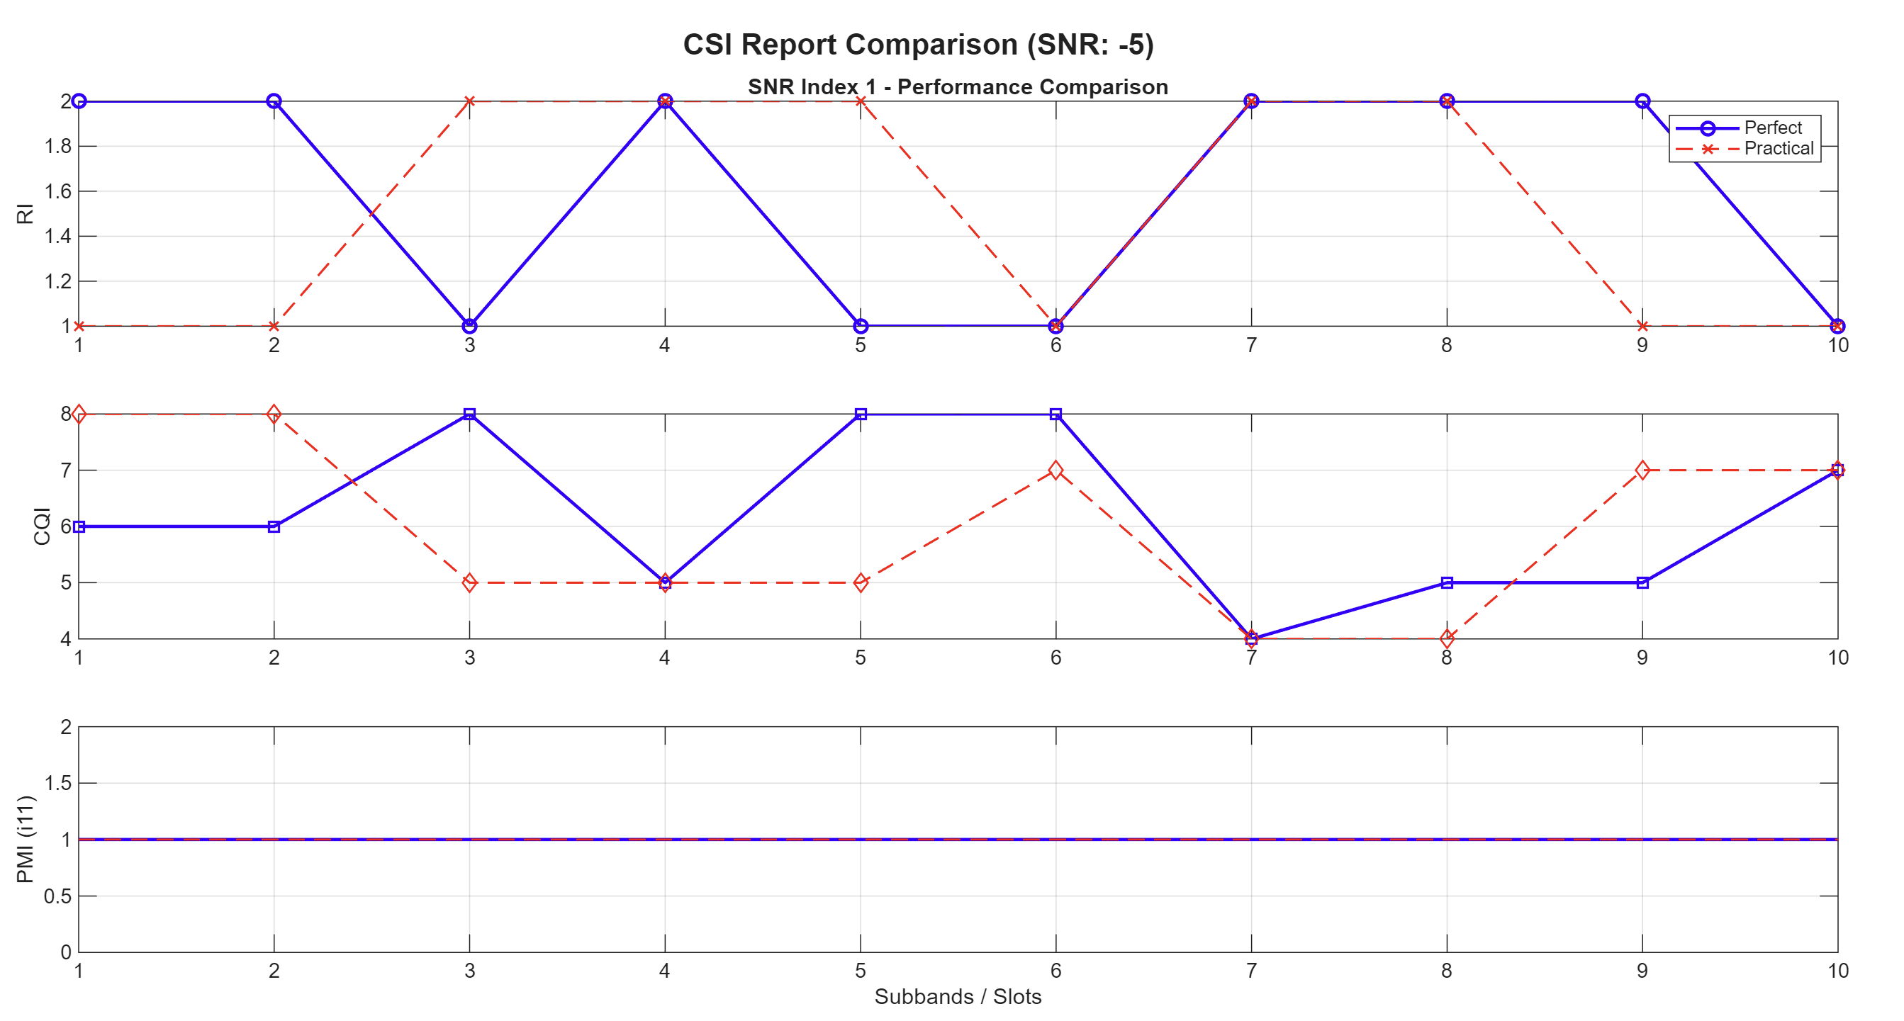 | 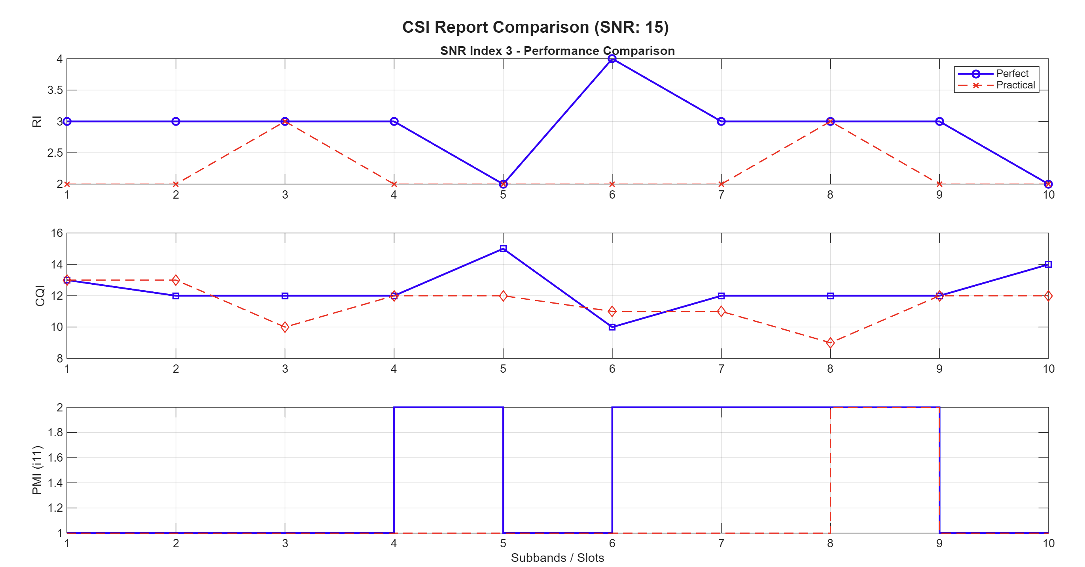
Sometimes good looking results:
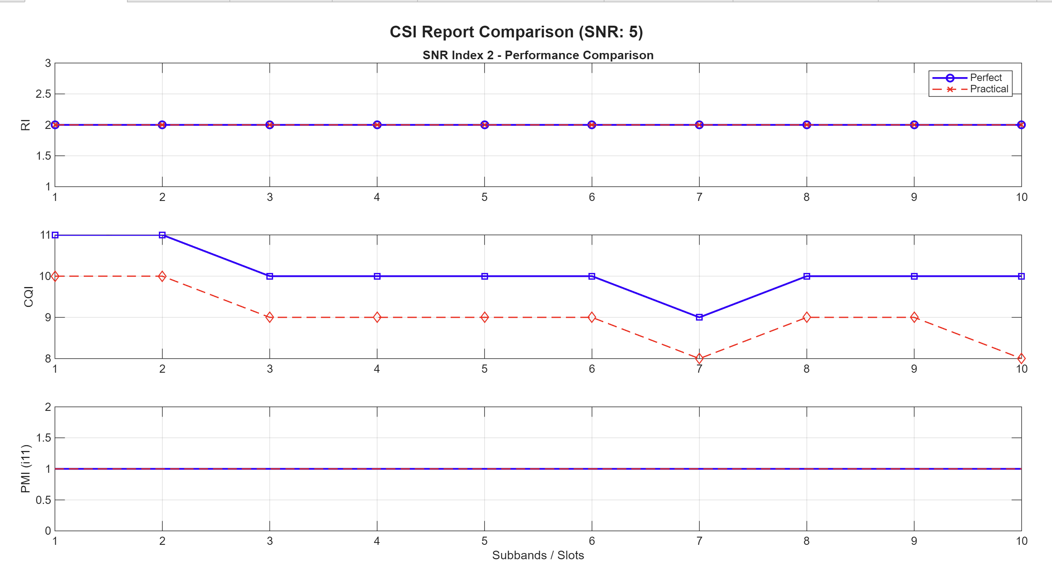

Overall trend against SNR
High variability at 20dB (also top of error bar & low seems to be fixed?
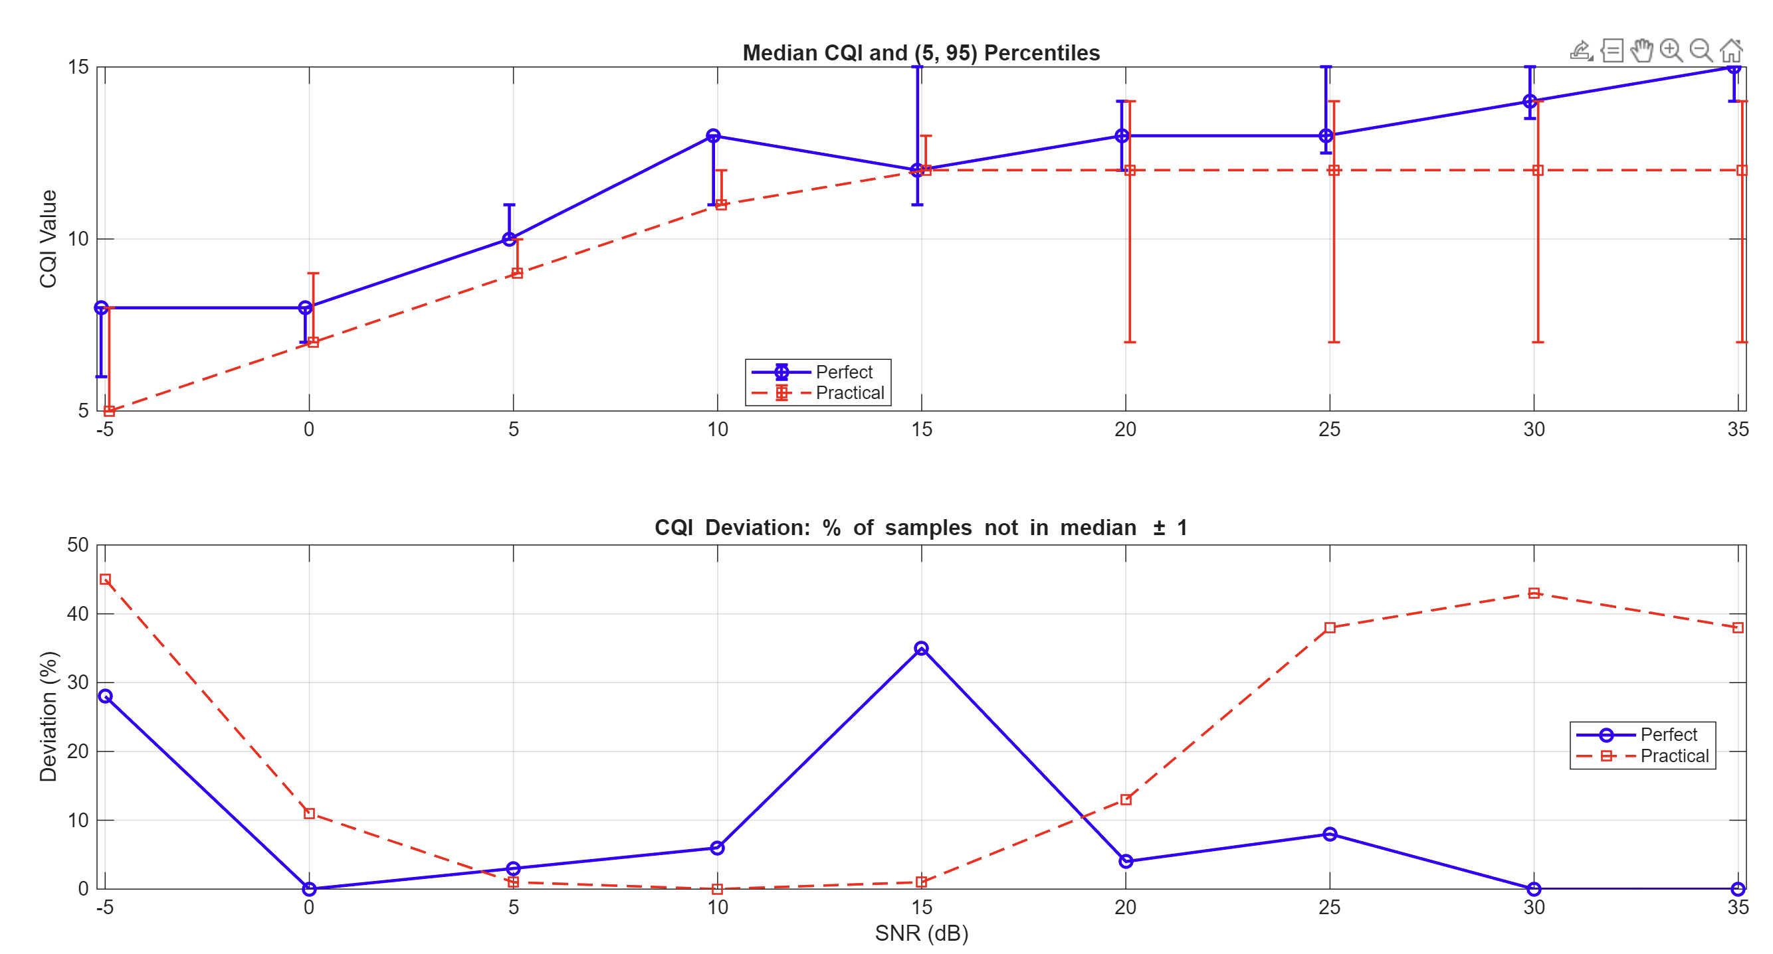 | 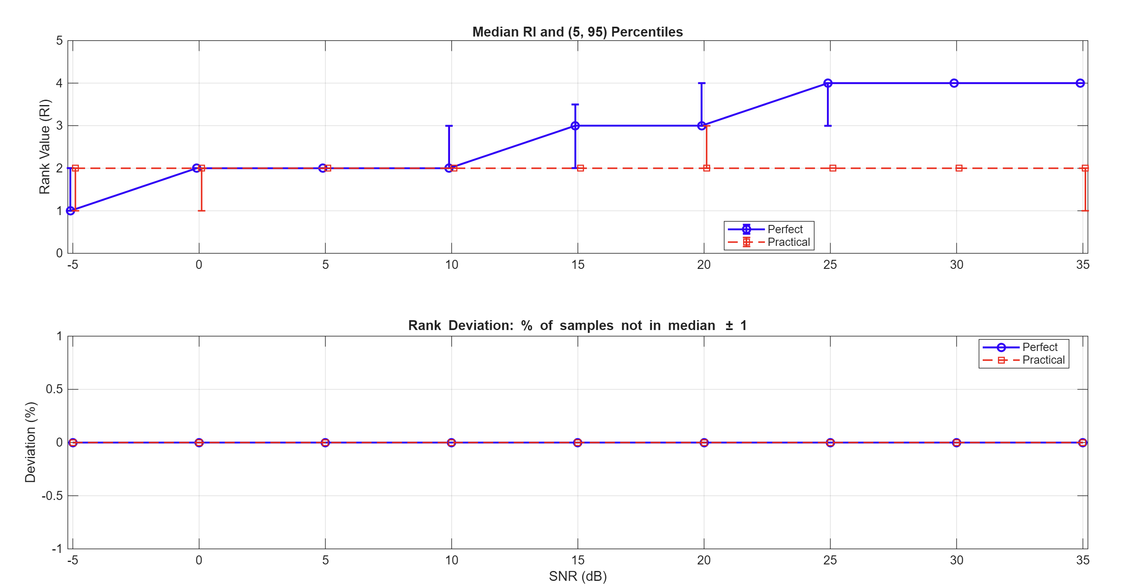
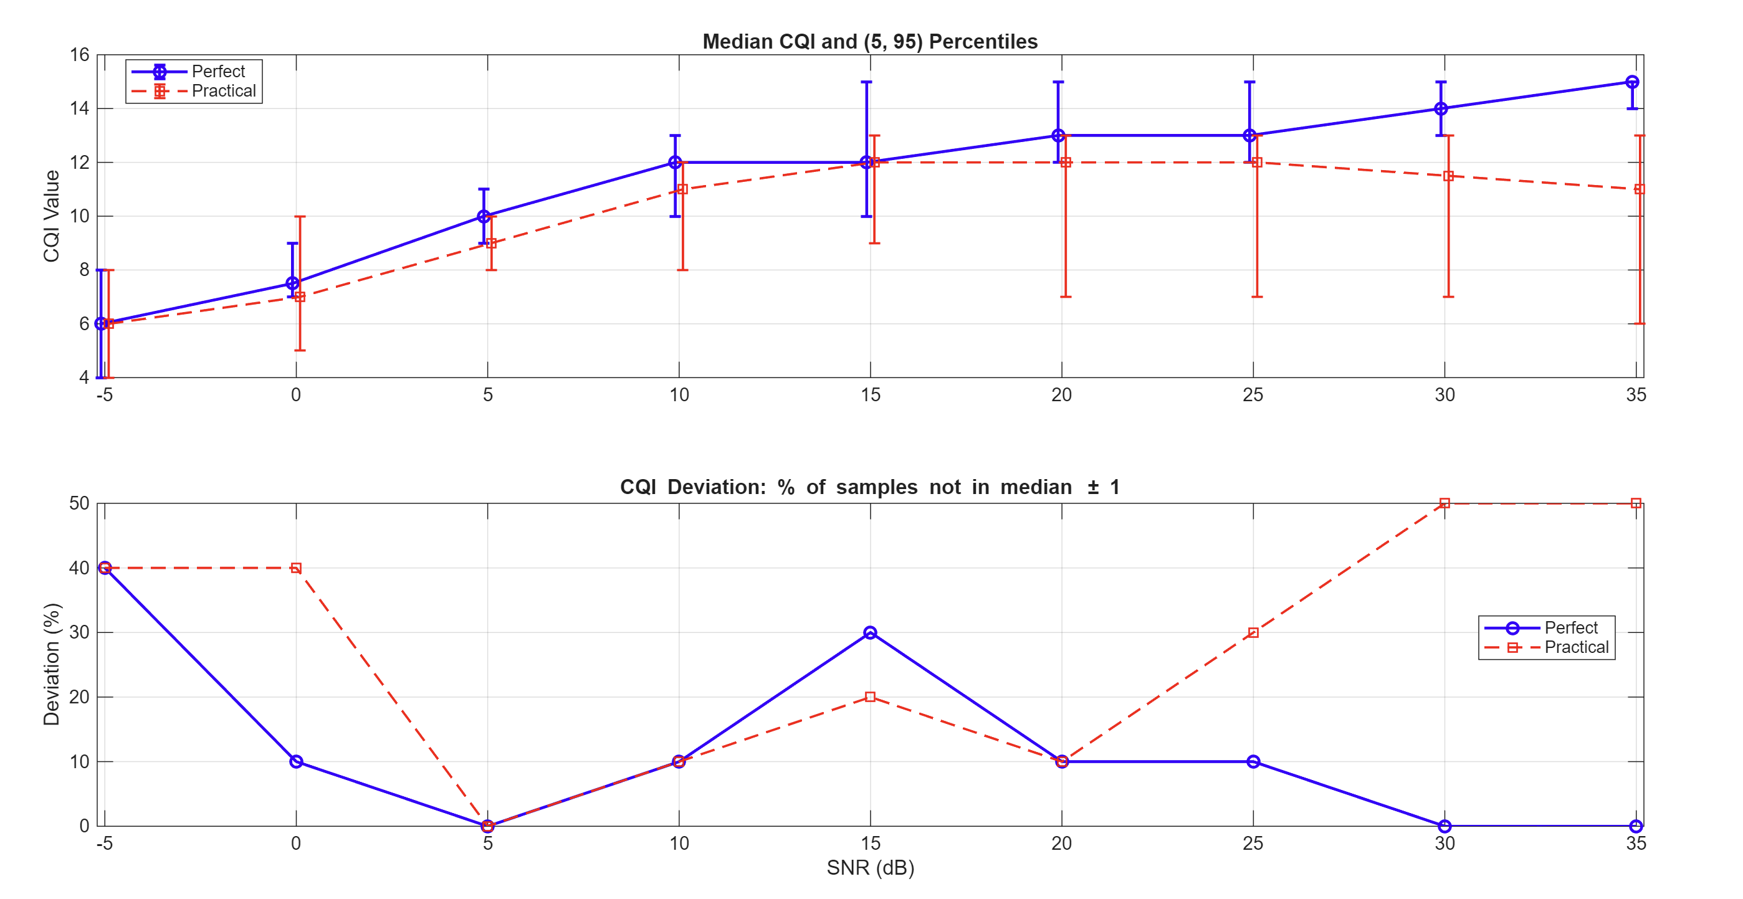 | 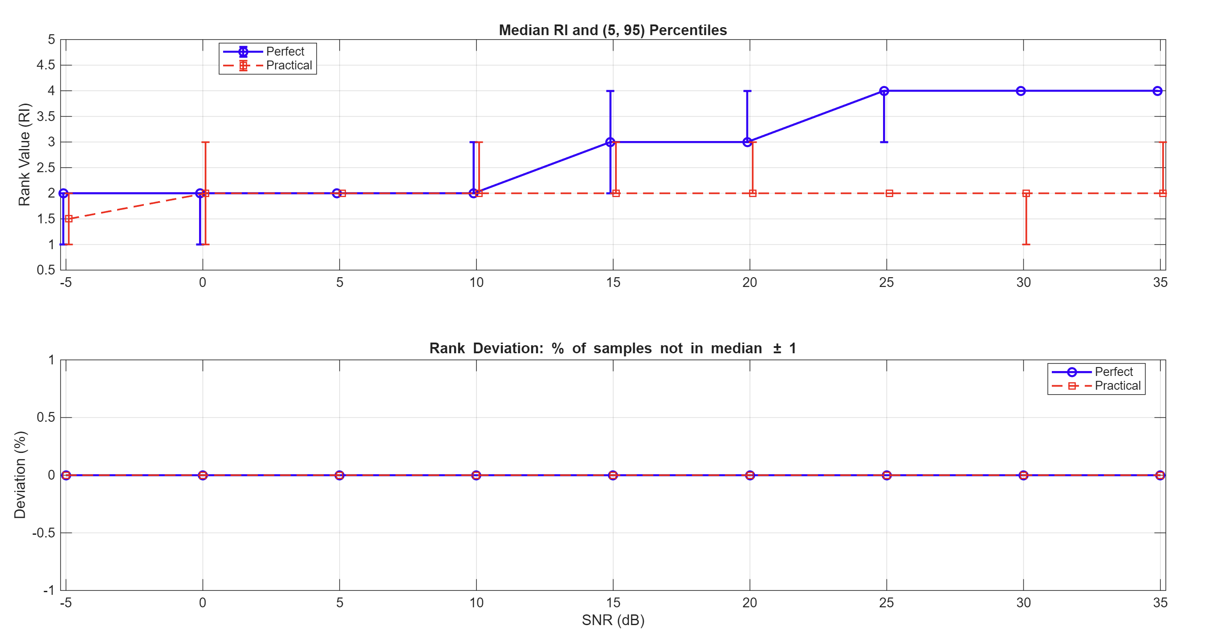
Why fix tot two layers for practical?

If fix to e.g. 2 layers:
10Hz
Why the variance is much smaller the previous case? Shouldn’t they be the same at high dB
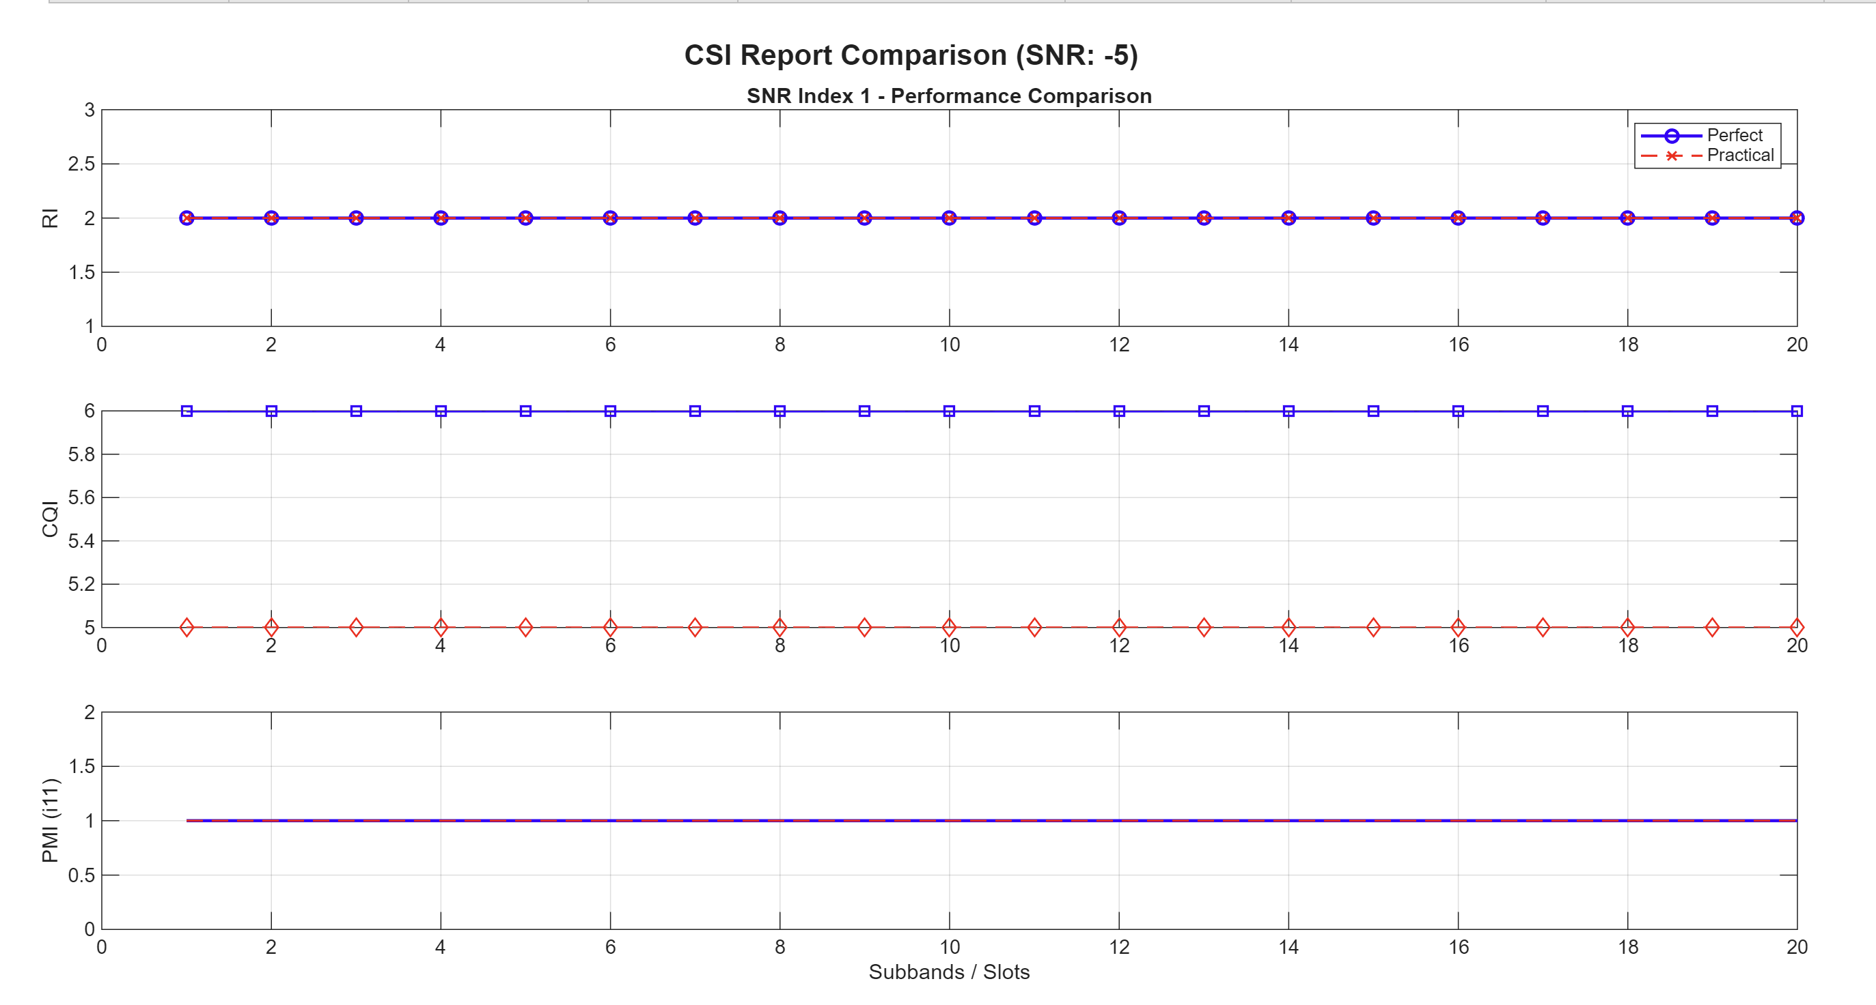 | 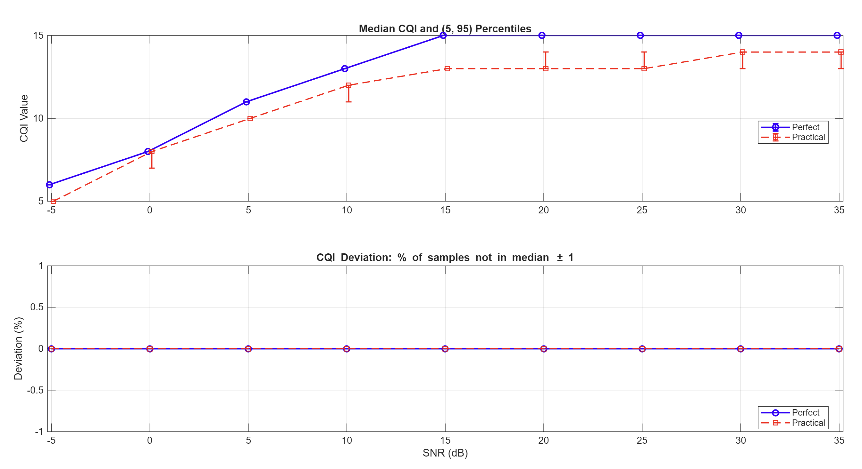

200Hz
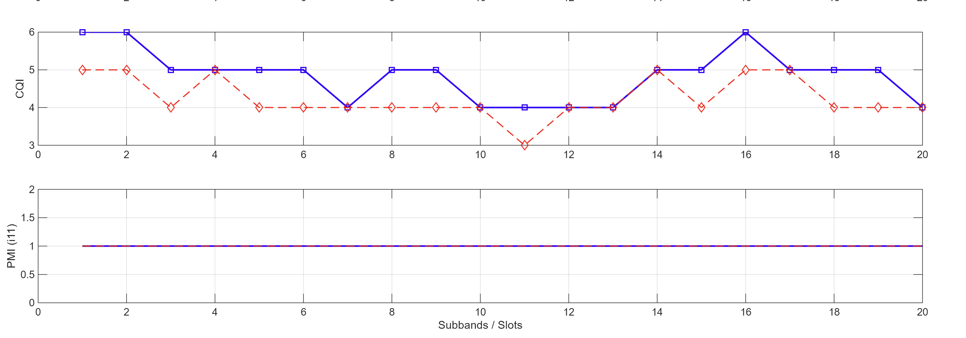 | 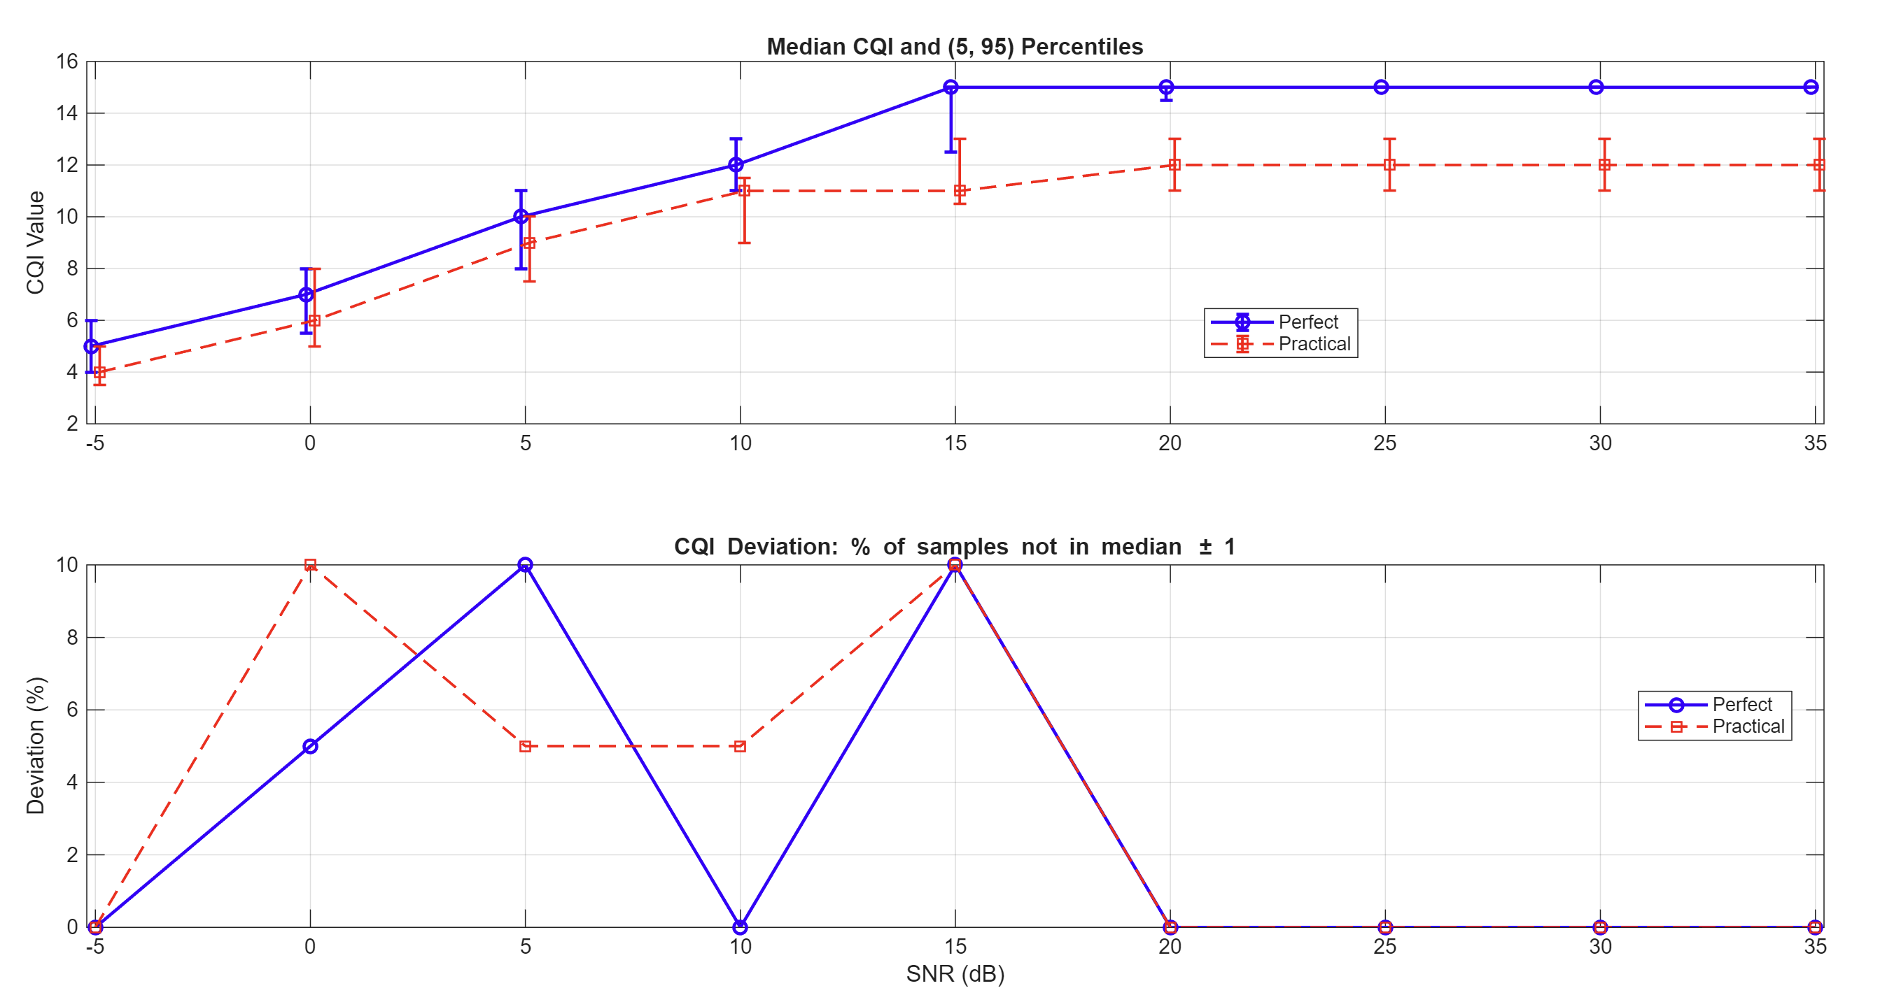

Maybe the “Outer Loop Link Adaptation” is used in this scenario to do the correction?
Based on ACK/NACK, which does not exist in this simulation -> OLLA in 6G (not running in 5G simulation) -> CQI (main) + OLLA (rear, small shift to the original one)

What if: I use the perfect-case reported CSI feedback in the practical case?
-> Guess: System will have very low throughput as the progressive MCS/TCR/CQI does not match with the poor receiver decoding ability

How does the throughput vs SNR curves now look like? With and without perfect estimation?
Results w 3GPP

