Recall results from last week:
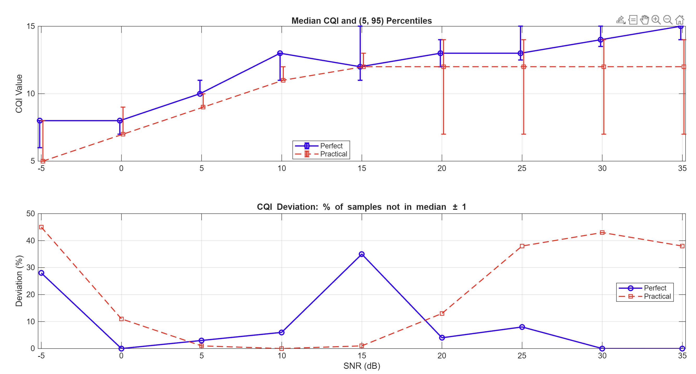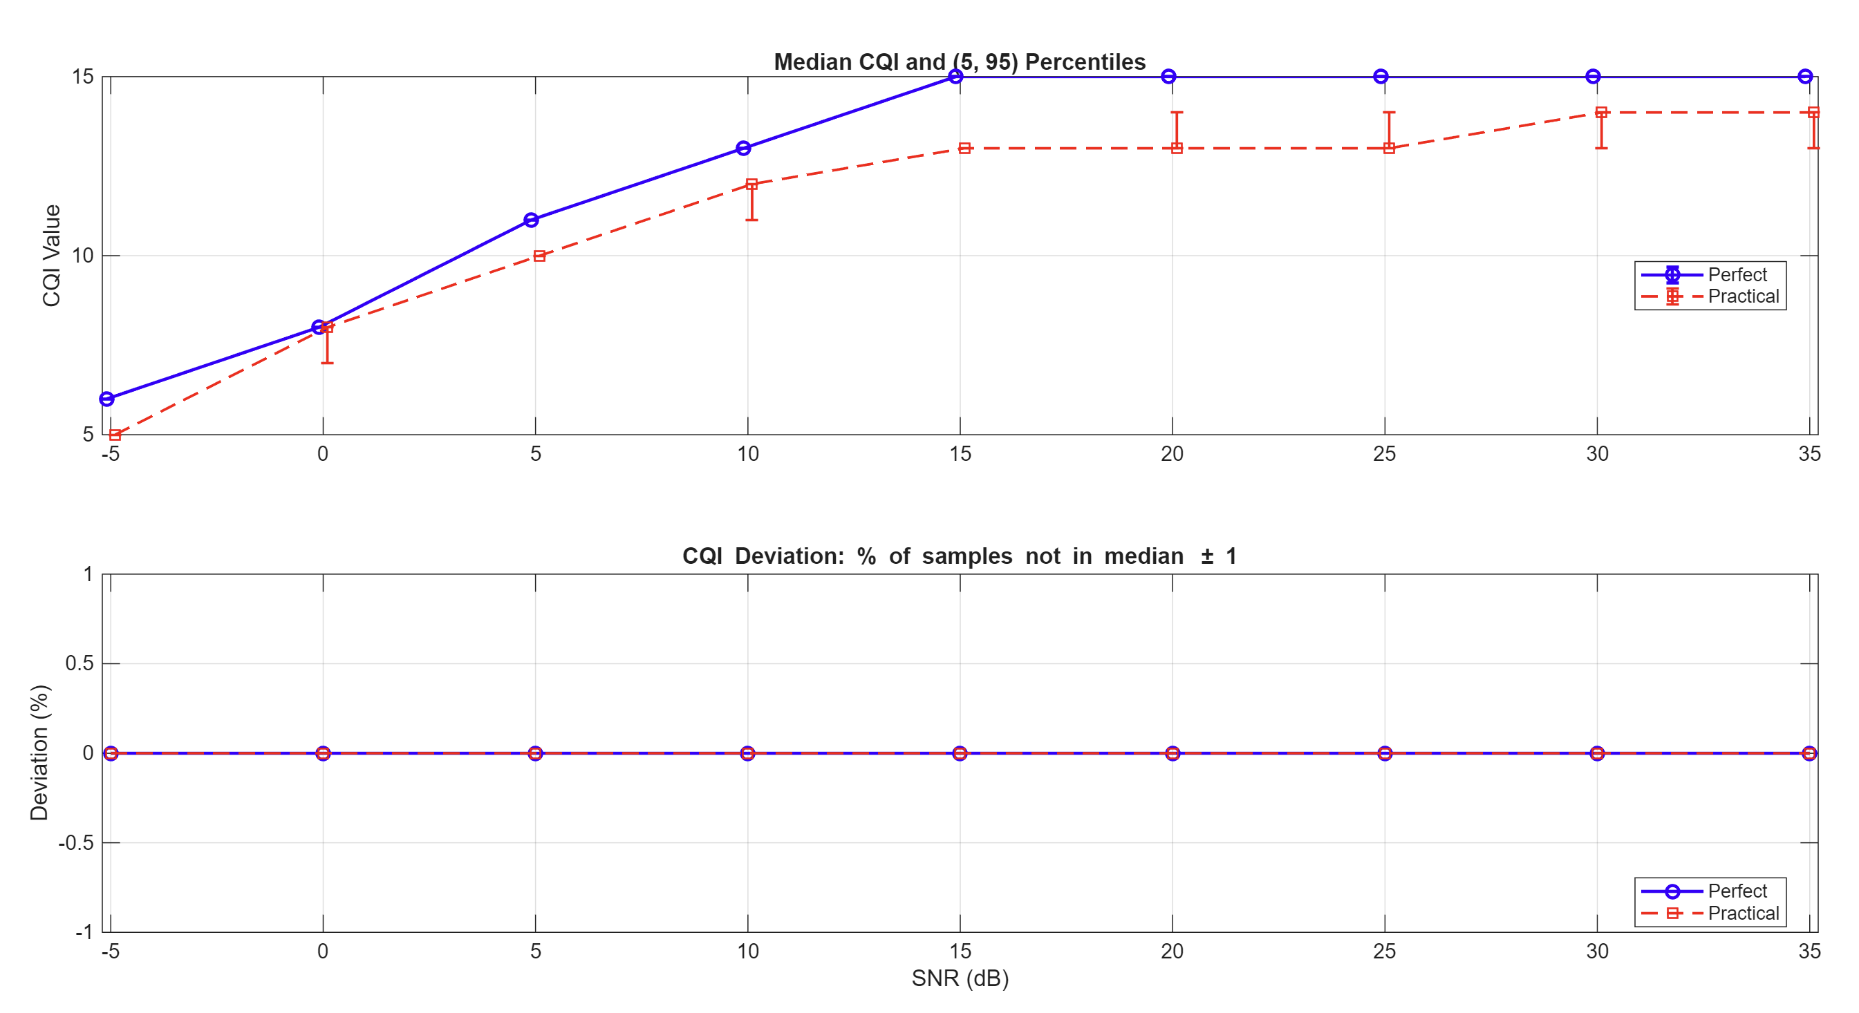
The results are inconsistent because:
both Perfect and Practical CQI estimates utilize the same WTX within a single simulation pass.
The precoder is determined by the system's global feedback mode.
To obtain unbiased results, the two modes must be executed independently to allow their respective feedback loops to converge to their unique steady states, then combined for comparison.

But the following graph should still be valid, as it is about “GIVEN Signal”:
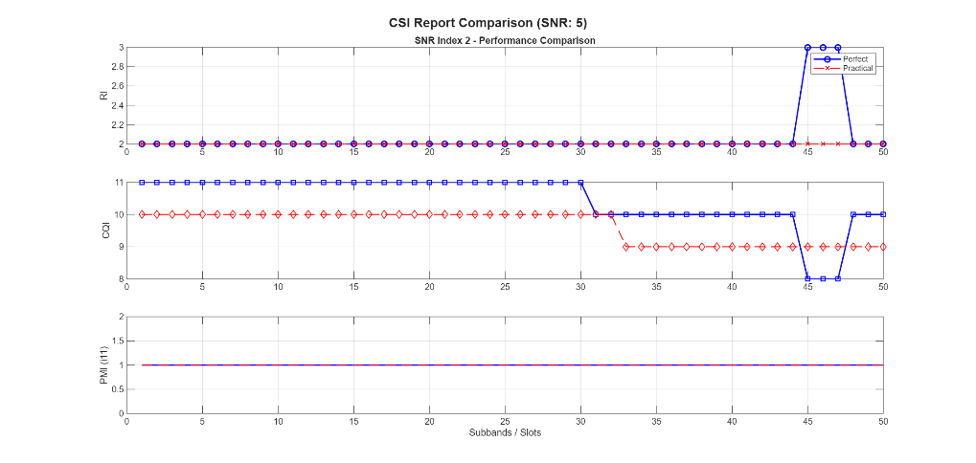

Now move to the other document.

