Systematic Analysis of CSI configurations
- Impact of CSI reporting period:
4 vs 64 vs 160 for 10Hz and 100Hz
More allocation, less PDSCH (Why 4 still have highest throughput, should take up more resources), should I always use 4?
Maybe throughput only calculating PDSCH (aggregate RB)
Or just mention in the report (Throughput contain PDSCH, or just multiply a percentage)

Also test 0Hz + perfect channel and see what will happen (4 should have worse performance)
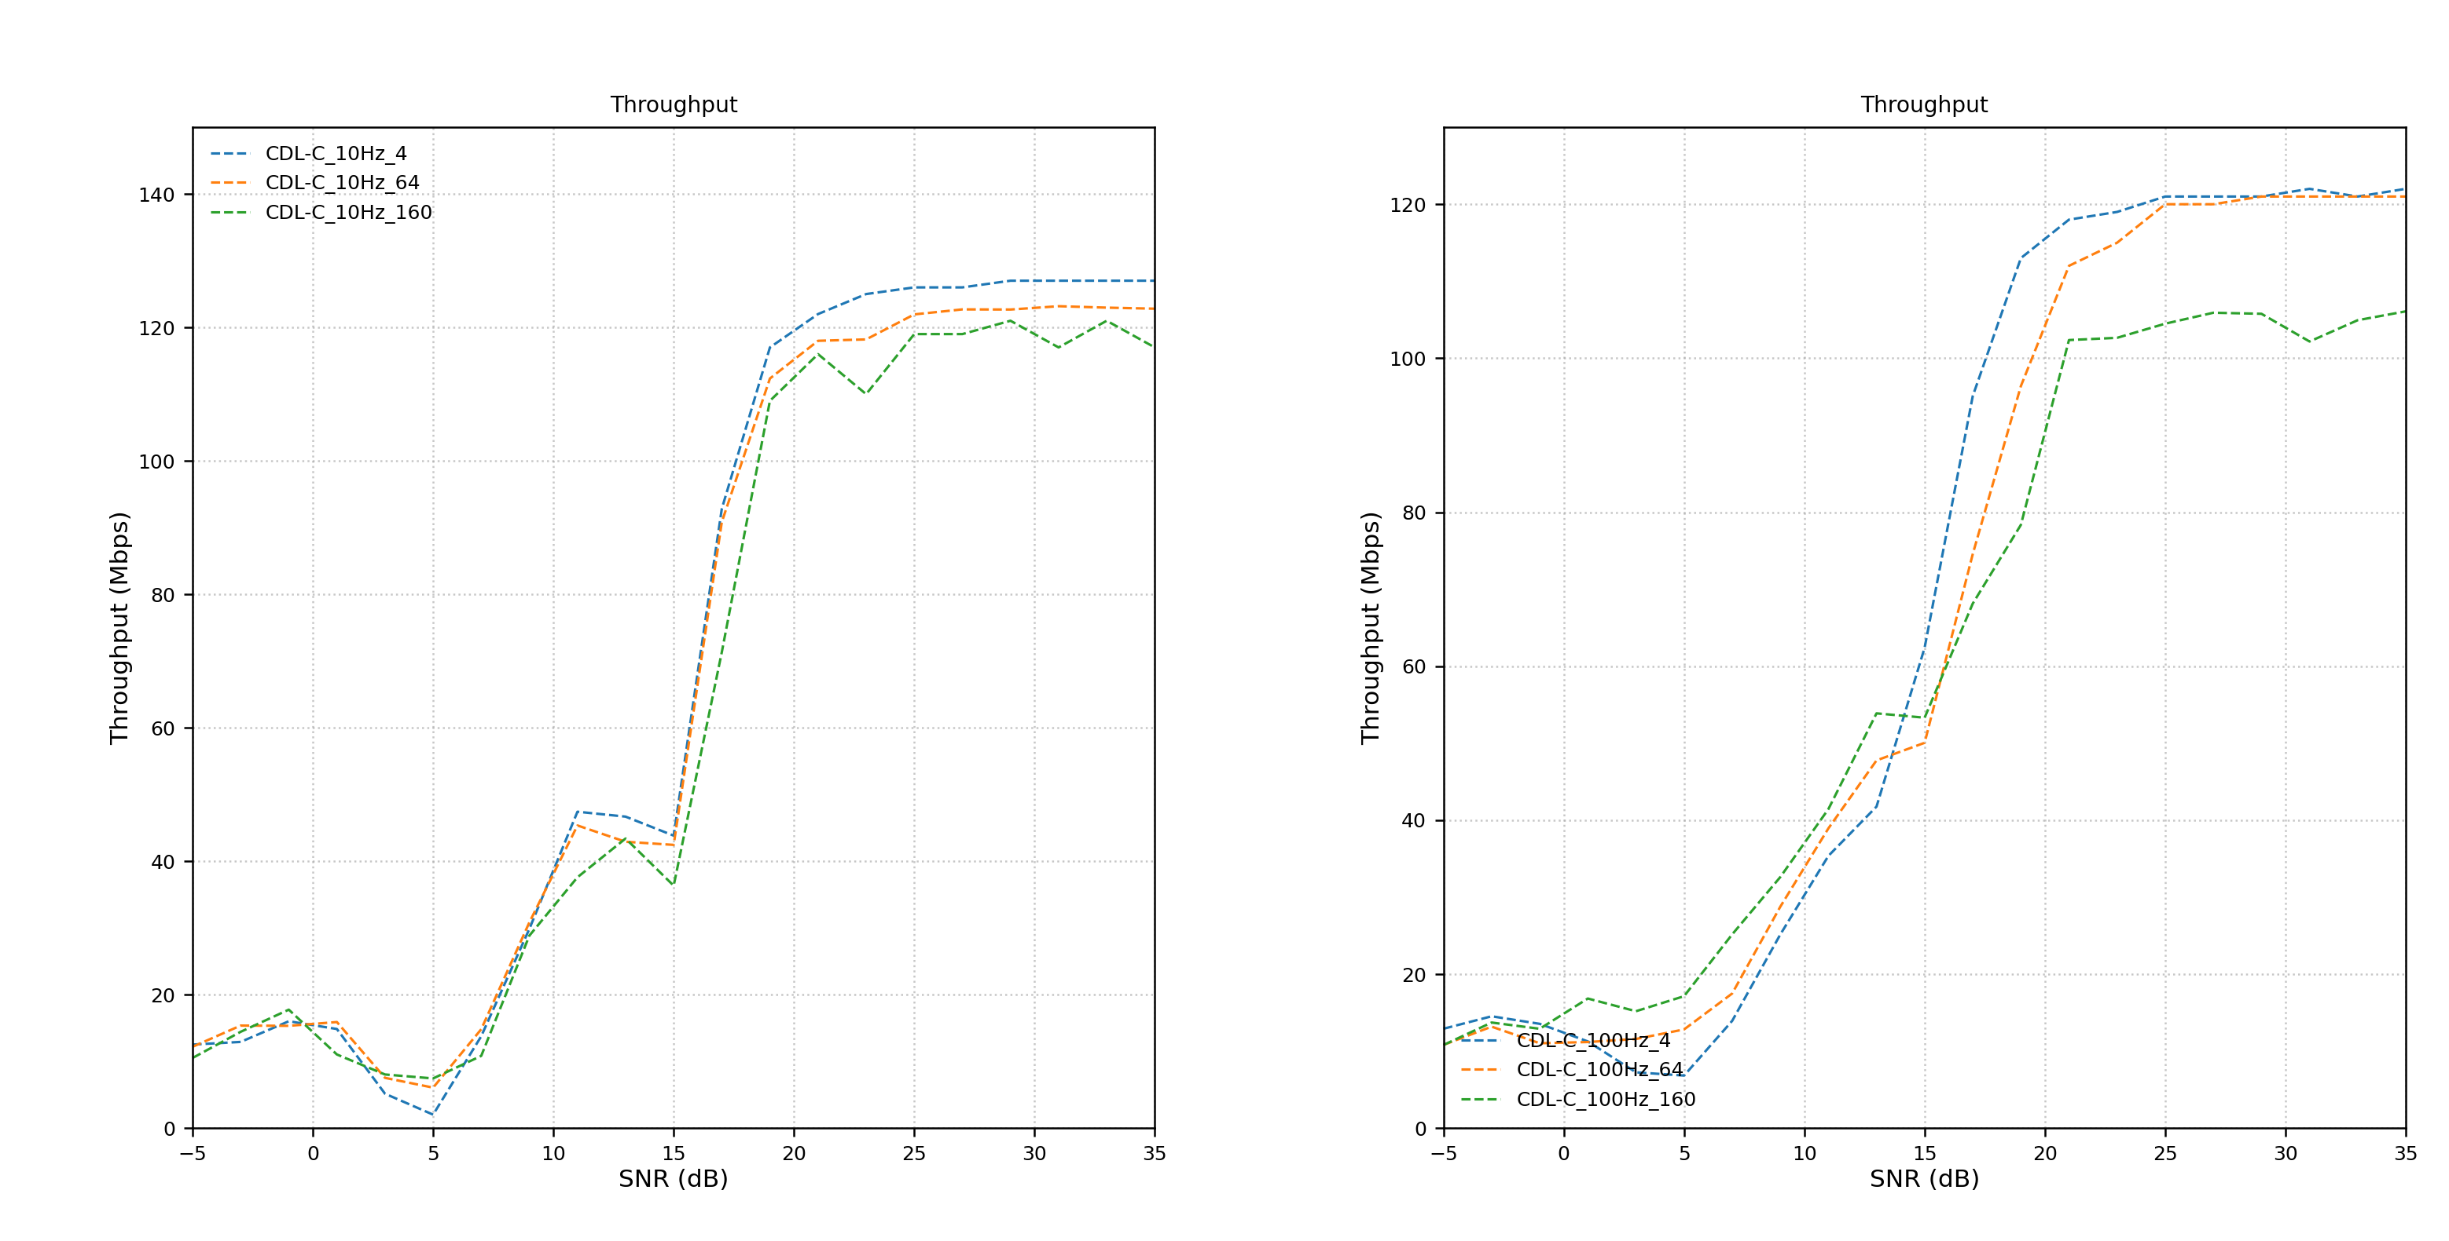

- Impact of UEDelay on system (restricted by the UE’s hardware)
UEDelay = 0 vs 7 (3.5ms) (default) vs 10 (5ms) for 10Hz and 100Hz
Impairment margin ~2.7dB shift to right in most simulation (Ericsson do 2~3dB random shift) -> Cause hard to align on a specific value for each variable
Highlight in final report difference between perfect simulation (academia) vs 3GPP actual practice (shortcuts in industry )
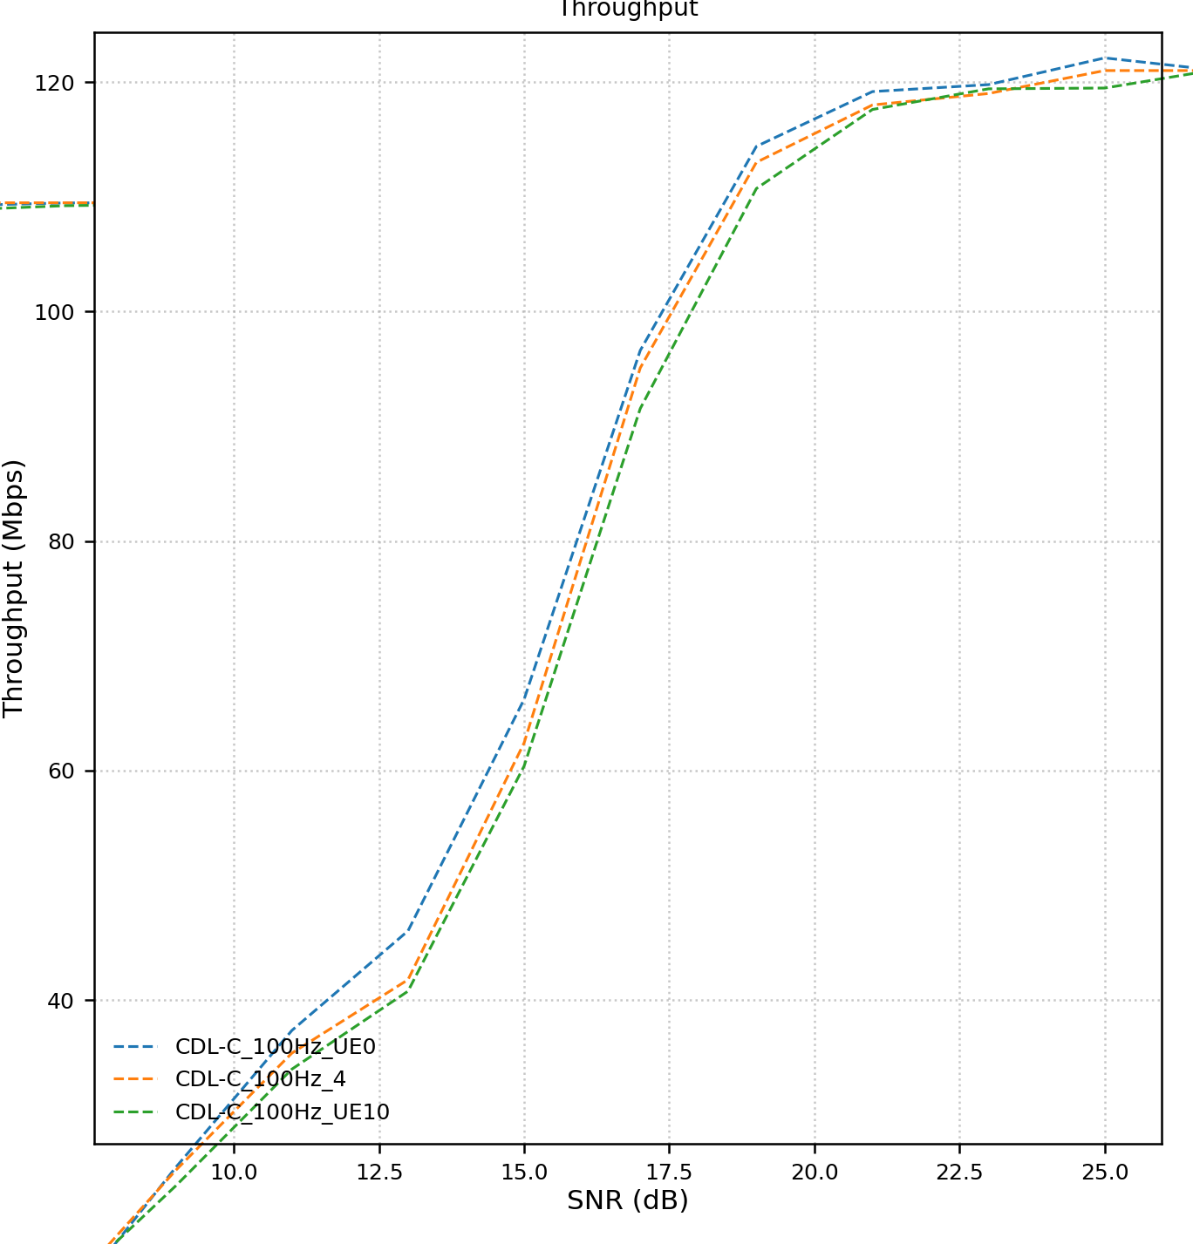
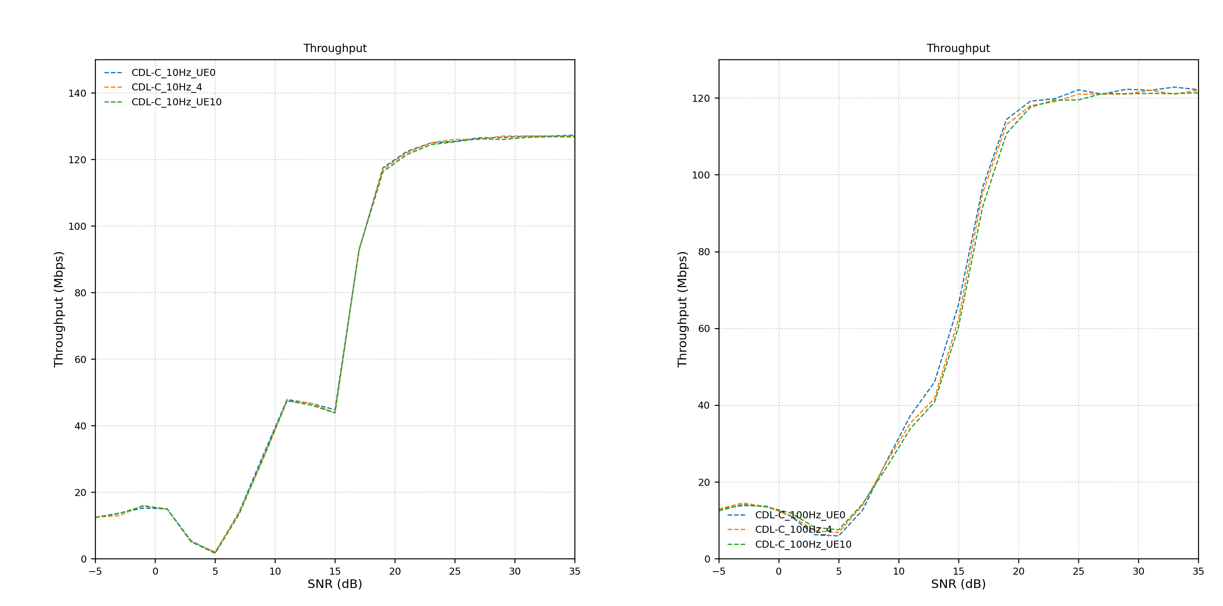

For the #Nframes issue:
- Draw Convergence of Multiple Trials
  - convergence of cumulative average throughput over 10 independent Monte Carlo trials at a fixed SNR. While significant fluctuations are observed at low frame counts, all trials converge to a stable mean value as the number of frames increases.
- Confidence Intervals
  - depicts the mean throughput (solid line) with its corresponding 95% confidence interval (shaded area). The rapid narrowing of the shaded region indicates a substantial reduction in statistical uncertainty as the sample size grows.

Following weeks’ agenda

