Not much this week

- Transmission Layers
Recall from last time:
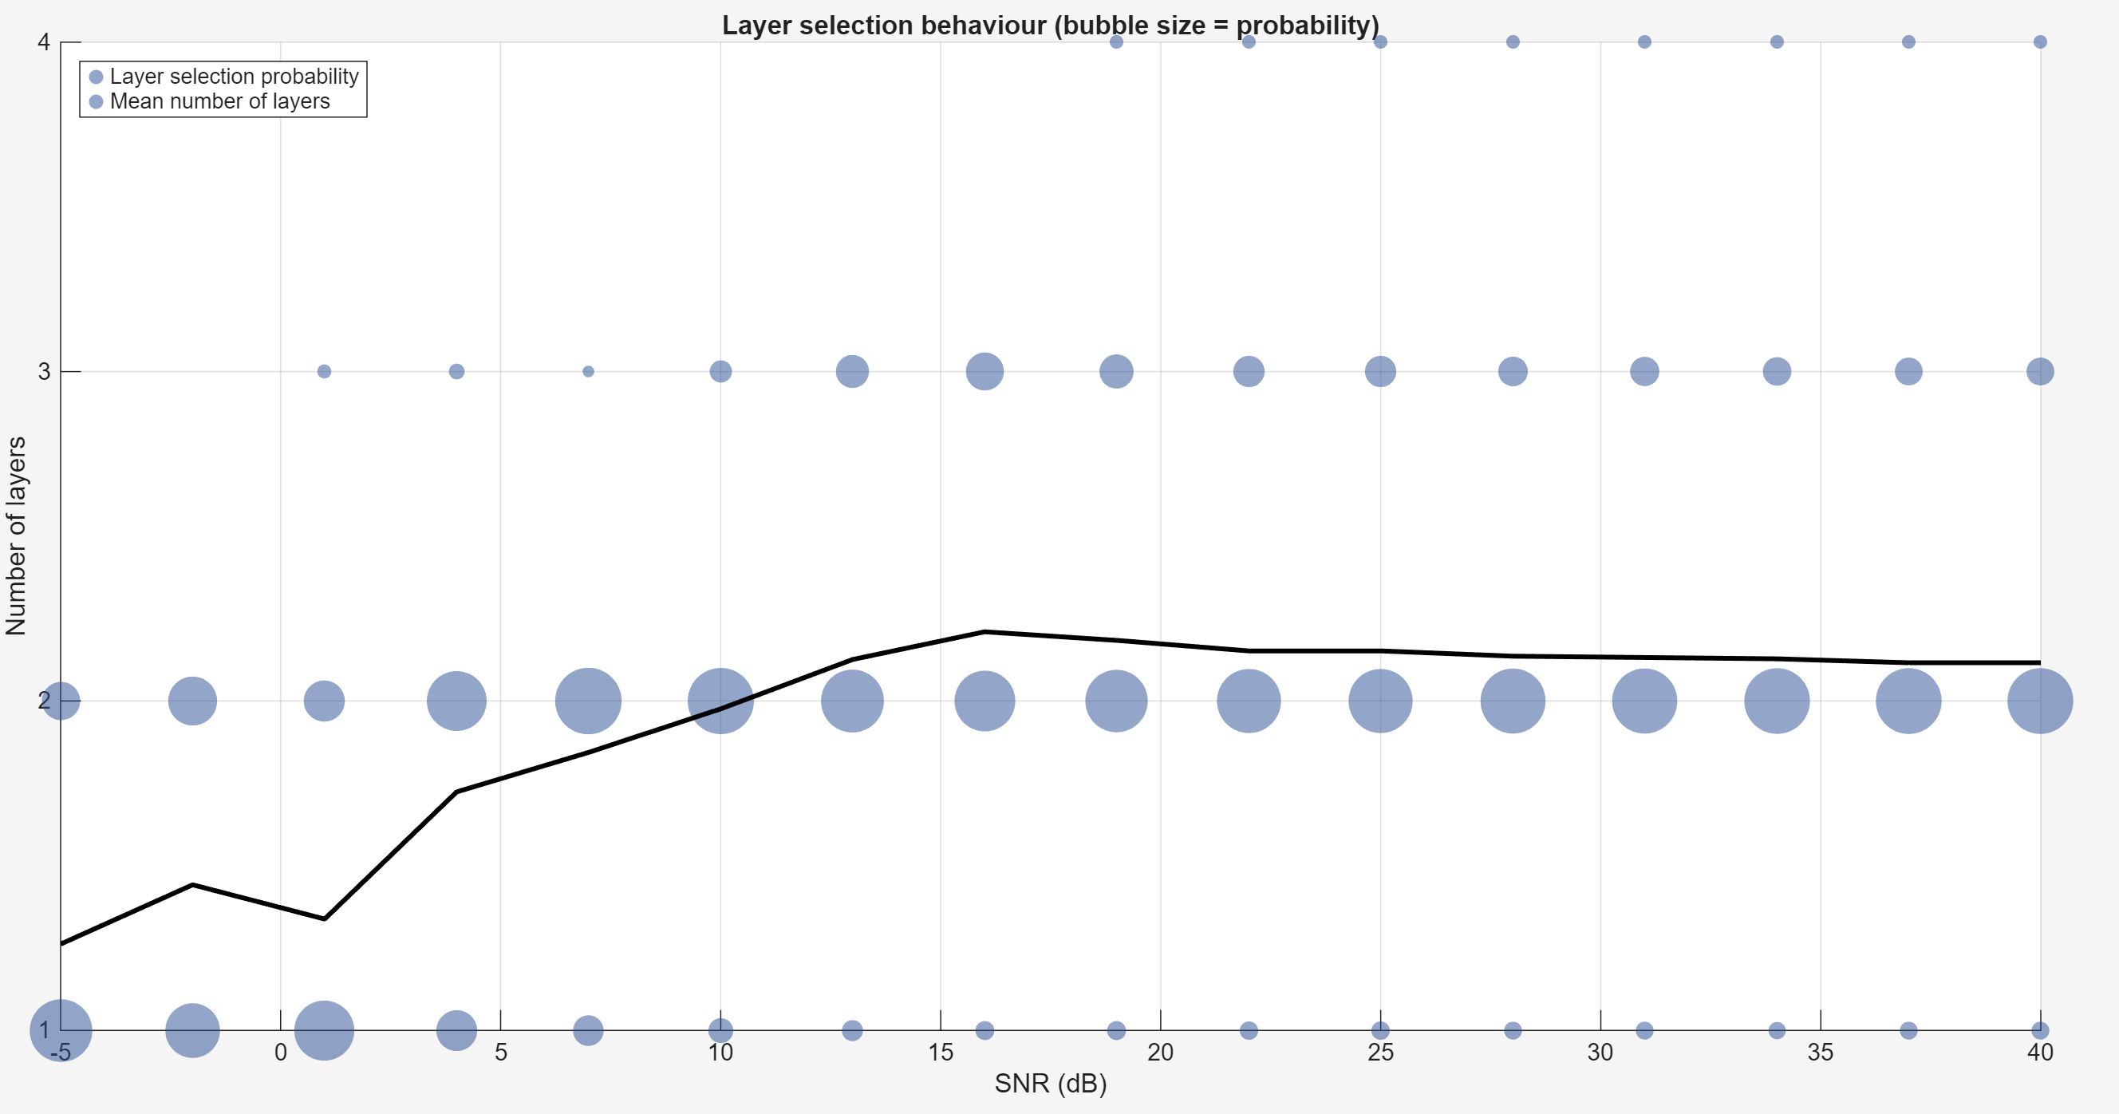
In practice:
Huawei Mate 30 (2019):
21 antennas:
2 for GPS
4 for WiFi (2 for 2.4G, 2 for 5G)
1 for NFC
14 for 5G (I think also 4x4)
Apple iphone 17 (2025):
5G (sub-6GHz) with 4x4 MIMO
Gigabit LTE with 4x4 MIMO
Apple Iphone 11 (2019):
Gigabit-class LTE with 2x2 MIMO and LAA
OPPO 5G CPE T1 (2020) <5G Router>:
“use the smart O-Reserve algorithm to select 4 antennas with better signals out of its 8 antennas” (4x4 MIMO->map antennas to csirs ports, untrue)
Sharetechnote Data (~2021):
Field testing
https://www.sharetechnote.com/html/5G/5G_FieldTest_01.html#:~:text=Following%20shows%20RI,each%20of%20UE%20Rx%20antenna
Mainly 5~15 dB, MCS<20, BLER<10%, rank mainly 2~3
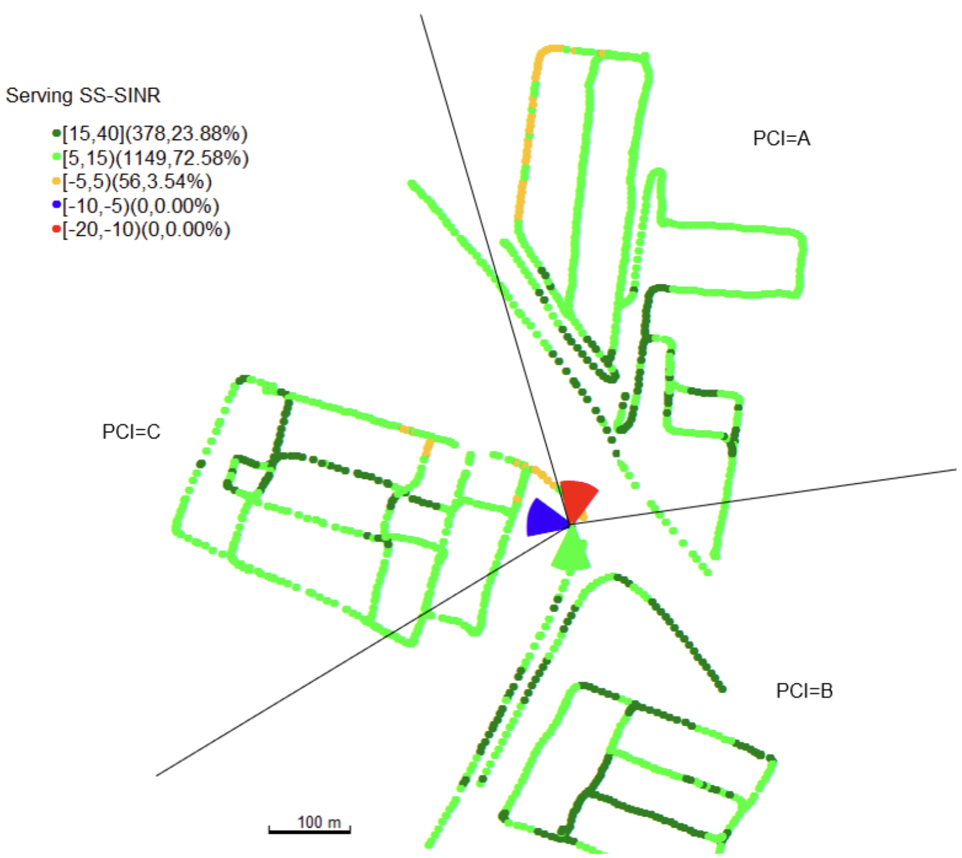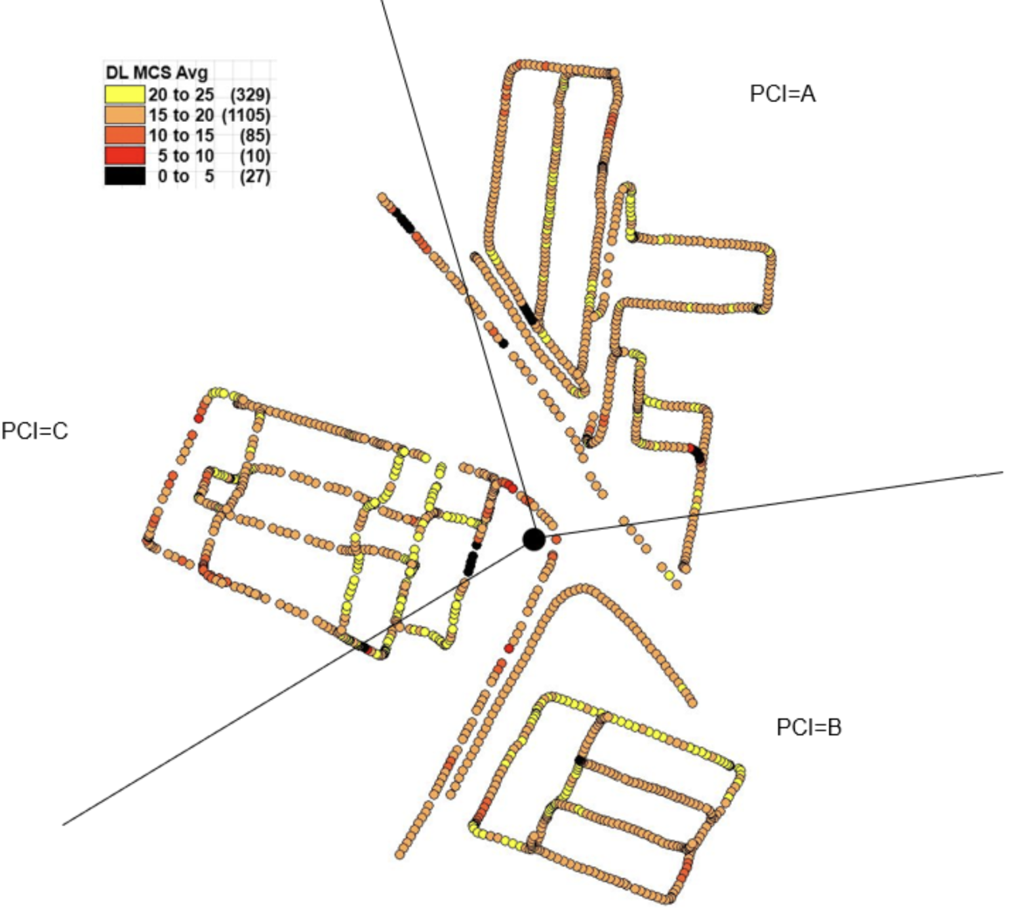
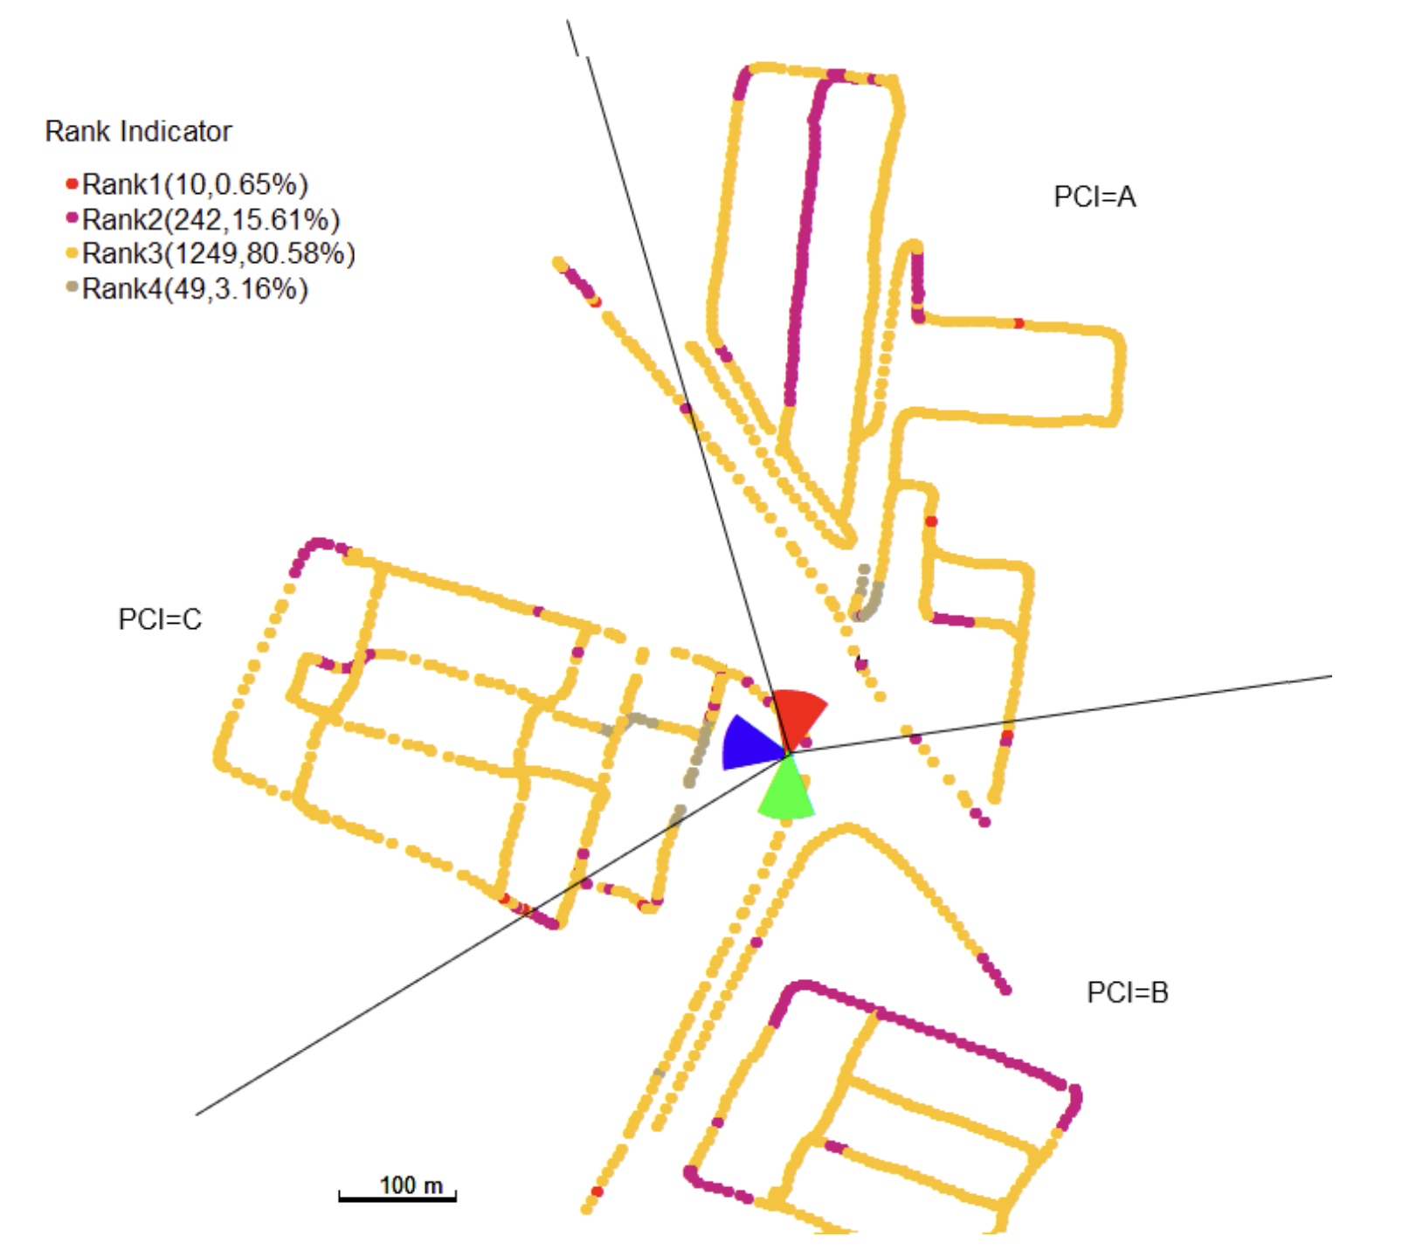
https://www.rohde-schwarz.com/us/solutions/critical-infrastructure/mobile-network-testing/stories-insights/article-how-4-4-mimo-can-boost-your-mobile-network_253229.html#:~:text=Result%20for%20frequency%20band%20n77%3A,MIMO%20rank%203%20and%204

- TDL v. CDL
Just started, not yet -> TDL correlation models (low?-High?) -> csirs no impact

- Fix to a certain layer
High layer (CDL vs TDL larger layers -> absolute SNR)
TDL-C CDL-C should have comparable results at lower layers (as less impact)
Need to check, CDL based UE velocity, TDL delay spread (need to check configuration)

