- CDL and TDL channel comparison
<Up to 4 layer, free selection, CSI default set>
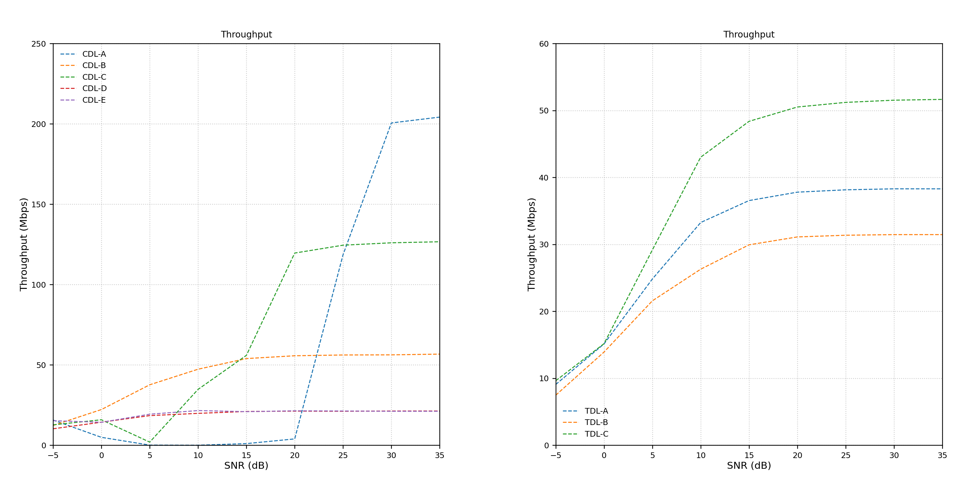
Reasoning (possibly):
- For CDL-A, -C, (NLOS) there might be a potential of using 256QAM at very high SNR
- LOS models (CDL-D, CDL-E) are not particularly compatible with MIMO, as 2 layer 64 QAM >> 1 layer 256 QAM
- TDL seems to have issue with dealing with MIMO -> only using QPSK and some 16QAM modulation to secure a good BLER -> the measured cqi is extremely conservative e.g. ~6 at 15dB
- Expect: A, D to be best, C to be worse? Deeper look
What if?
- Fix all to one layer transmission? -> For TDL, the Mbps barely changes. For CDL, significant decrease, bottleneck at 110 Mbps
- Disable CSI -> TODO

- Fixing layer
CDL-A vs TDL -A, flexible; fix 1 layer; fix 4 layers
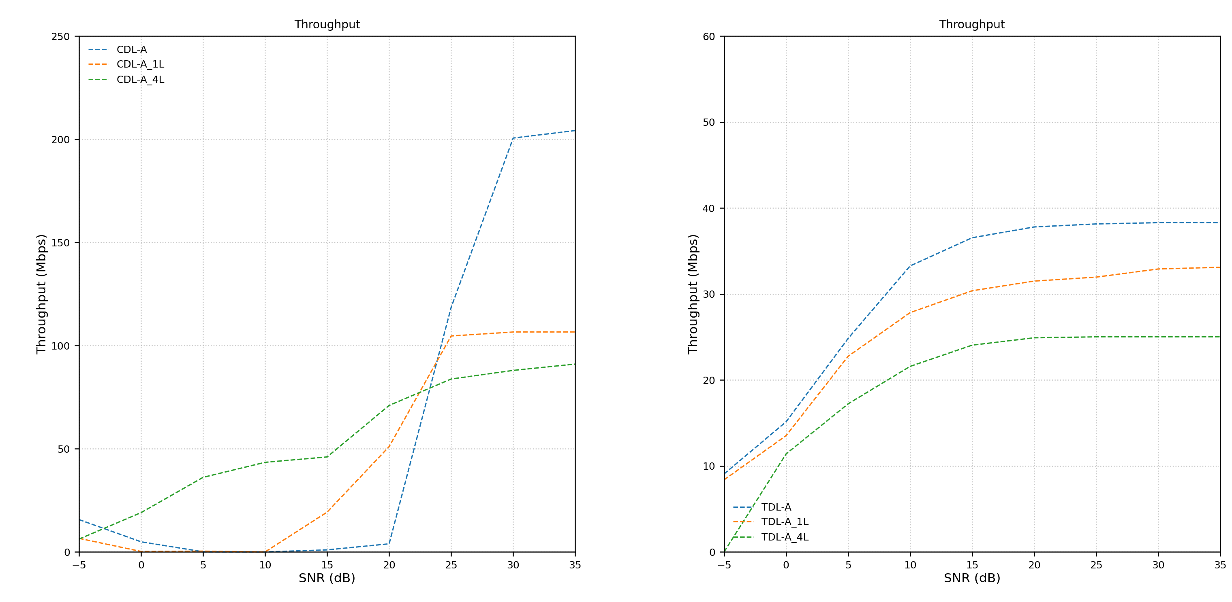
TDL only has minor impact due to this, while CDL has huge impact
Do 1 2 3 4, if the bubble graph is 2, 2 shoube be better than 1, 3, 4
- MCS, CQI Table 1, 2, 3 usage confirmed and simulated
  - Table 1 up to 64 QAM -> Balanced
  - Table 2 up to 256 QAM -> (maybe) for Enhanced Mobile Broadband (eMBB) -> to replace fiber connection inhouse
    - Should be having the similar performance as Table 1 at low SNR
    - Maybe have a look fixed layer
  - Table 3 up to 64 QAM -> “Low Spectral Efficiency” for ultra-reliable communication (URLLC) use case
CDL-A table 1 ~200Mbps at 35dB | CDL-A table 2 ~85Mbps at 35dB (Very likely bottleneck not yet achieved)
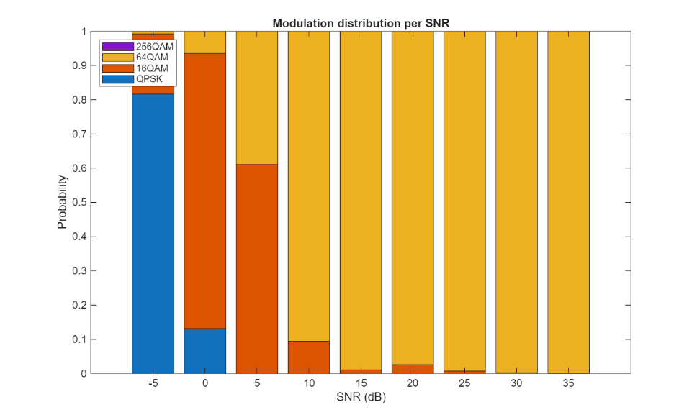 | 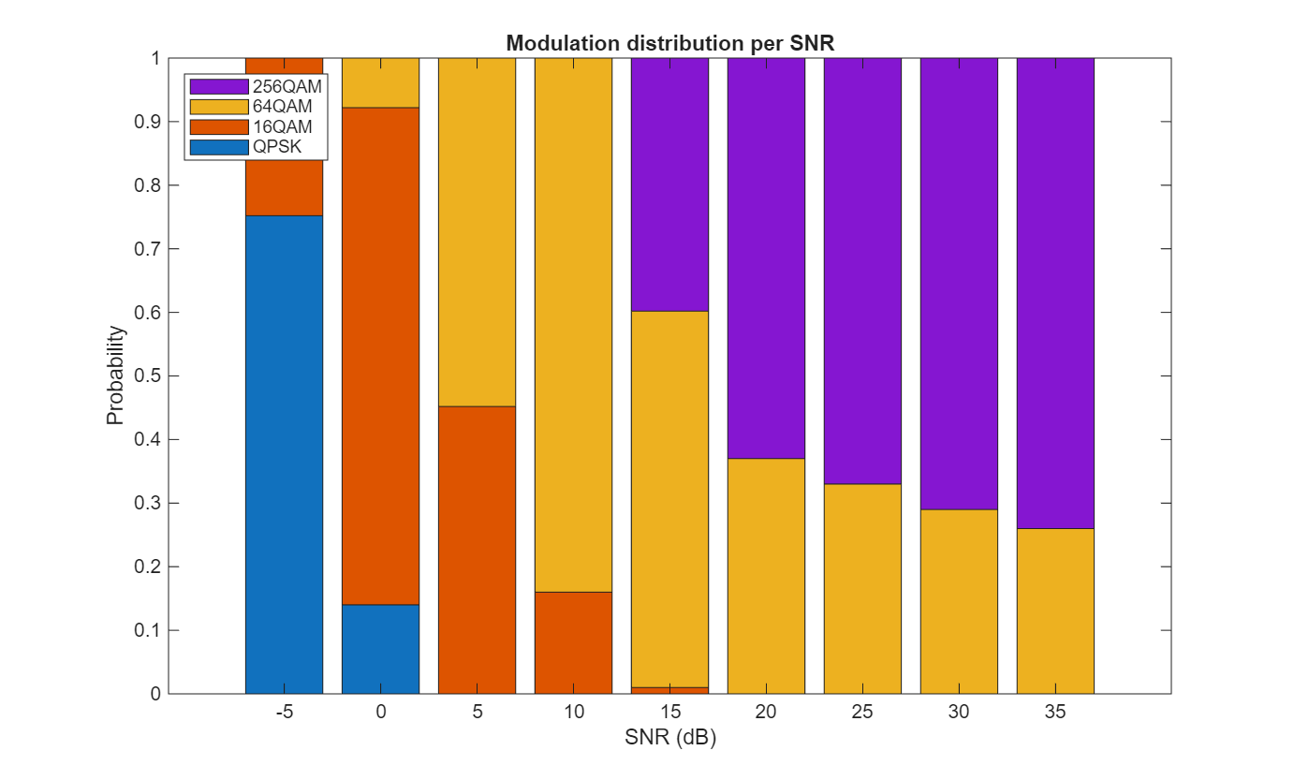
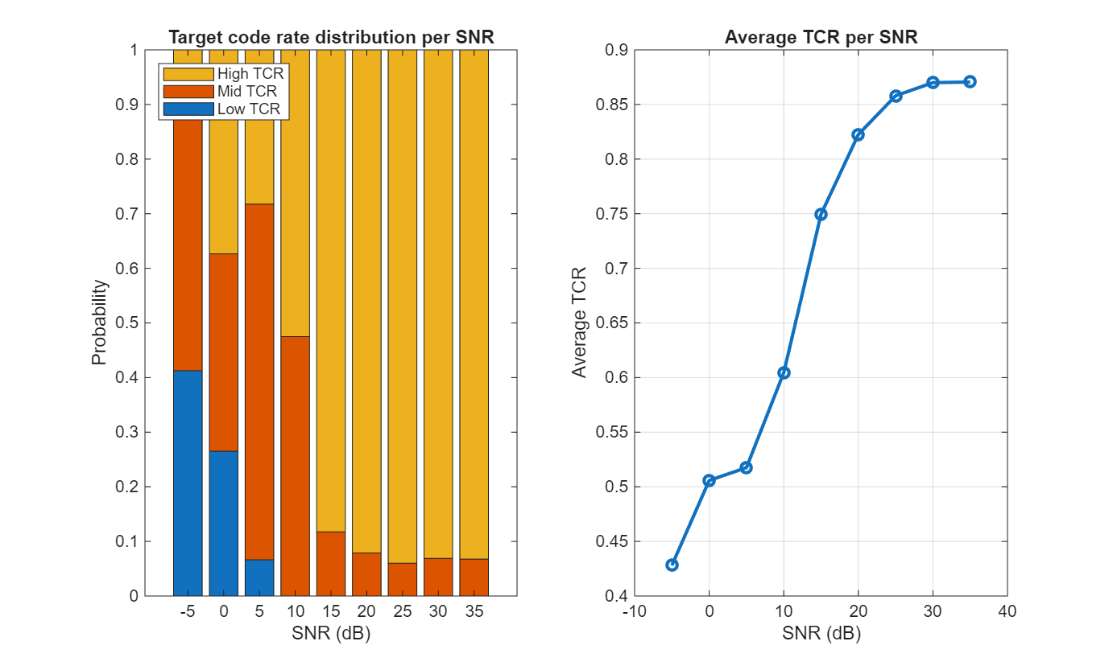 | 