- Different Rank-Indicator Performance
CDL-A, rank 1 2 3 4 and flexible:
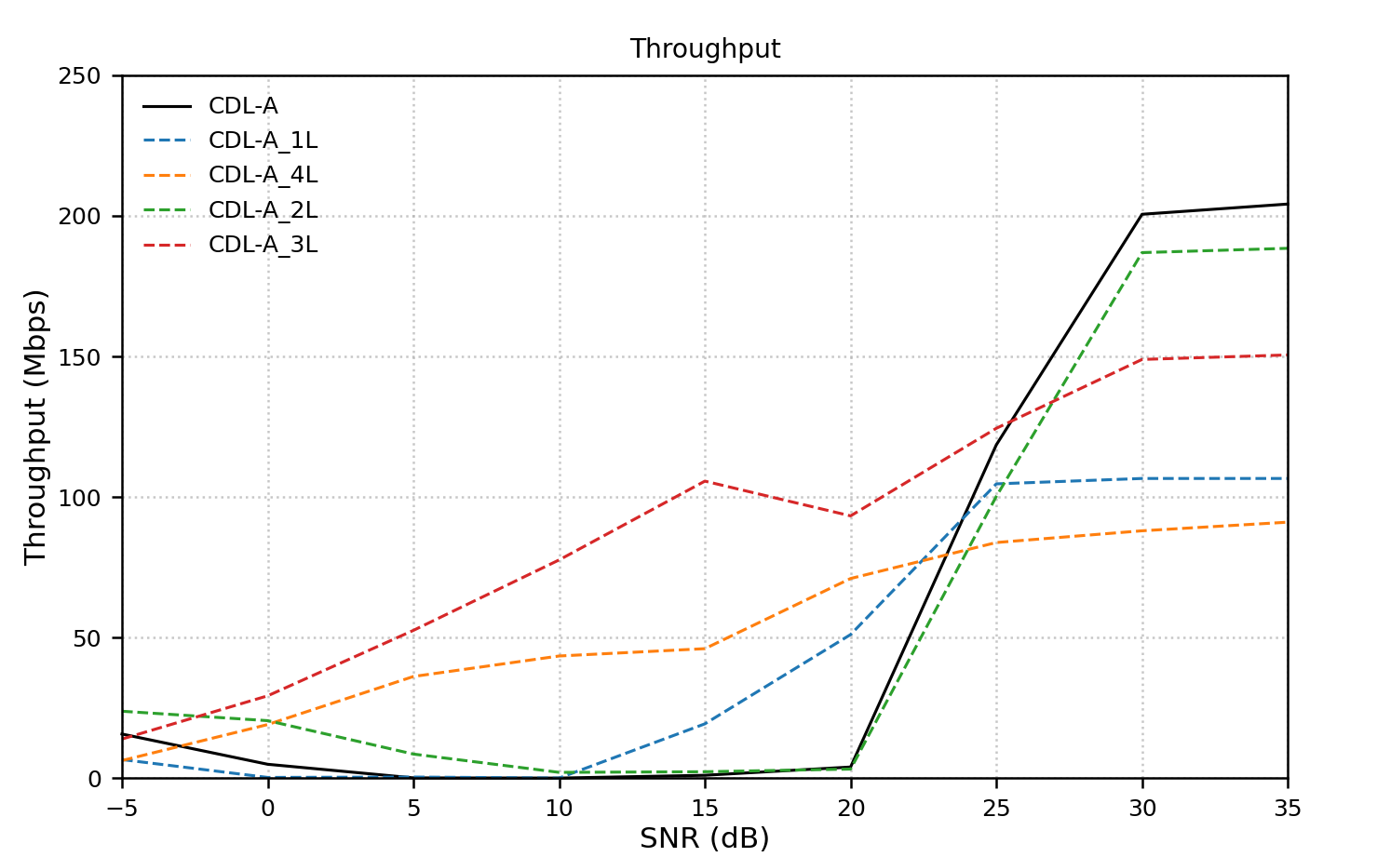
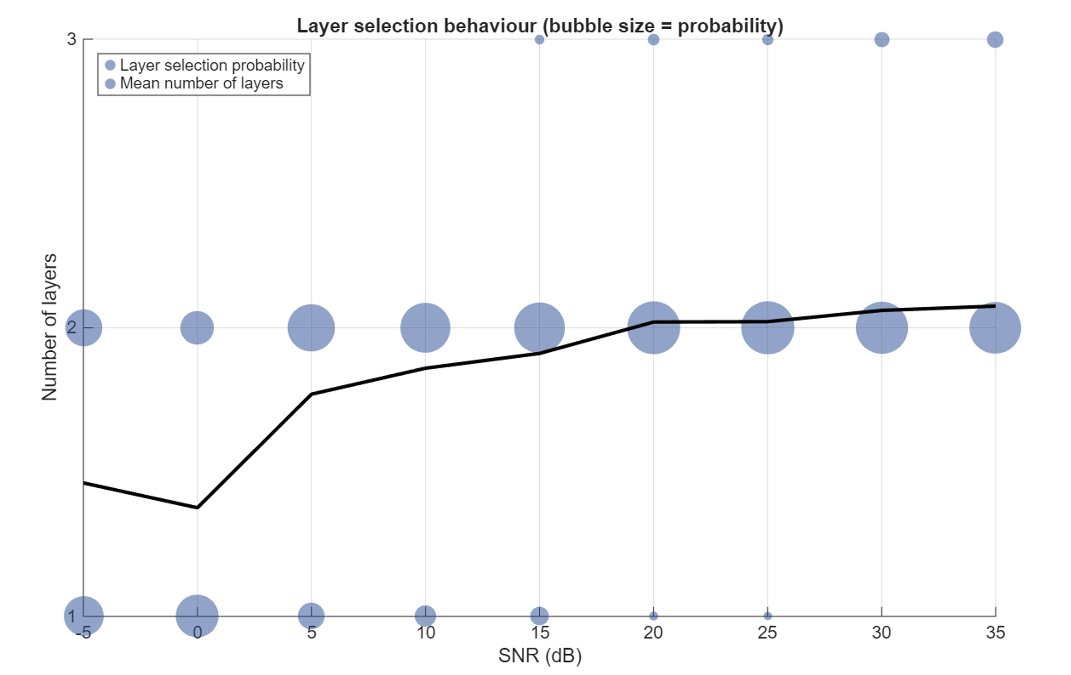
- At low SNR, forcing 3 and 4 layers perform better than flexible and 1,2 layers
- At high SNR, the performance makes sense.
Flexible> force 2>force 3>force 1 >force 4 （Should be like this no matter what SNR?）. The flex case perf. match with L1, 2 When >23dB, seeing impact of TXEVM (by basestation), 3.5% error clipping signal ~23dB (1dB compression) diverging point – when comparing to real world case
Test\dB | -5 | 10 | 30
Flex. | 16QAM (0.6)  QPSK (0.4) [1.5] | 64QAM (0.9)  16QAM (0.1)  [1.8] ? too optimistic | 64QAM  [2.1]
F1 | 16QAM (0.3)  QPSK (0.7) | 64QAM | 64QAM
F2 | QPSK | 16QAM (0.3)  64QAM (0.6) | 64QAM
F3 | QPSK | 16QAM (0.55)  QPSK (0.45) | 16QAM (0.3)  64QAM (0.7)
F4 | QPSK | QPSK | QPSK (0.45)  16QAM (0.65)
101-4 single layer vs 2 layers for TDL channel model under different config

Now for CDL-C model:
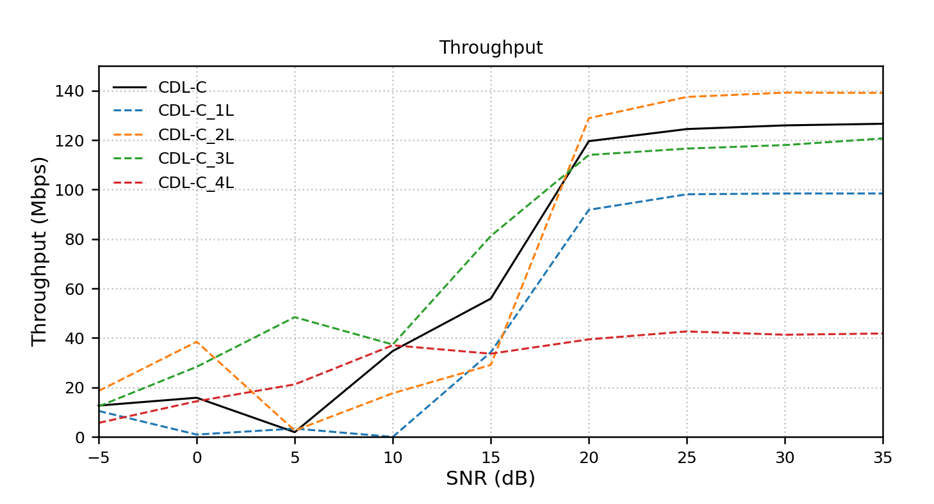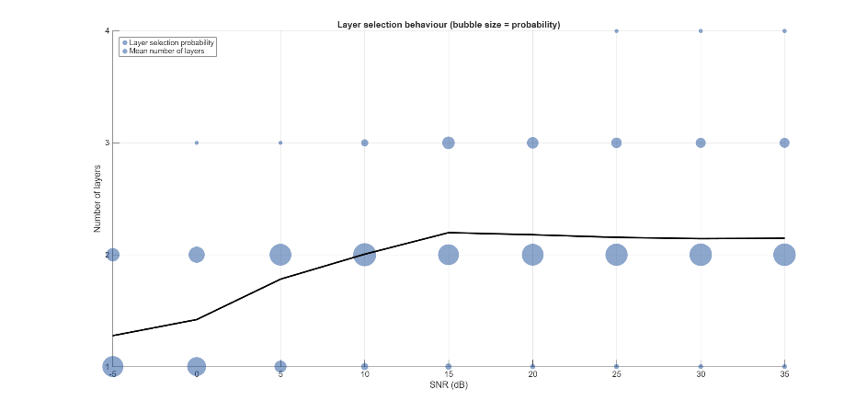

Possible reasons for poor performances at low SNR:
- CQI, RI from CSI feedback is simply not accurate? Compare with perfect channel estimation. TODO
**Not my results**
Maybe TDL/CDL have different gap size? Maybe certain models lead to larger gaps?
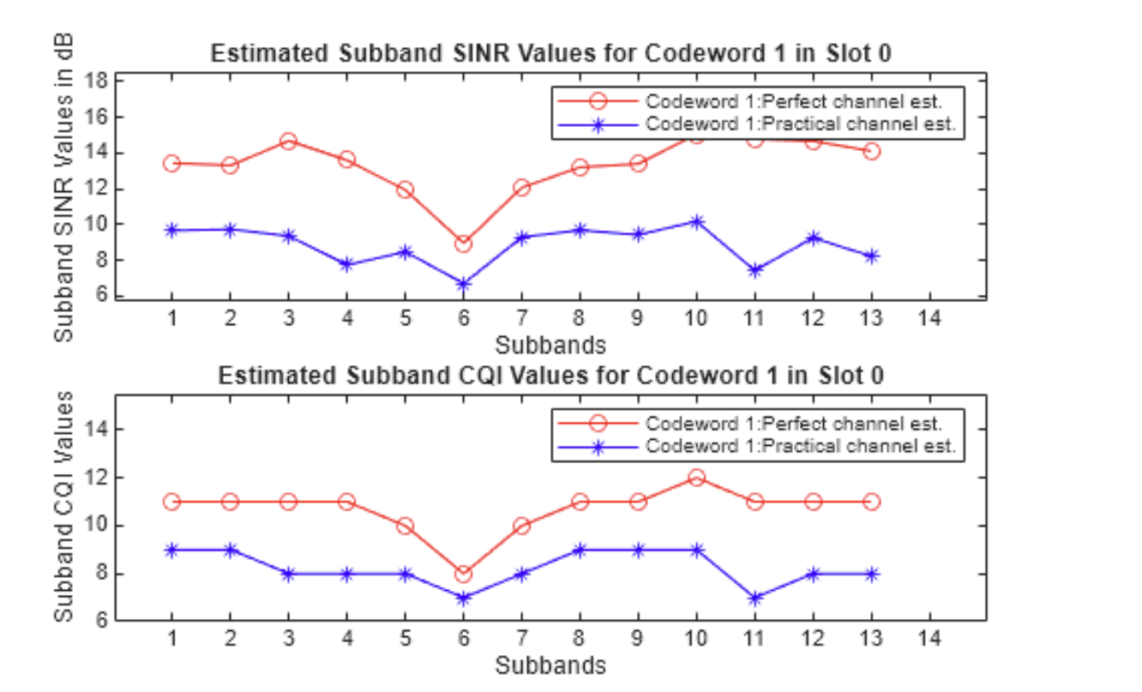
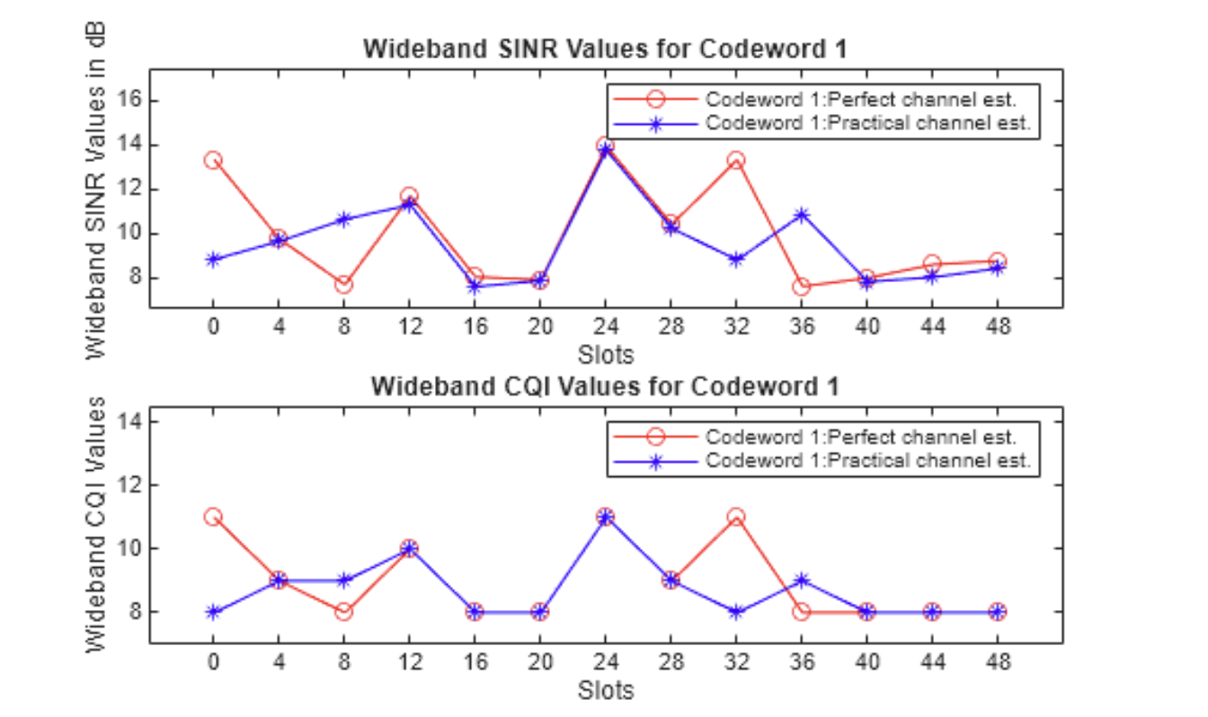

- How CDL-C fix rank 1 table 1 vs table 2 performs.
CDL-C, fix to layer 1, table 1 vs table 2:
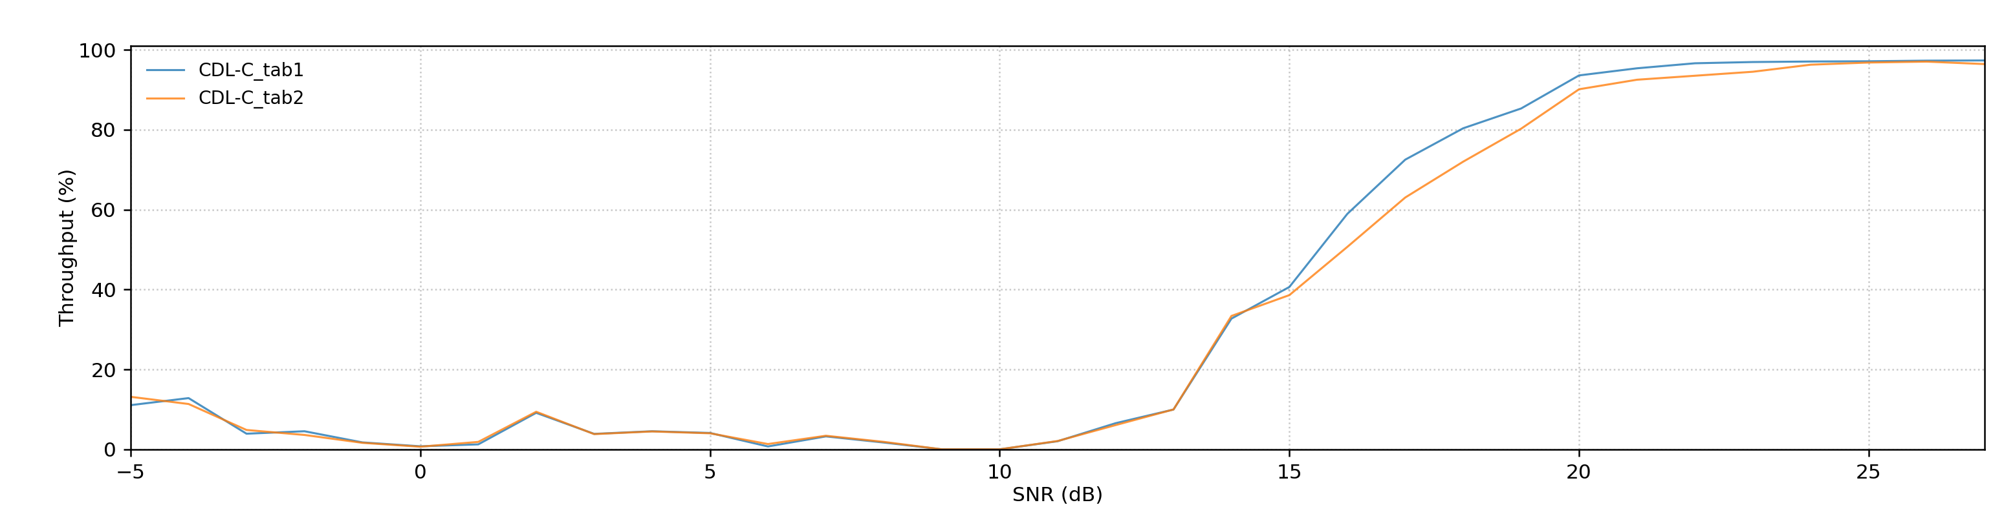
Bottleneck for table 1, doing better for table 2. E.g. Shannon limit? (theoretical limit)

- Maybe have a look at the (received) constellation diagram?
- Only Implemented the function, no experiment has been conducted yet
- Might be able the explain some weird behaviors during the simulation
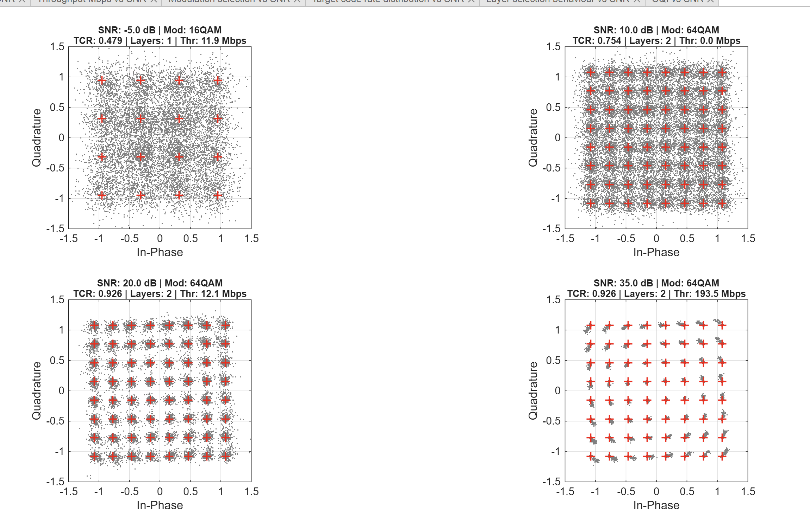
Phase noise? Not AWGN model. -> need to explain during report, maybe this is the real system performance.
No 3GPP requirements on this…

