- Phase noise
AWGN used, no explicit phase noise added
Recall:
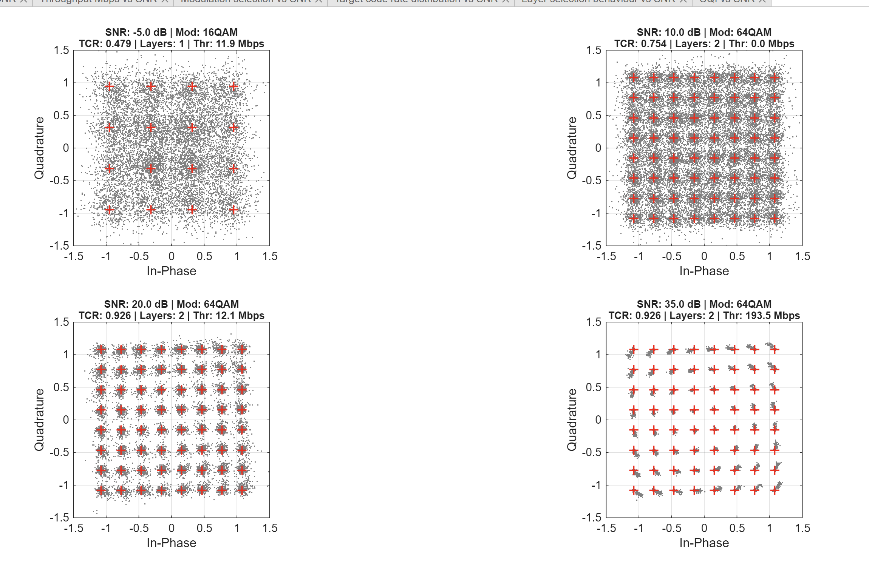

Non-perfect | Perfect, minus 10 SNR
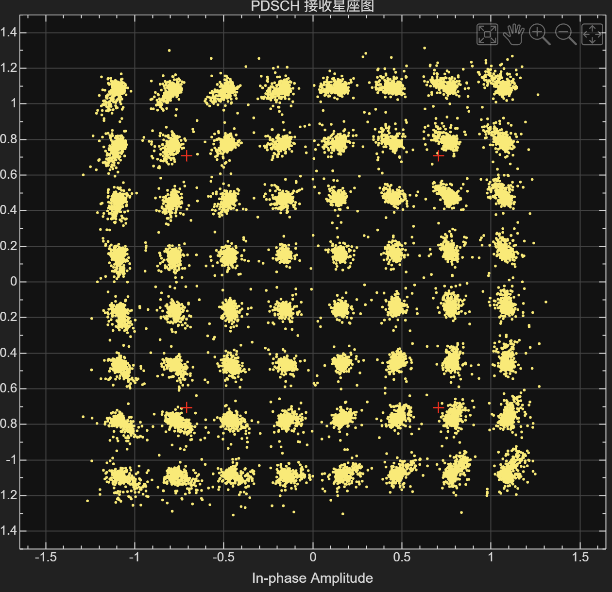 | 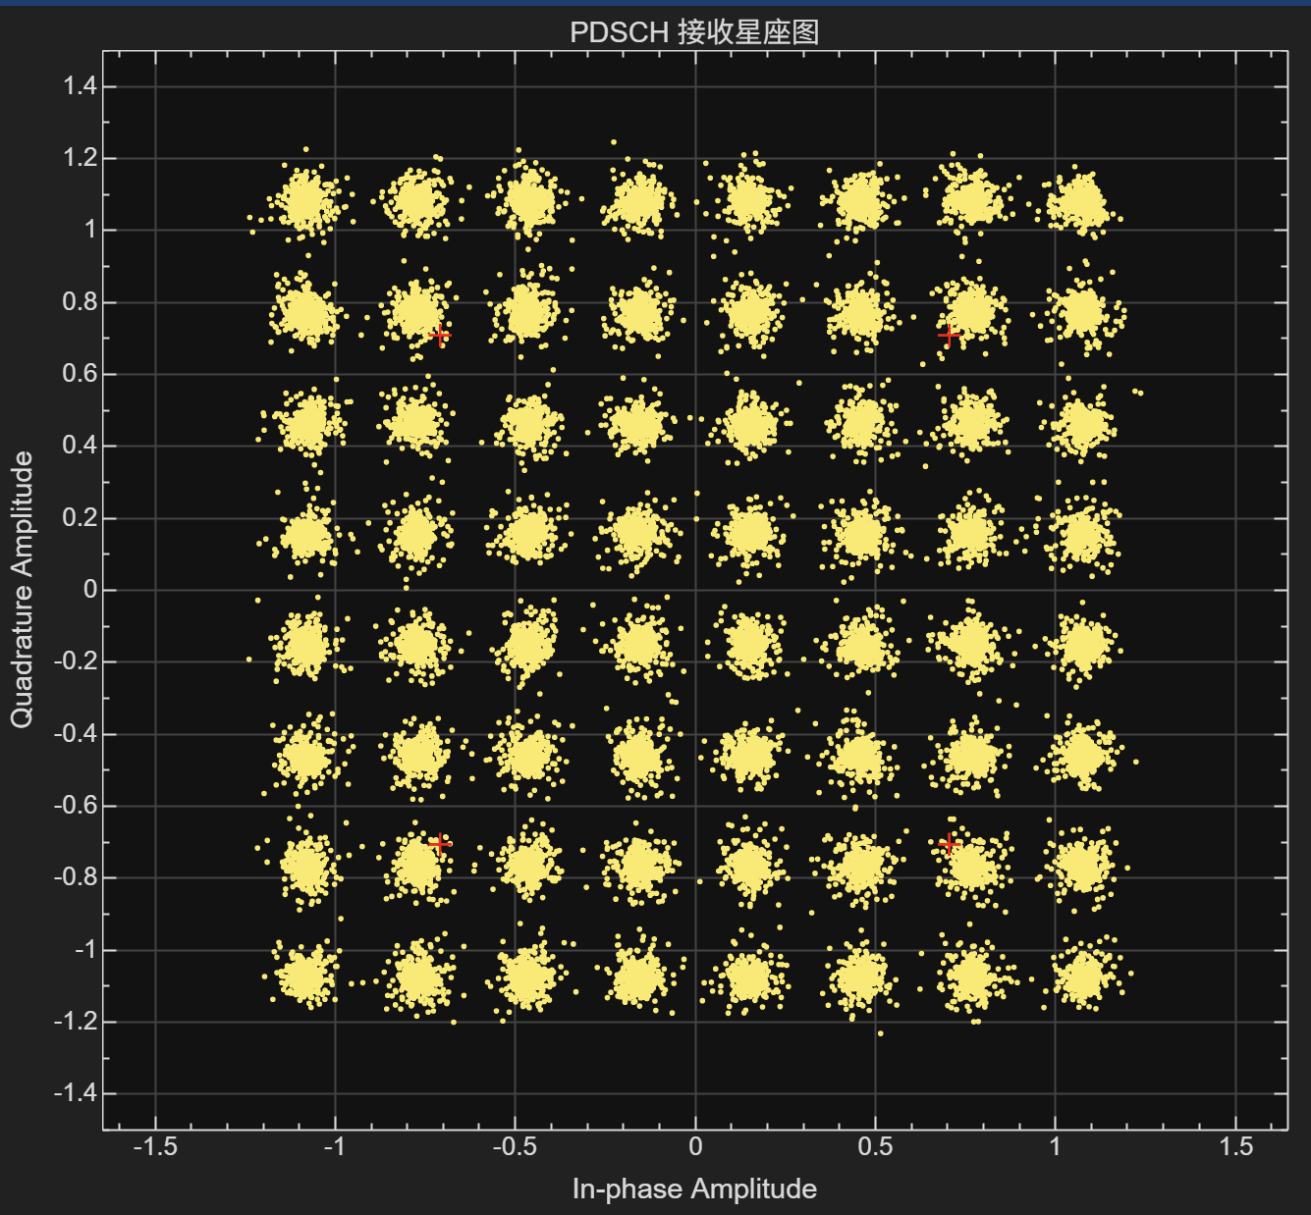

This is likely to be caused due to residue CFO (Channel Frequency Offset)
- Cause the whole Constellation Diagram to rotate (prev. case anti-clockwise, so negative frequency shift)
- Also cause the symbols to become long
Adding manual frequency shift to the received signal:
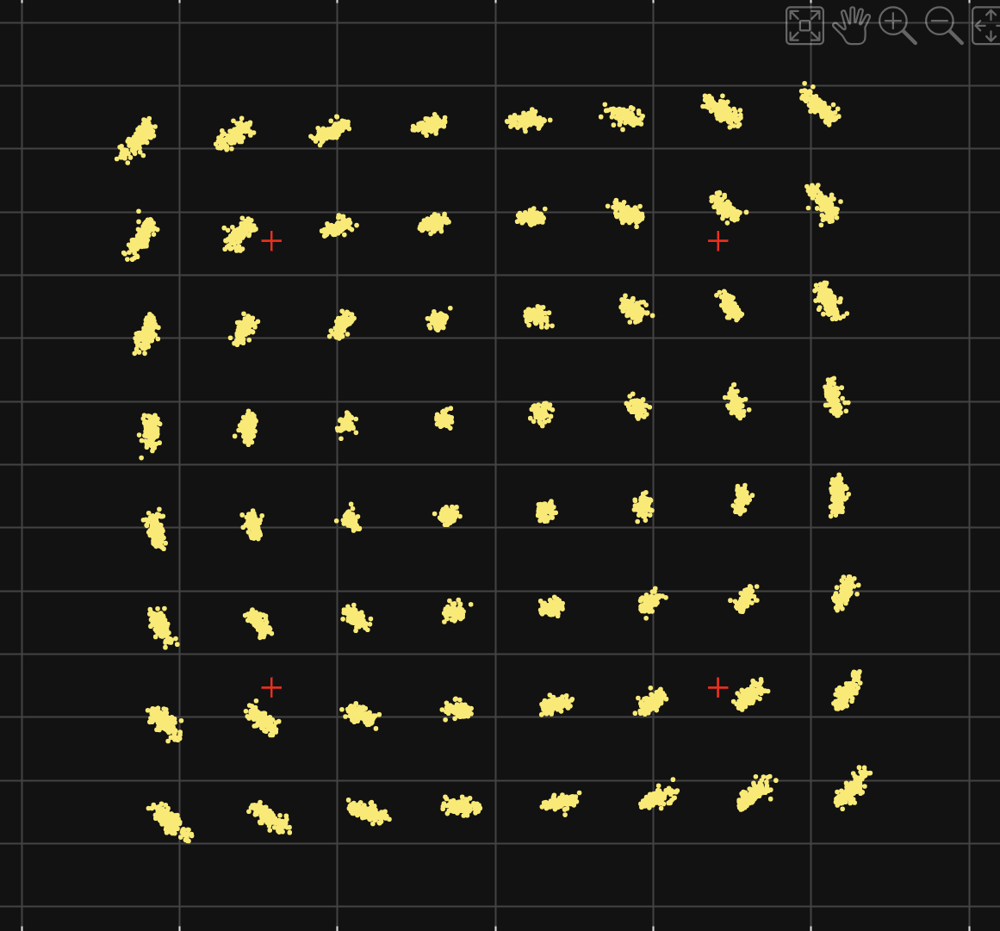 | 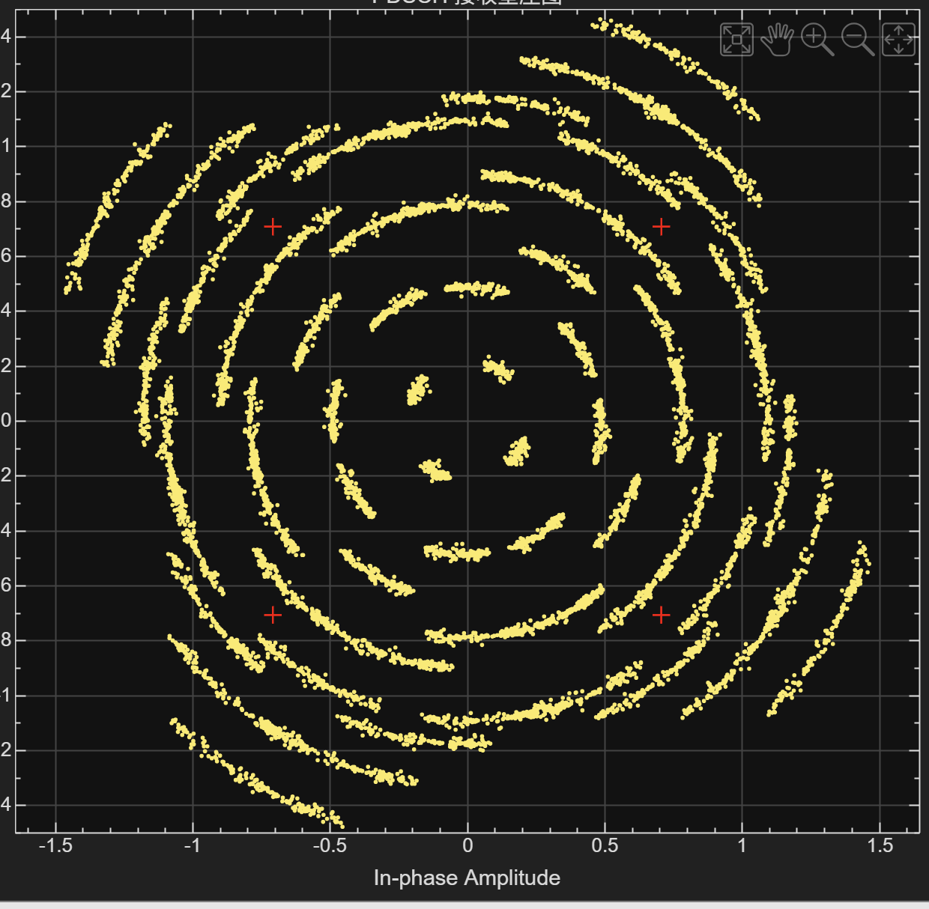
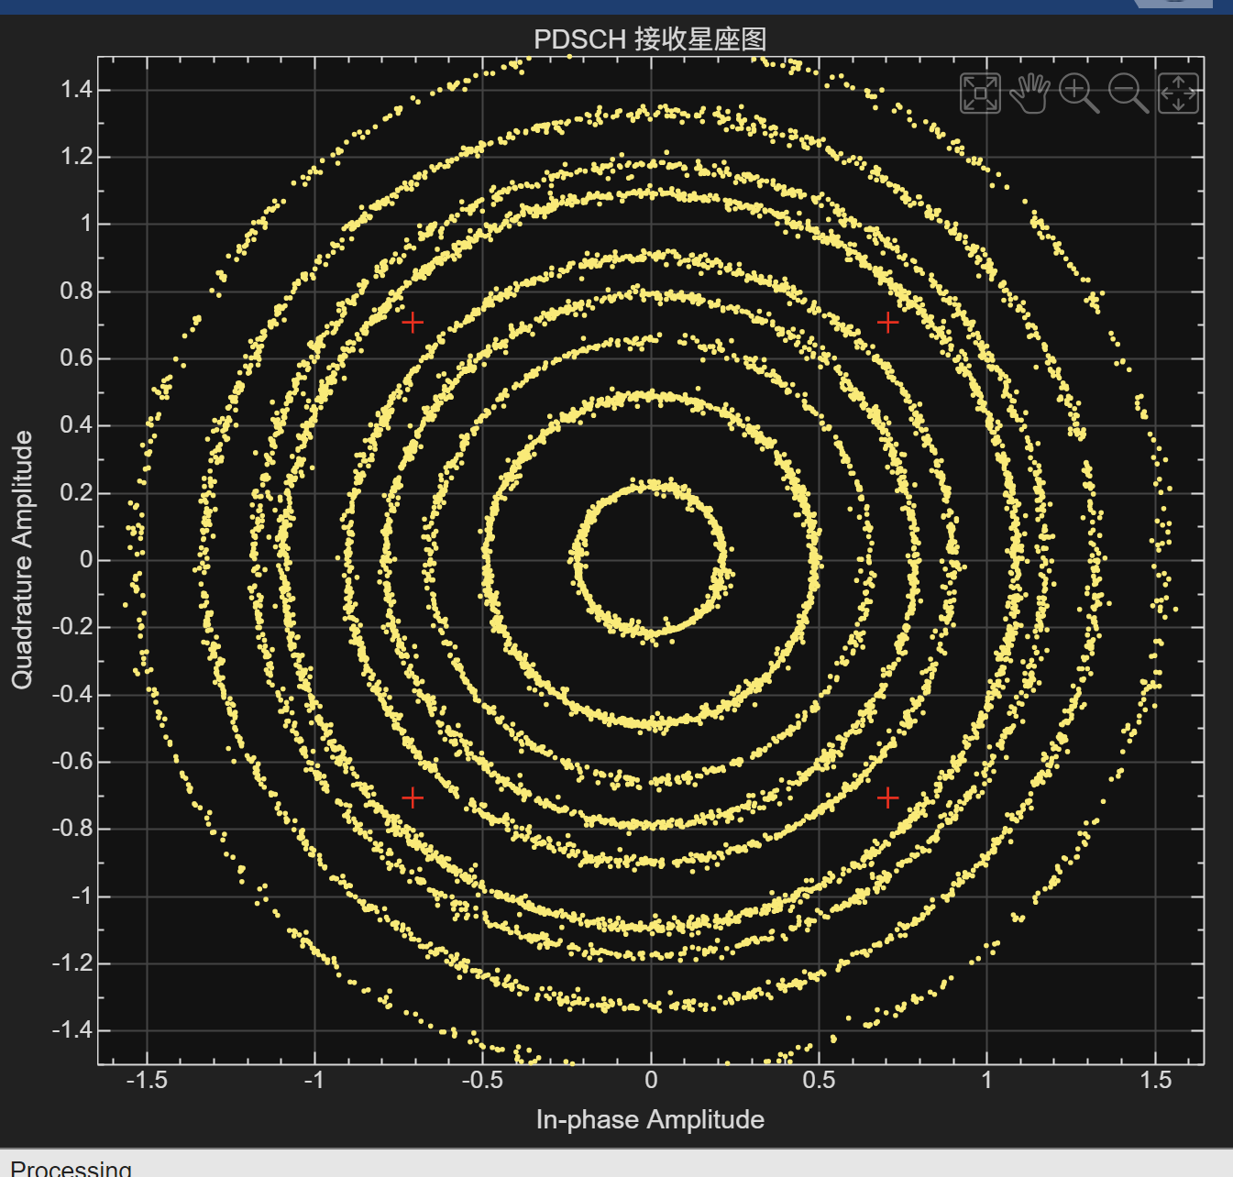 | 