PUCCH: BLER for UC, perfect channel estimator I
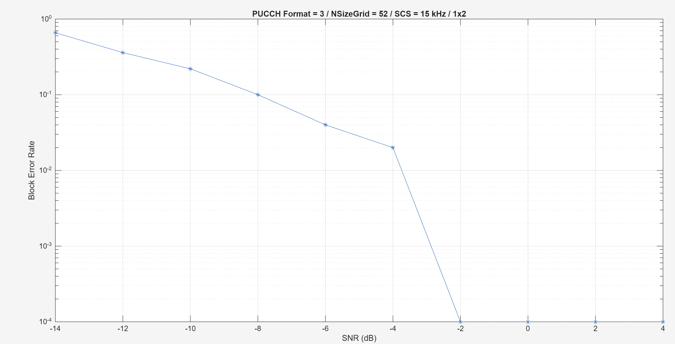

PUCCH: BLER for UC, non-perfect channel estimator I
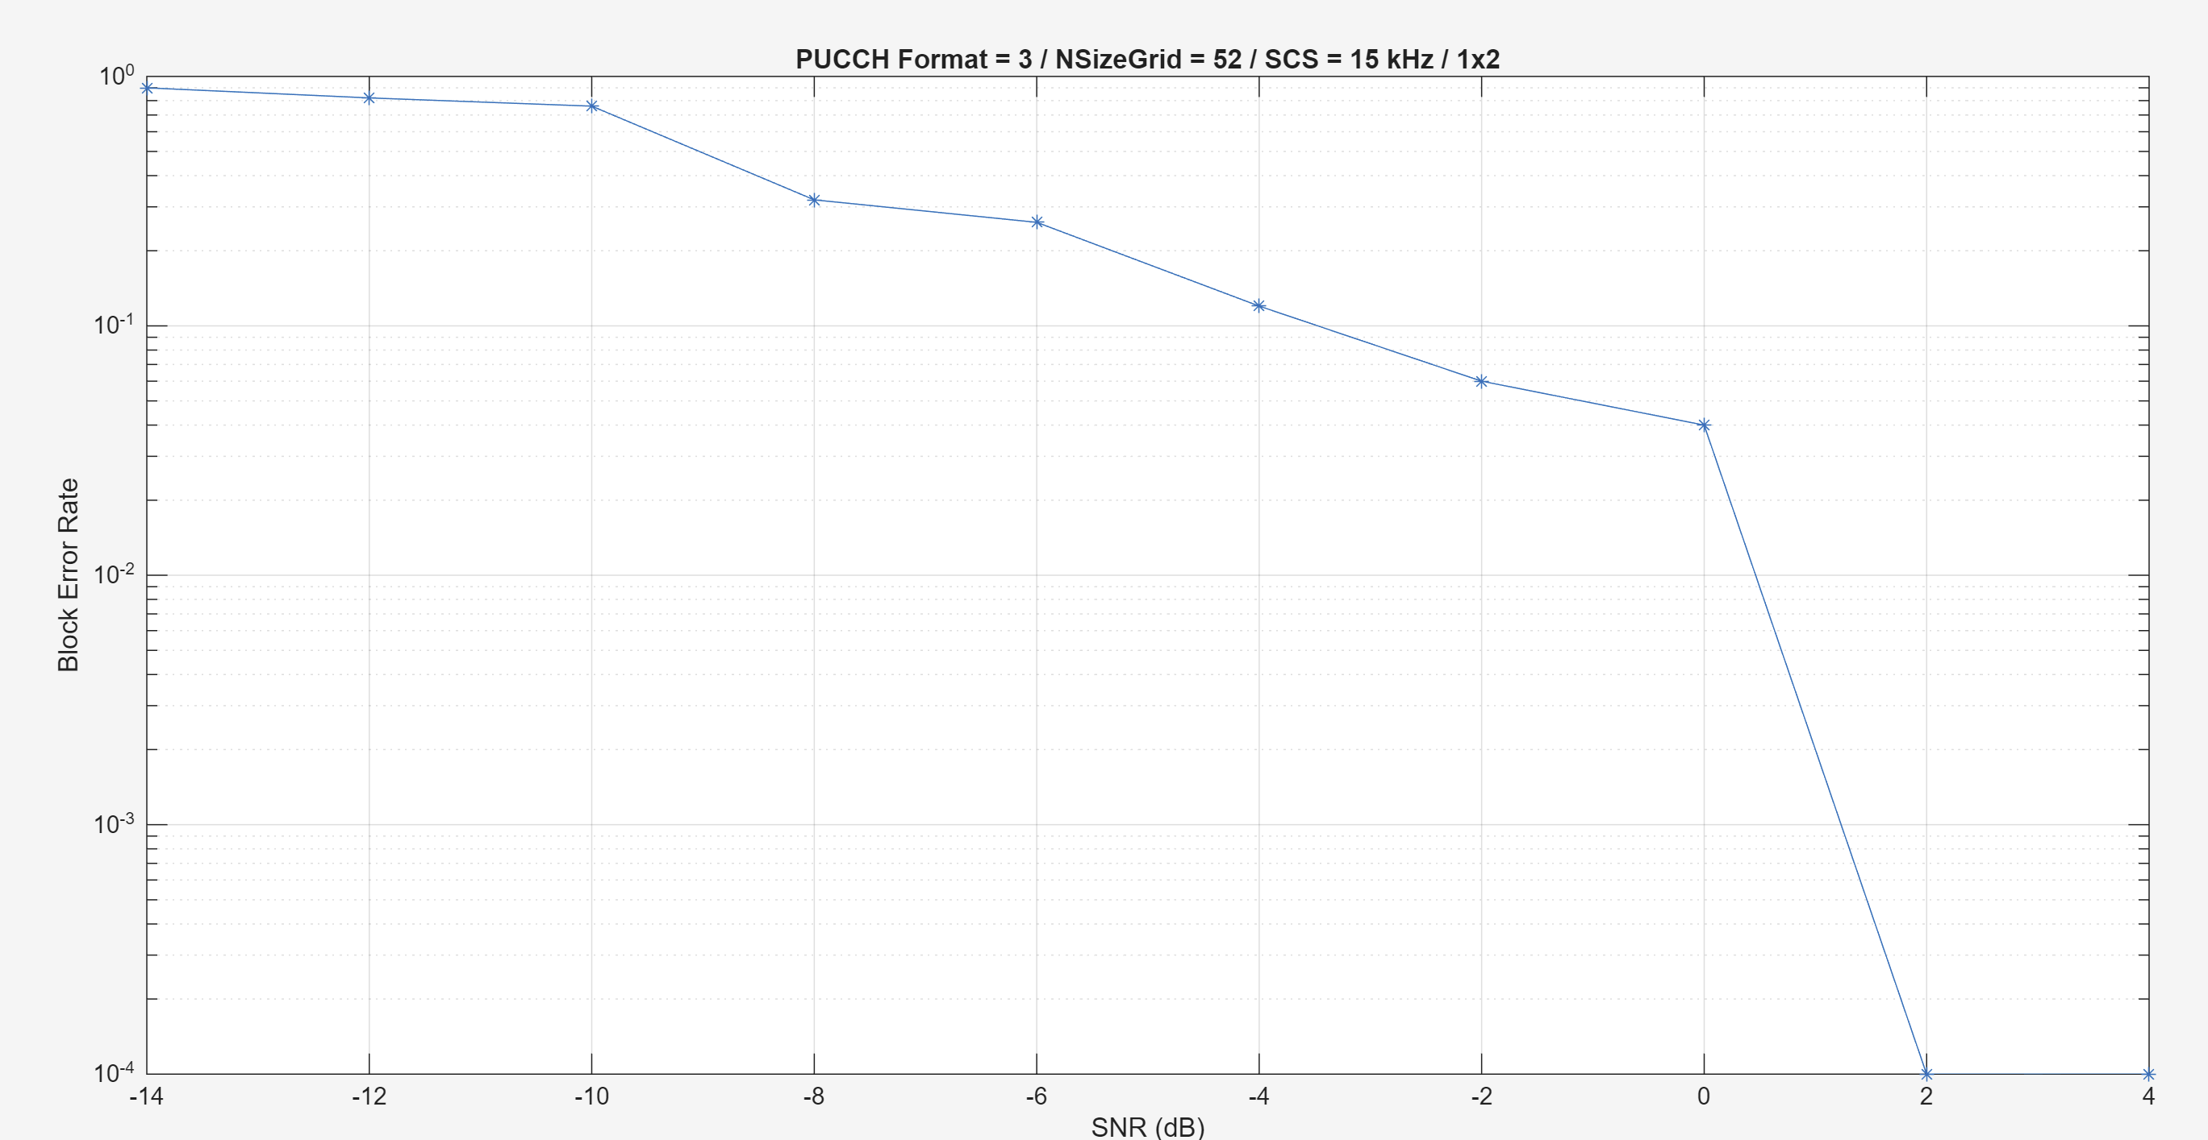
Sometimes: “Estimated timing offset (1677) is greater than the maximum channel delay (46). This will result in a decoding failure. This may be caused by low SNR, or not enough DM-RS symbols to synchronize successfully.”

Working correctly?:
Release 19, PDSCH % of maximum throughput. For each modulation, what is max. throughput it can provide when no error. PDSCH throughput curves
Focus on each individual channel. 4 of them are ‘channels’
HARQ enable. 0.1dB
Waterfall effect: error drops at the higher end of SNR
Throughput might have flat, not necessary always increasing because of HARQ

When increase number of testing points
-Probably because of the limited Nslots (49), so BLER is quantized
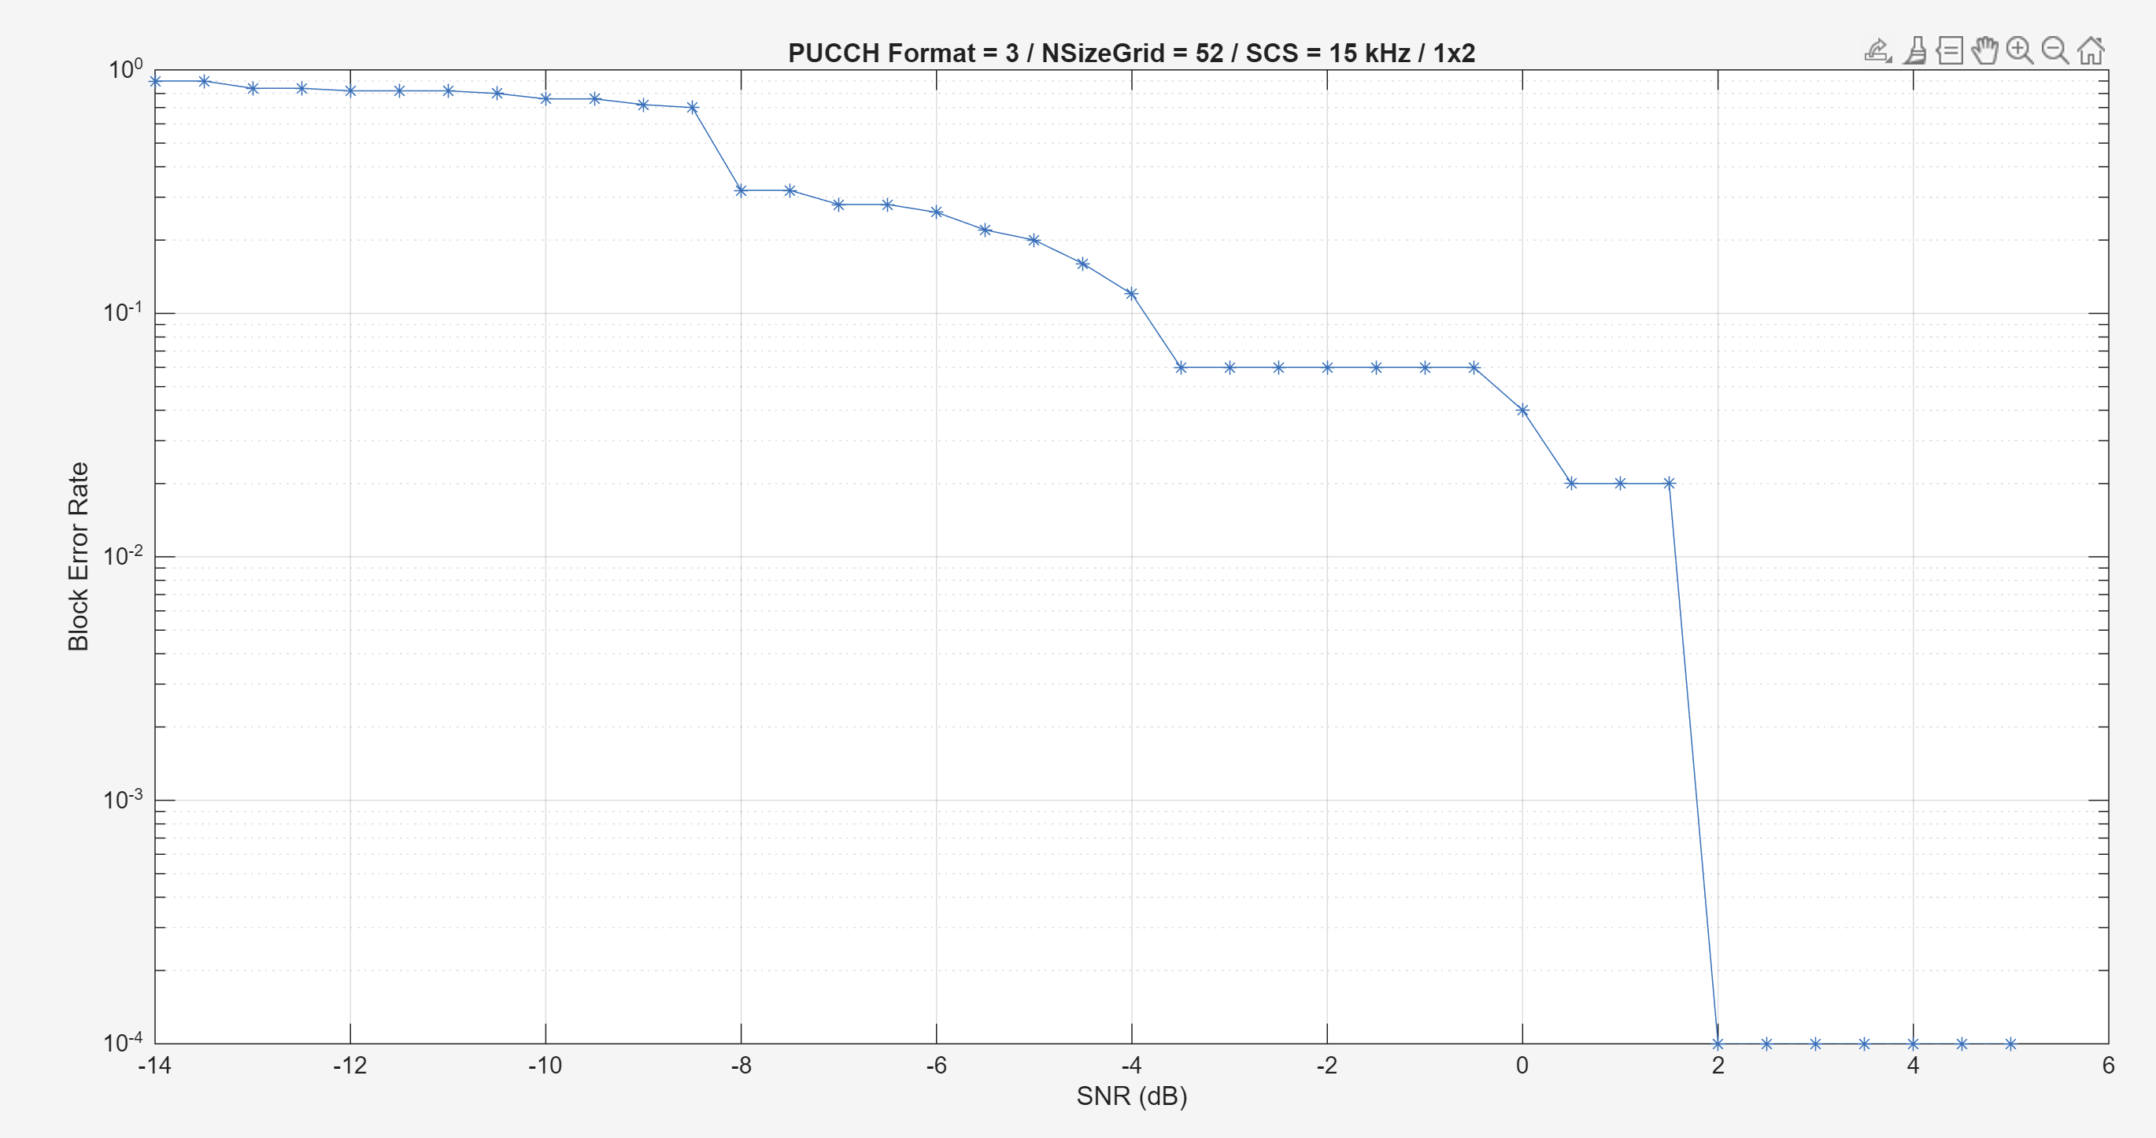

Will be better if multiple repeats are conducted. E.g.:

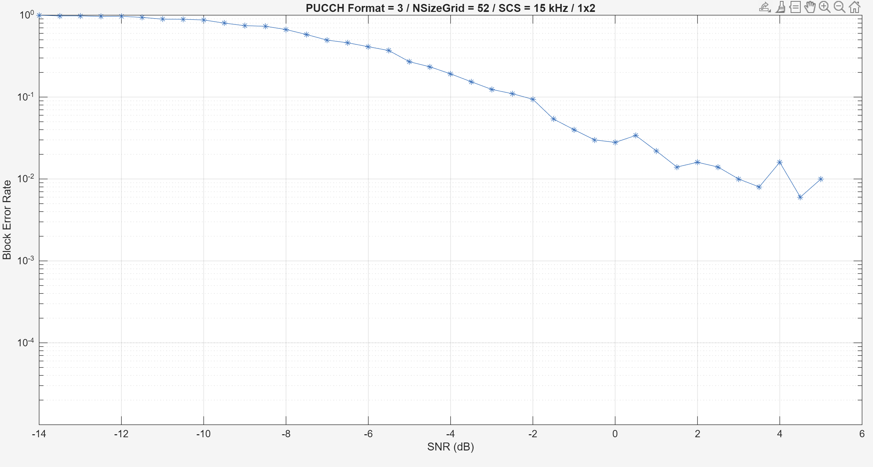

Sometimes, the system performs even better when max. doppler shift increases? (diversity gain?)
Perfect estimator: MaximumDopplerShift 100 vs. 300 Hz
reset to the same channel for each test
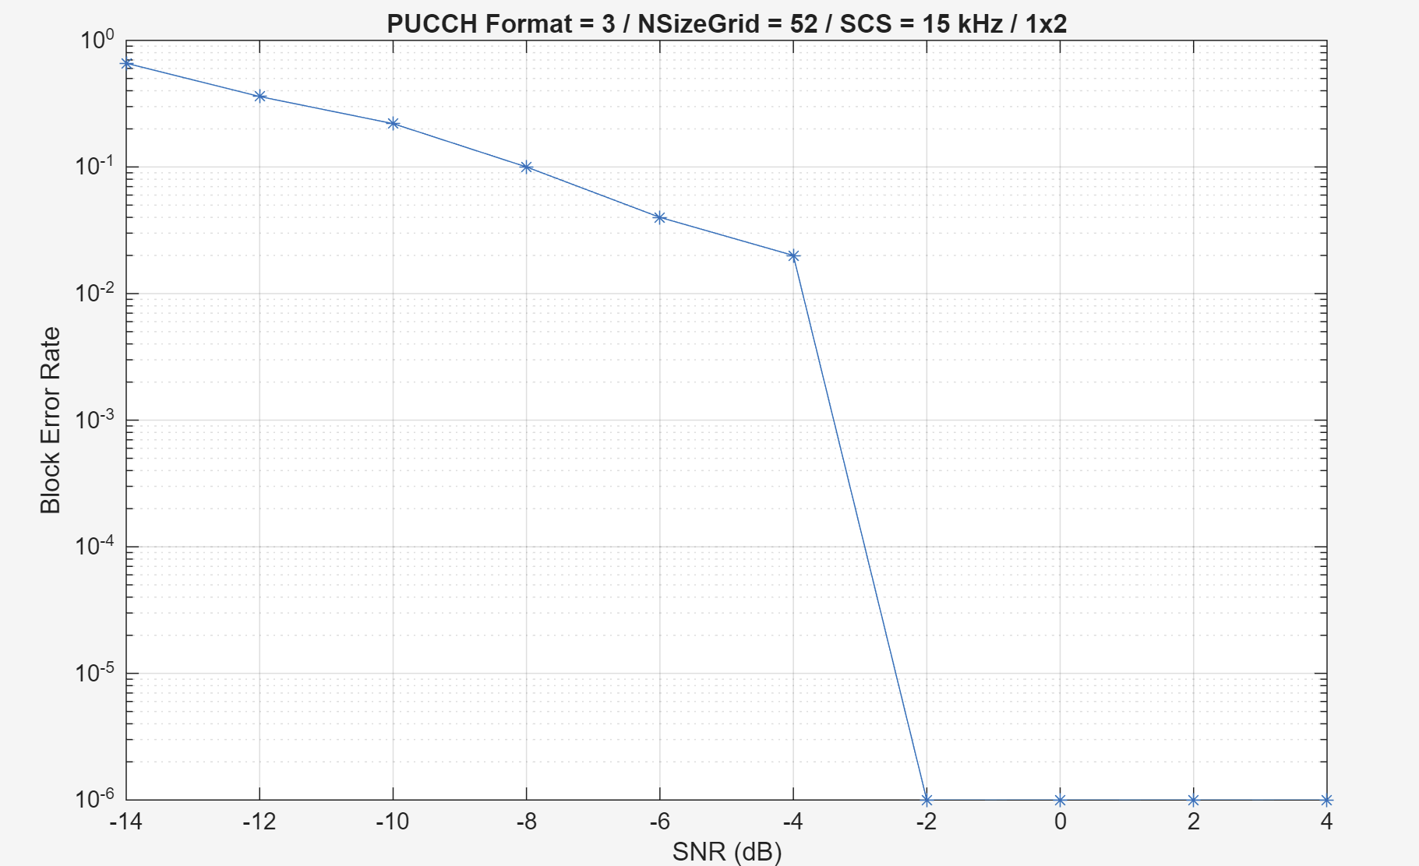 | 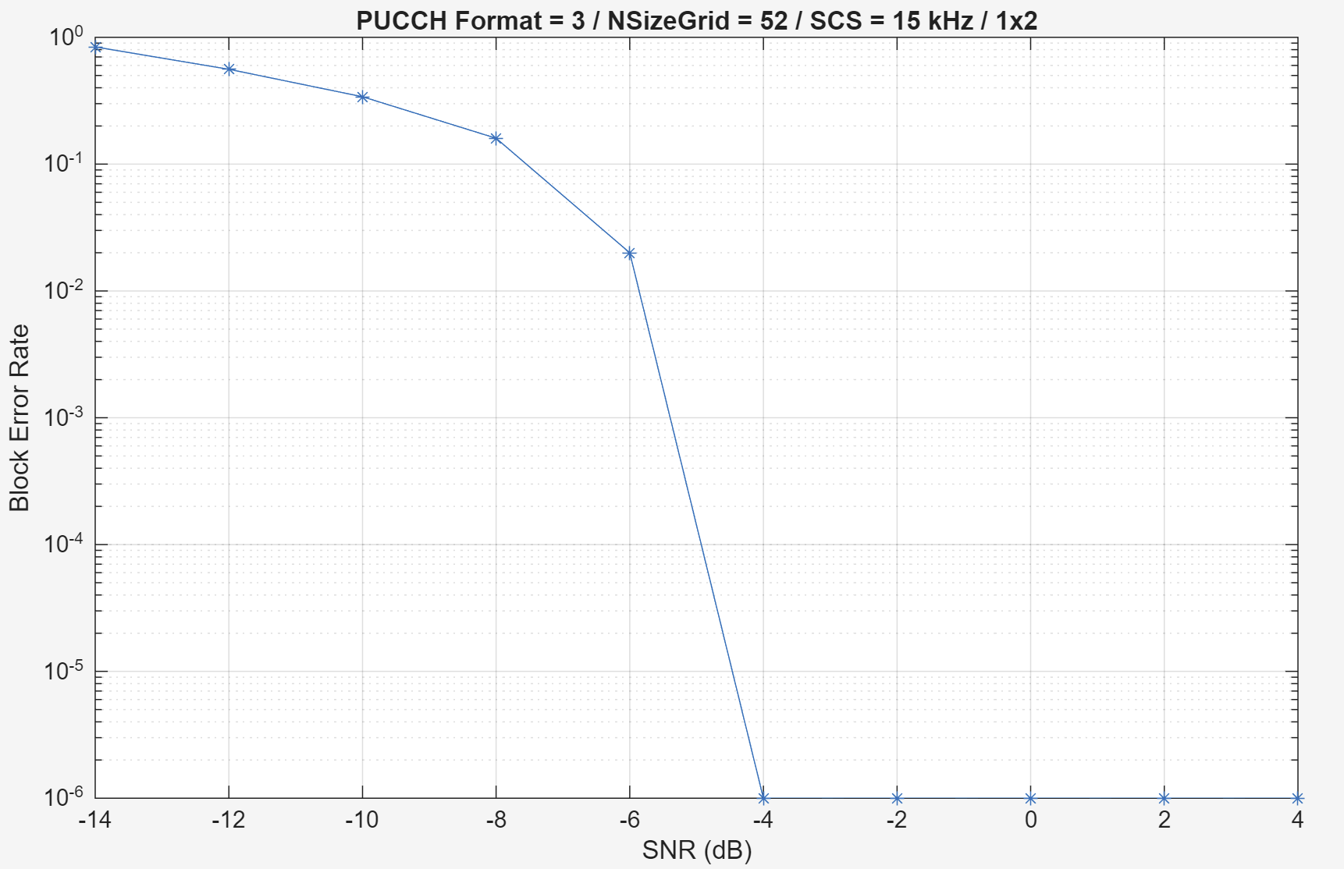

Non-perfect estimator, MaximumDopplerShift 100 vs. 300 Hz
reset to the same channel for each test
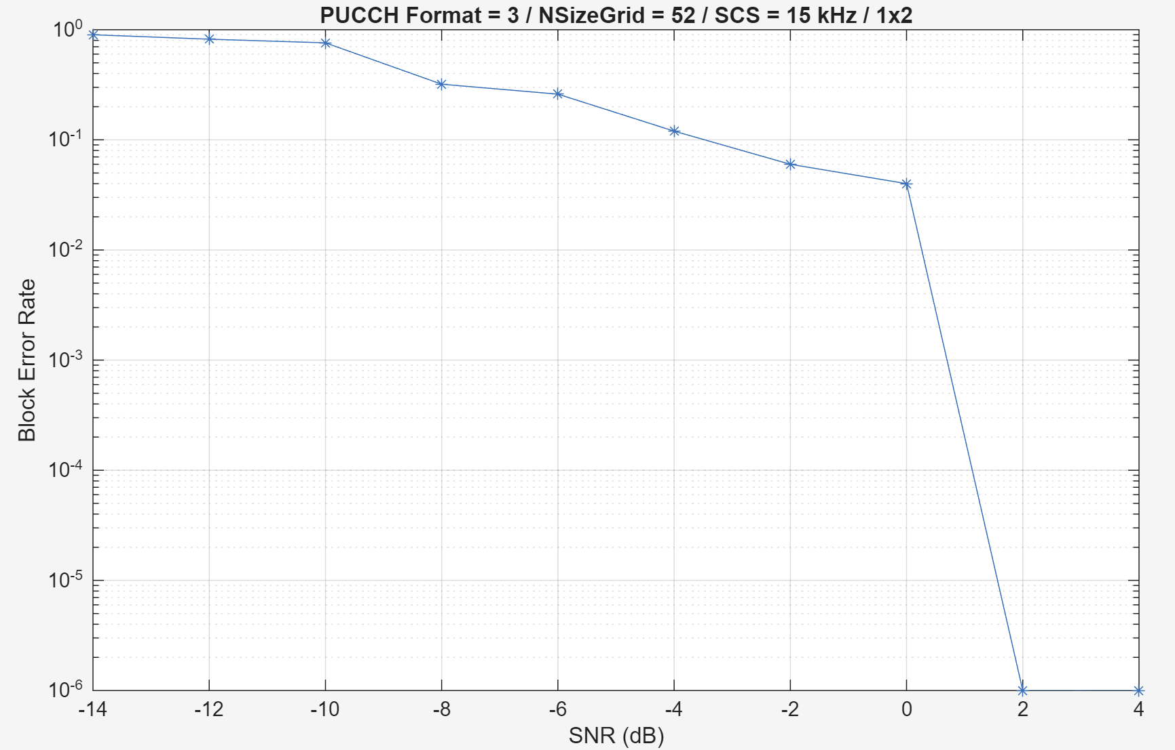 | 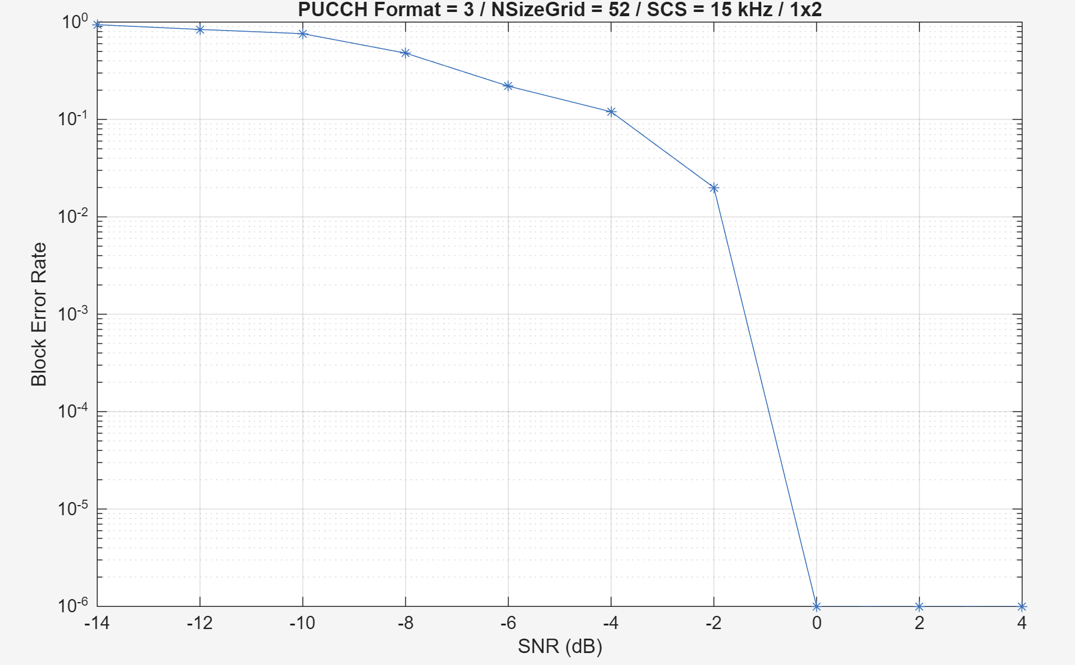

When moving:
For non-perfect estimator, average of 10 repeats, random channel every time
V=10km/h: SNR=-5 to have 0.1 BLER
A constant freq. may be easy for channel? Variablity of Doppler: airplane vs. traffic jam
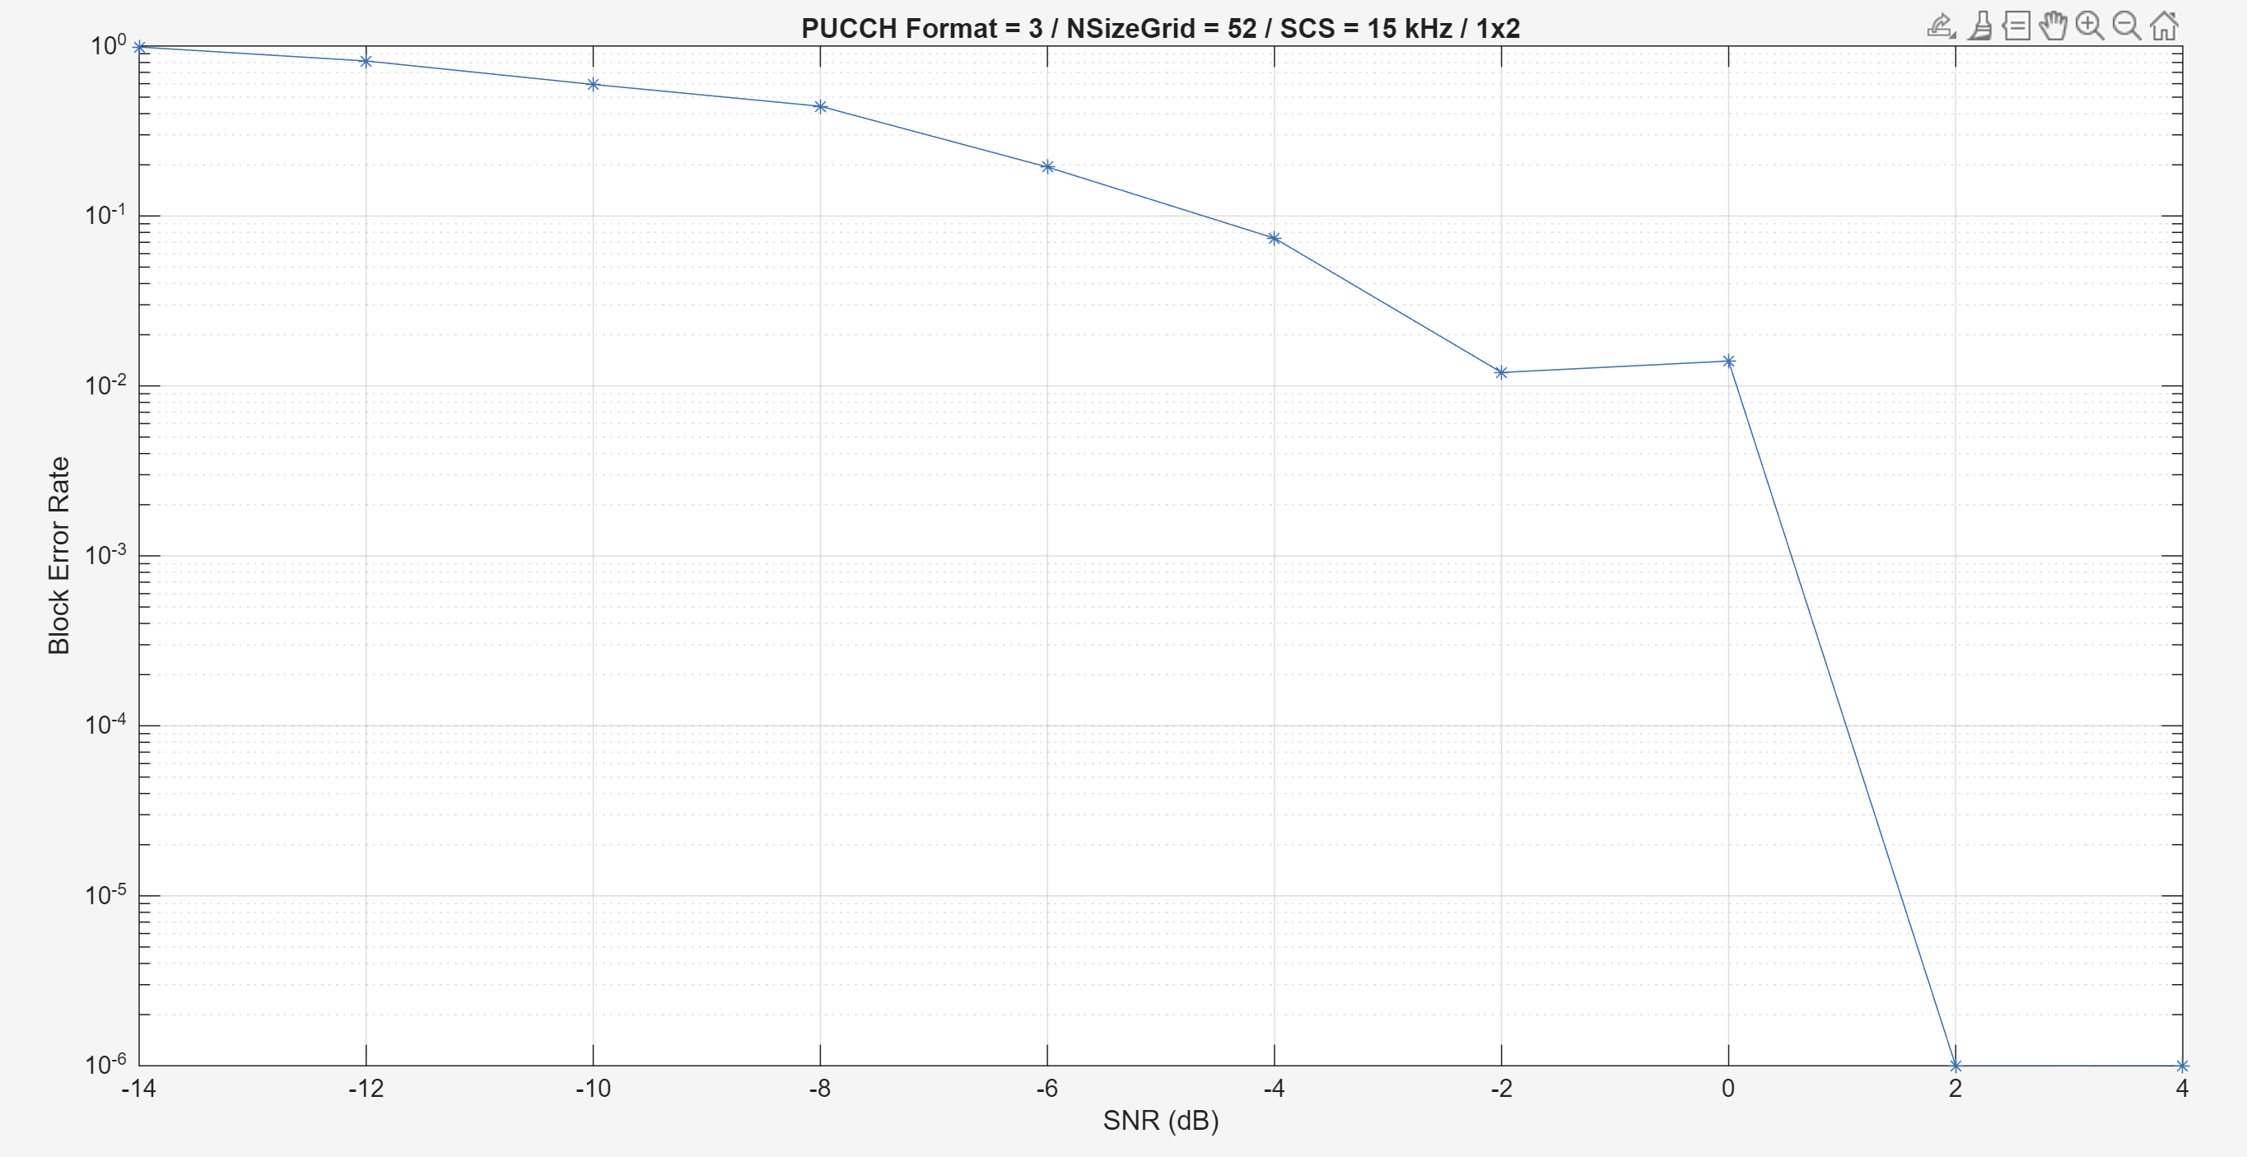
V=100km/h: SNR=-4 to have 0.1 BLER
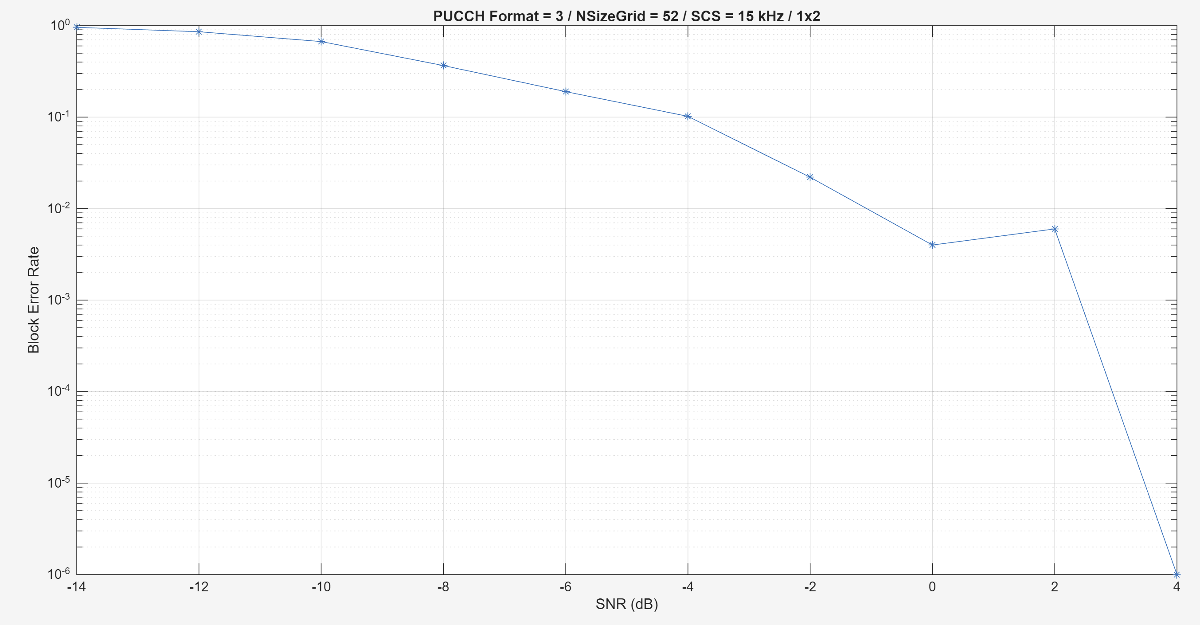

V=200km/h: SNR=-4 to have 0.1 BLER
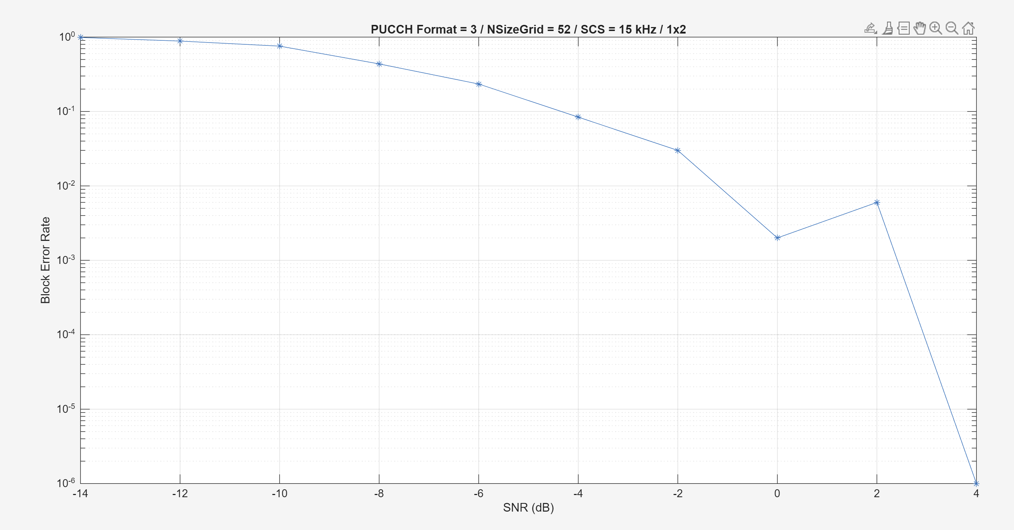
V=350km/h: SNR=-2 to have 0.1 BLER
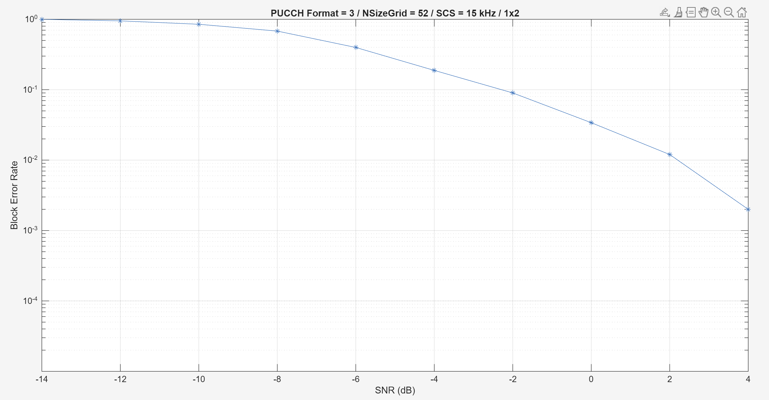

Also wrote the simulation for PDSCH, but have not yet properly tested.

