Throughput:

NFrame = 2, maximum channel delay 10Hz Doppler, CDL-A channel:
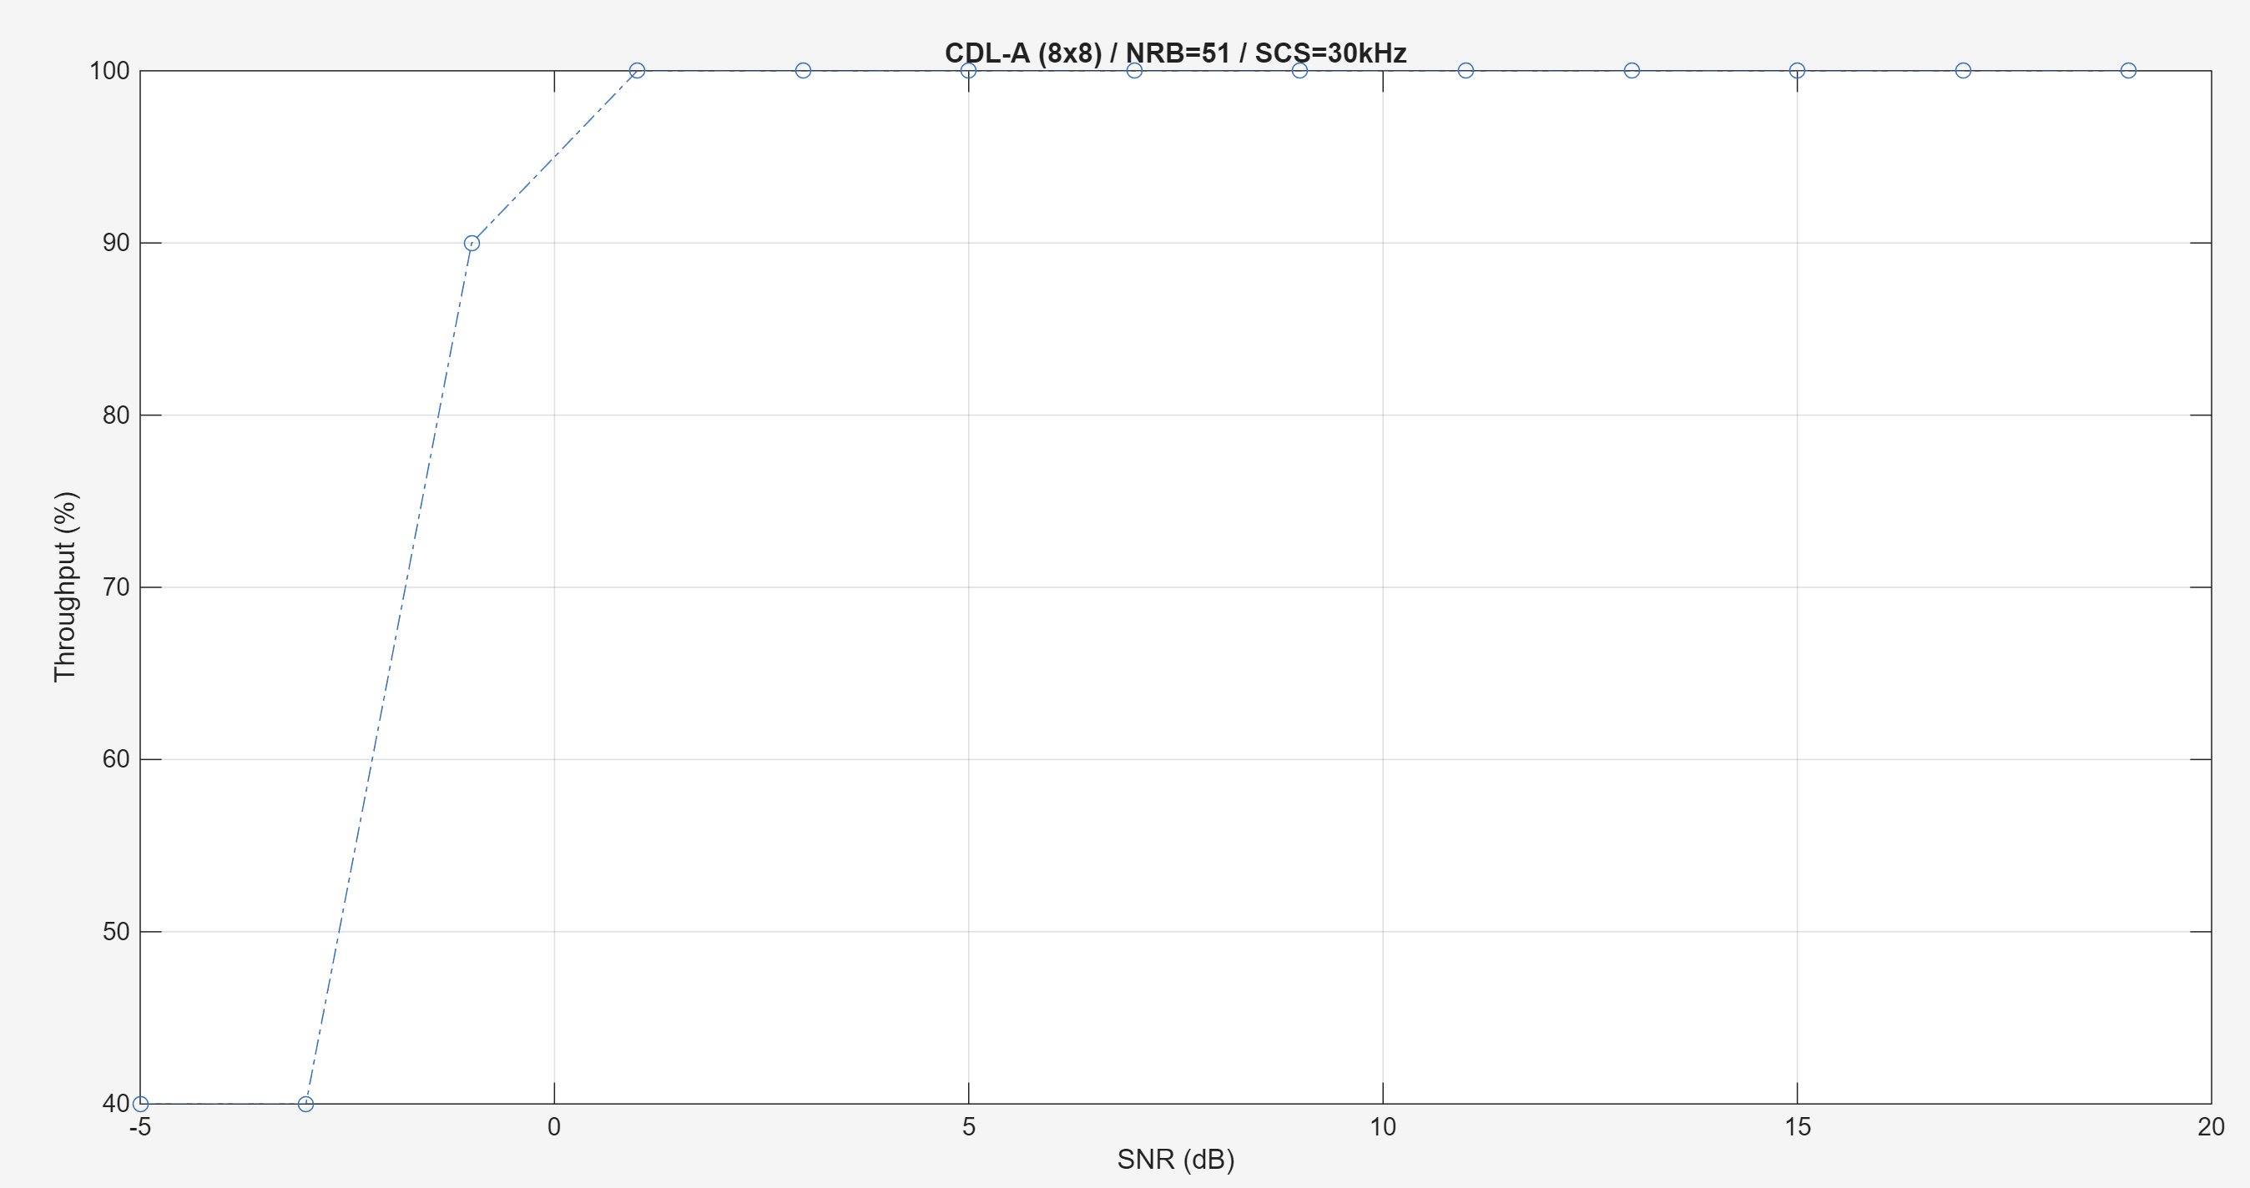

Simulation Case 1: 8Tx 8Rx, 8 Layers, 10 Hz doppler, CDL-C Channel, QAM 16 MCS 13 (Table 1) NFrame=20
Two codewords: Codeword 1 and 2, 1 should be better. Can show two curves.
Codeword 1 could have more throughput (despite fixed MCS has fixed throughput)
Problematic due to DM-RS (>4 layers), not yet solved
Warning: The maximum possible rank of the channel, given by min(NTxAnts,NRxAnts) = min(8,8) = 8, is equal to NumLayers (8). This may result in a decoding failure under some channel conditions. Try decreasing the number of layers or increasing the channel rank (use more transmit or receive
antennas).

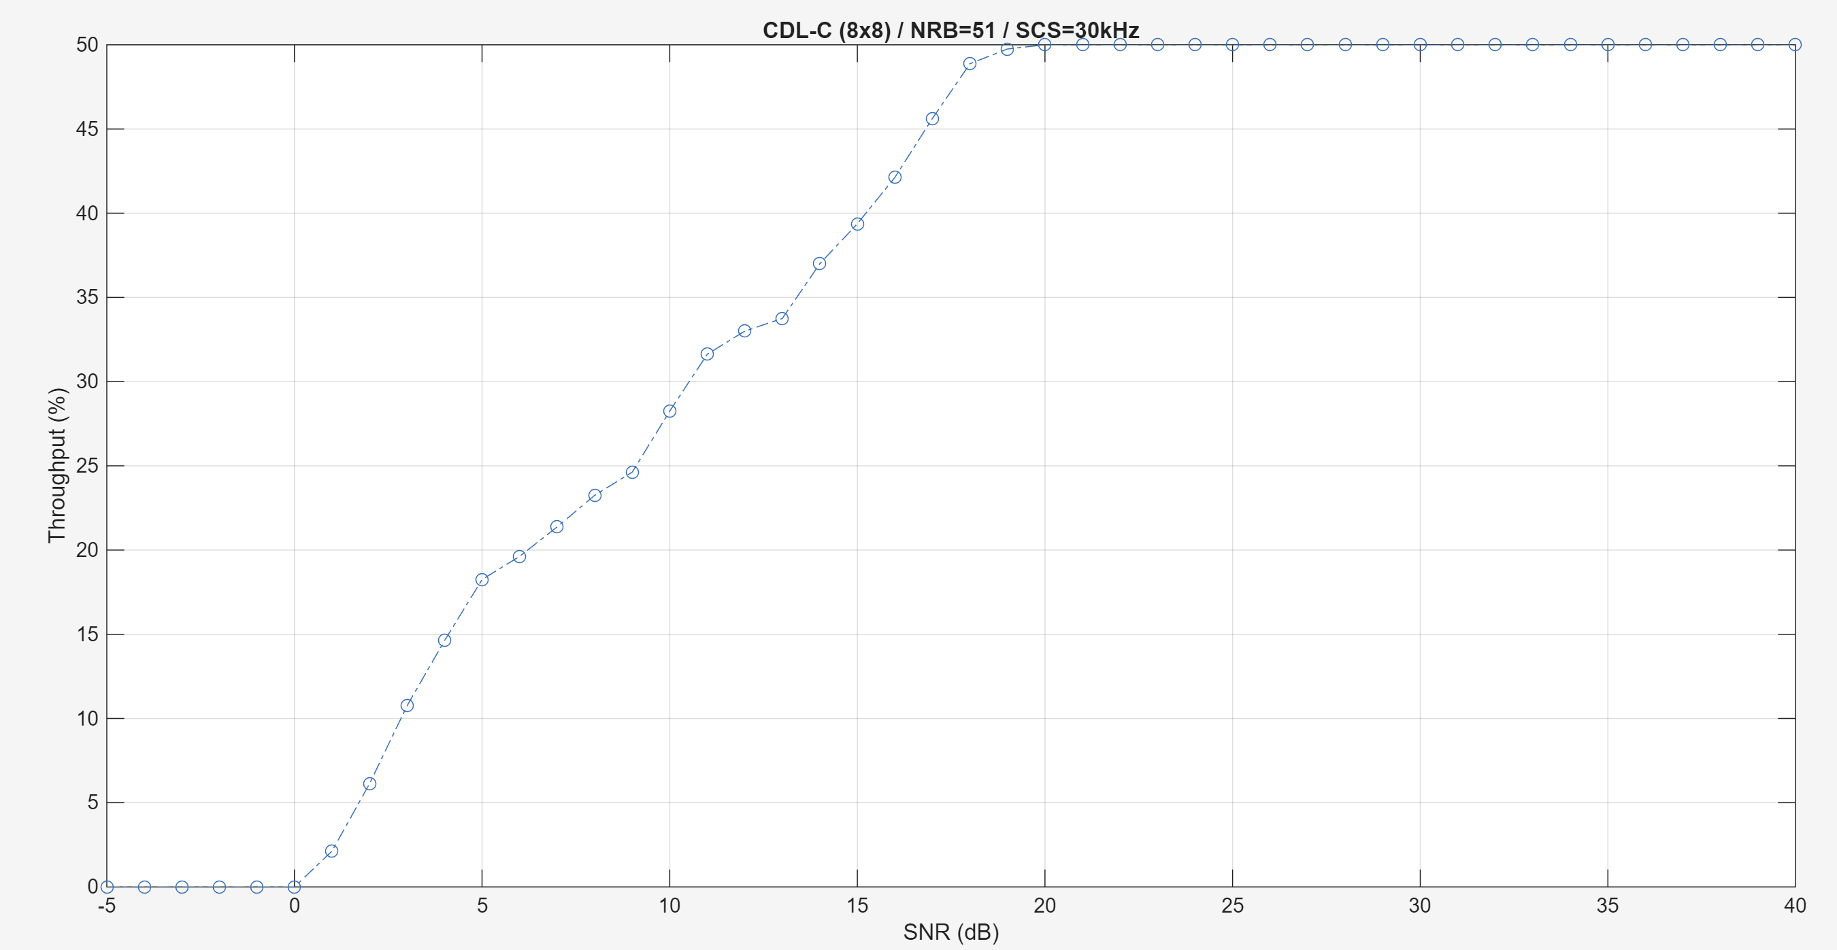
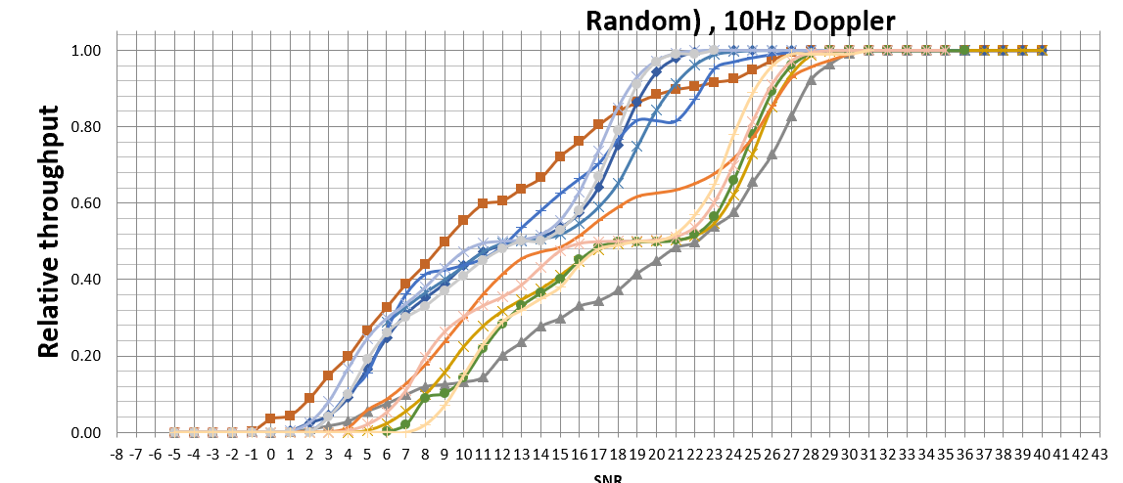

In this scenario, the second codeword’s CSI extremely low:
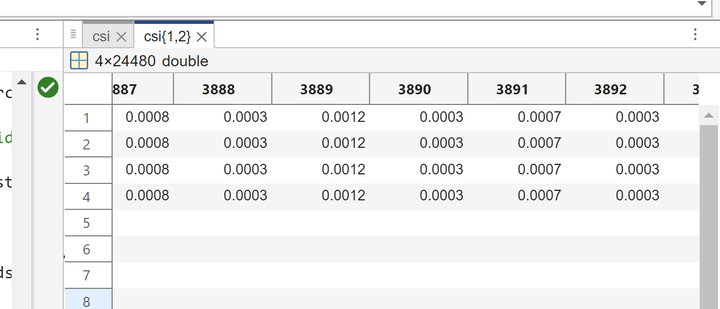

Pmi fixed -
Truncated CDL-C 12 taps instead of 20.

If CDL-A:
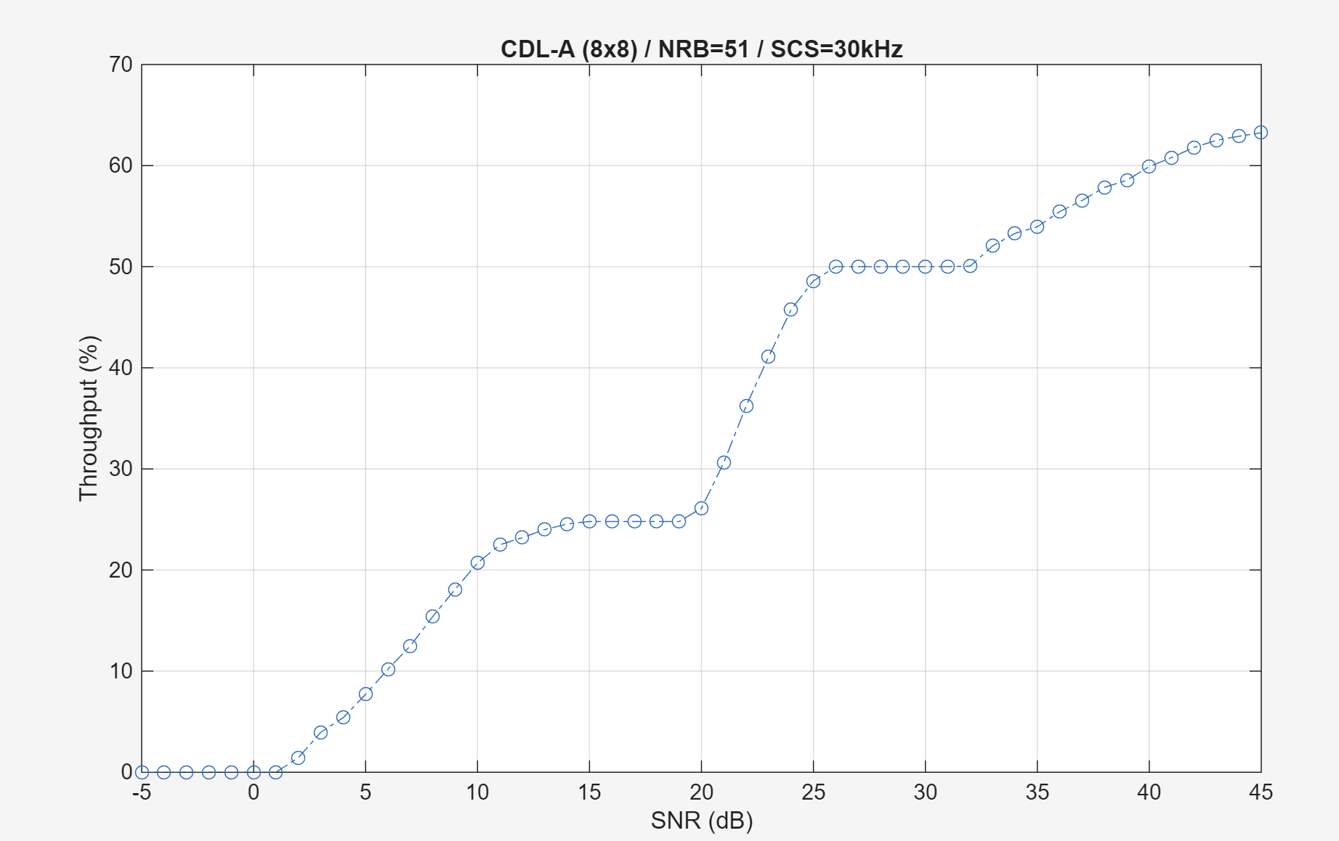
CDL-D:
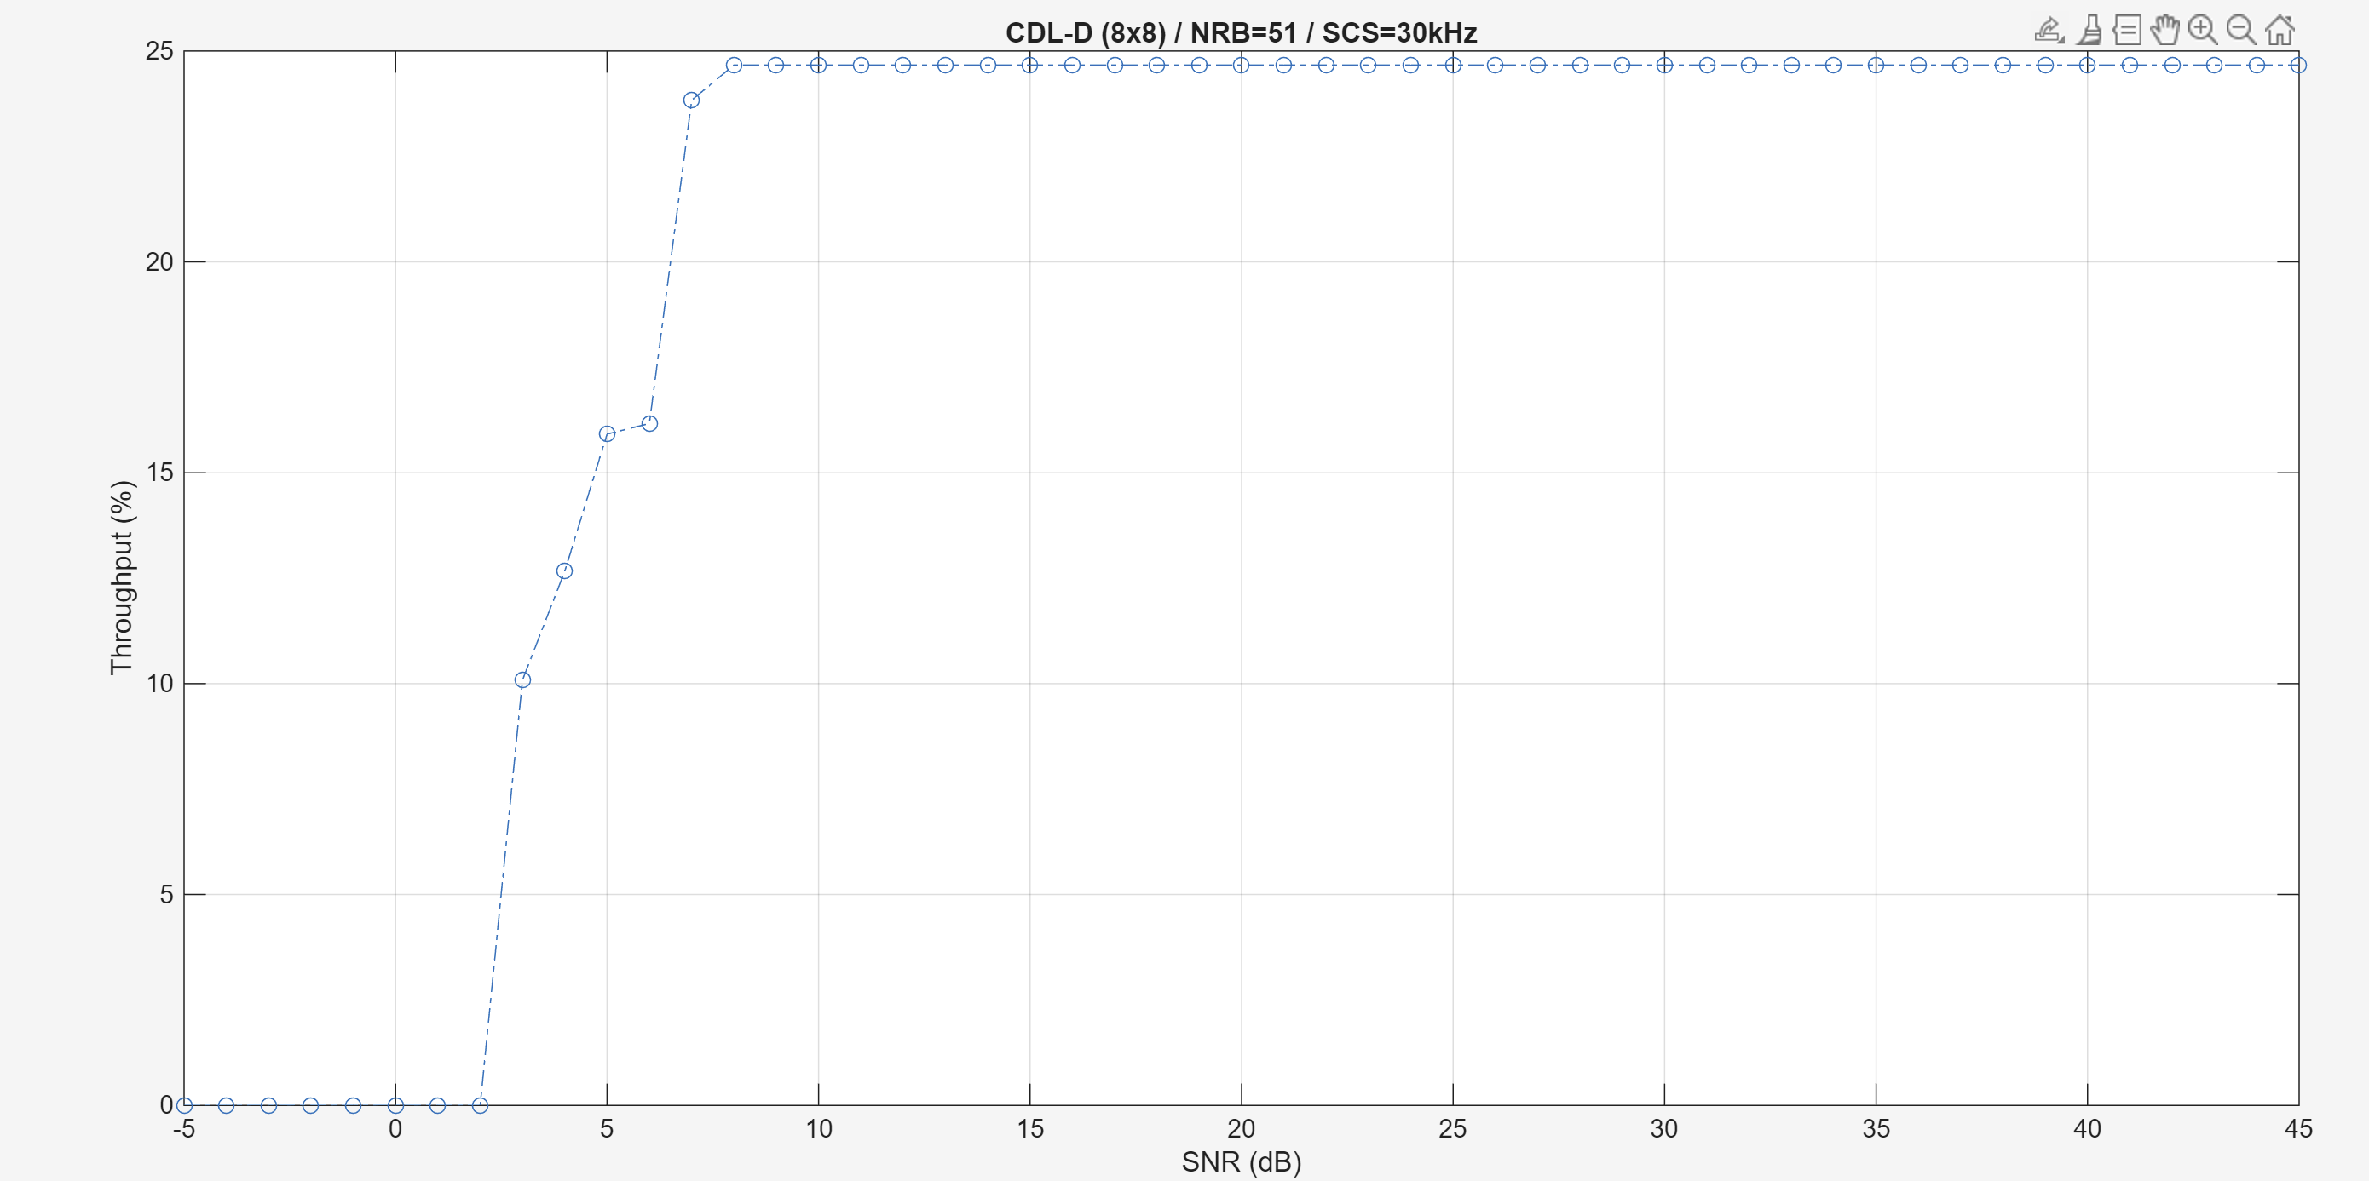

If 16Tx 16Rx, 8 Layers, CDL-A:
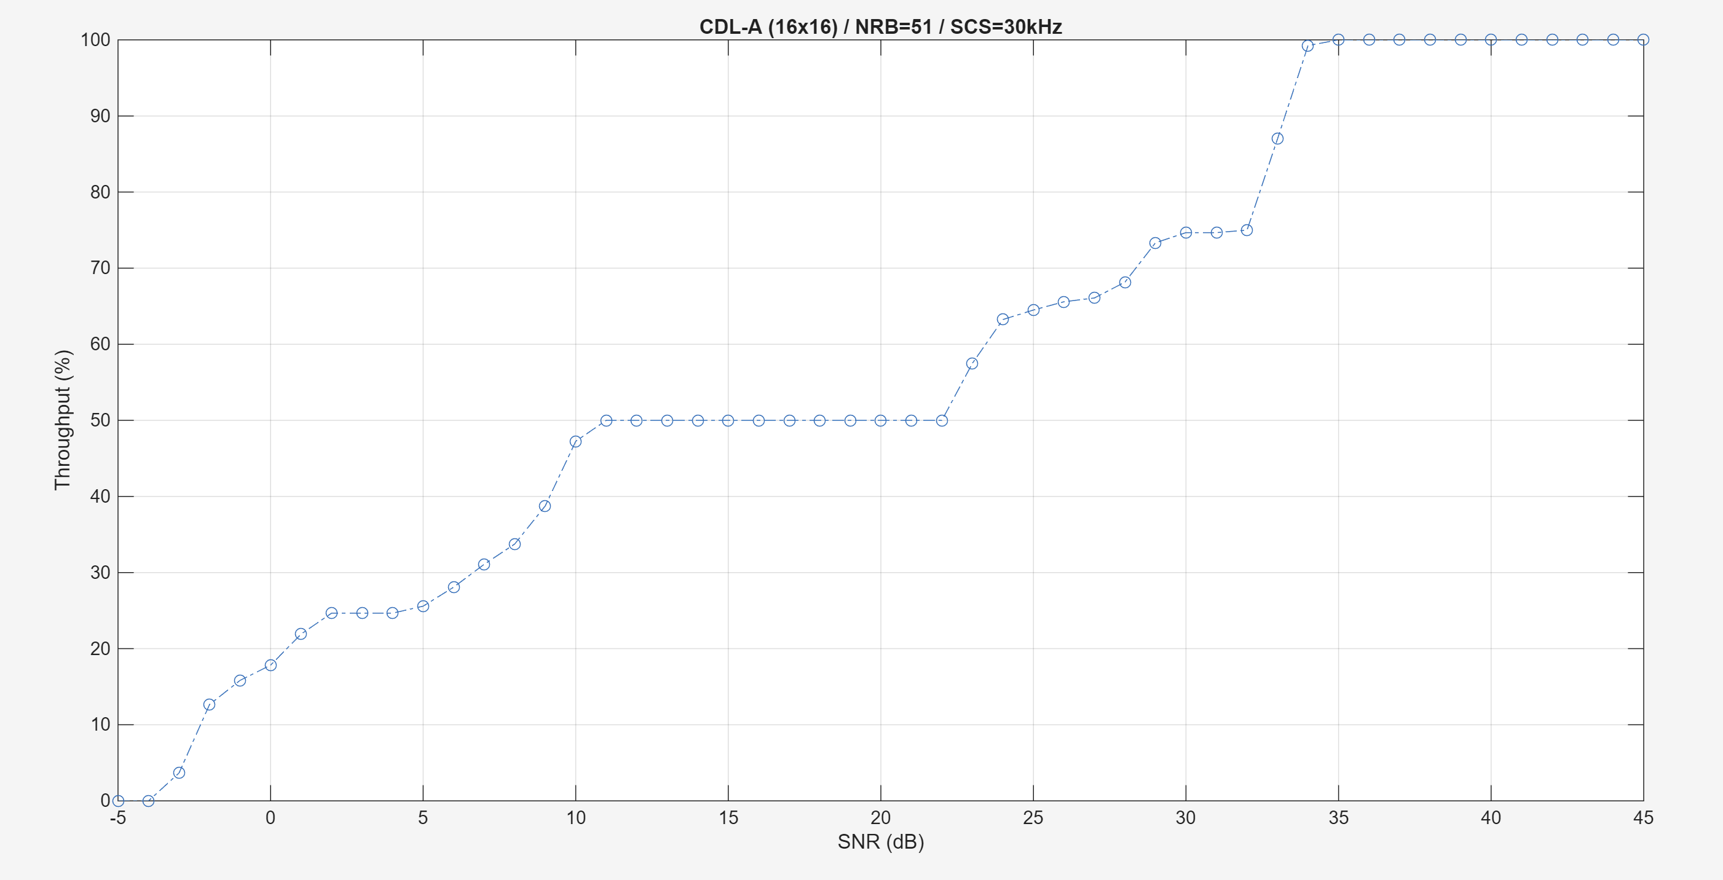

If 16Tx 16Rx, 8 Layers, CDL-C:
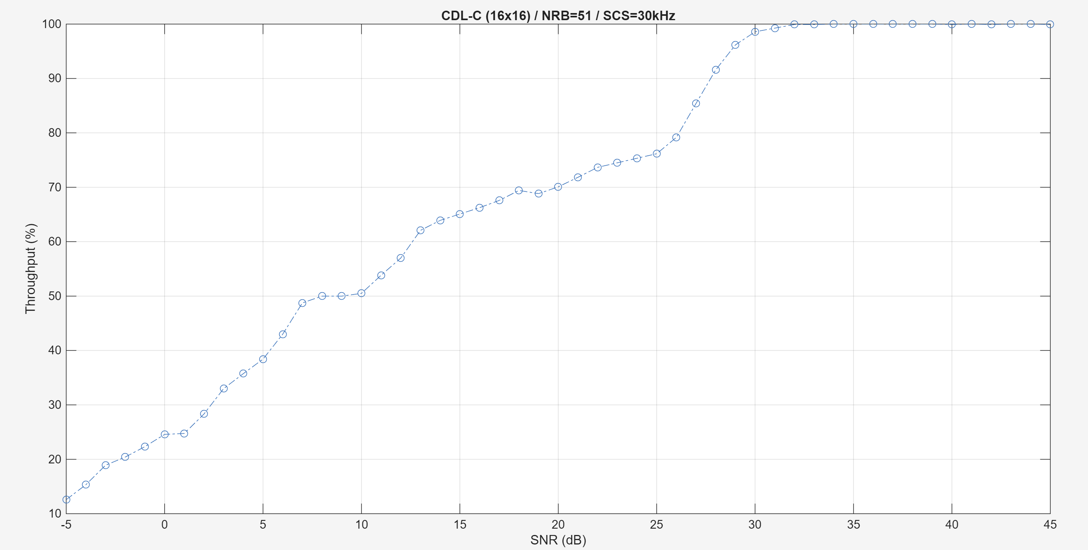
Only >=2 codewords should have platforms due to HARQ (two codewords)
Try to use the configurations by 3GPP to re-simulate

Simulation Case 2: 4Tx 4Rx, 4 Layers, 10 Hz doppler, CDL-C Channel, QAM 16 MCS 13 (Table 1) NFrame=2.
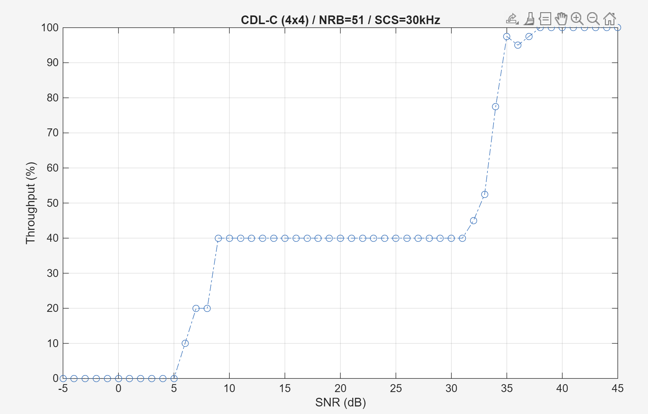

NFrame=2000:
*Took 6h+ to compute
