- Managed to implement simulation with 38.753 parameters, but the simulation still does not seem to match the result: still investigating, should be solved by next week
- Once CDL-C simulation works, will also try simulate TDL channels too
- Will look at Ian’s work in detail this week to gain some insights
- Will focus on learning some theory in the first few weeks of the term
  - Bigger picture
  - PMI CSIRS, theory behind layer mutual information, MIMO layer water filling
  - Mimo spatial domain multiple access:
    - LDPC limited by the worth layer e.g. four layers. Ideally one decoder for each layer, but realistically two for 8
  - Ask albert about the hpc computing

After checking Ian’s simulation file: seems like it is issues about settings, the simulation seems to be correct. If Code rate = 567/1024, MCS 13 (Table 2, QAM64), the simulation seems to make much more sense.
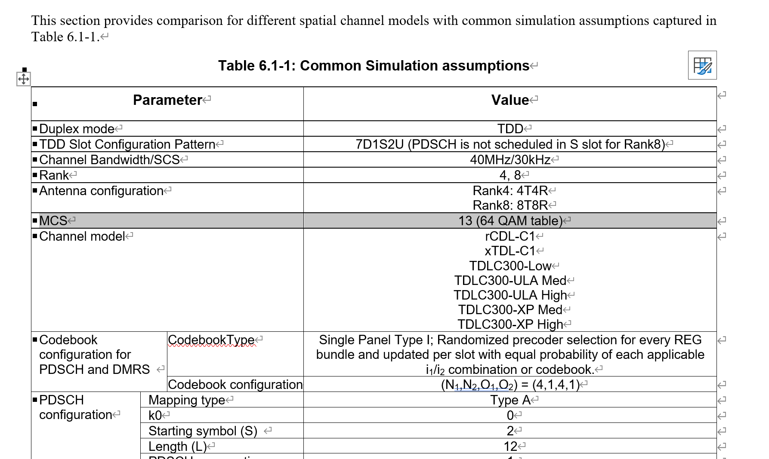
Tab 1
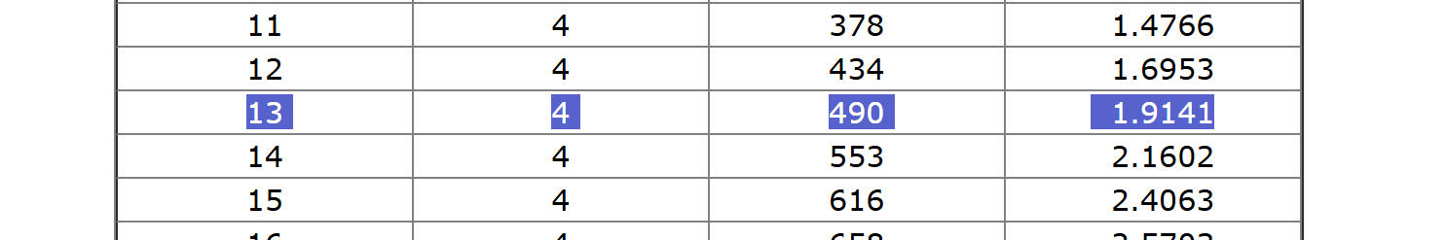
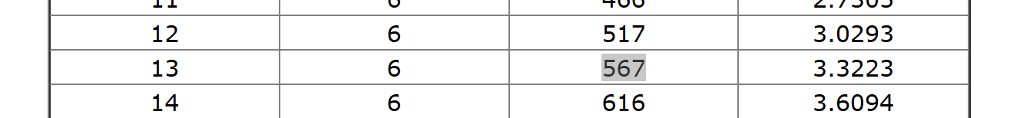
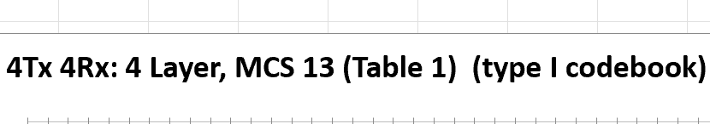

Is Ian’s simulation also on the same set of parameters?
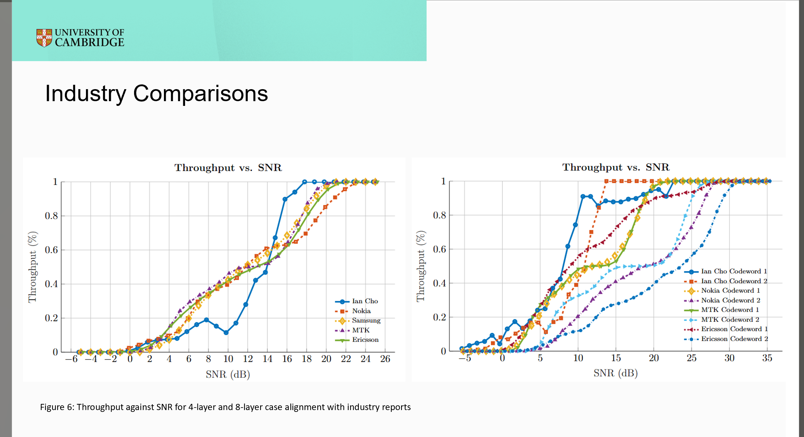
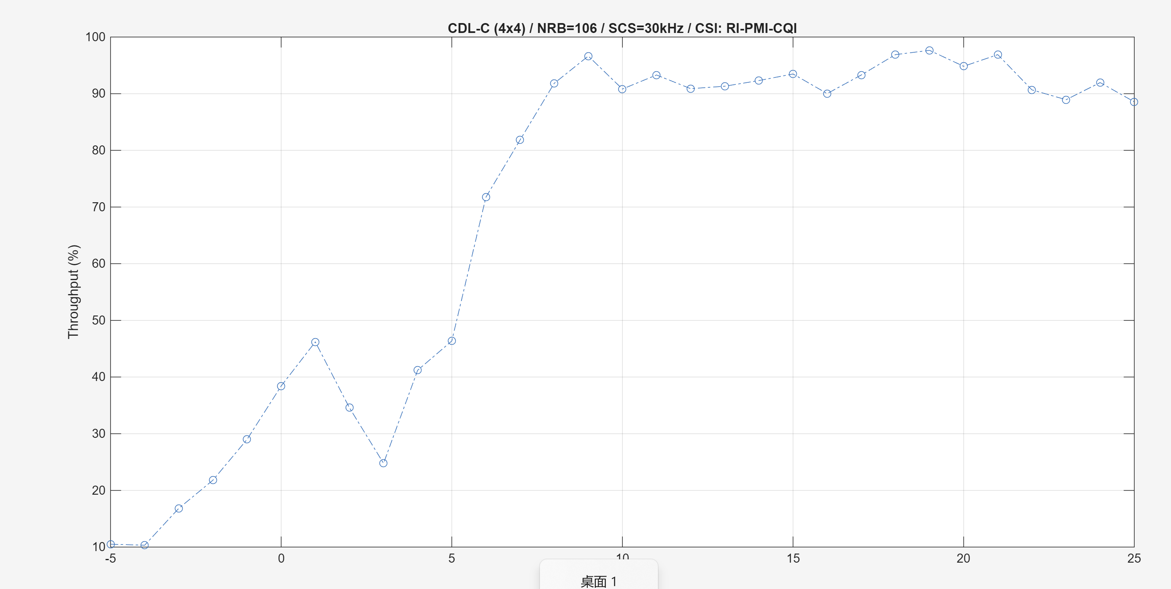

8Tx/[32Tx] 4Rx: meaning

