Progress:
- Matlab Simulation bug fixed, some features/settings topics investigated
- Obtained some simulation results
- 8x8=8 bug yet to investigate and fix

Results:
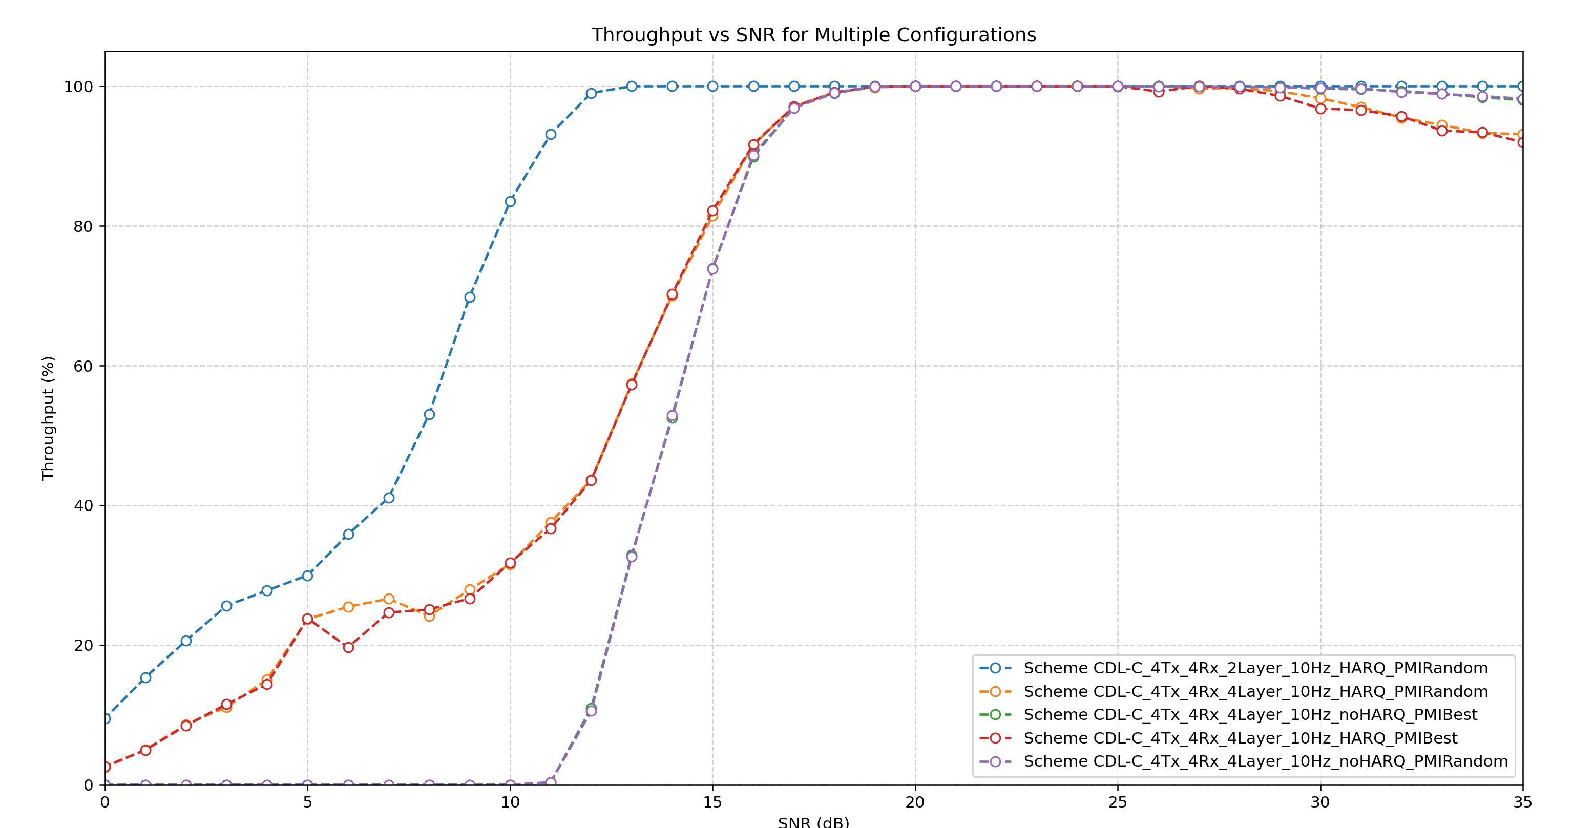
- (Does not really matter that much) Why is there a drop after SNR=27? 【layer mixing …?】
- 2 Layer vs 4 layer difference as expected
- HARQ vs no HARQ significant difference in low SNR as expected
- Why PMI best vs. random tiny different no matter HARQ on/off? 【should have clear difference】

Compare with industry:
4Tx 4Rx 4 Layer
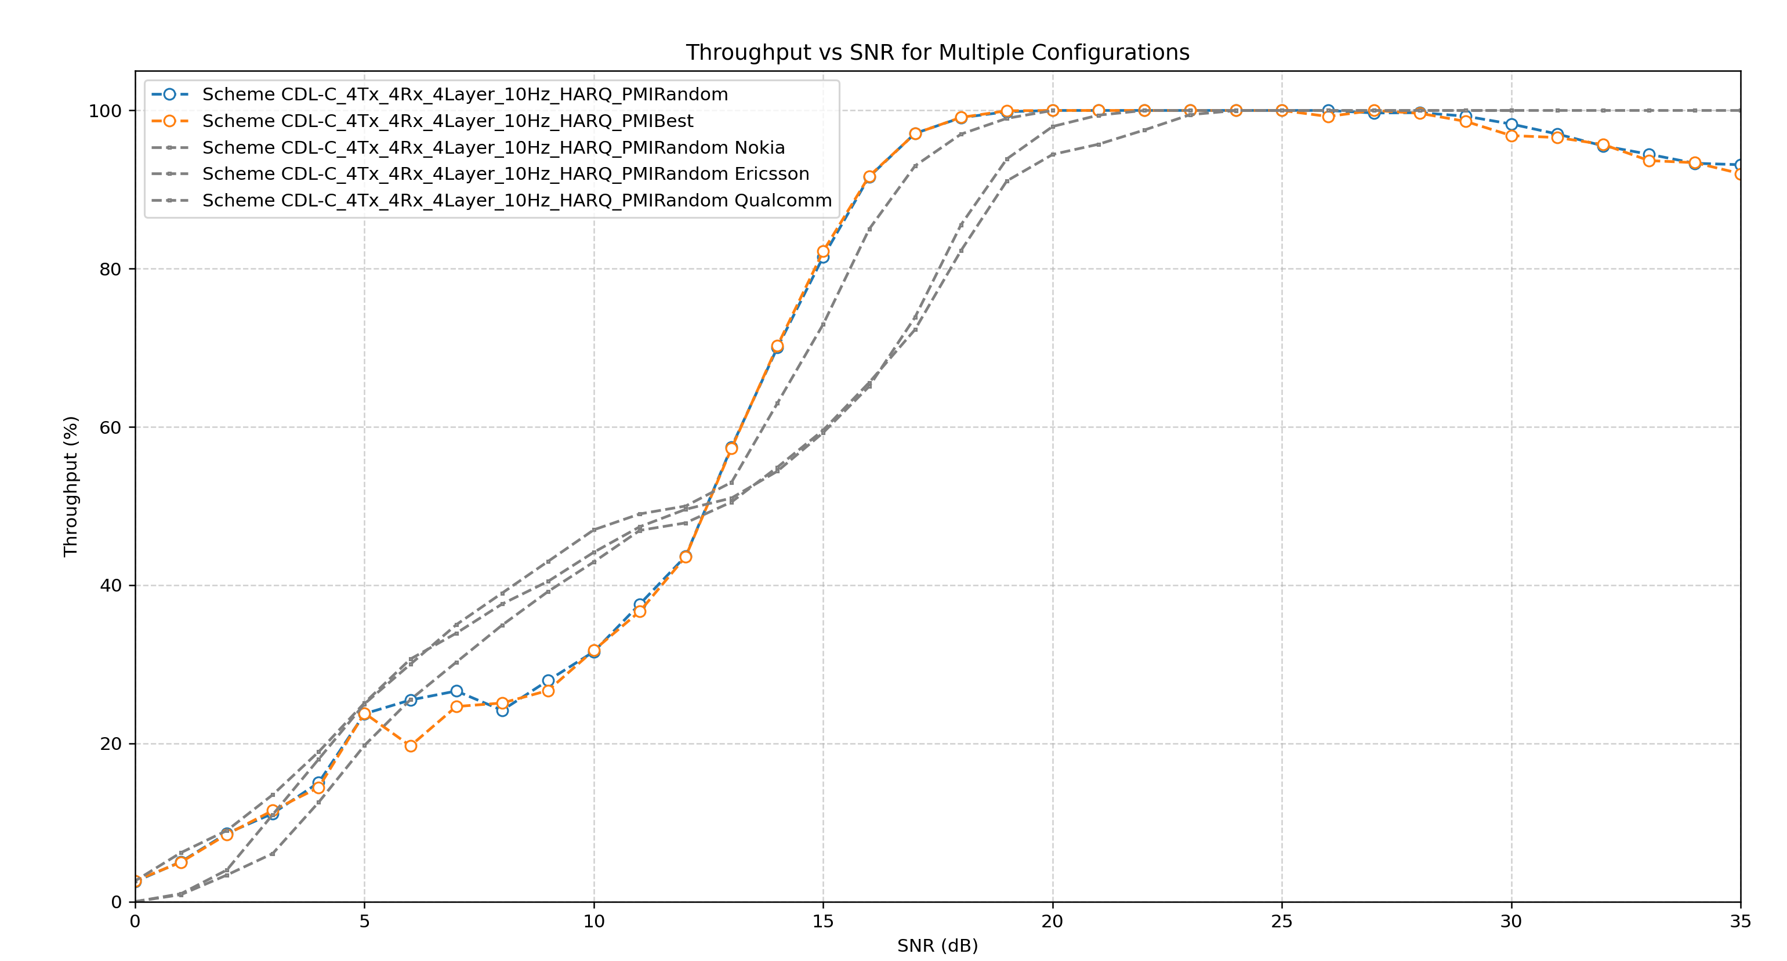
- Seems all right? Pretty close to the industry level.
- Take 30% and 70% throughput’s SNR (current way accord. specification). Here just [0, 2dB] off
- Nokia propose alignment on full curve? Is is possible to come alignment? At the end rejected

8x8=8 layers WIP, NFrame=5 only
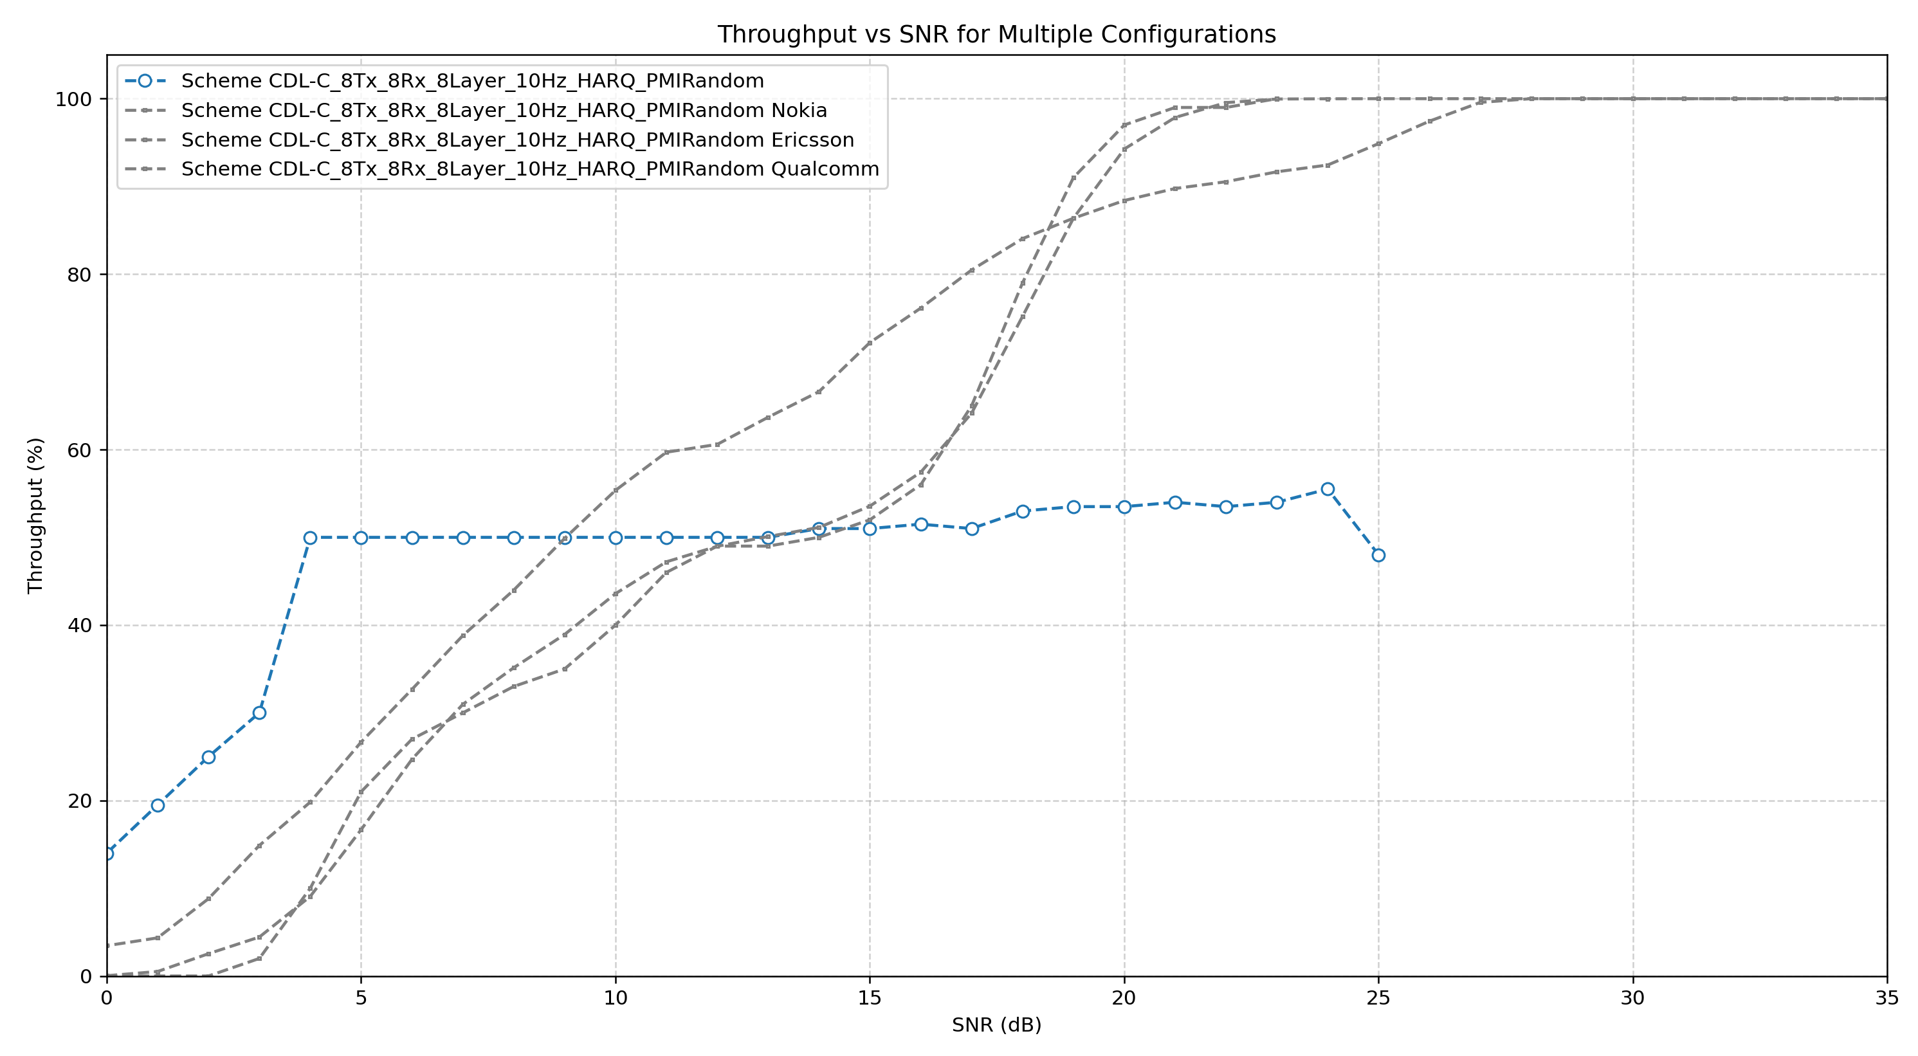
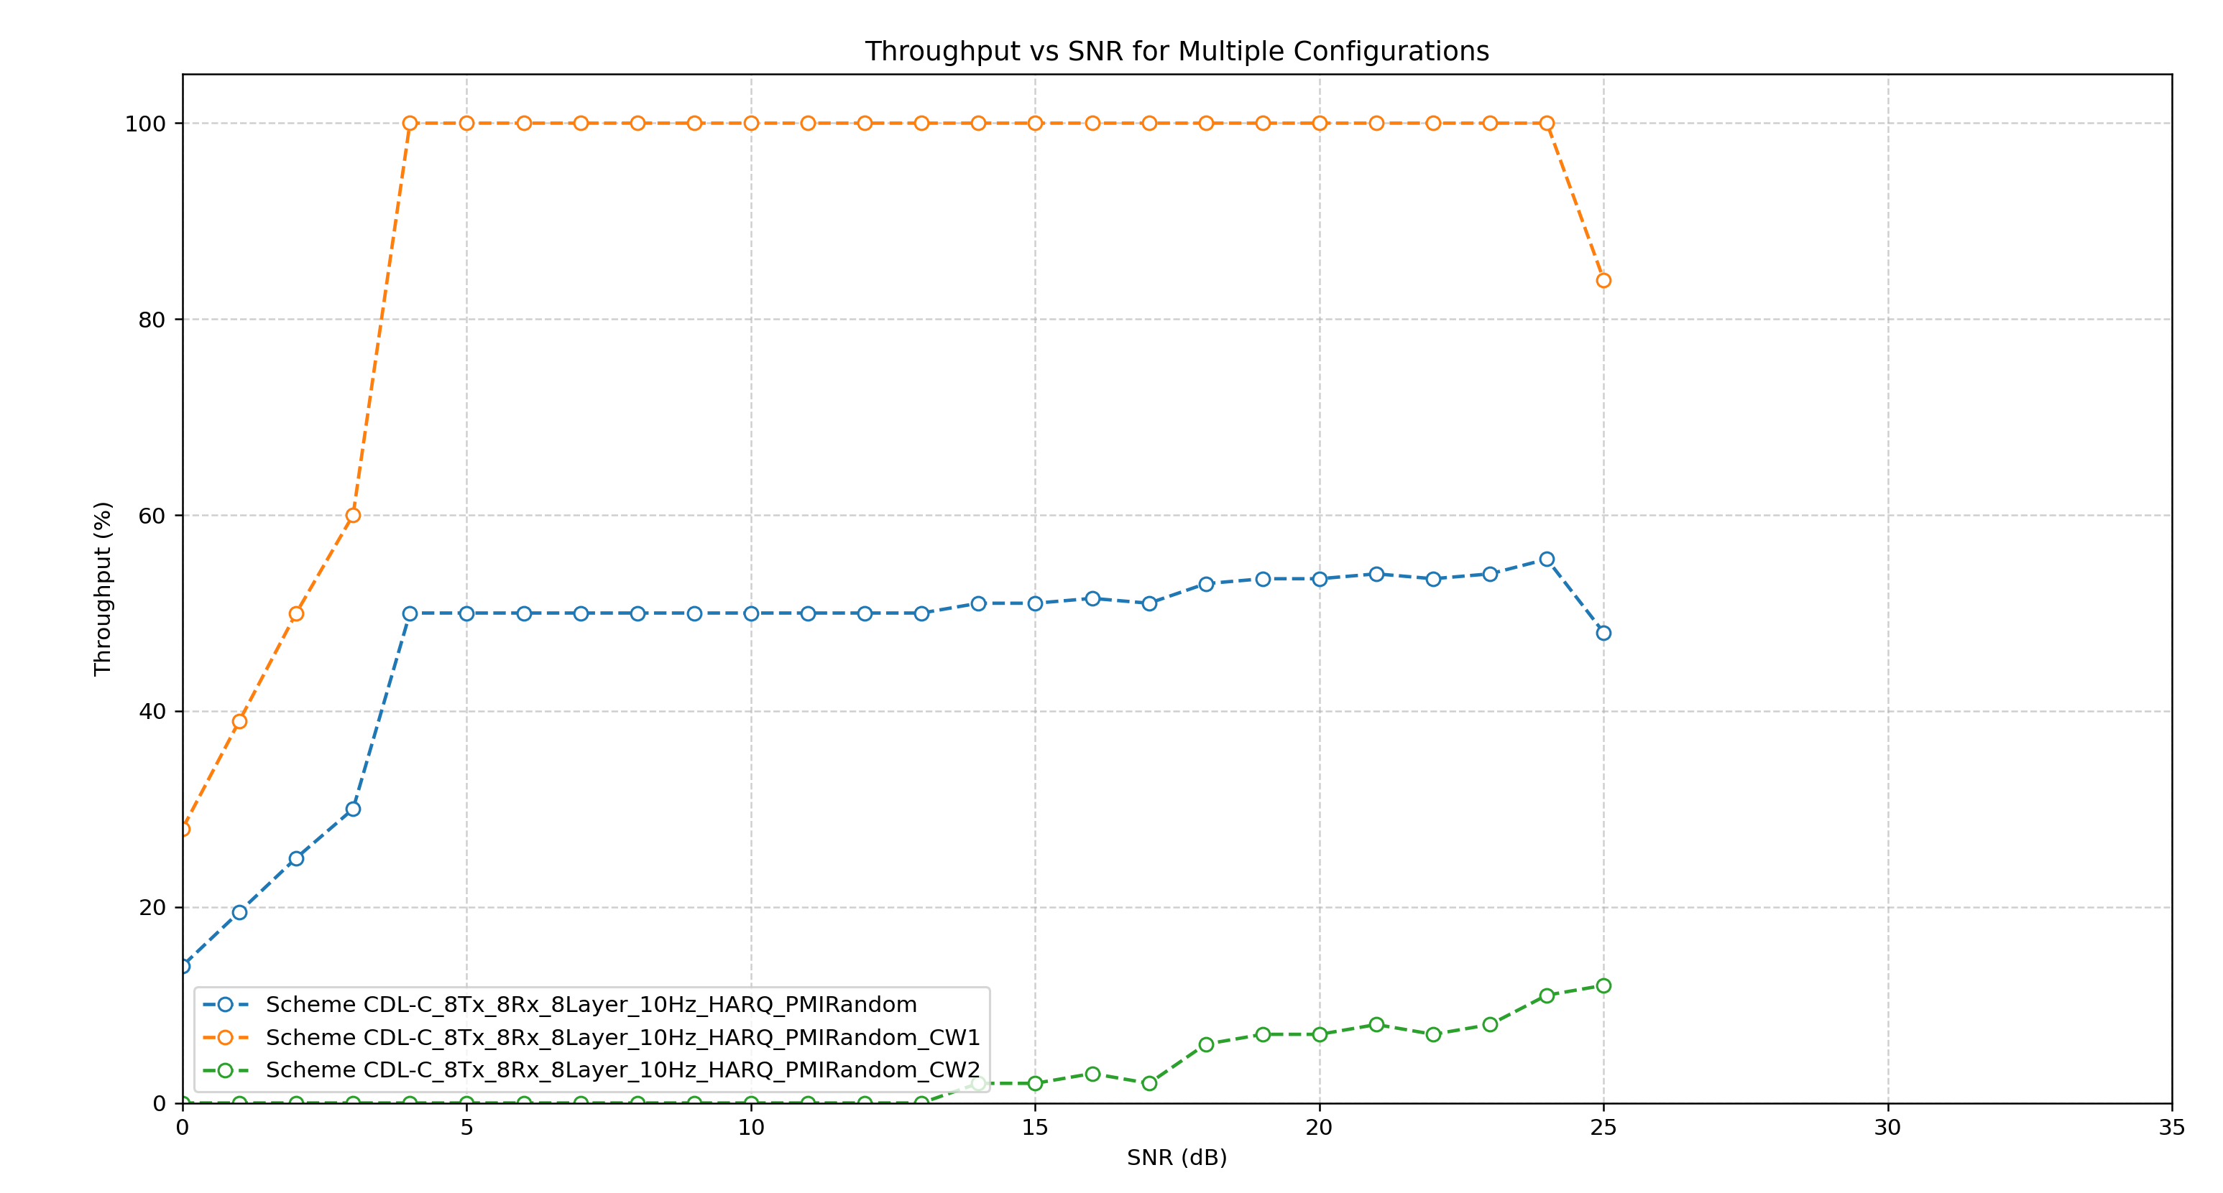
Expect: harq pleatou, stuck at 50% for a while for a few db (not good enough to do second CW, just repeat first dB) but not that wide here

In reality, assign MCS -》 to achieve same SNR for both CW (70% throughput at same SNR) -> now 3dB vs. inf. dB

Possible topics:
- MU-MIMO: explore MATLAB simulation feasibility next week
  - Two UEs, aggregate throughput (diff. pmi for diff, user) how does this impact. Different CDL channels for different users? Correlation? How to model? Or just one do interference
  - 8 Layers -> 4 + 4 to each, how does interference, correlation work
  - Next year doing this Rel-20
- xTDL, rCDL, TDLC300. Further exploration on channels
  - 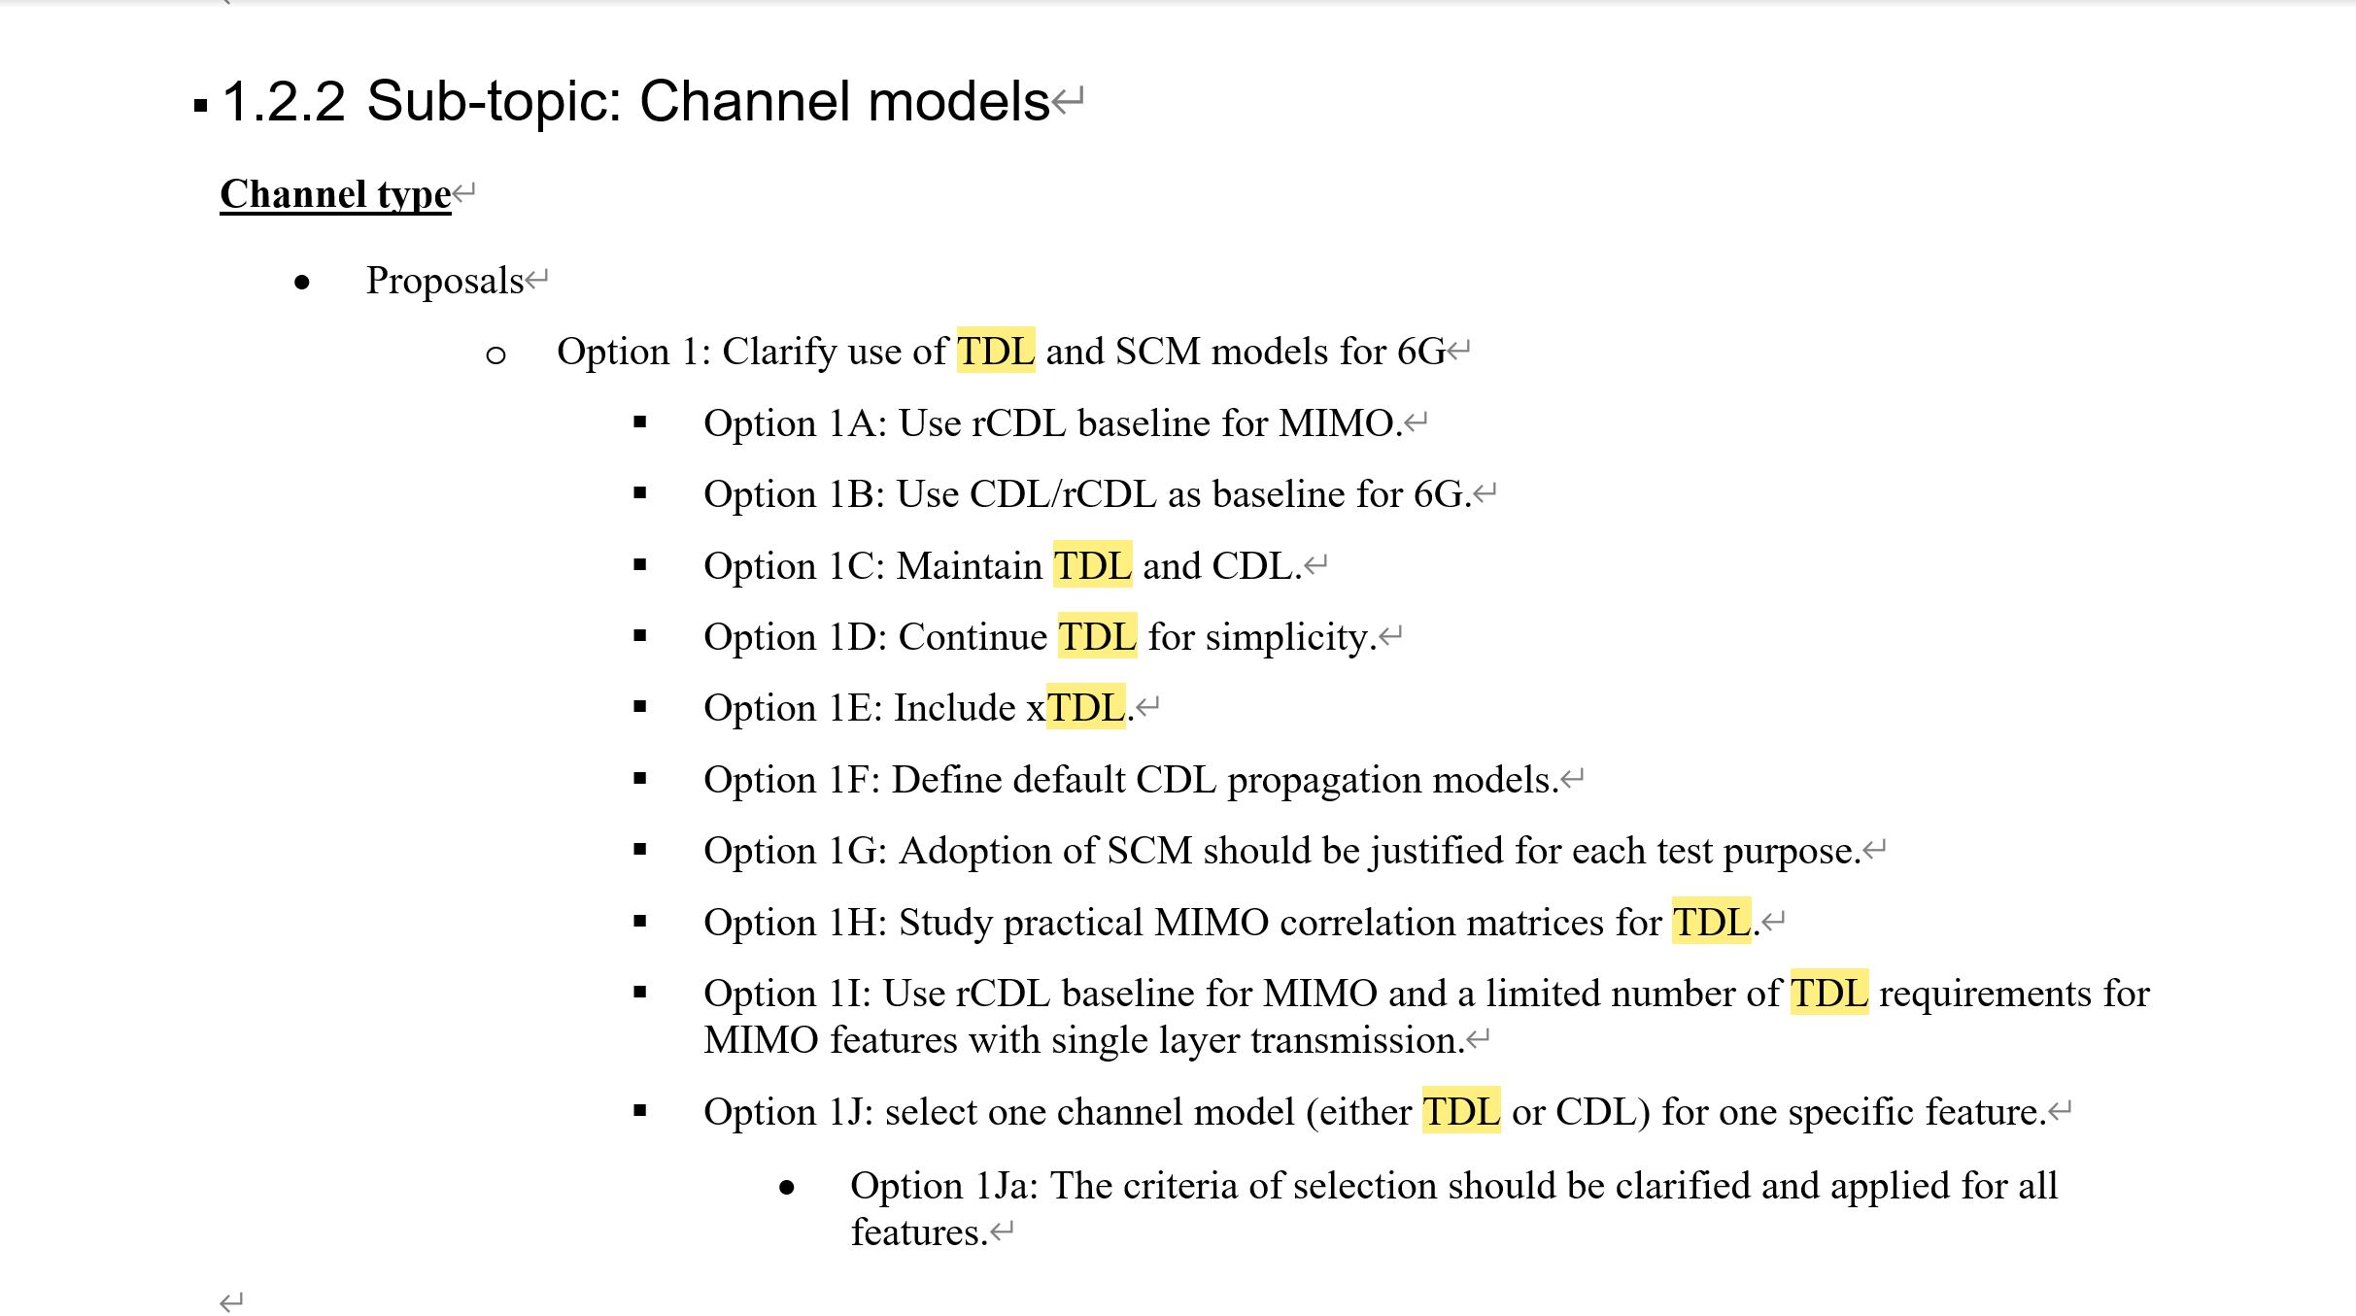
  - 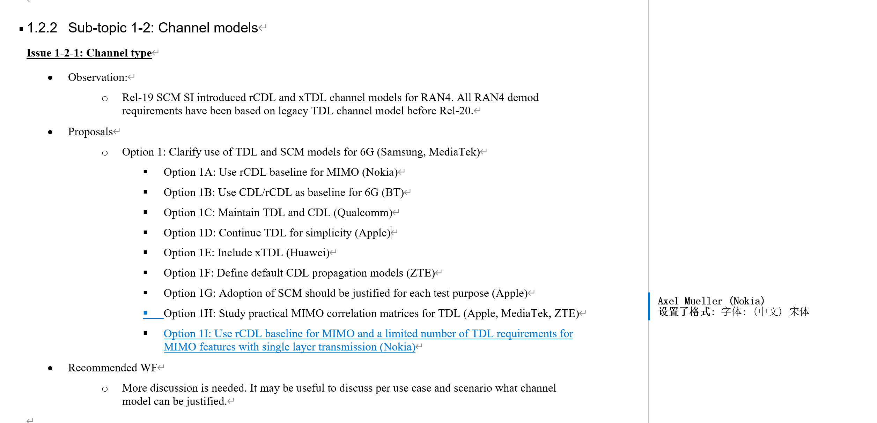
  - How can I come to a ‘conclusion’ based on the simulation results?
    - CDL spatial features (CDL PMI performance vs. TDL no PMI effect)
      - Functional: as long as it works its fine apple
      - Performance: performance boost
- (Previously discussed) Theoretical vs Practical LDPC codeword to layer mapping (one for each layer vs. one for each codeword)
- Tests based on the current framework, by tuning parameters
  - HARQ
  - CSI timing, RI/PMI delay, outdated csi
  - dm-rs pattern
  - MCS fixed vs SNR adaptive
  - codewords 1 vs 2

To do:
- Work on the Michaelmas presentation (should already have enough things to write & present)

