Progress:
- Fixed some PMI issue
- 8x8 8 layer new simulation
- PPT Draft

Things to discuss:
- Simulation result
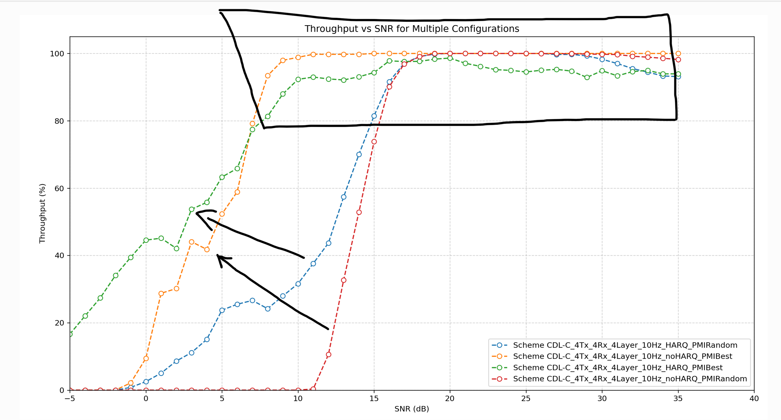
- PMI works now, magnitude kind of make sense. CORE
  - Throughput measurement? What Layers are they using (RI when decrease)
  - How often does PMI index change? Consistent/90% of time?? How does it vary
  - No spatial feature in TDL channel.
- There seems to be a conflict between HARQ and PMI at high SNR? Same thing observed in the 8x8 8 layers case
  - If PMI is choose in one instant, during retransmission, maybe need a new pmi?
  - Any possible reasons for that?
  - Will investigate further next week

- Still working on 8x8 =8 layers, not yet fully fixed
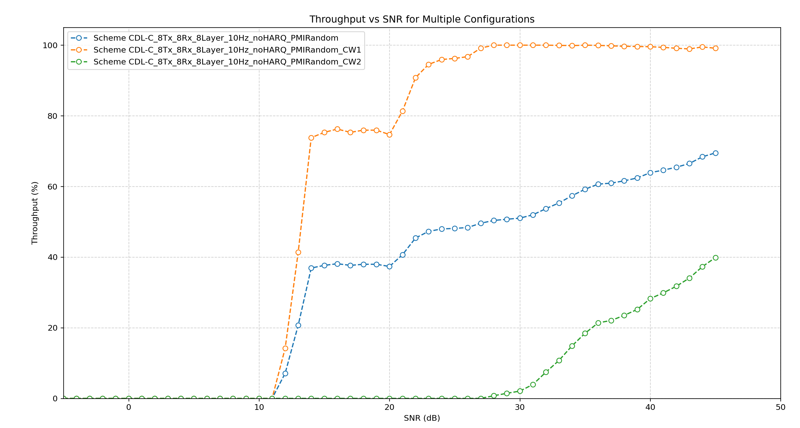
- Report explain how different CW behaves, e.g. CW2 only start at higher SNR
- This is the KEY for the chart

- When saying ‘CDL’ is a more complicated model than ‘TDL’ , are they purely referring to the simulation time? Or are they referring to some other things that might affect their ability in using CDL to replace TDL？
  - Is it necessary for me to also record the time taken on the simulation?
    - ? Too uncertain
    - Maybe a bit in report?
  - Longer simulation, engineering time, company have own software
  - Test equipment e.g. Key sight, CDL extra cost (but honestly they already paid for this?) FPGA model with physical ports to test real modem, physical wires
  - X OTA transmission -> air, only 2 layers, conducted performance requirements

- See PPT

