Things to discuss:
- TDL Simulation result
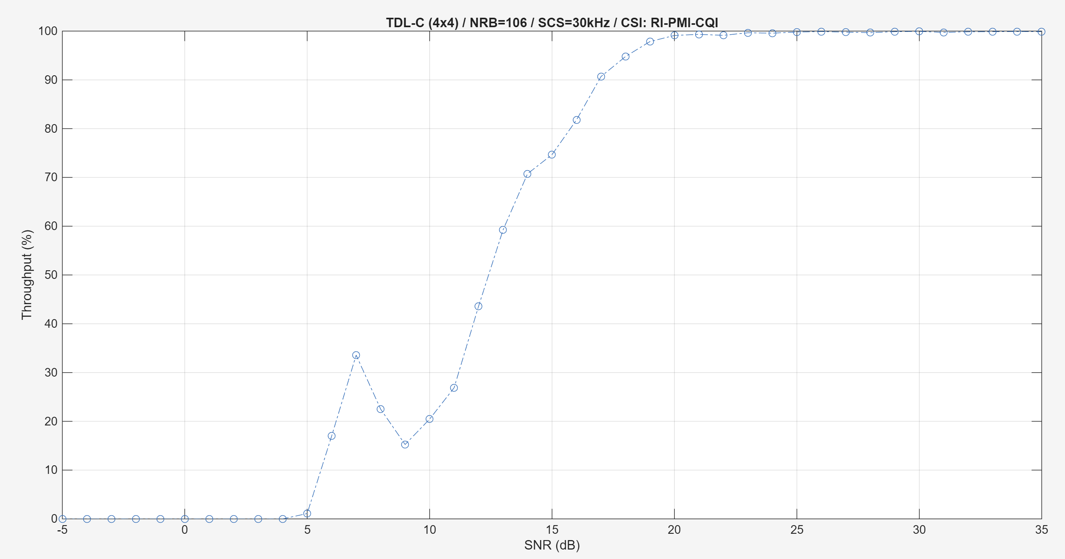
TDL-C- HARQ off – PMI Random
- In CDL-C worth PMI, all PMI should average to the tdl performance？
  - Is tdl-c random comparable to avg or best PMI on CDL
- How should the curves behave under TDL channel?
- TDL-C =spatial filtering of CDL C (CDL-C define by UE velicoity, and TDL by doppler shift), comparable under certain channel models. UMA (urban macro case)

Change in RI:
TDL-C
SNR=5, 20dB
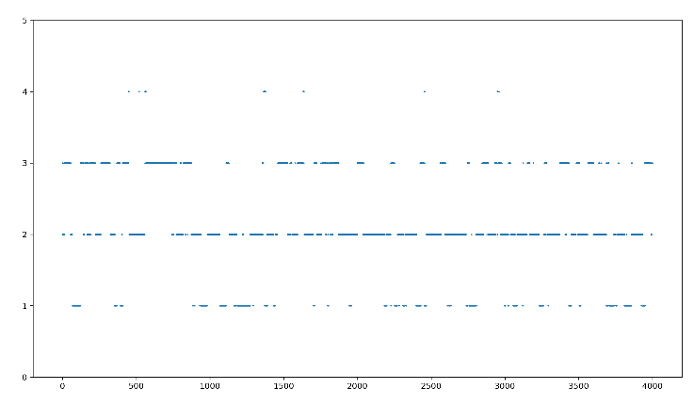
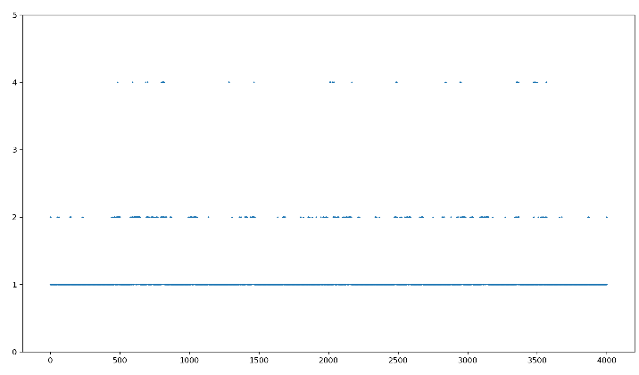

Similarly, for CDL-C channel:
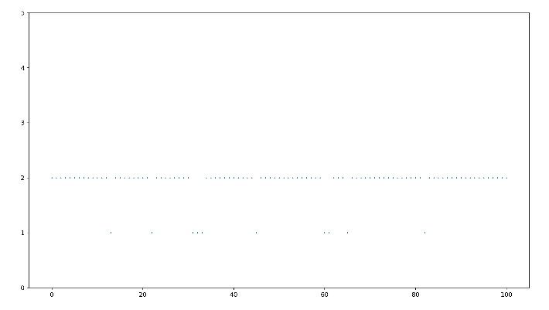
SNR=-5, 5, 35dB
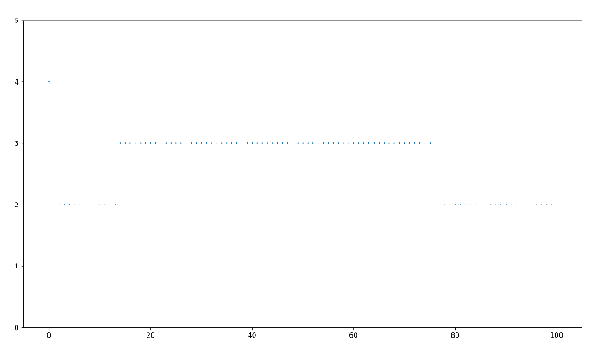
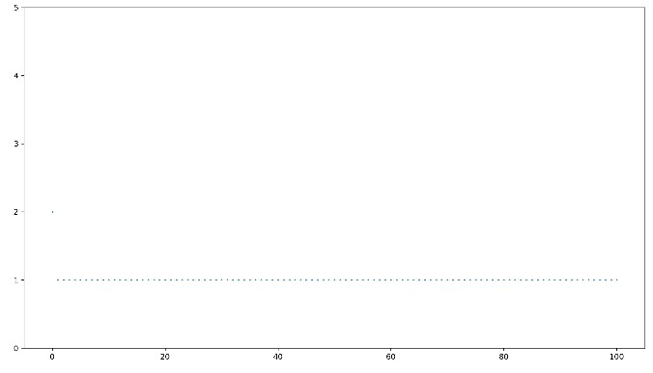

Similarly, for CDL-C channel, but with HARQ on:
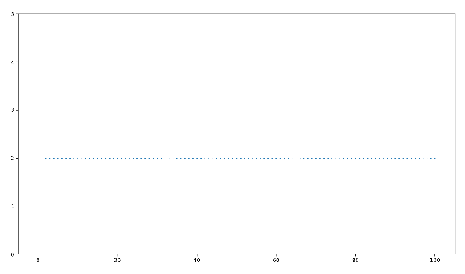
SNR=-5, 25dB, 35dB
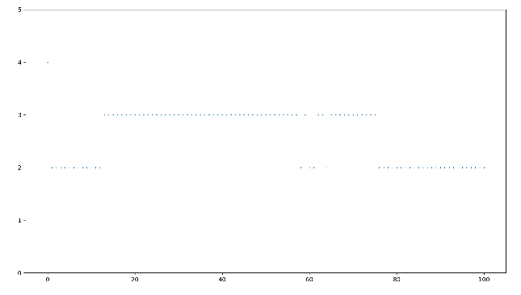
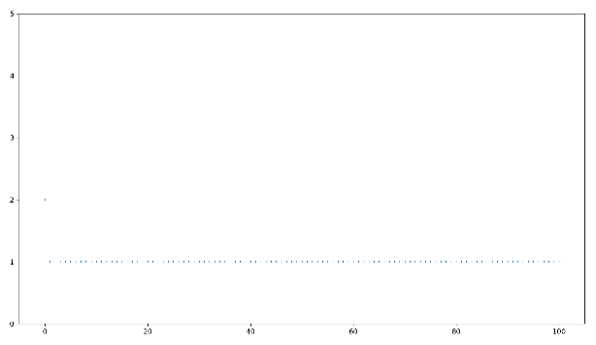

- Seems to work, but RI is ‘conservative’ and not willing to allocate 4 layers even at a high SNR
  - What is causing this? Mutual information? How well conditioned of the matrix??
- Now it is PMI random vs best, so RI is always functioning (RI should be lower if PMI is worse). Will test what will happened if CSI simply does not exist
  - Spec 38.211: PMI defined per layer (codebook?)

To do:
- Meeting schedule during the break

