- Intermediate Report
- Findings
No restriction on Layer, Modulation and Target Code rate, 4Tx 4Rx
Scenario 1: Extremely dense vs extremely loose csi, exactly the same channel condition (same random seed)
Dense | Loose
Higher overall Mbps
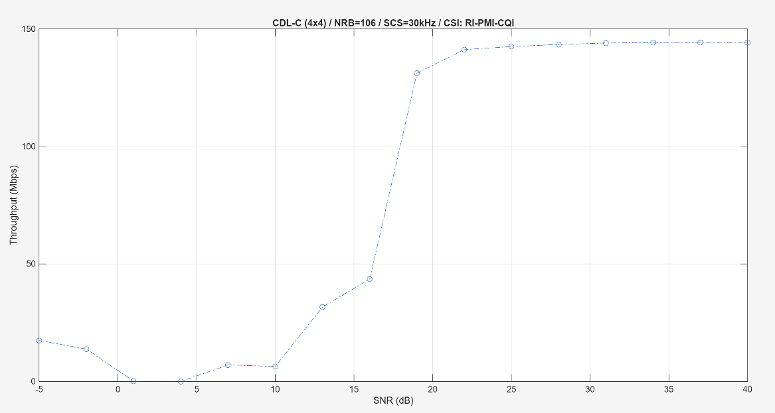 | 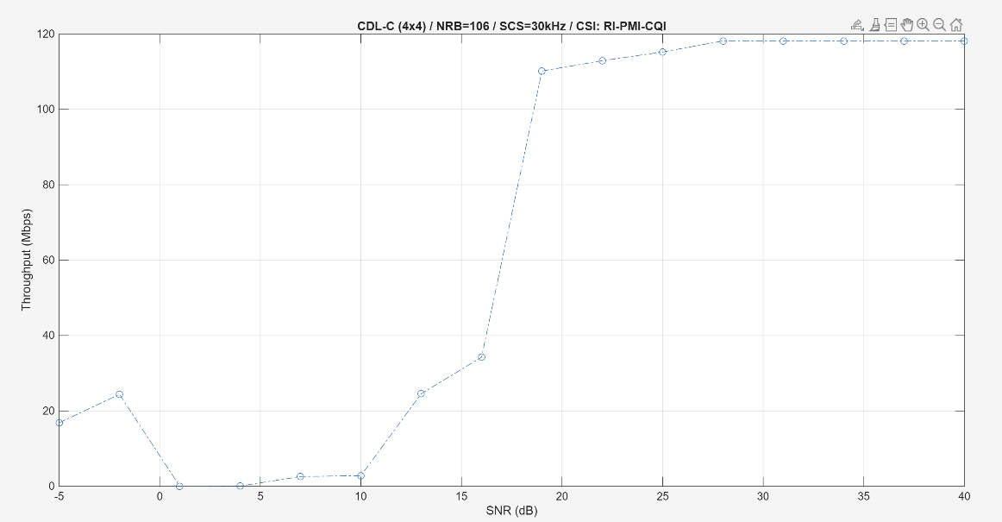
Have more ‘courage’ to use 64QAM
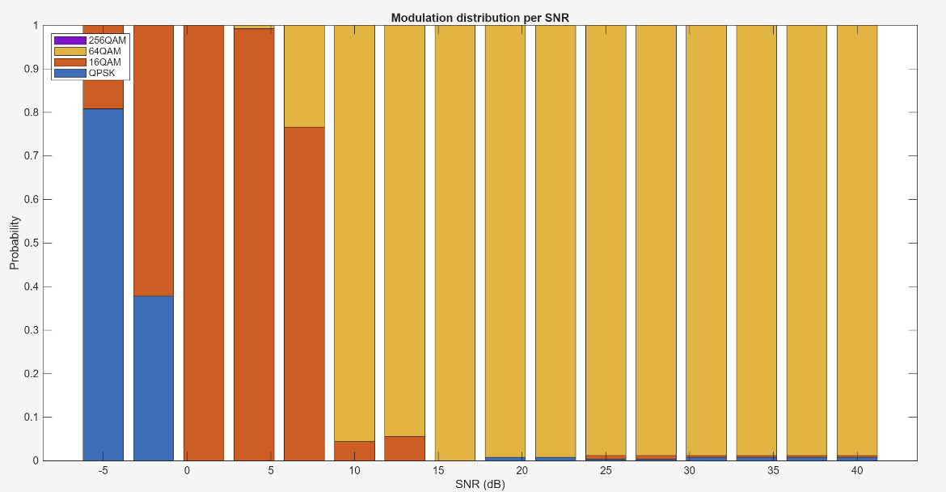 | 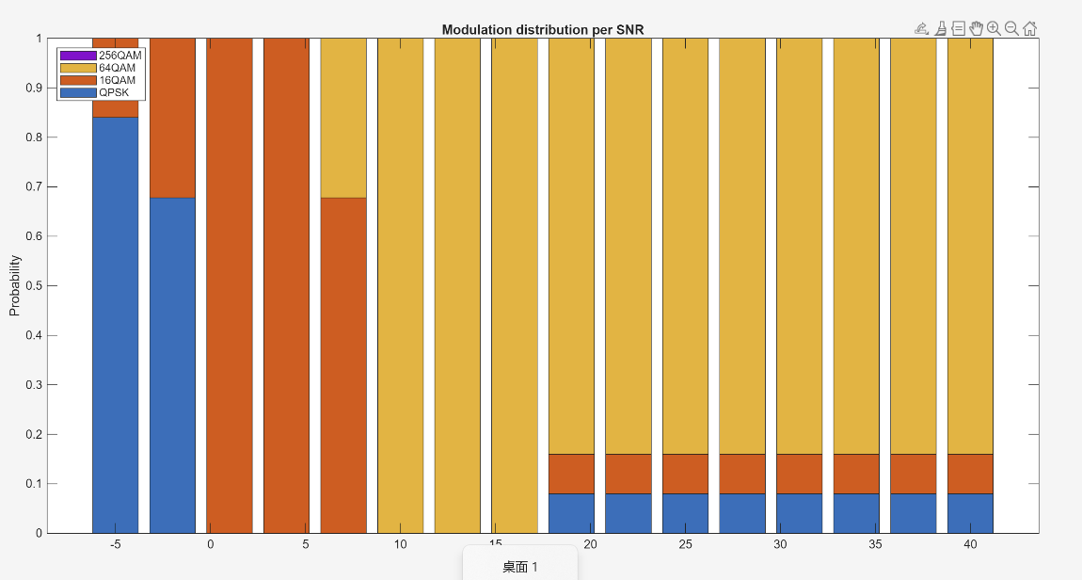
Willing to use higher target code rate
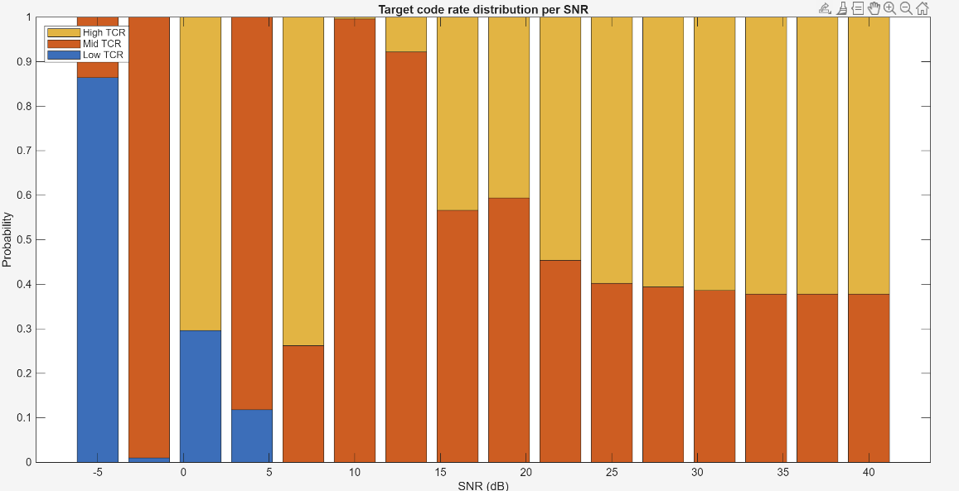 | 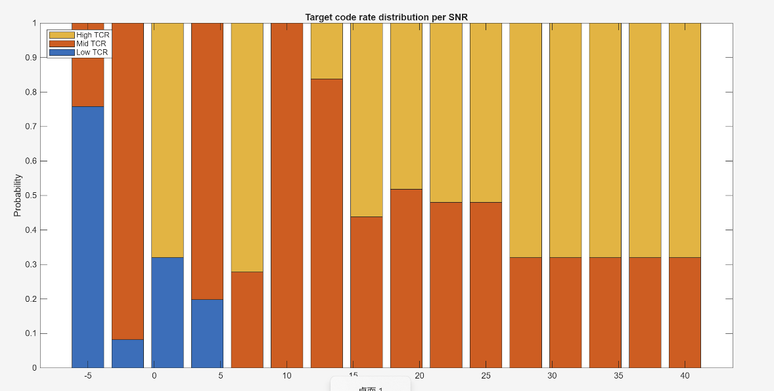
Layer selection honestly no big difference
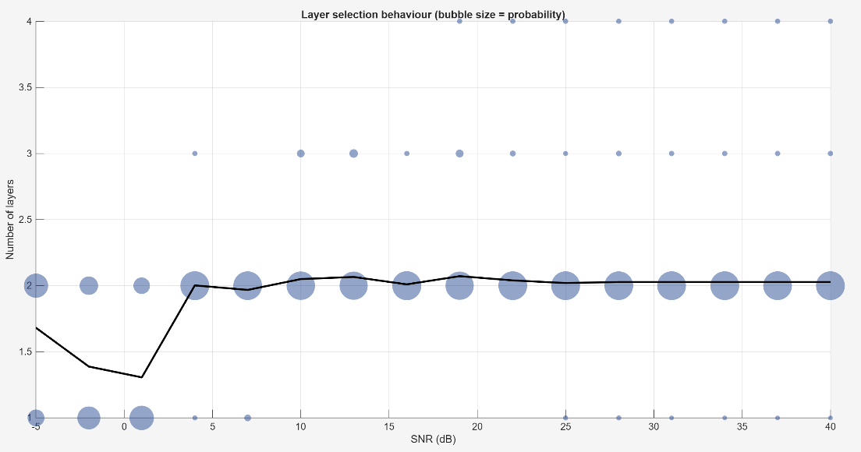 | 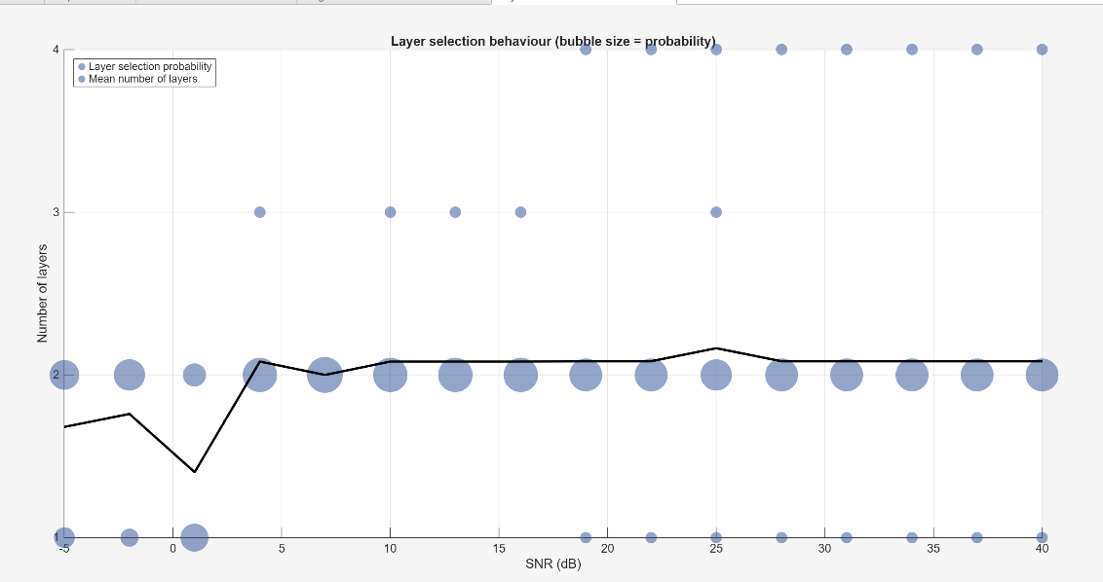

In both tests I used mcs table 1 and cqi table 1, i.e. the most conserved selection. It might be a good idea to use table 3 for both, as the different in the two scenarios will be larger?
Also need to use at least 1000 Frames to achieve a ‘fair’ result

Scenario 2: 10Hz vs 100Hz
10Hz | 100Hz
Higher overall Mbps
 | 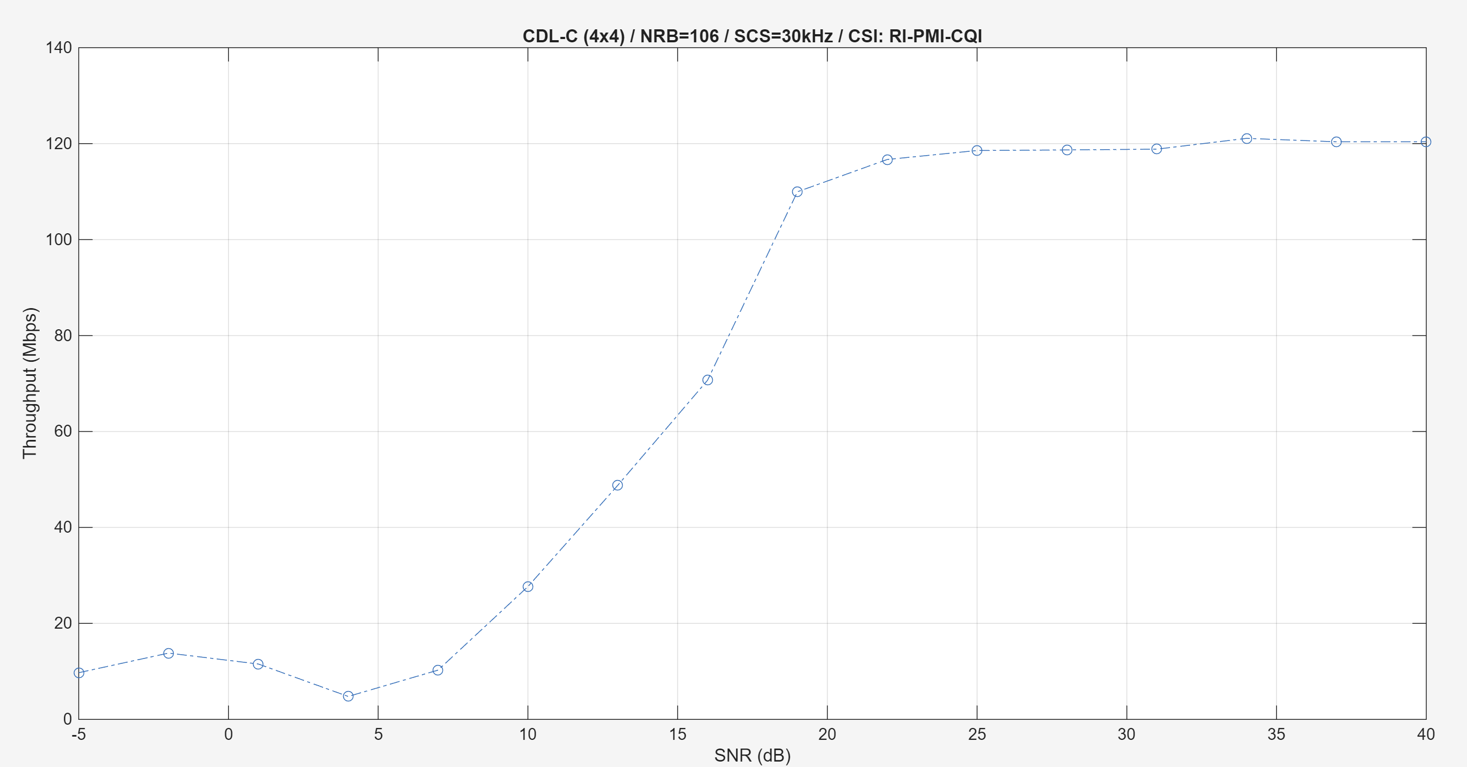
Have more ‘courage’ to use 64QAM
 | 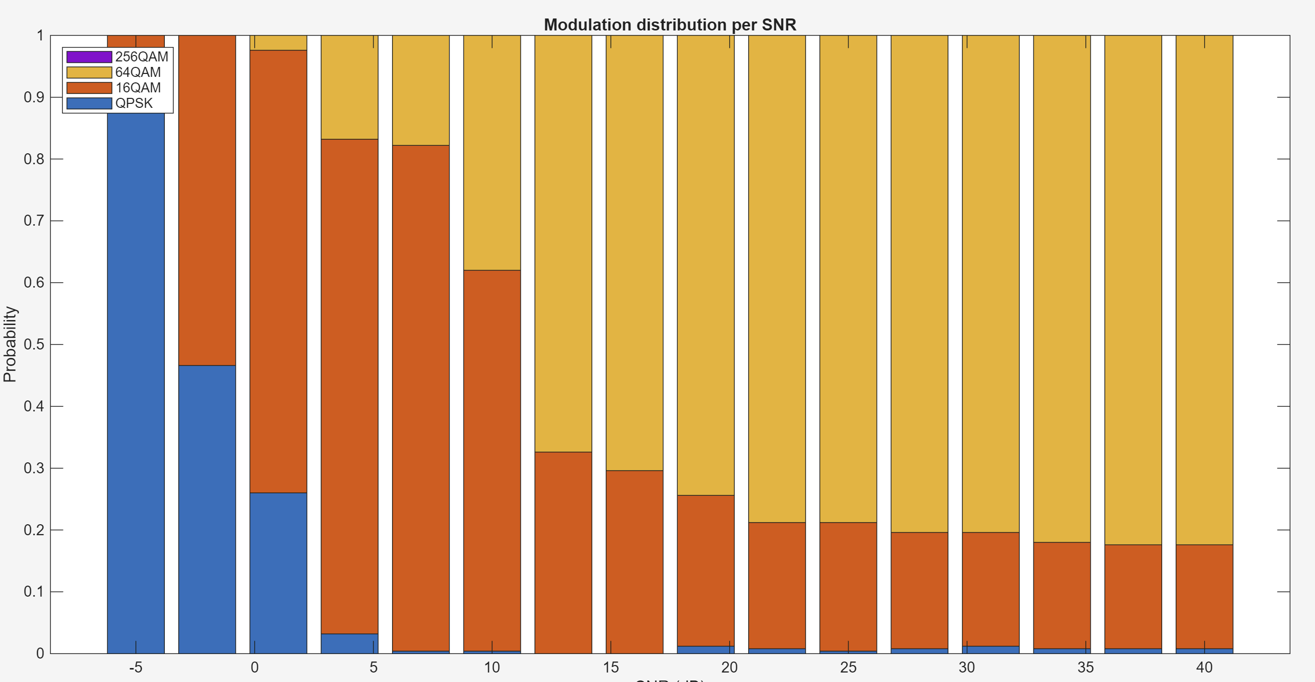
Willing to use higher target code rate
 | 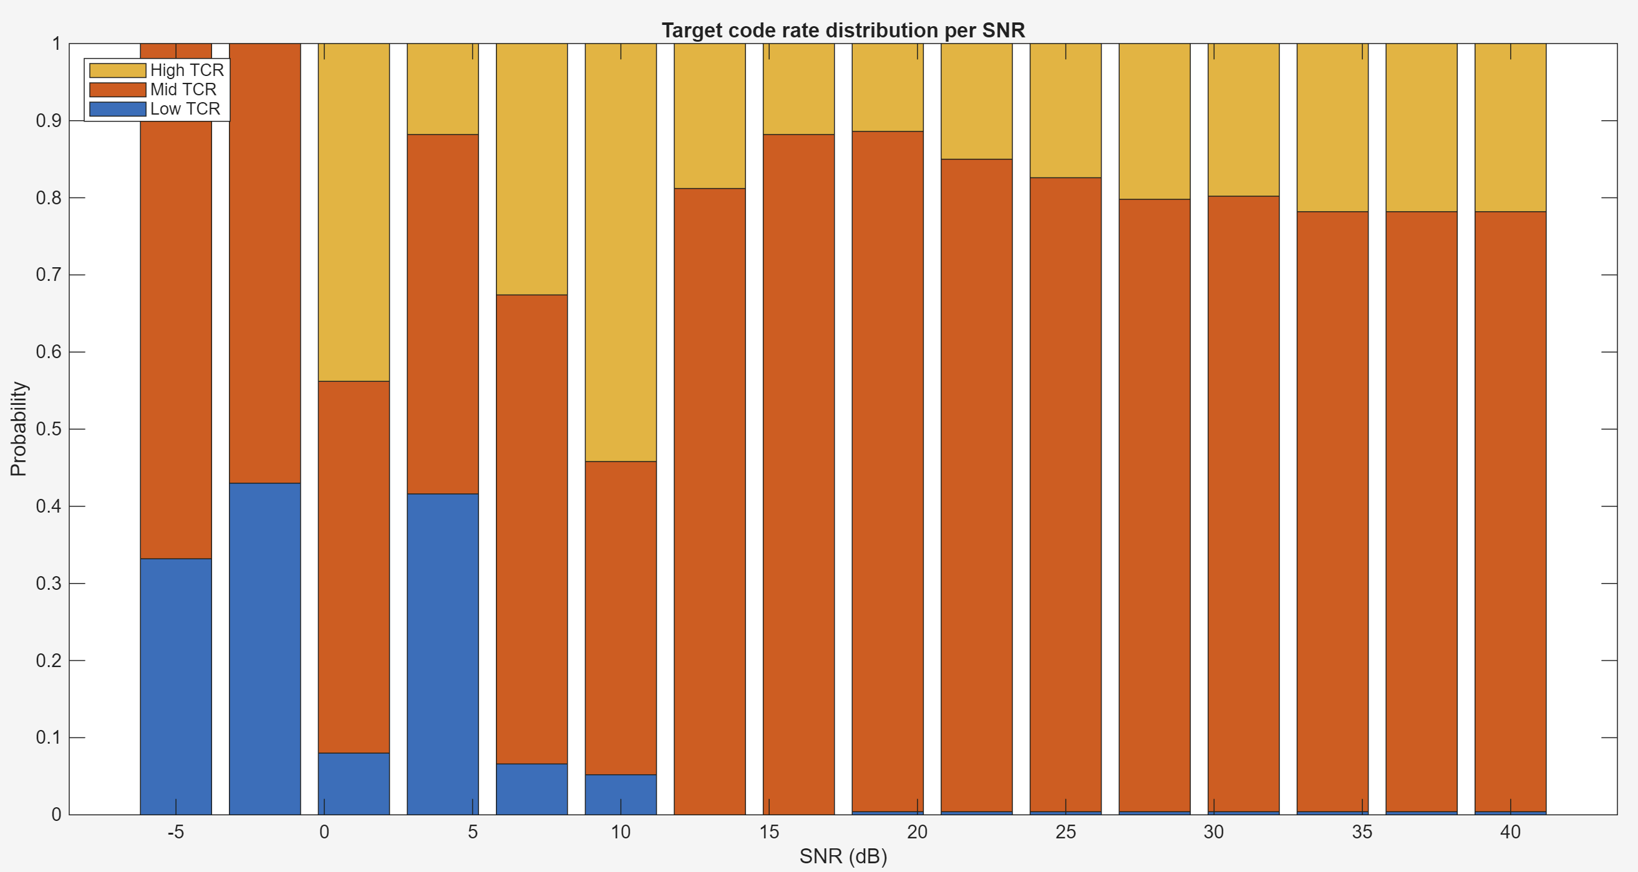
Layer selection honestly no big difference
 | 