- Subband vs Wideband CSI
Subband CSI does not behave as expected. No matter 10Hz or 100Hz
Most 3GPP discussions are in wideband. Do people even actually use Subband?
IP:
Patents from standards (declare by companies -> licensing fee); interdigital make money just from patents (sell in a bucket, e.g. buy them all including subband)
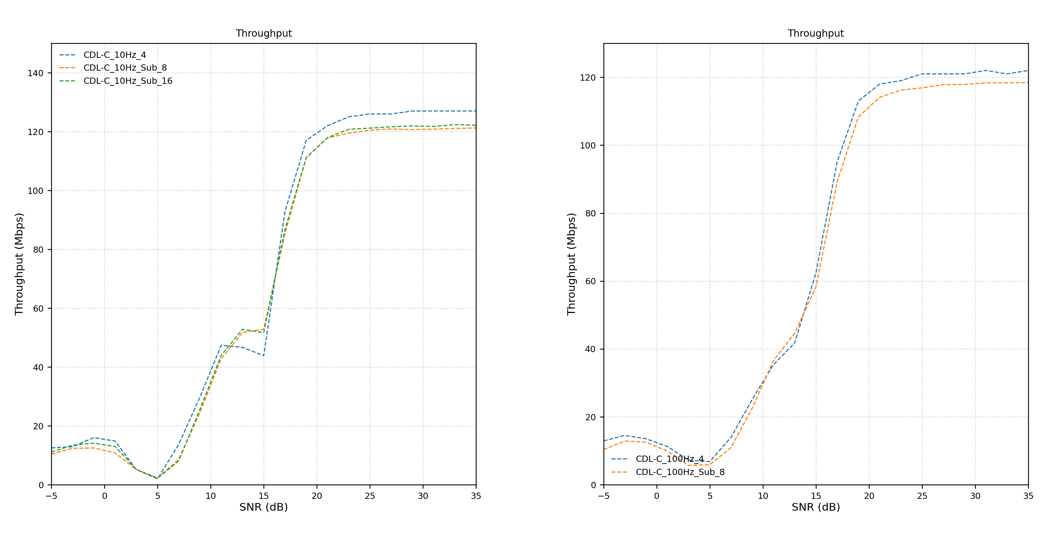
The Subband CQI does, however perform as expected.
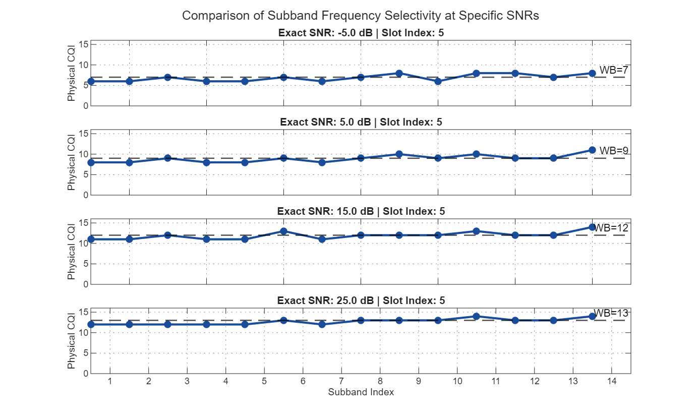
Since I am utilizing full bandwidth to achieve peak throughput rather than employing frequency-selective scheduling, a uniform MCS is applied across the entire spectrum. Consequently, granular subband CQI feedback provides little additional value.

- DM-RS Settings
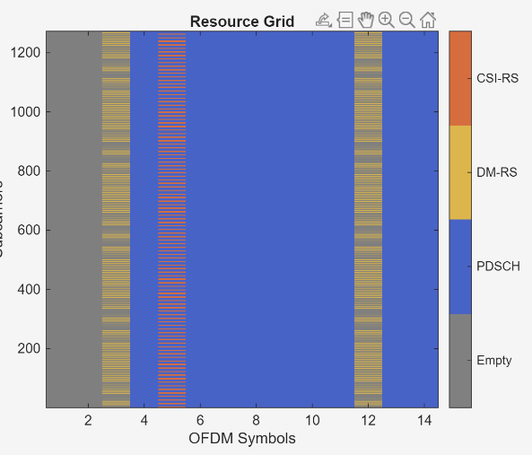 | 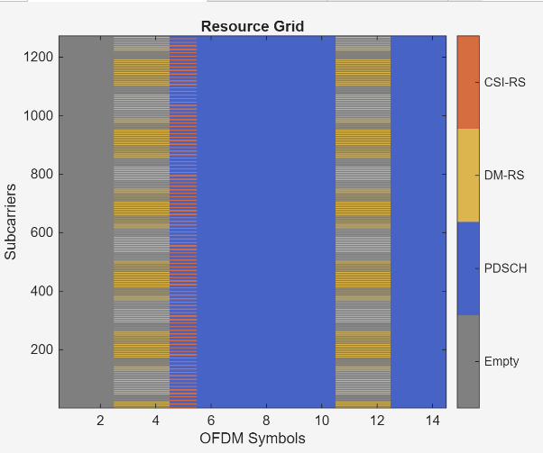
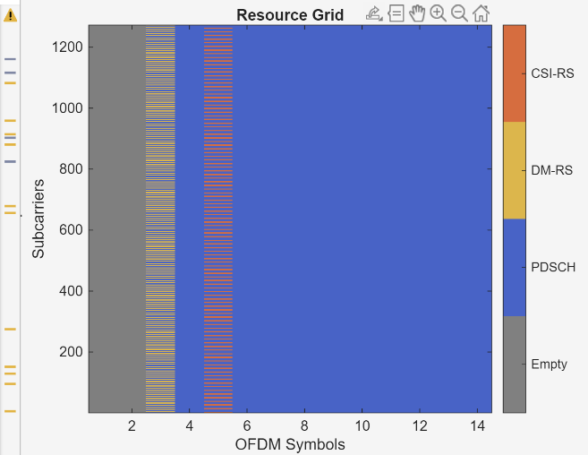 | 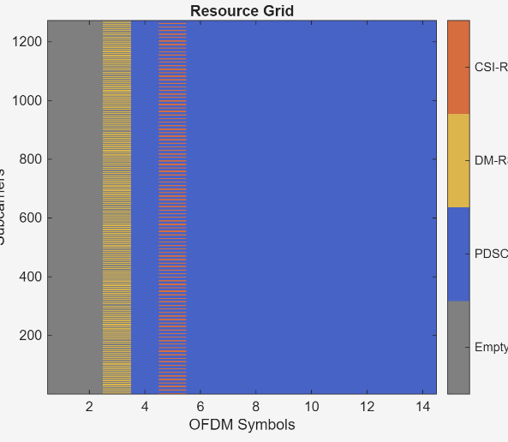

The common setting?
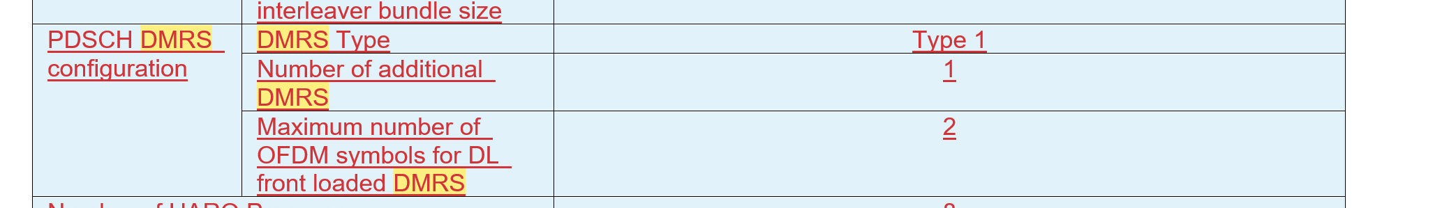
dmrs.DMRSConfigurationType=1；
dmrs.DMRSAdditionalPosition=1;
dmrs.DMRSLength=2;

What about:
dmrs.NumCDMGroupsWithoutData = 1 or 2 or 3;
Change with number of layers (1)

- CSI report period
0Hz scenario

Pure AWGN remove all taps (no errors introduced from channels). (when simply no multipath)
