Progress:
No Progress

Some of the simulation sets that are waiting to run:
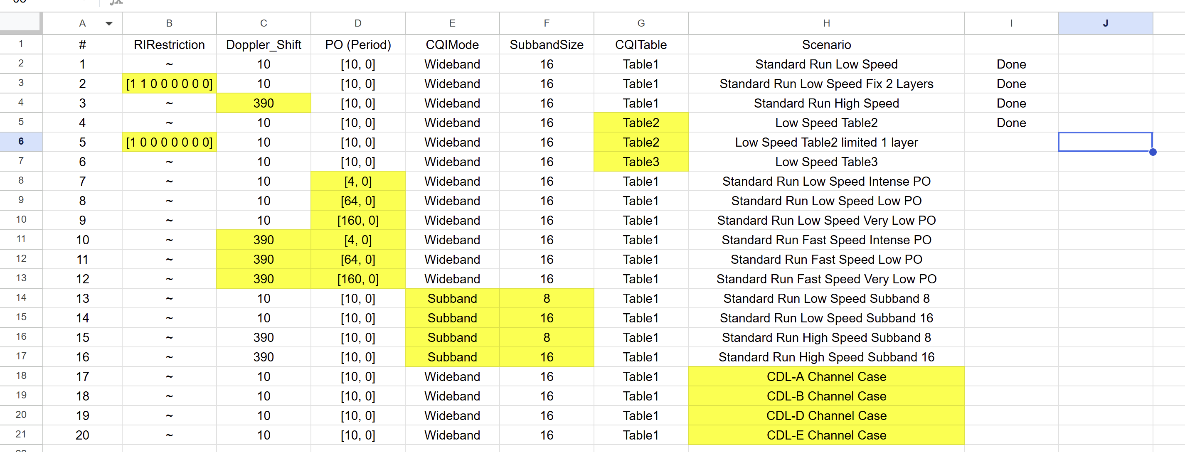
Example:
#1 vs #3 (different speed)
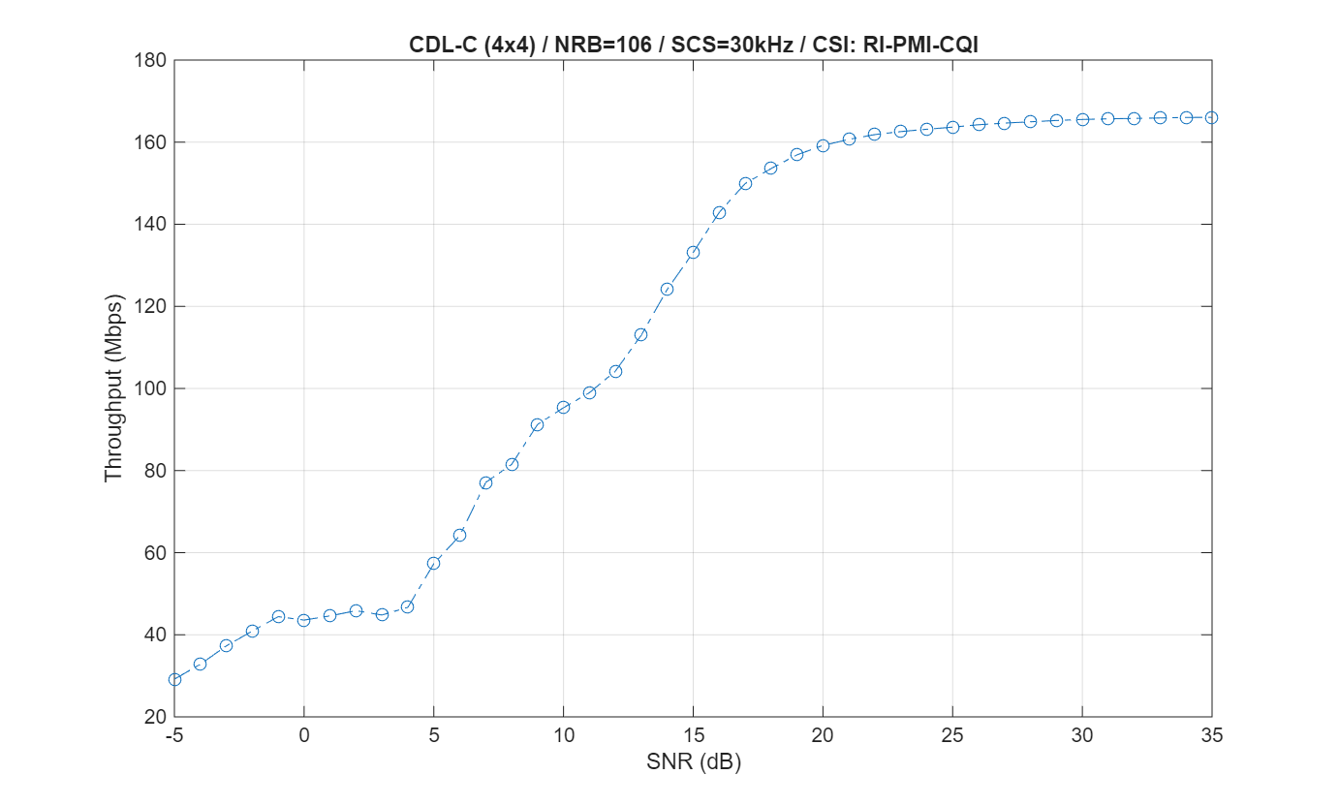 | 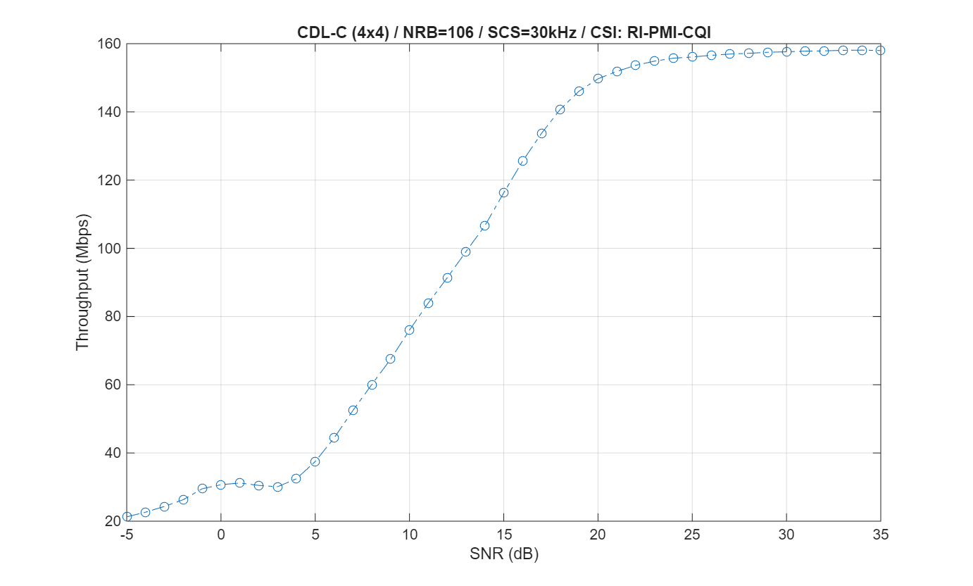
More detailled analysis + further results next week
