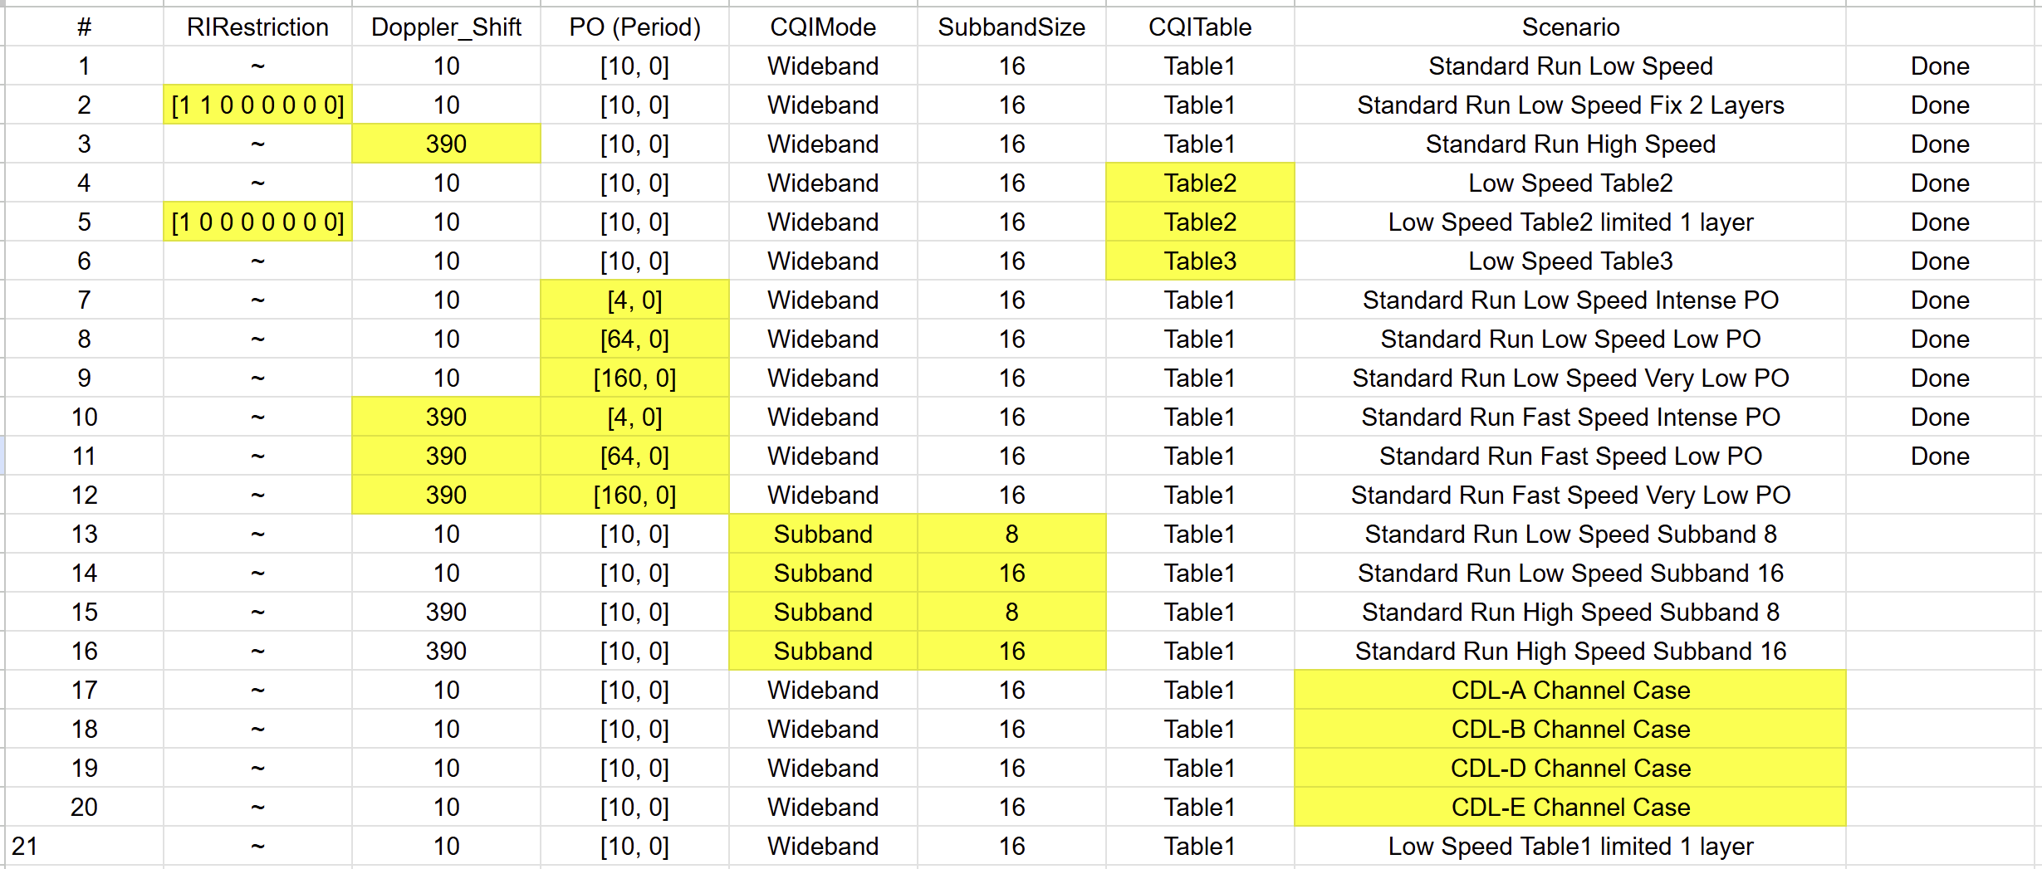

- Table 1, 2, 3 comparisons
CQI Table 3 (URLLC) + MCS Table 3 (64QAM low SE) perform better at low snr and worse at high SNR
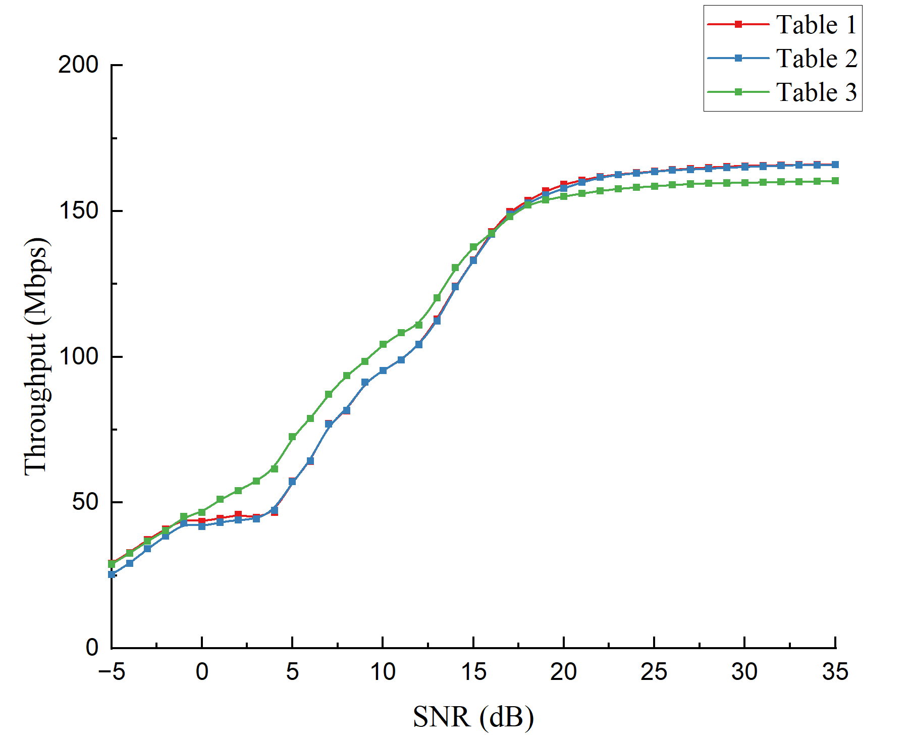
0~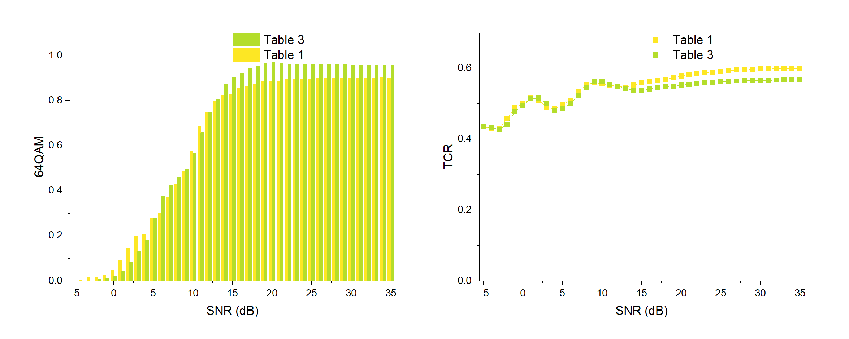
Observation
  - Table 3 performs better than table 1 at low SNR
    - Maybe because the MCS table 3 is denser than table 1 => better fine tuning
  - Table 1 starts to use 64QAM earlier -> CQI table 3 aims a much lower block error rate
  - Table 3 used 64 QAM more at higher SNR, but lower TCR

Difference between academic theoretics vs engineering (here, engineering decisions)
Trade-off of different tables (practice), best (academia)
In requirements, only use table 1 and 2 (fixed wireless access use tab 2 for higher spectrum efficiency, WIFI router).
URLLC defined by ITU, in 3GPP no such ‘feature’, ‘concept’.

- CSI period
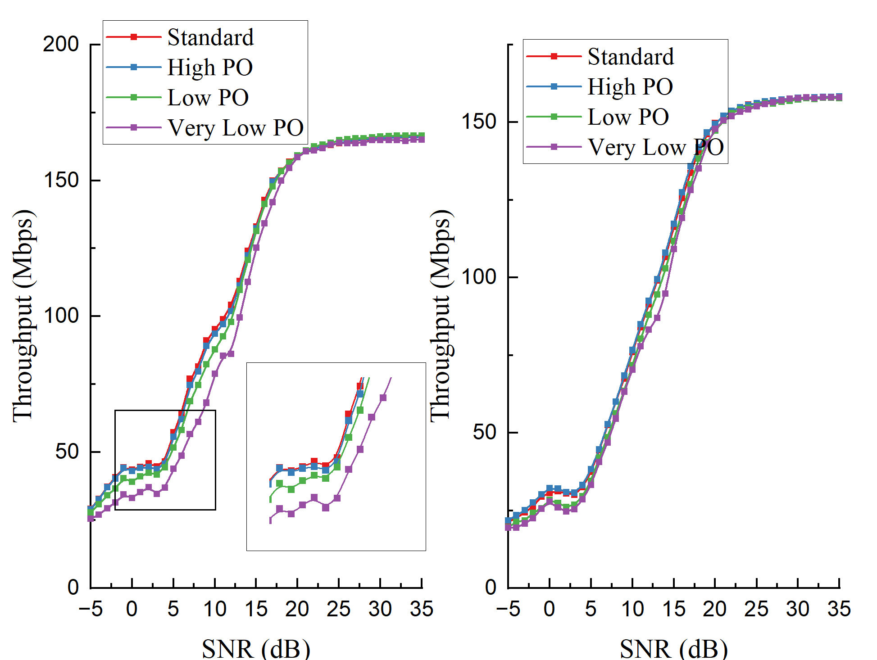
As speed increase, the performance converges? Opposite to our hypothesis?
Conduct two additional cases, 1. Stationary 2. 60km/h. Why high-speed performances converge?

