Tried CDL A-E again, the results still seems a bit interesting
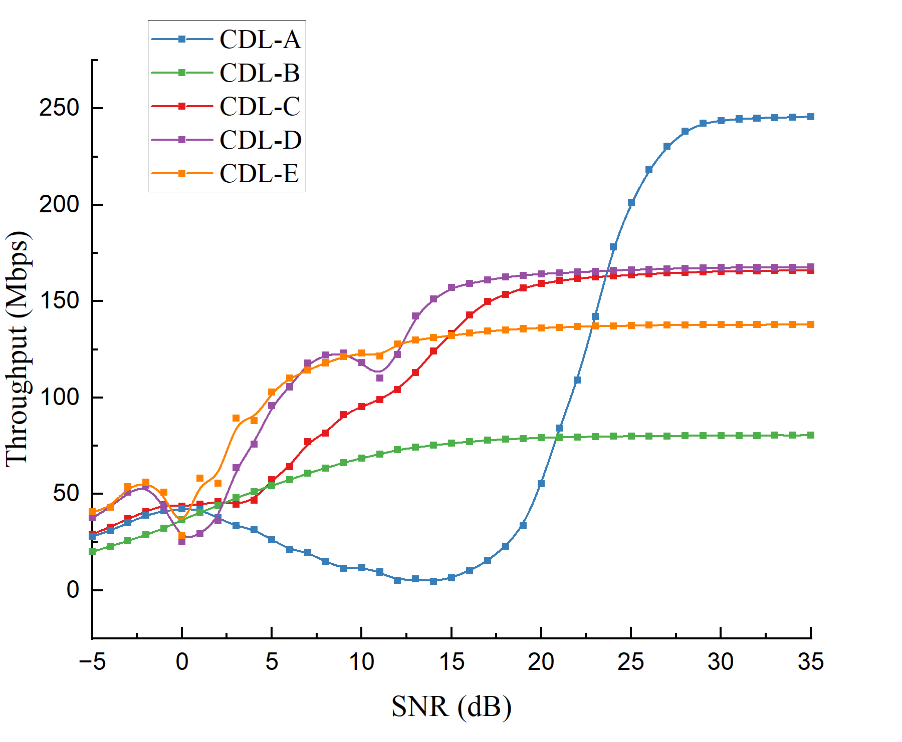
- D, E is more computationally expensive
- At high SNR, CDL A>D=E>E>B
  - D and E are good LOS, but RI limited to 2, not going above that (early capped from ~15dB)
  - A and C can use its MIMO ability easily, very rich spread
  - B has very high doppler? Vehicle use cases C; 300e-9 100Hz, B: 100, 400
  - The issue with B is that the energy spread is more dispersed, so perhaps will only perform better when massive MIMO e.g. 16Tx 4Rx?. In this case, it cannot support higher rank
- Perhaps to do:
  - I assume it will be CDL D=E>C>B>A when I use [1x1] configuration
  - MIMO Gains – Spatial diversity. e.g TDL no such effect. TDL maybe easiest channel `wins’ but in CDL, might be based on the opposite trend
- The reason behind the oscillation of the curves is unclear
  - But clearly for A, it is `high risk – high return’

Subband CSI proven to be completely useless
Not going to discuss during report
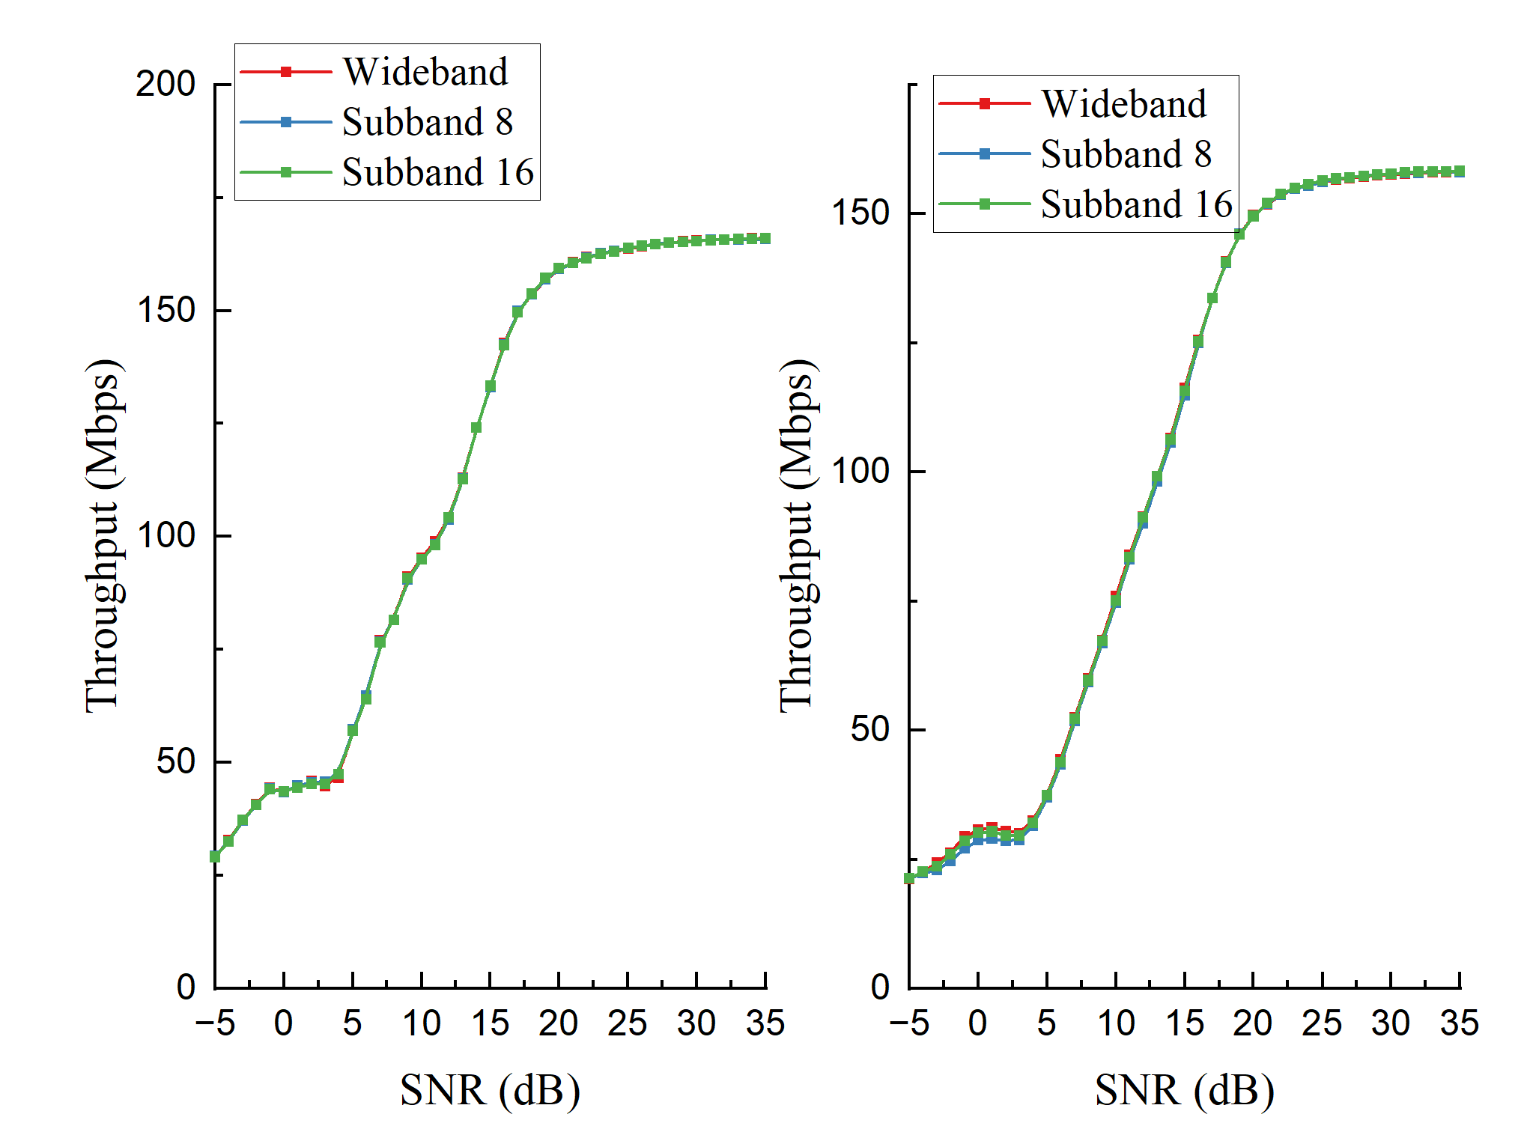

Antenna configurations
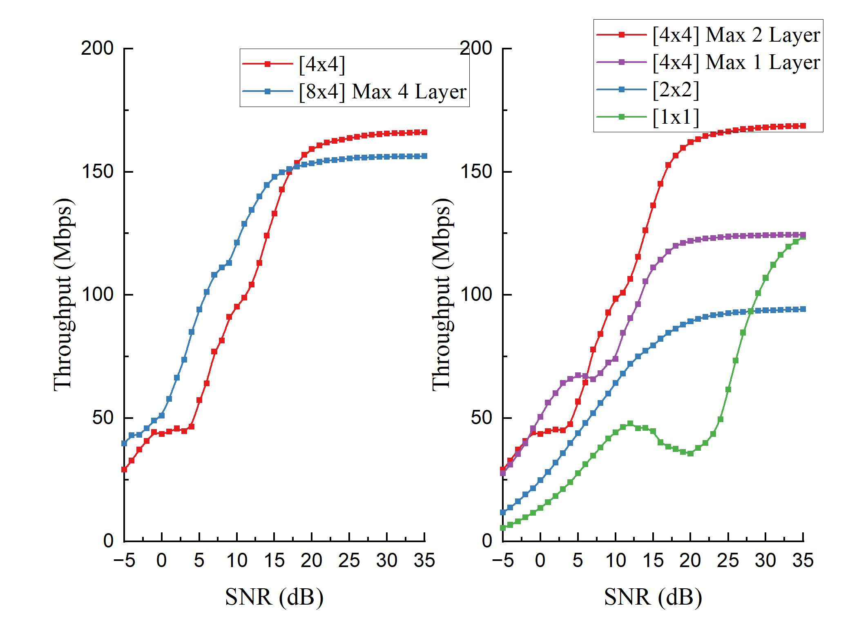
From the simulation, I have the following assumption:
Absence of Outer Loop Rate Control (OLRC):
- The simulation relies solely on inner-loop CSI feedback (RI, MCS, CQI) without HARQ-based error correction.
- Without OLRC to adjust the CQI offset based on ACK/NACK history, the system fails to aggressively pursue the 10% BLER target, leading to a conservative throughput plateau.
The difference at the high SNR plateau is caused simply because of the difference in estimation between the two scenarios. Does not necessary reflects the actual maximum performance.
i.e -> Just cut at 25 dB, everything will make so much more sense

