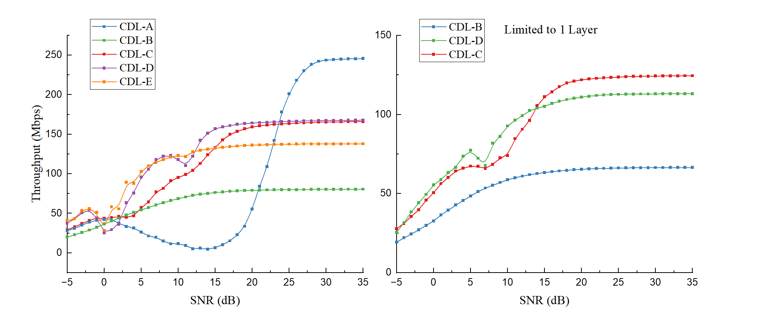
[4x4] so CDL_C still has some diversity at high SNR
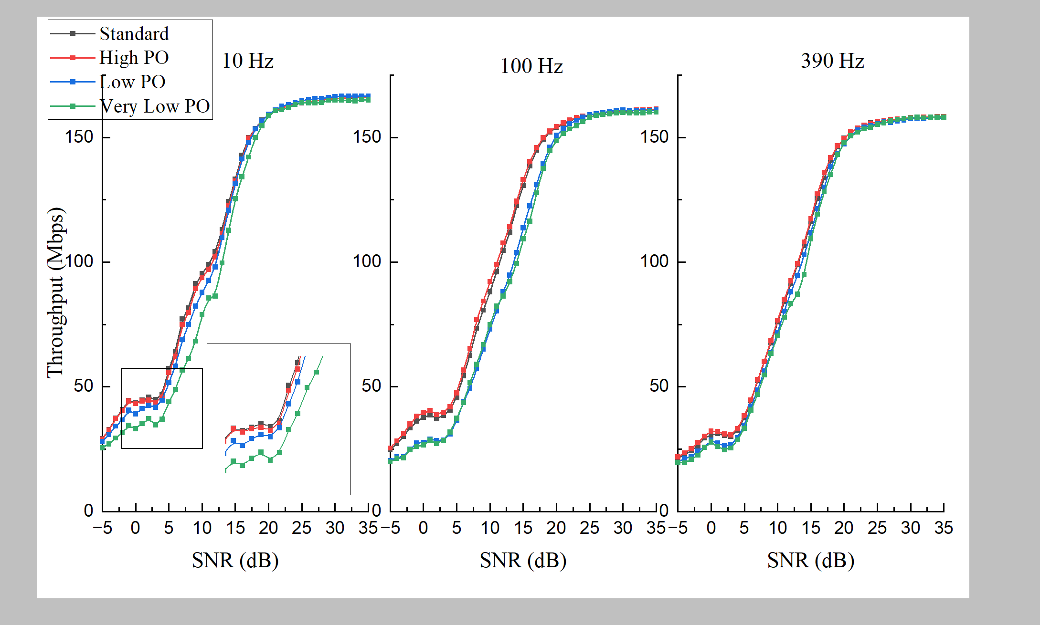
At low mobility scenario, ~5dB benefit
As the mobility increases, it becomes vital to using High PO, low PO will be significantly worse scenario
At very high mobility (120km/h), even a high PO does not help much
Check: How the throughput is measured? – shouldn’t really change here OK
Time diagram – blocks -> how to measure throughput in the introductory section
Maybe to add: CSI random -> how does it perform?

Report overall structure

Main Results:
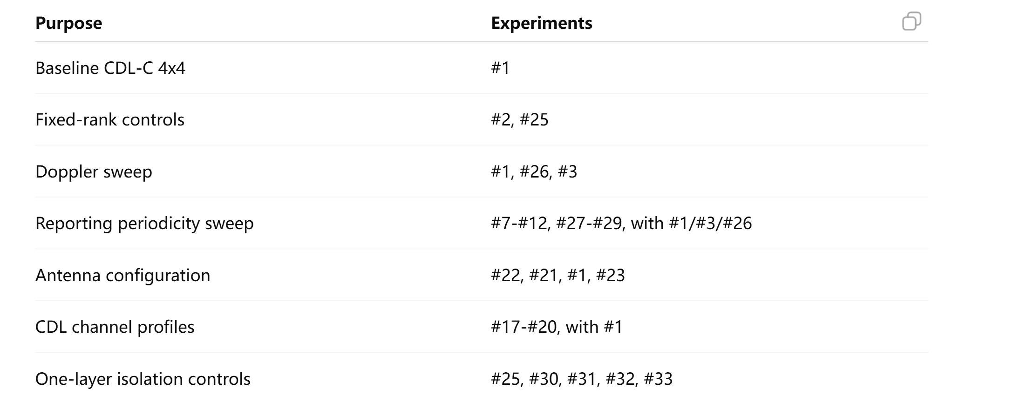

Chapter 1: Introduction
Chapter 2: Background and Simulation Methodology
2.1 5G NR downlink physical layer overview
2.2 MIMO transmission and CSI feedback
2.3 CDL channel model and Doppler shift
2.4 MATLAB 5G Toolbox simulation framework
2.5 Baseline configuration and experimental design
Chapter 3: Baseline CSI-Feedback Downlink Behaviour
3.1 Baseline CDL-C 4x4 throughput behaviour
3.2 CSI-driven link adaptation statistics
3.3 Fixed-rank controls
3.4 Summary of baseline findings
Chapter 4: Impact of Mobility and CSI Reporting Periodicity
4.1 Doppler shift under default CSI reporting period
4.2 Reporting periodicity at low, medium and high mobility
4.3 Joint interpretation: CSI freshness
4.4 Discussion of feedback overhead and practical trade-off
Chapter 5: Robustness across MIMO and Channel Configurations
5.1 Antenna configuration sweep
5.2 CDL channel profile sweep
5.3 One-layer control experiments
Chapter 6: Discussion and Conclusion
6.1 Overall interpretation of results
1. CSI feedback as adaptive link control
2. CSI freshness under mobility
3. Robustness across spatial/channel settings
6.2 Limitations
6.3 Future work

