

Department of Engineering

CSI-Feedback-Driven Link Adaptation in 5G NR Downlink MIMO: A Link-Level Simulation Study

Author Name: Kaiyuan Bao
Supervisor: Prof. Albert Guillen i Fabregas, Alexander Hamilton (Nokia)
Date: 30 May 2026

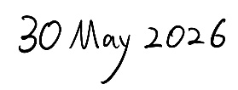
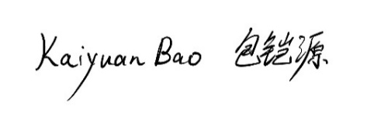
I hereby declare that, except where specifically indicated, the work submitted herin is my own original work.
Signed _______________________________ date _____________________________

