**Step by Step Process for Online Admission Application for VK NRL School of Nursing**

**Step 1:**

Open our website and click **“Register”**  button

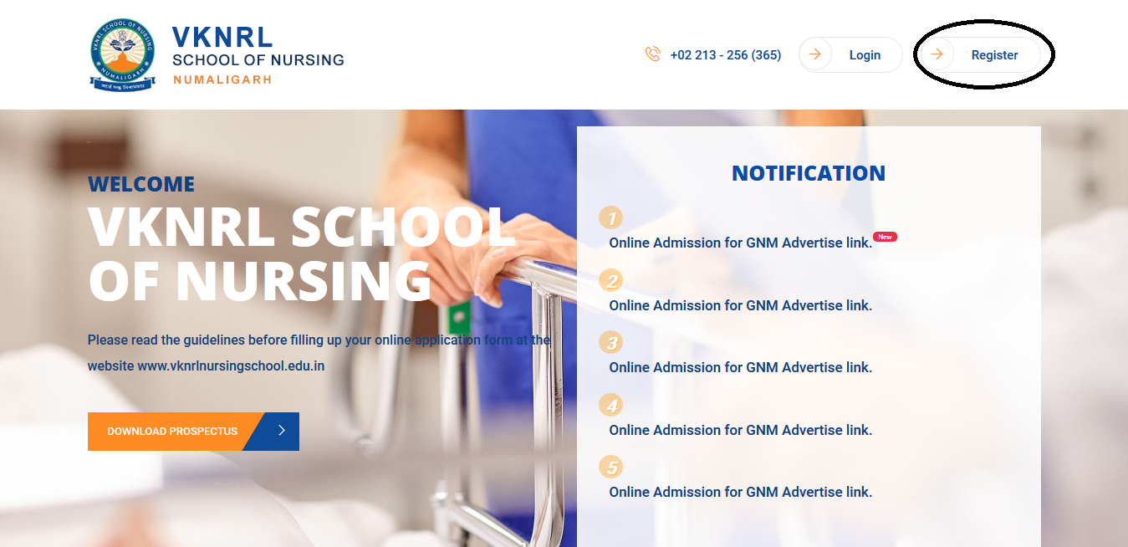

**Step 2:**

After opening Registration please fill up the details as shown Registration Form, then click **“Register”**

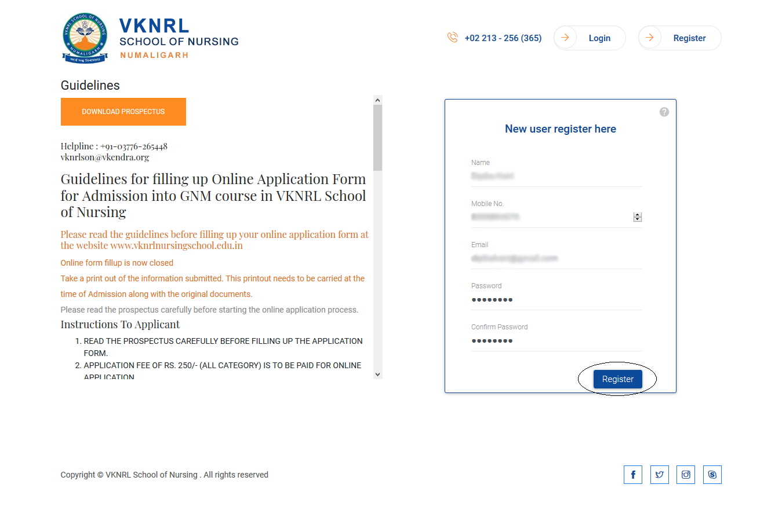

**Step 3:**

After submitting the details you will get an OTP to your registered mobile number to verify. Please click on **“Verify OTP”**

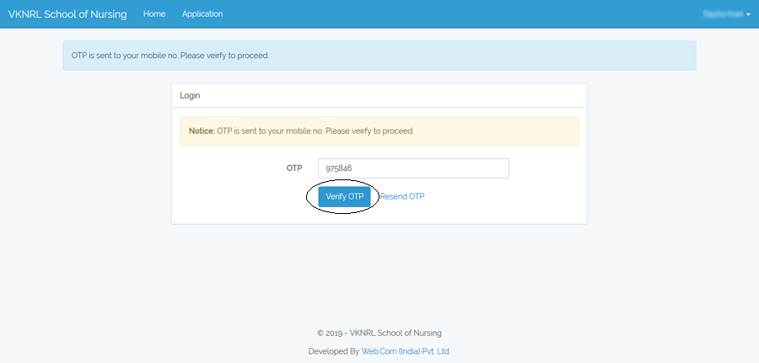

**Step 4:**

After verify OTP, you are logged in and continue for the next step. A window will appear where you can fill up the Application Form. Please click on **“Apply New Application”**

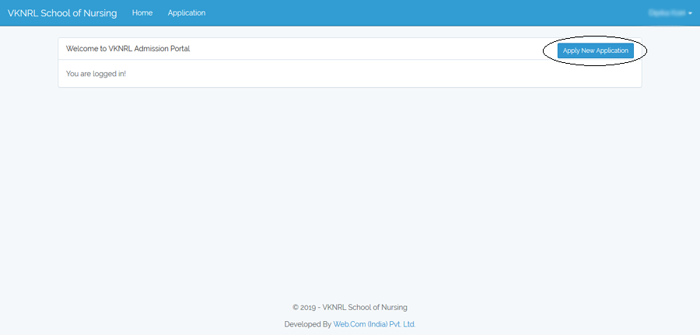

**Step 5:**

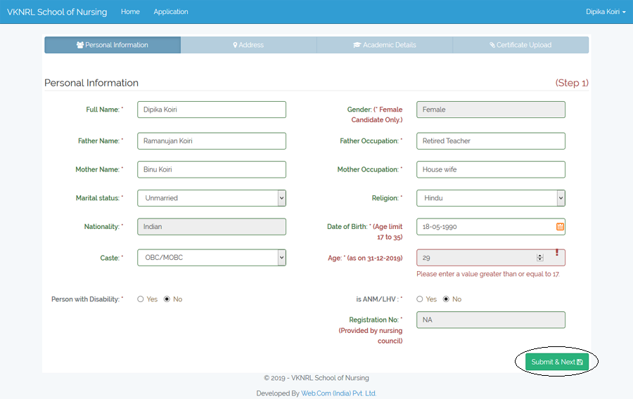After click on **“Apply New Application”** a new window will appear where you have to provide your Personal Information.

Here you are complete and saved **Step 1**. Click on **“Submit & Next”** button for **Step 2.**

**Step 6:**

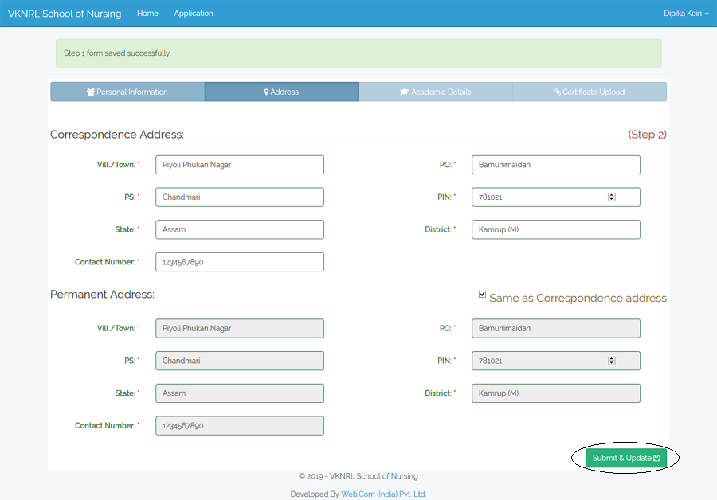After click on **“Submit & Next”** a new window will appear where you have to provide your Address in details.

Here you are complete and saved **Step 2**. Click on **“Submit & Update”** button for **Step 3.**

**Step 7:**

Now its turn to fill up your Academic Details.

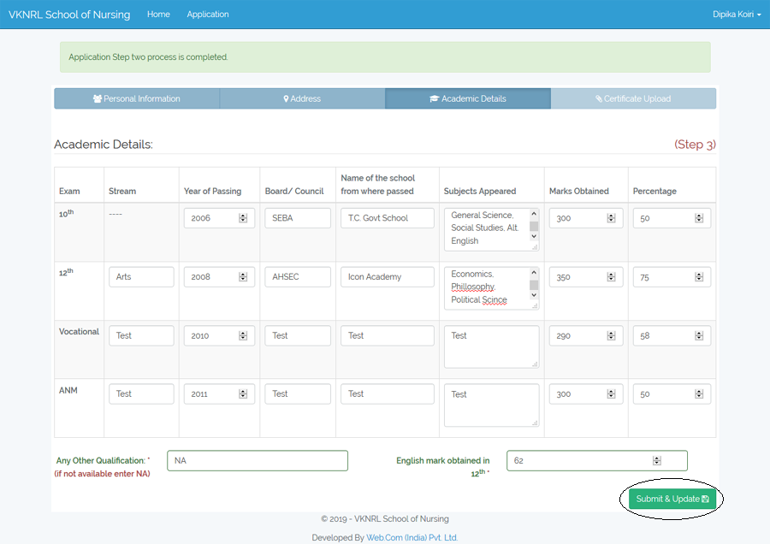

Here you are complete and saved **Step 3**. Click on **“Submit & Update”** button for **Step 4.**

**Step 8:**

This is your final step of Application Form. Here you have to upload your passport photo, signature and qualification certificate.

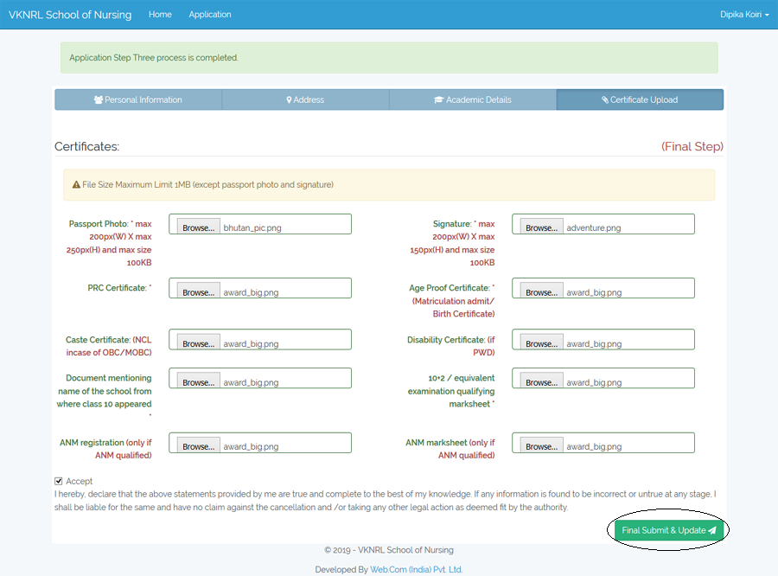

Here you are complete and saved **Final Step**. Click on **“Submit & Update”** button.

**Step 9:**

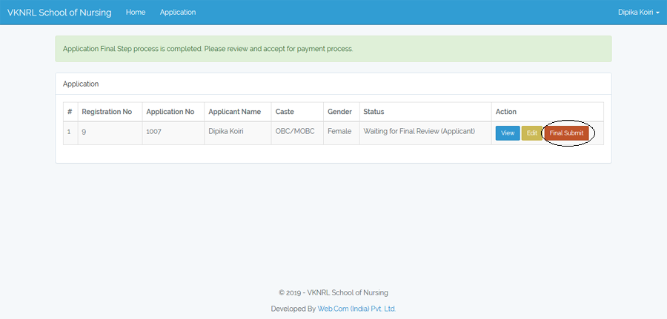After complete Final Step, you will get a new window to review and accept for payment process. Here you can edit your Application Form. Then click on **“Final Submit”** button.

**Step 10:**

Online payment option window will appear after click on **“Final Submit”** . Then click on **“Go for Payment”** button.

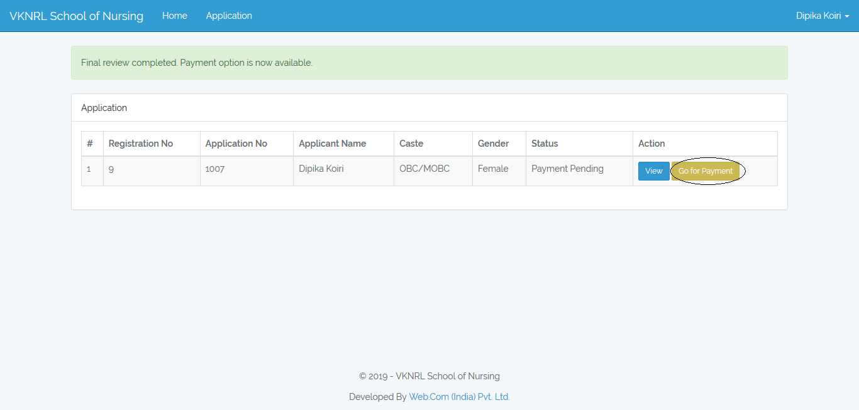

**Step 11:**

After click on **“Go for Payment”** button, a window will appear. Click on **“Proceed to Payment”** button.

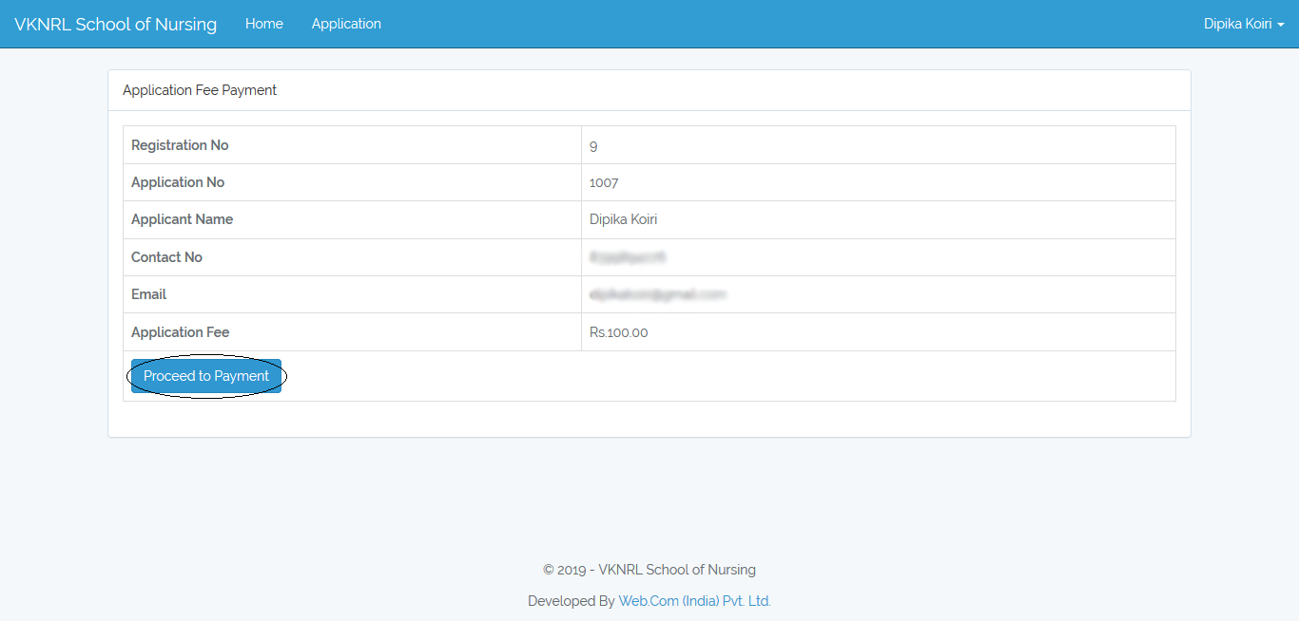

**Step 12:**

After click on **“Proceed to Payment”** button a popup image will appear where you have to click on **“CARD”.**

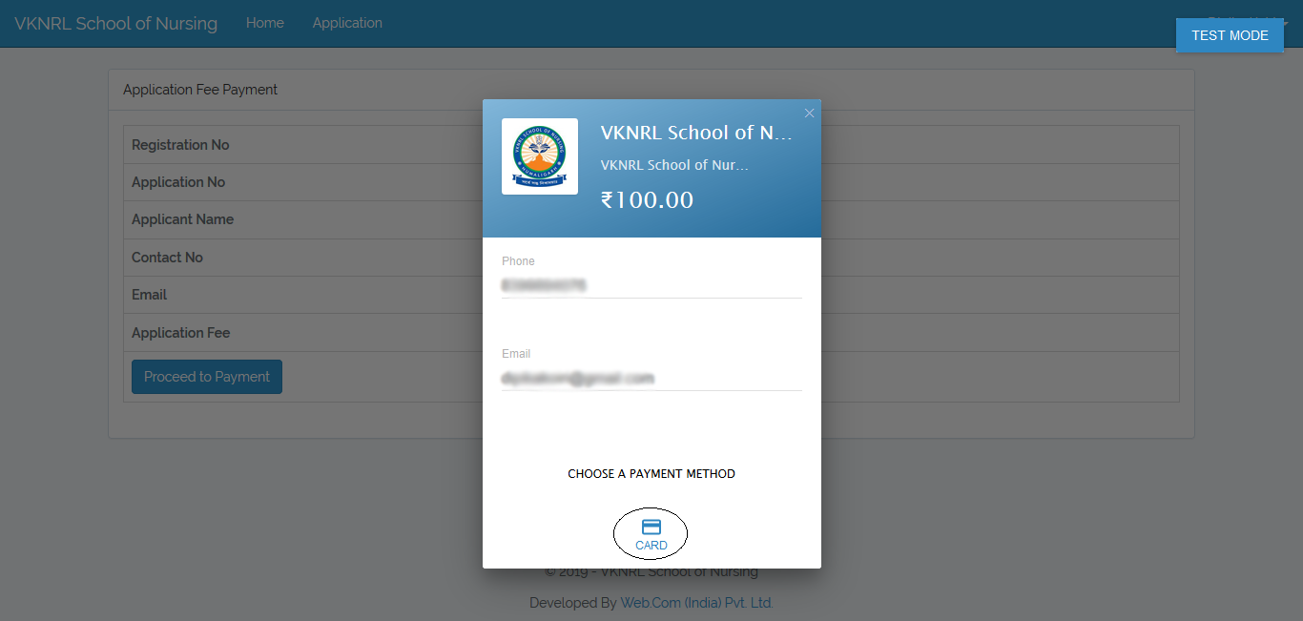

**Step 13:**

After click on **“CARD”** button another popup image will appear. Here you have to entered your Debit Card details and after that click on **“Pay** ₹ **100.00”.**

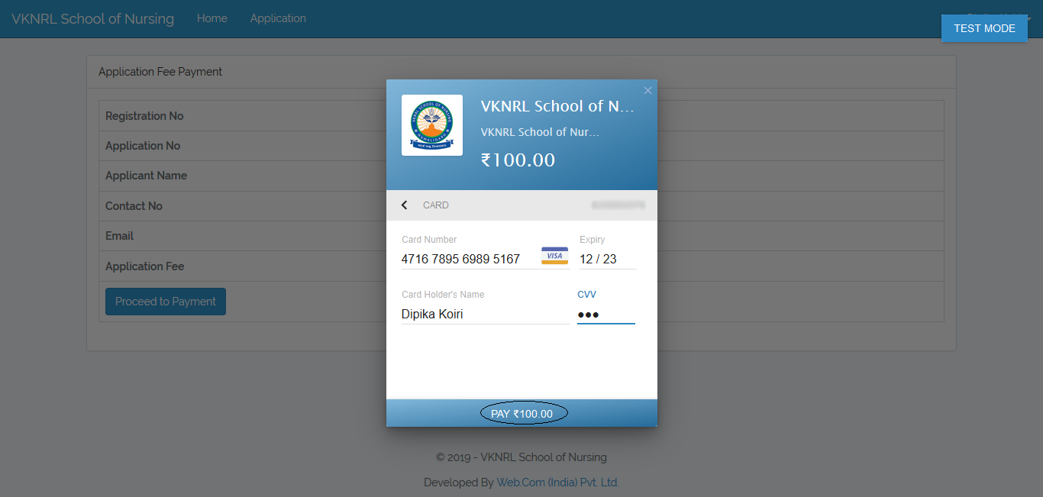

**Step 14:**

After click on **“Pay** ₹ **100.00”** a window will appear where you have to click on **“Successful”** button.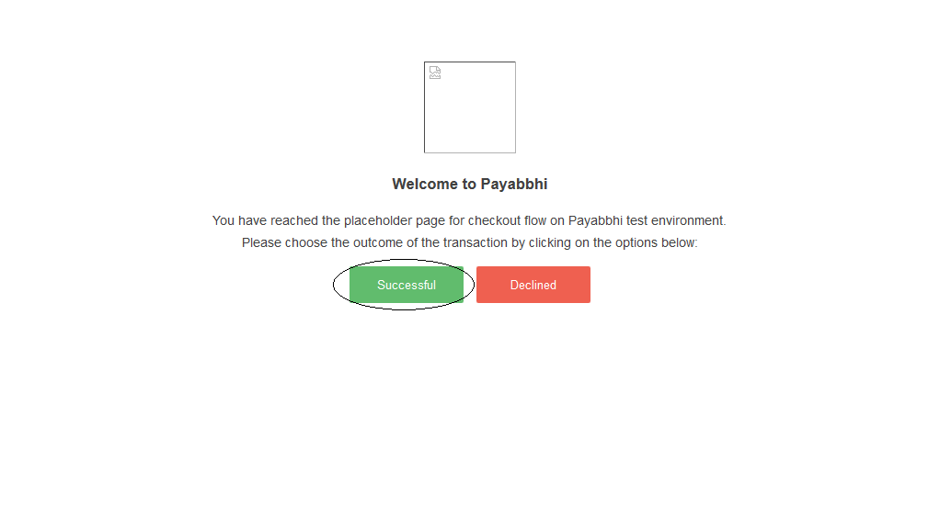

**Step 15:**

After click on **“Successful”** button, a new window will appear where you can download Payment Acknowledgement Receipt by click on **“Payment Receipt”** button.

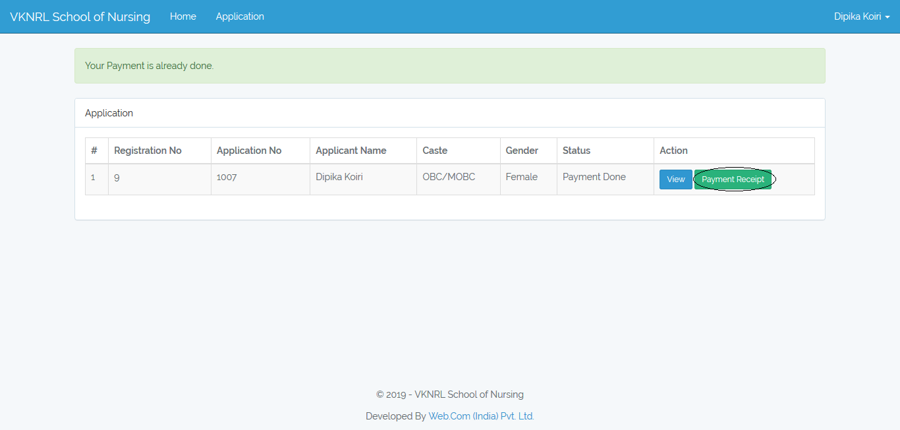

**Step 16:**

After click on **“Payment Receipt”** button, you can print your Payment Acknowledgement Receipt

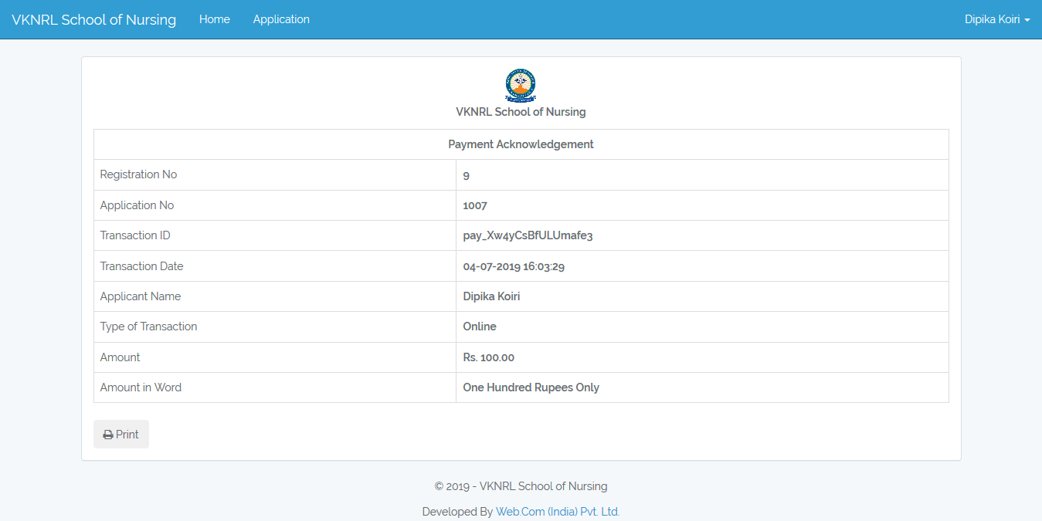

**Step 17:**

You can also view and download your Application Form by click on **“View”** button.

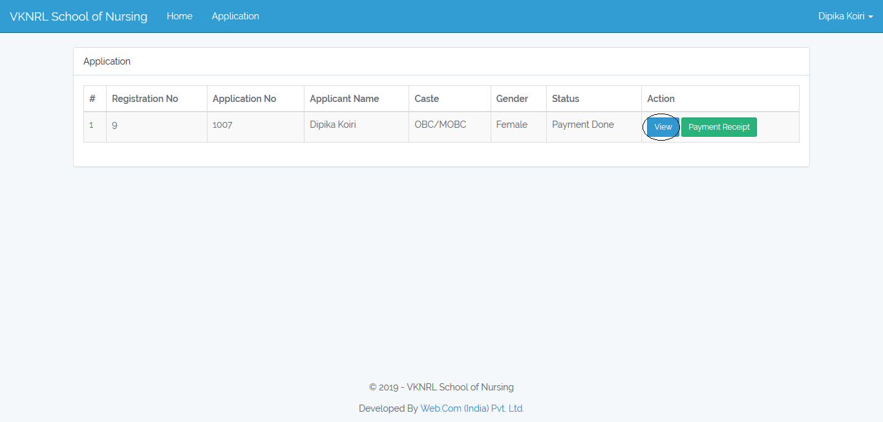

**Step 18:**

You can view Application Form –

