**Draw Usecase and Domain Diagram**

Assignment

Presented to Sir, Hunaid

Muhammad Barkat Ansari 16501556-003

Hafiz Usama

16501556-023  
Muhammad Ali 16501556-055

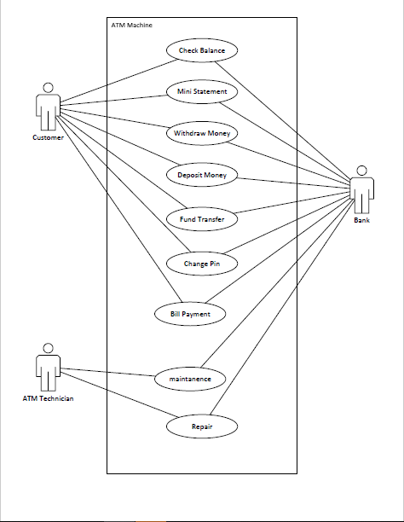

**Use case ATM Machine:** Process Transaction

**Primary Actor:** Customer

**Stakeholders and Interests:**

* Bank: Wants accurate and fast transaction, no transaction errors and maintenance
* ATM Technician: Wants sales commissions updated

**Preconditions:**

* Customer is identified and authenticated
* Technician is the Bank’s Worker

**Success Guarantee (Postconditions):**

* Transaction is saved. Credited or Debited and Tax are accurately calculated.
* Change of Pin is saved.
* Mini Statement and Transaction receipt(optional) are given

**Main success scenario (or basic flow):**

* The Customer arrives at the ATM Machine and put in the ATM card in the Machine and Enters the PIN.
* The System provide with the options of transaction and if Customer wants to cancel the transaction he/she can do so and the card will be pushed out by the machine.
* The Credit or Debit transaction the ATM machine will calculate the amount and saves it to the account of the Customer.
* In case of Credit or Debit transaction the ATM Machine should save the amount, time and date of transaction along with the location.
* After completion ask for another transaction.

**Extensions (or alternative flows):**

* After Invalid PIN ask for PIN two more time and then store the card in ATM for security.
* Credit/Debit transaction is more than amount in account then show message and cancel transaction.

**Special requirements:**

* Touch screen UI
* Input keyboard
* Card Scanner

**Open issues:**

* What are the tax law variations?