

12/31/2020

Barkat Opu

ID: 1731466, Section: 02

CENTRAL DEPOSITORY BANGLADESH LIMITED

**Contents**

Investor. 1

Human Resource. 1

Director 2

Guest user 2

DPs: participant of CDBL. 2

ADMIN (Employee of BSEC) 2

Class Diagram: 3

Classes of the project: 4

# Investor.

1. **Goal: Investor should be able to apply for new BO account (apply for a new account from login page).**
2. **Goal: Investor should be able to buy new products (share).**
3. **Goal: Investor should be able to sell products (share).**
4. **Goal: Investor should be able to Change existing DPs (participant of CDBL).**
5. **Goal: Investor should be able to complain about any service.**

# Human Resource.

1. **HR should be able to Select new candidate for DPs member and give their license.**
2. **HR should be able to recruit candidates on online.**
3. **HR should be able to hire right employees (Guest employee).**
4. **HR should be able to conduct disciplinary actions.**
5. **HR should be able to update company policies.**

# Director

1. **Checking meeting update.**
2. **Creating new meeting.**
3. **Checking notice from BSEC.**
4. **Checking Documents**
5. **Proposing new rules and regulation to other directors.**

# Guest user

1. **Checking overview of CDBL.**
2. **Checking Services.**
3. **Checking latest share price of DSE or CSE.**
4. **Checking DPs and ISIN list.**
5. **Checking CDBL FEES AND DEPOSITS.**

# DPs: participant of CDBL.

1. **Applying to be participant of CDBL.**
2. **Creating new BO account for an investor.**
3. **Closing BO account for a current investor.**
4. **Transferring sold out share (products) for an investor to another investor.**
5. **Checking market value in CDS(Tk)- stats.**

# ADMIN (Employee of BSEC)

1. **Goal: Admin should be able to create new account.**
2. **Goal: Admin should be able to select new DPs.**
3. **Goal: Admin should be able to delete an account.**
4. **Goal: Admin should be able to restrict any account.**

# Class Diagram:

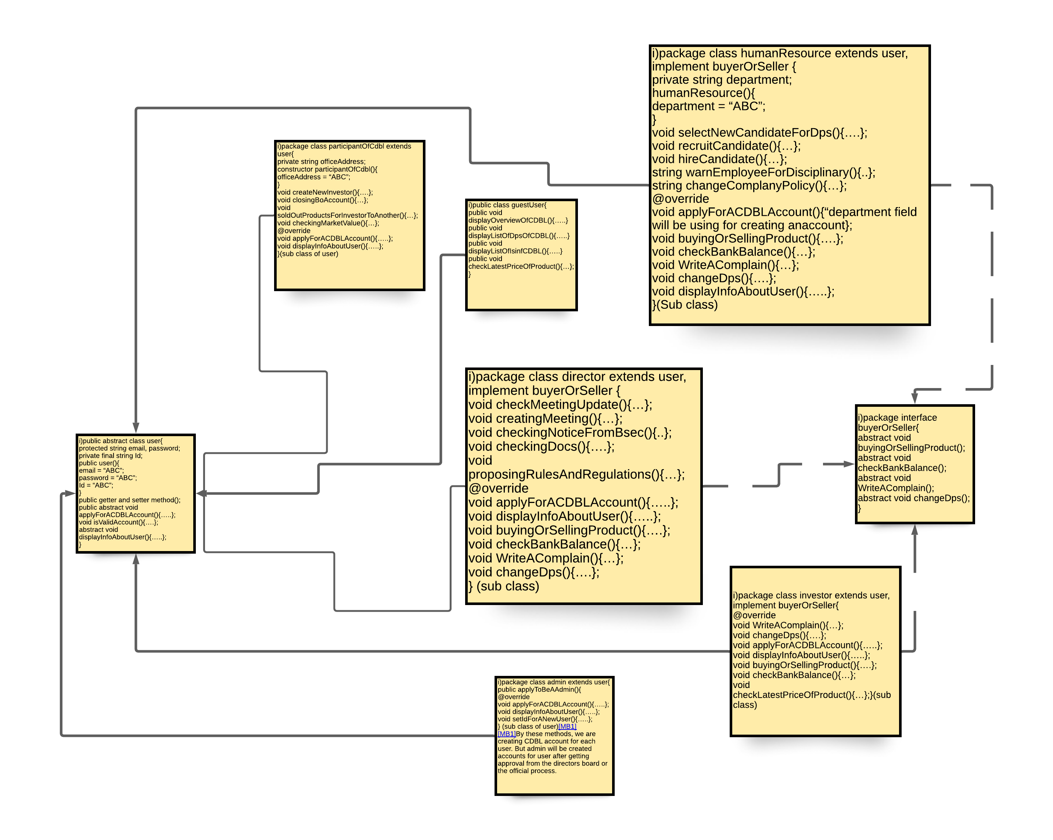

**abstract class user{**

**abstract void setInfo();**

**Void showInfo(){…};**

**}**

**abstract interface abcd{**

**abstract Flksdag;**

**abstract Fsdlkfj;**

**abstract void setInfo();**

**}**

**Class dip extends user,abcd{**

**Void setInfo(){**

**Cout<<”Enter your name: “;**

**Cin>>name;**

**}**

**Void showInfo(){…};**

**}**

**Class Barkat extends user {**

**Void setInfo(){**

**Cout<<”Enter your first name: “;**

**Cin>>name;**

**}**

**Void showInfo(){…};**

**}**

# Classes of the project:

|  |
| --- |
| 1. public abstract class user{   protected string email, password;  private final string Id;  public user(){  email = “ABC”;  password = “ABC”;  Id = “ABC”;  }  public getter and setter method();  public abstract void applyForACDBLAccount(){…..};  void isValidAccount(){….};  abstract void displayInfoAboutUser(){…..};    } |

|  |
| --- |
| 1. package interface buyerOrSeller{   abstract void buyingOrSellingProduct();  abstract void checkBankBalance();  abstract void WriteAComplain();  abstract void changeDps();  } |

|  |
| --- |
| 1. package class investor extends user, implement buyerOrSeller{       @override  void WriteAComplain(){…};  void changeDps(){….};  void applyForACDBLAccount(){…..};  void displayInfoAboutUser(){…..};  void buyingOrSellingProduct(){….};  void checkBankBalance(){…};  void checkLatestPriceOfProduct(){…};  }(sub class) |

|  |
| --- |
| 1. package class humanResource extends user, implement buyerOrSeller {   private string department;  humanResource(){  department = “ABC”;  }  void selectNewCandidateForDps(){….};  void recruitCandidate(){…};  void hireCandidate(){…};  string warnEmployeeForDisciplinary(){..};  string changeComplanyPolicy(){…};  @override  void applyForACDBLAccount(){“department field will be using for creating an account};  void buyingOrSellingProduct(){….};  void checkBankBalance(){…};  void WriteAComplain(){…};  void changeDps(){….};  void displayInfoAboutUser(){…..};  }(Sub class) |

|  |
| --- |
| 1. package class director extends user, implement buyerOrSeller {   void checkMeetingUpdate(){…};  void creatingMeeting(){…};  void checkingNoticeFromBsec(){..};  void checkingDocs(){….};  void proposingRulesAndRegulations(){…};  @override  void applyForACDBLAccount(){…..};  void displayInfoAboutUser(){…..};  void buyingOrSellingProduct(){….};  void checkBankBalance(){…};  void WriteAComplain(){…};  void changeDps(){….};  } (sub class) |

|  |
| --- |
| 1. public class guestUser{   public void displayOverviewOfCDBL(){…..}  public void displayListOfDpsOfCDBL(){…..}  public void displayListOfIsinfCDBL(){…..}  public void checkLatestPriceOfProduct(){…};  } |

|  |
| --- |
| 1. package class participantOfCdbl extends user{   private string officeAddress;  constructor participantOfCdbl(){  officeAddress = “ABC”;  }  void createNewInvestor(){….};  void closingBoAccount(){…};  void soldOutProductsForInvestorToAnother(){…};  void checkingMarketValue(){…};  @override  void applyForACDBLAccount(){…..};  void displayInfoAboutUser(){…..};  }(sub class of user) |

|  |
| --- |
| 1. package class admin extends user{   public applyToBeAAdmin(){  @override  void applyForACDBLAccount(){…..};  void displayInfoAboutUser(){…..};  void setIdForANewUser(){…..};  } (sub class of user) |