Conceptual model

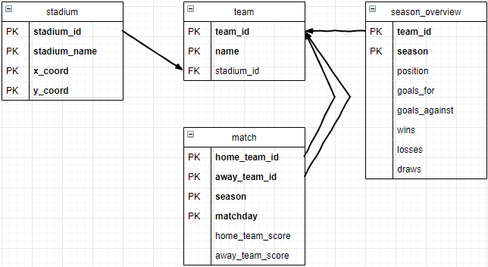

Season will be the year of the season start. E.g. 2019/20 season will be stored in the database as 2019.  
Matchday will be 1 to 38.  
I initially thought of having an upcoming_match table and a match table but from discussion with my tutor I decided to have a null score for matches that are yet to be completed.  
season_overview was a name change from league_position that I initially had. I feel like season_overview captures what the table is used for. It will be used to store multiple seasons of data per team.