In Class Activity 8 Adnan Inusah
Activity 0: Open AWS Account
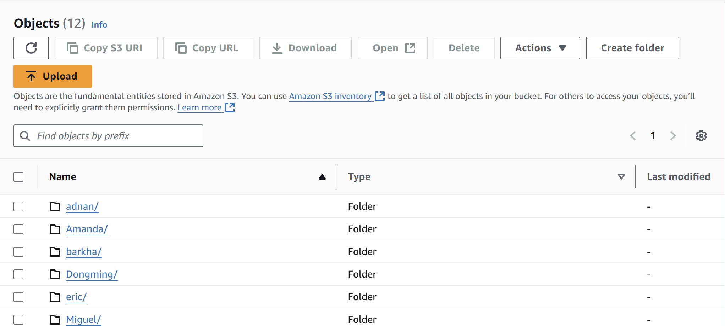

Activity 1: Creating tables
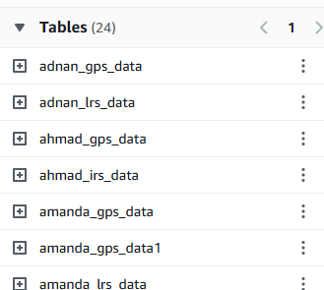

Activity 2: GeoSQL
SELECT ST_POINT(-93.610065, 41.948637) AS point_feature
LIMIT 1;

SELECT ST_DISTANCE(
ST_POINT(-93.610065, 41.948637),
ST_POINT(-93.610229, 41.997339)
) AS distance_btn_points
LIMIT 1;

WITH points AS (
SELECT
ST_POINT(-93.610065, 41.948637) AS point_1,
ST_POINT(-93.610229, 41.997339) AS point_2,
ST_POINT(-93.619738, 41.972017) AS point_3
)

SELECT ST_DISTANCE(
ST_LINESTRING(ARRAY[point_1, point_2]),
point_3)
AS distance_to_line
FROM points
LIMIT 1;

WITH points AS (
SELECT
ST_POINT(-93.610065, 41.948637) AS point_1,
ST_POINT(-93.610229, 41.997339) AS point_2,
ST_POINT(-93.619738, 41.972017) AS point_3
)

SELECT ST_DISTANCE(
ST_LINESTRING(ARRAY[point_1, point_2]),
point_3) * 364567
AS distance_to_line_in_feet
FROM points
LIMIT 1;

WITH buffer_area AS (
SELECT ST_BUFFER(ST_POINT(-94.295980, 41.502954), 0.05) AS buffer_area
)

SELECT *,
ST_POINT(longitude, latitude) AS point_geometry
FROM adnan_gps_data;

WHERE
ST_CONTAINS(buffer_area, ST_POINT(longitude, latitude))
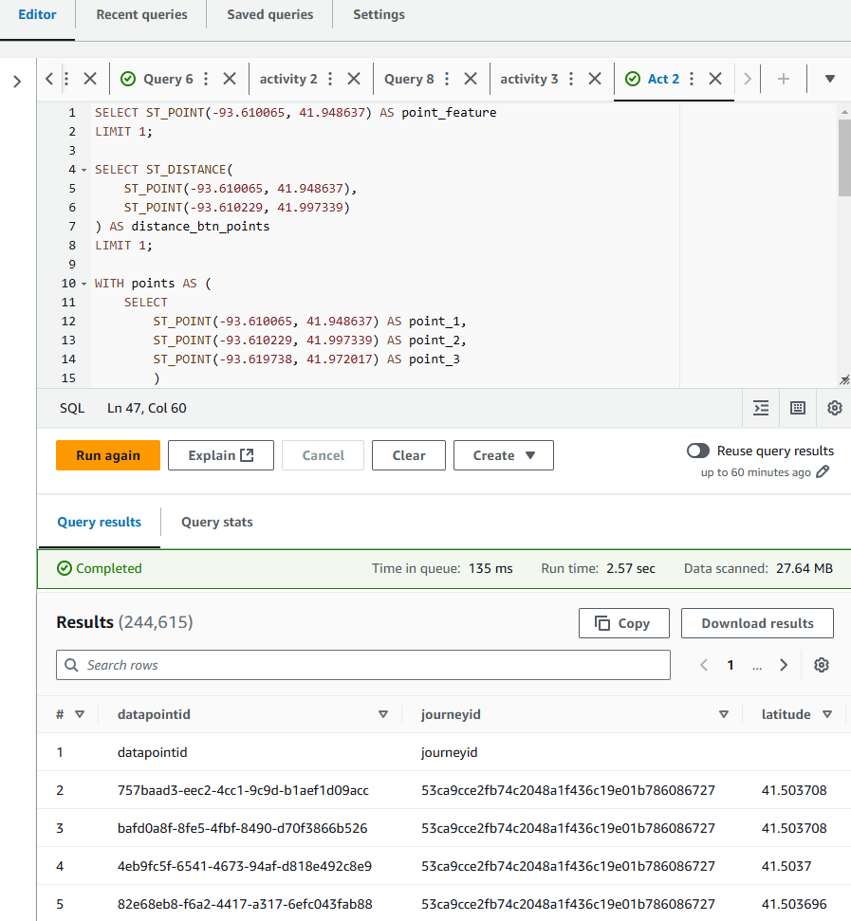

Activity 3: Data conflation through spatial join
WITH line_segments AS (
SELECT
route_id,
ST_LINESTRING(ARRAY[
ST_POINT(segment_start_longitude, segment_start_latitude),
ST_POINT(segment_end_longitude, segment_end_latitude)
]) AS route_line
FROM adnan_lrs_data
WHERE NOT (segment_start_latitude = segment_end_latitude AND segment_start_longitude = segment_end_longitude)
),
point_to_line_distances AS (
SELECT
b.datapointid,
b.journeyid,
b.latitude,
b.longitude,
a.route_id,
ST_DISTANCE(ST_POINT(b.longitude, b.latitude), a.route_line) AS distance_to_route
FROM (
SELECT *
FROM adnan_gps_data
WHERE hour = 1 AND day = 2
) AS b
CROSS JOIN line_segments AS a
)
SELECT
datapointid,
journeyid,
latitude,
longitude,
route_id,
distance_to_route
FROM (
SELECT
datapointid,
journeyid,
latitude,
longitude,
route_id,
distance_to_route,
ROW_NUMBER() OVER (PARTITION BY datapointid ORDER BY distance_to_route) AS row_num
FROM point_to_line_distances
) AS ranked_distances
WHERE row_num = 1

