**CE 5900 – 16   
Lecture 7 – In-class Activity**

**By Revanth Mamidala**

**Activity 1: Create table and load data from gps_data, vehicle_data**

**Script:**

-- First, create the tables

CREATE TABLE gps_data (

datapoint_id VARCHAR PRIMARY KEY,

journey_id VARCHAR(50),

captured_timestamp TIMESTAMP,

latitude NUMERIC(10, 7),

longitude NUMERIC(10, 7),

month INTEGER,

day INTEGER,

hour INTEGER

);

CREATE TABLE vehicle_data (

datapoint_id VARCHAR PRIMARY KEY,

geohash VARCHAR(12),

speed NUMERIC(5, 2),

make VARCHAR(50),

model VARCHAR(50),

route_id VARCHAR(50),

segment_start_measure NUMERIC(5, 2)

);

-- Now, use the COPY command to import data into gps_data

COPY gps_data(datapoint_id, journey_id, latitude, longitude, month, day, hour)

--FROM 'C:\\Users\\revan\\Desktop\\Data\\gps_data.csv'

FROM 'D:\\gps_data.csv'

DELIMITER ','

CSV HEADER;

-- COPY command for vehicle_data

COPY vehicle_data(datapoint_id, geohash, speed, make, model, route_id, segment_start_measure)

FROM 'D:\\vehicle_data.csv'

DELIMITER ','

CSV HEADER;

Output:

**Activity 2: Filtering**

1. Select datapoints from October 3, 4AM

**Script:**

SELECT *

FROM gps_data

WHERE month = 10 AND day = 3 AND hour = 4;

SELECT COUNT(*)

FROM gps_data;

SELECT COUNT(DISTINCT journey_id)

FROM gps_data

WHERE month = 10 AND day = 3 AND hour = 4;

**

1. Count how many rows in gps_data table (Ans: 244614)

**Script and Output:**

1. Find how many unique journey_ids in the data filtered as per (1) (Ans: 7)

1. Filter data on Oct 1st and 3rd and hour between 3AM and 6AM (101116 rows)

Solution:

If we select only days Oct 1 and 3:

If we select days between Oct 1 and 3:

1. Select all journey_ids contain “abc” from whole gps_data table (find 8 of them)

1. Count how many datapoint_ids start with “9” (Ans: 15256)

1. Select all rows where journey_id ends with “cc” (66)

8. Select all columns, also prepare a new column that combines datapoint_id and day with a “-”

symbol

Ex(“sajgdfaj1334254kgjhsa-3”) and name it dpid_day

**Script:**

SELECT *,

CONCAT(datapoint_id, '-', day) AS dpid_day

FROM gps_data;

**Output:**

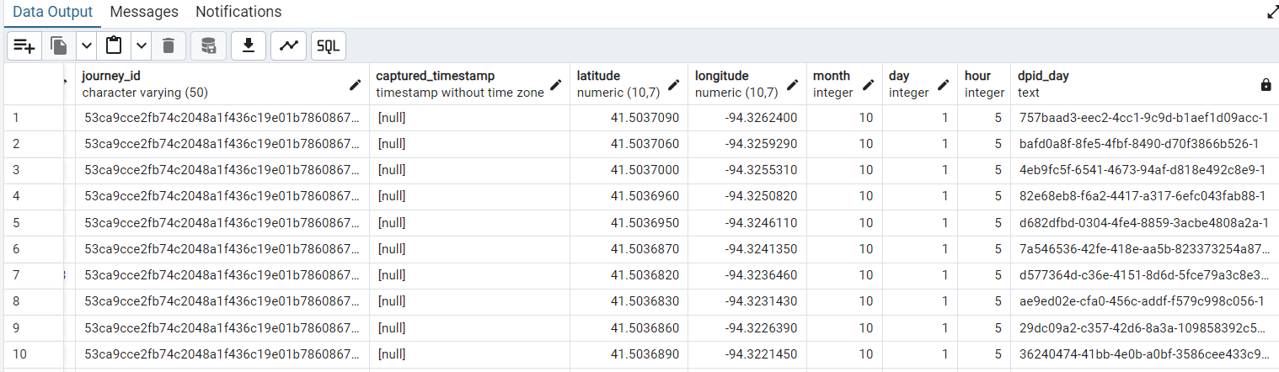

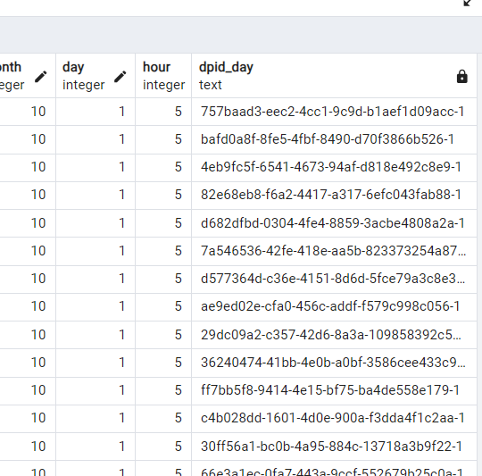

**Activity – 3: Aggregations**

1. Find maximum speed from table vehicle_data (Ans: 162.43)

1. Find average, minimum, maximum and standard deviations of speeds for “CHEVROLET” make

1. Create seg_id by combining “route_id” and “segment_start_measure”

**Script:**

SELECT *,

CONCAT(route_id, '-', segment_start_measure) AS seg_id

FROM vehicle_data;

**Output:**

1. Add this seg_id to existing vehicle_data table and verify it • Alter_table and update

**Script:**

-- Alter the Table to Add the seg_id Column

ALTER TABLE vehicle_data

ADD COLUMN seg_id VARCHAR(100);

-- Update the Table to Populate seg_id

UPDATE vehicle_data

SET seg_id = CONCAT(route_id, '-', segment_start_measure);

-- Verify the seg_id Column

SELECT *

FROM vehicle_data

LIMIT 10; -- Use LIMIT to view the first 10 rows for verification

**Output:**

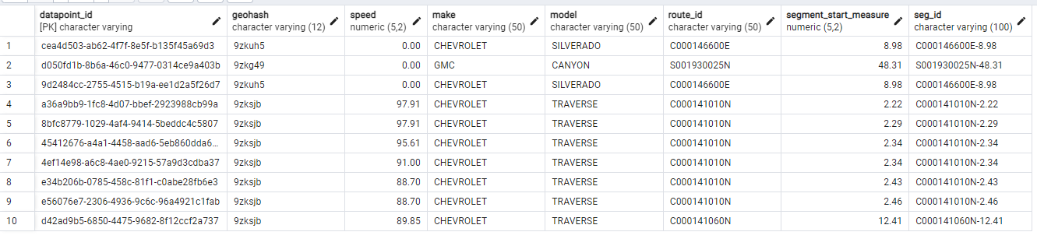

1. Find 85th percentiles speeds for each segment_id

**Script:**

SELECT seg_id,

PERCENTILE_CONT(0.85) WITHIN GROUP (ORDER BY speed) AS speed_85th_percentile

FROM vehicle_data

GROUP BY seg_id;

**Output:**

1. Find the highest speeds for each model? (Compare 95th percentile speeds for each model)

**Script:**

SELECT model,

PERCENTILE_CONT(0.95) WITHIN GROUP (ORDER BY speed) AS speed_95th_percentile

FROM vehicle_data

GROUP BY model;

**Output:**

|  |  |
| --- | --- |
| **model** | **speed_95th_percentile** |
| ACADIA | 126.71 |
| ATS | 118.65 |
| AVEO_SONIC | 130.17 |
| BLAZER | 126.71 |
| CAMARO | 127.87 |
| CANYON | 80.64 |
| COLORADO | 129.02 |
| CORVETTE_STINGRAY | 124.41 |
| CRUZE | 129.02 |
| CTS | 127.87 |
| ENCLAVE | 123.26 |
| ENCORE | 136.4474999999998 |
| ENVISION | 131.32 |
| EQUINOX | 126.71 |
| ESCALADE | 130.17 |
| ESCALADE_ESV | 23.5575 |
| IMPALA | 125.56 |
| LACROSSE | 133.63 |
| MALIBU | 131.32 |
| SIERRA | 126.71 |
| SIERRA_HD | 130.17 |
| SILVERADO | 127.87 |
| SILVERADO_HD | 125.56 |
| SPARK | 131.32 |
| SRX | 118.65 |
| SUBURBAN | 130.17 |
| TAHOE | 126.71 |
| TERRAIN | 124.41 |
| TRAVERSE | 129.02 |
| TRAX_TRACKER_TRAILBLAZER_B | 127.87 |
| VERANO | 127.87 |
| XT4 | 125.56 |
| YUKON | 131.32 |
| YUKON_XL | 127.87 |

**Activity 4: Joins**

1. Join the “gps_data” and “vehicle_data” tables using “JOIN” on datapoint_id

**Script:**

SELECT *

FROM gps_data

JOIN vehicle_data

ON gps_data.datapoint_id = vehicle_data.datapoint_id;

**Output:**

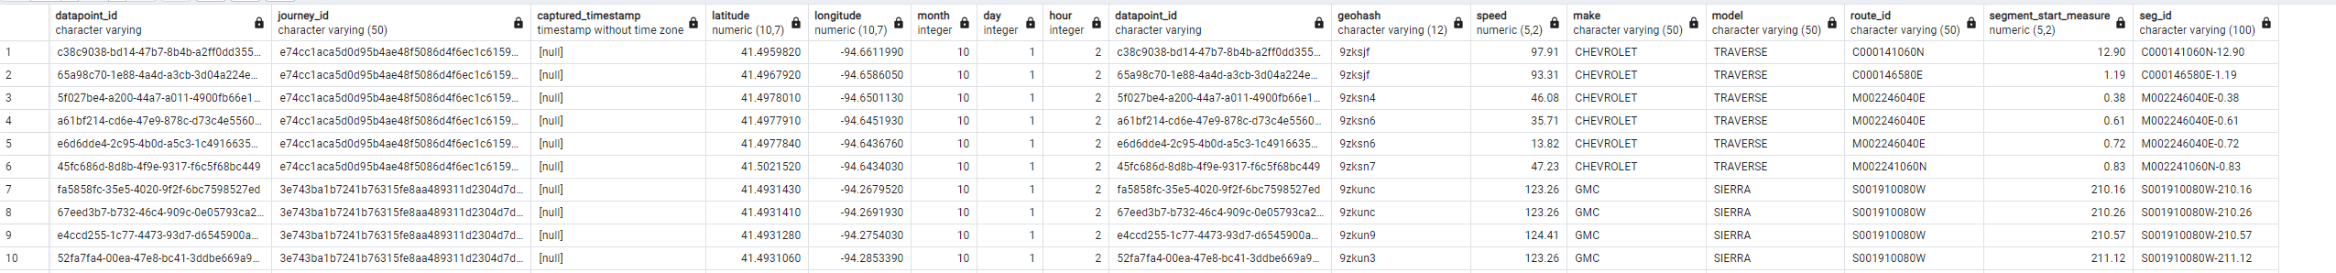

1. Select datapoint_id, journey_id, speed, seg_id from the above join

**Script:**

SELECT gps_data.datapoint_id,

gps_data.journey_id,

vehicle_data.speed,

vehicle_data.seg_id

FROM gps_data

JOIN vehicle_data

ON gps_data.datapoint_id = vehicle_data.datapoint_id;

**Output:**

1. Count the unique journey_ids that came to stop at least once (Speed = 0)

**Output:**

**Activity 5: Nested queries**

1. Filter points in “gps_data” with model = GMC from “vehicle_data”
   1. Use join

**Script:**

SELECT gps_data.*

FROM gps_data

JOIN vehicle_data

ON gps_data.datapoint_id = vehicle_data.datapoint_id

WHERE vehicle_data.make = 'GMC';

**Output:**

* 1. Use nested query

**Script:**SELECT *  
FROM gps_data  
WHERE datapoint_id IN (  
 SELECT datapoint_id  
 FROM vehicle_data  
 WHERE make = 'GMC'  
);

**Output:**

1. Count number of unique journeys in each car make and model using nested query order by make and model in descending order for each

**Script:**

SELECT make, model, COUNT(DISTINCT journey_id) AS unique_journey_count

FROM (

SELECT gps_data.journey_id, vehicle_data.make, vehicle_data.model

FROM gps_data

JOIN vehicle_data

ON gps_data.datapoint_id = vehicle_data.datapoint_id

) AS combined_data

GROUP BY make, model

ORDER BY make DESC, model DESC;

**Output:**

1. Filter the gps data of the journey with highest speed from the whole dataset
   1. You should find the jounrney_id with max speed from joining tables (JID: a37cf85fe887cb5b54fd828664ace413938a6e5d)

* 1. Then filter the corresponding journey data from gps_data (Ans: 343 rows)

**Activity 6:**

1. Find distance between points below:
   * Point 1: 41.948637, -93.610065, Point 2: 41.997339, -93.610229

1. Create a line string from above points and calculate distance from Point 3 : (41.972017, 93.619738)

1. Make point geometry from latitude and longitude in gps_data table

1. Create a buffer around point: 3 for 3 miles and filter all datapoints from gps_data within the buffer

**Script:**

According to the script result, the nearest point to the given point: 3 is at 54 miles distance.

The details of the point are as below:

