**Lecture 8**

**Activity 0: AWS account setup and folder creation**

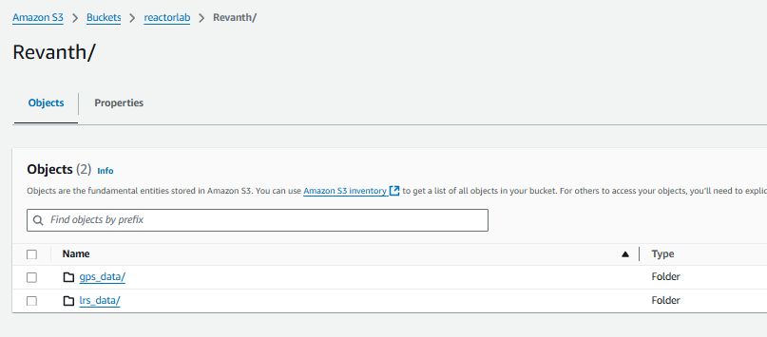

**Activity 1: Creating Tables**

1. **Creating Revanth_lrs_data:**

**Script:**

CREATE EXTERNAL TABLE IF NOT EXISTS `aiml_class`.`Revanth_lrs_data` (

`route_id` varchar(50),

`segment_start_latitude` float,

`segment_start_longitude` float,

`segment_end_latitude` float,

`segment_end_longitude` float,

`segment_start_measure` float,

`geohash_lrs` float)

ROW FORMAT SERDE 'org.apache.hadoop.hive.serde2.lazy.LazySimpleSerDe'

WITH SERDEPROPERTIES ('field.delim' = ',')

STORED AS INPUTFORMAT 'org.apache.hadoop.mapred.TextInputFormat' OUTPUTFORMAT 'org.apache.hadoop.hive.ql.io.HiveIgnoreKeyTextOutputFormat'

LOCATION 's3://reactorlab/Revanth/lrs_data/'

TBLPROPERTIES ('classification' = 'csv');

1. **Creating Revanth_gps_data**

**Script:**

CREATE EXTERNAL TABLE IF NOT EXISTS `aiml_class`.`revanth_gps_data` ( `datapointid` varchar(50), `journeyid` varchar(50), `latitude` float, `longitude` float, `month` int, `day` int, `hour` int, `geohash` varchar(10), `speed` float

) COMMENT "GPS_data"

ROW FORMAT SERDE 'org.apache.hadoop.hive.serde2.lazy.LazySimpleSerDe'

WITH SERDEPROPERTIES ('field.delim' = ',')

STORED AS INPUTFORMAT 'org.apache.hadoop.mapred.TextInputFormat' OUTPUTFORMAT 'org.apache.hadoop.hive.ql.io.HiveIgnoreKeyTextOutputFormat'

LOCATION 's3://reactorlab/Revanth/gps_data/'

TBLPROPERTIES ('classification' = 'csv')

**Output:**



**Activity 2: GeoSQL**

1. Make point feature from Point 1: 41.948637, -93.610065 using ST_POINT

**Script:**

SELECT ST_POINT(-93.610065, 41.948637) AS point1;

**Output:**

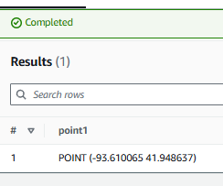

1. Find distance (ST_DISTANEC) between points below: (Ans: 0.048702)

Point 1: 41.948637, -93.610065, Point 2 : 41.997339, -93.610229

**Script:**

SELECT ST_DISTANCE(

ST_POINT(-93.610065, 41.948637),

ST_POINT(-93.610229, 41.997339)

) AS distance_in_degrees;

**Output:**

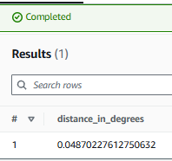

1. Create a line string (ST_LINESTRING) from above points and calculate distance from Point 3 : 41.972017, -93.619738 (Ans: 0.0095942)

**Script:**

SELECT ST_DISTANCE(

ST_POINT(-93.619738, 41.972017), -- Point 3

ST_LINESTRING(

ARRAY[

ST_POINT(-93.610065, 41.948637), -- Point 1

ST_POINT(-93.610229, 41.997339) -- Point 2

]

)

) AS distance_to_line;

**Output:**

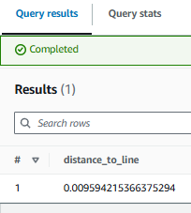

1. Get it in feet by multiplying 364567 (Ans: 3497.7 ft)

**Script:**

SELECT

ST_DISTANCE(

ST_POINT(-93.619738, 41.972017), -- Point 3

ST_LINESTRING(

ARRAY[

ST_POINT(-93.610065, 41.948637), -- Point 1

ST_POINT(-93.610229, 41.997339) -- Point 2

]

)

) * 364567 AS distance_in_feet;

**Output:**

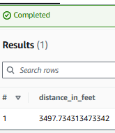

1. Make point geometry column from latitude and longitude in gps_data table
2. Create a buffer (ST_BUFFER) around 41.502954, -94.295980 for 0.05 units and filter all datapoints (ST_CONTAINS) from gps_data within the buffer (Ans: 54,581 rows)

**Script:**

WITH unique_gps_points AS (

SELECT

DISTINCT datapointid, -- Ensure unique datapoints

journeyid,

latitude,

longitude,

month,

day,

hour,

geohash,

speed

FROM revanth_gps_data

)

SELECT COUNT(*) AS num_points_in_buffer

FROM (

SELECT

ST_POINT(longitude, latitude) AS geom -- Create point geometry after deduplication

FROM unique_gps_points

) AS geom_points

WHERE ST_CONTAINS(

ST_BUFFER(ST_POINT(-94.295980, 41.502954), 0.05), -- Create buffer with a radius of 0.05 units

geom_points.geom -- Check if the points are within the buffer

);

**Output:**

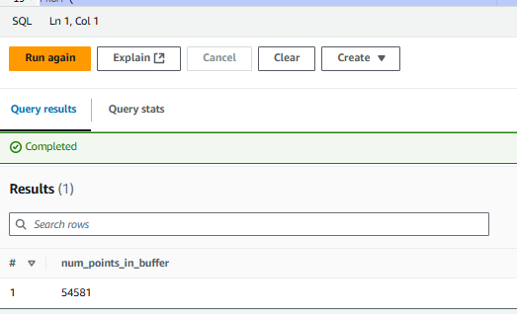

**Activity 3: Data conflation through spatial join**

1. Find distance from each point to all line strings in the database

**Script:**

select *, st_distance(

st_point(a.longitude, a.latitude),

st_linestring(array[

st_point(b.segment_start_longitude, b.segment_start_latitude),

st_point(b.segment_end_longitude,b.segment_end_latitude)])) distance from "raghu_gps_data" a

cross join (select * from "aiml_class"."raghu_lrs_data" where not segment_start_latitude = segment_end_latitude and not segment_start_longitude = segment_end_longitude) as b

where a.day =1 and a.hour = 1

**Output:**

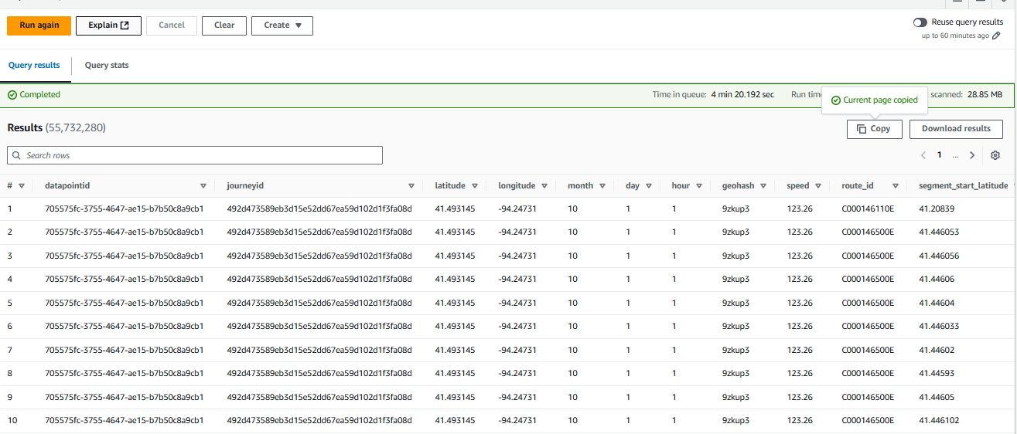

1. Filter the nearest one for each point through a nested query

**Script:**

WITH filtered_gps AS (

SELECT

datapointid,

journeyid,

latitude AS gps_lat,

longitude AS gps_lon,

day

FROM

revanth_gps_data

WHERE

day = 1 AND -- Use AND instead of a comma

hour = 1 -- Filter for hour = 1 as well

),

distance_calculation AS (

SELECT

gps.datapointid,

gps.journeyid,

gps.gps_lat,

gps.gps_lon,

lrs.route_id,

lrs.segment_start_latitude AS start_lat,

lrs.segment_start_longitude AS start_lon,

lrs.segment_end_latitude AS end_lat,

lrs.segment_end_longitude AS end_lon,

-- Haversine formula for distance to start of segment

6371 * acos(

cos(radians(gps.gps_lat)) * cos(radians(lrs.segment_start_latitude)) *

cos(radians(lrs.segment_start_longitude) - radians(gps.gps_lon)) +

sin(radians(gps.gps_lat)) * sin(radians(lrs.segment_start_latitude))

) AS distance_to_start,

-- Haversine formula for distance to end of segment

6371 * acos(

cos(radians(gps.gps_lat)) * cos(radians(lrs.segment_end_latitude)) *

cos(radians(lrs.segment_end_longitude) - radians(gps.gps_lon)) +

sin(radians(gps.gps_lat)) * sin(radians(lrs.segment_end_latitude))

) AS distance_to_end

FROM

filtered_gps gps

CROSS JOIN

revanth_lrs_data lrs

)

SELECT * FROM distance_calculation;

**Output:**

