In Class Activity 9 Adnan Inusah

Activity 1

Activity 2

Bar Chart (Vertical)

Pie Chart

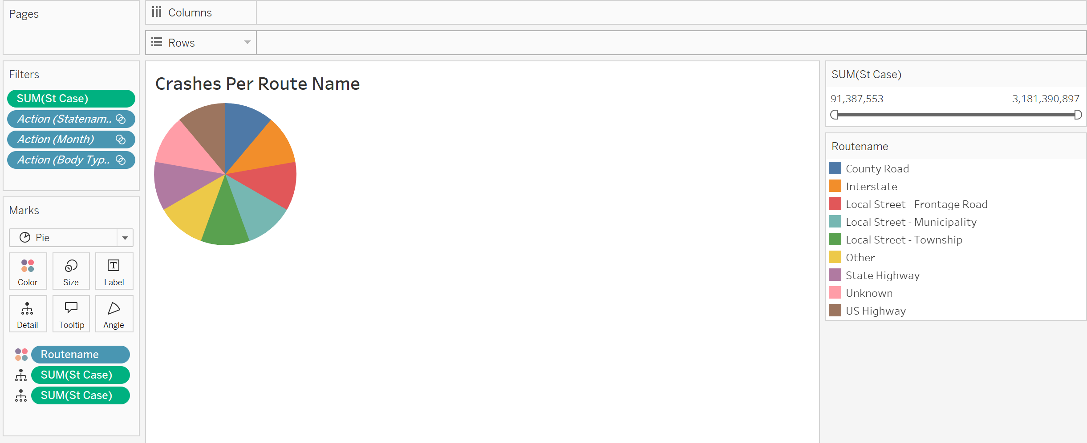

Line Graph

Map

Bar Chart (Horizontal)

Activity 4 & 5

Interactive Dashboard with More Visuals

