Design Project #1

Thermal Fluids Design – MAE 3524

William Van Dyke

# Section 1

This paper will explore the process of selecting and validating a compressor to replace an existing compressor in a vapor compression cycle. The purpose of replacing the compressor is to reduce power consumption while cooling the specified space more efficiently.

This paper references software, Engineering Equation Solver (EES), which is used to find thermodynamic properties and solve systems of equations presented by the problem.

In this paper the size that needs to be cooled is 830 ft2 and the original vapor compression cycle is defined in Table 1.1.

Using the given information it is possible to use common assumptions and the first law of thermodynamics to fully define the system. The EES code below in Fig 1 is used to evaluate the original system. After the needed thermodynamic properties are found it is possible to find the systems isentropic efficiency, coefficient of performance (COP), energy cost per hour, energy cost per month, and capacity. Table 1.1. also displays the size of the space that the system is being optimized for and the capacity required to cool that space.

Table - Evaluation of Original System

Table - Section 1 Calculations

Table - Section 1 Results

# Section 2

This project chose to focus the scope on Copeland compressors. It was possible to find two suitable compressors that met all the design requirements. The two selections fit within the physical bounds, use R410A refrigerant, and use single phase 60Hz 208/230 V power input. The compressors that have been selected are the CP22K8ME-PFV and the ZP21K6E-PFV. More information about each compressor can be seen from Table 4.

As stated previously, the goal of this paper is to explore possible replacements for a compressor to decrease the economic cost and increase efficiency of the current system.

Table - Alternative Compressors

# Section 3

To aid the evaluation of the compressors mathematical model were created in EES using the compressor coefficients provided by the Copeland. These coefficients can be seen on Table 5 and Table XXX. The models were validated against the manufacture data so that they could be used to predict how to compressor will function under the operating conditions.

## Compressor 1

Table - CP22K8ME-PFV Coefficients

Table - CP22K8ME-PFV Validation Data

Table - CP22K8ME-PFV Code

Table - CP22K8ME-PFV Solutions

Table - CP22K8ME-PFV at Predicted Operation Conditions

## Section 2

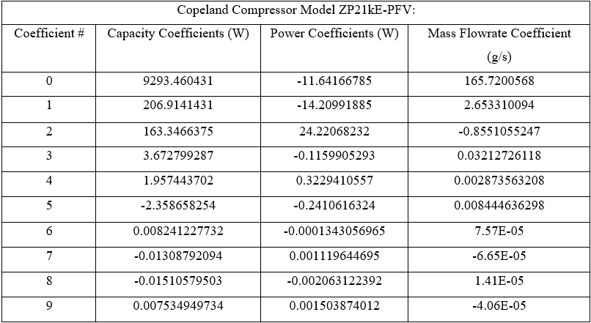

Table - ZP21KE-PFV Coefficients

Table - ZP21KE-PFV Validation Data

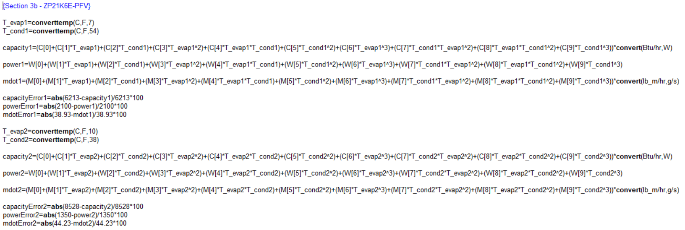

Table - ZP21KE-PFV Code

Table - ZP21KE-PFV Solutions

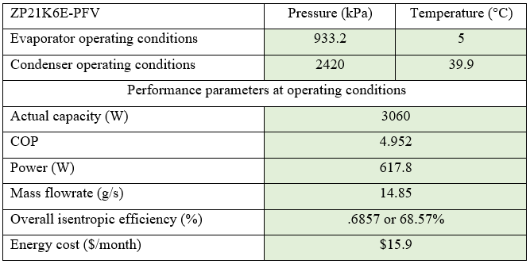

Table - ZP21KE-PFV at Predicted Operation Conditions

# Section 4

The compressor that was chosen for the improved design is the ZP21K6E-PFV. This compressor was chosen for its improved efficiency and lower operating cost. This compressor will adequately cool the space while using much less power to do so compared to the other option. Below is the summary of the compressor working at the predicted operation condition and a TS and PH diagram of the VCC. 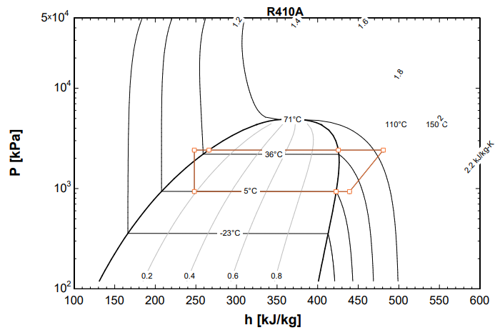

Table - VCC P-h Diagram

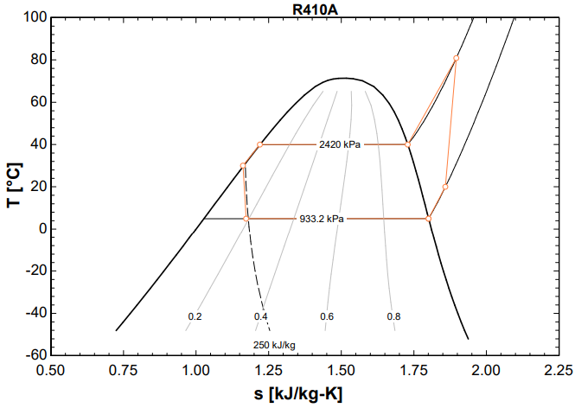

Table - VCC T-s Diagram

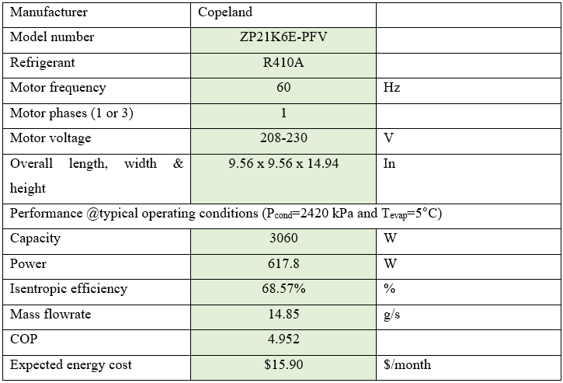

# Appendix

