**An Investigation into the Non-Linearity of UK Equity Factors**

**ES30029 - Final Year Research Project**

**Barnaby napier (14041)**

2020

**Contents**

1. Acknowledgements 2

2. Abstract 2

3. Introduction & Background 2

4. Literature Review & Theory 3

4.1. Efficient Market Hypothesis 3

4.2. Factor Models 3

4.2.1. CAPM (the market factor) 3

4.2.2. Fama French 3 Factor Model 3

4.2.3. Fama-French 5 factor model 4

4.3. Market Anomalies 4

4.3.1. Momentum 4

4.3.2. Volatility 4

4.4. Non-Linearity 4

4.4.1. Non-Linear Regression Models 4

5. Analysis 4

5.1. Data 4

5.1.1. Collection & Sources 4

5.1.2. Exploratory Analysis 5

5.2. Models & Methodology 6

5.2.1. Linear Regression 6

5.2.2. Non-Linear Models 6

5.3. Results 7

5.3.1. Results 7

5.3.2. Limitations 7

6. Conclusion 7

7. Bibliography 7

8. Appendix 7

Acknowledgements

* Patrick
* Andrzej

Abstract

what is the goal of the paper

what does the paper discover/prove/conclude

1. Introduction & Background

For as long as the stock market has existed, its participants have been searching for ways to accurately assess the expected return of a stock. The main motivation is usually to make money, but beyond this an accurate evaluation of a stock’s expected return can be informative for the company’s management in choosing a discount factor for projects it is considering undertaking. Along the same lines, a security’s expected return can be used to estimate the cost of capital of a company and hence determine its discounted fundamental value today.

The theory of equity risk premia is that the expected return of a stock can be decomposed into a contemporaneous function of various factor exposures. The generalized linear specification is shown in equation [x].

Where each is the return of factor in period , and is the exposure of stock to factor . For a factor model to be complete, must statistically indifferent from 0, and must be independent and identically distributed (i.i.d) with a normal distribution. Together these two facts imply that there is no autocorrelation in the error terms, hence no information could be added to improve the model, and that the model captures the entirety of an asset’s return.

As a result, investors can tilt their portfolios toward companies with higher factor exposures, increasing the expected return of their portfolio as a result.

contemporaneous regression 🡪 for return decomposition

regression with underlying characteristics 🡪 for prediction

There are three broad causes of return factors (Pioch, 2018). Firstly, there is compensation for risk, in which an investor earns a higher expected return in exchange for taking mr risk. For example, the illiquidity risk of owning a small company leading to the size effect. Secondly, there are factors caused by behavioural biases of market participants. Our tendency to overweight recent observations, disproportionately fear losses and idolise a compelling story lead to some of the persistent inefficiencies that we observe in the markets today. Thirdly, equity risk premia can be a product of market structure. An example of this is the January effect, where fund managers sell stock in December to lock in their gains, then buy it back in January in order to make returns for the new year, leading to lower returns in December and higher returns in January.

Beyond the drivers mentioned above, some equity factors have their roots in financial economic theory. Fama and French (2015) use the dividend discount model to show that the book to market effect is engrained into traditional and commonly used asset pricing models.

either explain theoretical model or remove it ^^

As will be elaborated on in the following section, equity factors have generally been modelled and tested using a linear specification such as the one shown above. The simplicity of the linear model makes it easy to interpret and hence an attractive choice for the estimation of equity factors, but that simplicity may in turn sacrifice accuracy. We may wish to use more advanced statistical models to estimate the expected return of a stock, allowing for the relaxation of the linearity constraint, as well as allowing for interaction terms between predictors.

As a result of this fact, the goal of this thesis is to investigate the extent to which nonlinear statistical models perform better in decomposing security returns into their factors in the UK, as well as using these factors for return prediction.

Some analysis of this type has been done over the years, with the idea for this thesis being born out of a recent publication by Gu, Kelly and Xiu (2019). Given the larger dataset in the US, most of the research on this topic has been conducted there. I believe that there should be an attempt made to do the same on UK data, allowing for a comparison of non-linear multi factor models across the two countries. That being the case, UK data has a shorter time scale and less detail, which this thesis acknowledges.

The rest of this paper is broken down into [X] main sections. Firstly, section [y] provides a summary of the research that has been done on equity factors and their nonlinearity. Following this, section [y] elaborates on the models applied in this thesis, as well as concluding the key findings from their application.

1. Literature Review & Theory

The literature for this thesis originates from two main fields, namely, equity risk premia and machine learning. After a brief summary of the efficient market hypothesis, section 2.2 outlines the main models that have been researched in the field of equity factors, meanwhile section 2.3 summarises the literature on machine learning and its application to modelling risk premia.

* 1. Efficient Market Hypothesis

As a precursor to the literature on equity factors. It is first important to acknowledge the implications for market efficiency. Eugene Fama (1970) proposed the idea of the efficient market hypothesis (EMH) in which he posited that at any given moment, prices will fully reflect all information that is available to the market. Consequently, assuming that the discovery of new information is a random process, stock returns must also follow a random process.

Depending on the driver of excess returns, an equity factor may or may not contradict the EMH. Of the three drivers of risk premia mentioned above, compensation for risk is undoubtedly in line with the EMH given the risk-return trade-off of the markets. The other two drivers however create the potential for market participants to achieve risk adjusted returns that are consistently higher than the market, and therefore contradict the EMH.

The implications of the EMH for equity factors are as follows; no investor, statistician or trader can use the set of publicly available information to correctly and consistently forecast asset returns.

* 1. Equity Risk Premia
     1. The Market

The first model that proposes stock returns are composed of a set of factors is the Capital Asset Pricing Model (CAPM) put forward independently by William Sharpe (1964) and John Lintner (1965). It states that the excess return of a stock above that of the risk-free rate is equal to a stock specific measure of risk, beta, multiplied by the risk premium of the stock above that of the market.

The beta of a stock represents its riskiness relative to the market and can be defined by equation 2 below, or more commonly by the regression coefficient produced when running OLS on equation 1.

In the risk-reward space, the CAPM model is represented by the Security Market Line (SML), depicted in figure [y]. This line is upward sloping, indicating that taking on additional risk entitles an investor to a higher expected return. By taking the risk of the market as defined by a beta of 1, figure [y] graphically represents what is known as the equity risk premium, which equals the expected return on the stock market in excess of the risk-free rate.

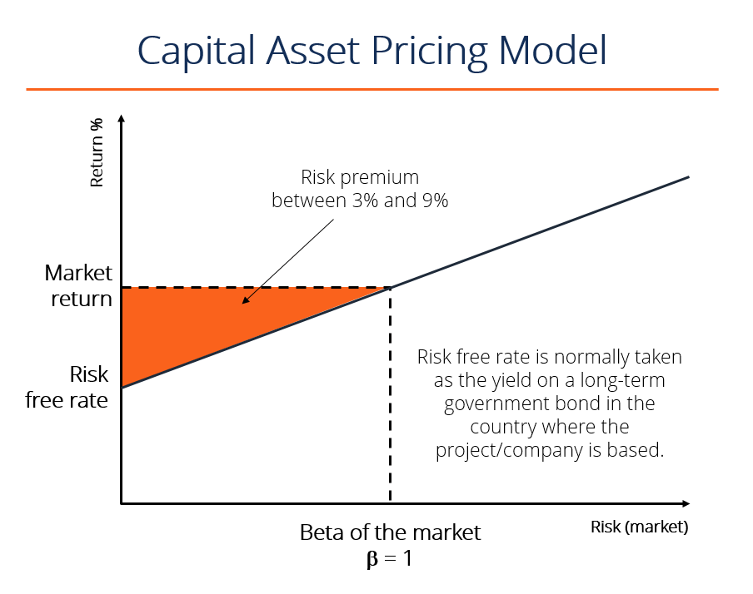

The existence of the such a premium is in accordance with the EMH, because investors are rewarded with a higher expected return for taking the additional risk of putting their money into the stock market, which is the highest risk asset class.

* + 1. Size and Value

A few decades after Sharpe and Lintner, Eugene Fama and Kenneth French (1993) introduced the concept of multiple equity factors by suggesting that stock returns are driven by more than just the equity risk premium. In their three-factor model, Fama and French (hereby FF) showed that as well as the market risk premium, stocks are also exposed to the size (SMB) factor and value (HML) factor. They found that, in their dataset, over 90% of the variation in security returns could be explained by the three factors in question. The FF (1993) three-factor model is specified in equation [x].

Firstly, *the Size factor* is represented by the difference in average return on the smallest and largest 20% of stocks, resulting in the “Small Minus Big” (SMB) factor. There are two common explanations for the outperformance of smaller companies (Size factor definition - Risk.net, 2020). Firstly, smaller companies are less liquid, and so in buying shares in the company, an investor is accepting the risk that she may not be able to sell them for a fair price in the future if demand dries up. Secondly, smaller companies are viewed as inherently riskier as they are more susceptible to changes in the economy and business cycle. Either way, there is no doubt that the size factor is a result of investors being compensated for taking additional risk.

Secondly, *the Value factor* is calculated as the difference in average return on the 20% of companies with the highest and lowest book-to-market value, giving the “High Minus Low” (HML) factor. The idea of value investing is that cheap stocks tend to outperform expensive ones in the long run. There are various definitions of value in a company, including dividend yield, book to market value and price to book value. However, all indicate the same characteristic, namely, that the investor is getting a lot for what they are paying.

* + 1. Momentum

Momentum is the observation that stocks with strong past performance will continue to outperform in the future, meanwhile those that performed poorly will continue to underperform. The idea that equity returns possess this serial autocorrelation was first put forward by Jegadeesh (1990), who found a negative autocorrelation at short lags such as one month but positive correlation at longer lags, especially twelve months.

The prevailing reason behind the existence of momentum is that humans participate in the stock market, and humans have behavioural biases (Carlson, 2020). There are specifically two biases which are broadly accepted as contributing to the momentum factor. Firstly, there is recency bias. This says that people put too much value on recent observations when making decisions, including investment decisions. Consequently, stocks that have performed well recently will look like good investments and hence perform better in the future as more investors buy into the story. Secondly, individuals often suffer from social proof, or herding. Typically, when a person is facing a tough decision, they look to the actions of others to discover the best choice. If the price of a stock has been rising, that means that other people have been buying it, so in order to follow what others are doing an investor should also buy the stock too, driving up the price.

Jegadeesh’s 1990 paper was built on by two more influential papers. Firstly, Jegadeesh and Titman (1993) followed up on the paper, evaluating the consequences of momentum for stock market efficiency. They conclude that returns from momentum trading strategies are not due to a risk-reward relationship and hence are in contrast to the EMH.

Secondly, Mark Carhart (1997) proposed the *Carhart four-factor model* a few years later. The model adds a momentum factor to the FF three-factor model by including an Up Minus Down (UMD) factor, which equals the average return of past winners minus the average return of past losers.

talk more about carhart model

* + 1. Quality

Many years later, Fama and French (2015) added to their three-factor model by incorporating a Quality factor exposure. Quality implores managers and investors to buy good companies who invest well and make solid profits.

Firstly, *low investment* as defined by the CMA factor equals the return of companies that invest conservatively minus the return of companies that invest aggressively. The intuition is that companies that do not invest a lot have higher standards for projects that they take part in, ensuring a higher rate of return as they are not experiencing the same level of diminishing marginal returns that those companies investing heavily are.

Secondly, *profitability* is defined by the RMW factor, which takes the return of companies with robust profits minus the returns of companies with weak profits. More profitable companies will intuitively earn a higher return as investors pay more for a share of the higher profits. However this does not explain why the EMH is not functional here, and hence why any excess return is not bought up immediately.

The two components of the quality factor can be explained using the Dividend Discount Model (DDM) of asset pricing (Miller and Modigliani, 1961), which posits that the current value of a company is equal to the discounted present value of its expected future dividends.

Dividends can be defined as company earnings minus the change in book value of the company, giving equation [x].

Finally, in accordance with FF (2015), dividing through by current book value gives equation [x].

Robust profitability refers a high value of in equation [x], while conservative investment implies a low . Both lead to a higher value of in equation [x] and in equation [x].

Together these additional factors make up the FF five-factor model specified in equation [x].

* + 1. Volatility

Finally, Andrew Ang (2006) showed that companies have an exposure to market volatility, and those with a lower sensitivity would have higher expected returns. Specifically, he used the VIX index, a measure of market volatility, to show that companies with less exposure to changes in the index saw statistically significant outperformance in future periods.

Low volatility is a rather confusing factor in that it appears to directly contrast the risk-reward framework at the centre of financial markets. The main theory behind its existence is what is known as the lottery effect (What is Low Volatility and Why Does It Matter? - Invesco, 2020). The idea is that in order to achieve a higher expected return, investors go looking for high risk companies that can offer these higher returns. As a result, lower risk companies are underbought and hence offer a return premium to investors as a result of being avoided in the first place.

In his paper, Ang proposed multiple models for volatility, two of which built off of the CAPM and FF three-factor models respectively, as specified in equations [x] and [x].

* 1. Non-Linearity

So far all of the models put forward use a linear specification to estimate the relationship between the respective factor and equity returns. This section summarises the models and respective papers which relax the assumption of linearity, in most cases finding promising results.

* + 1. Generalised Linear Models

The first extension of the linear model which allows for nonlinearity is a family of models which fall under the generalised linear models. Despite the name, these models are linear only in specification. Generalised linear models involve running OLS on functions of the independent variables as opposed to the variables themselves. As the name suggests, this is a highly generalised setup as it allows for any function to be passed. The generic form of the model is specified in equation [x].

As a result, these models allow for nonlinearities between each and . A simple example is the polynomial regression. Most papers that apply machine learning to equity risk premia modelling also include a polynomial regression or other form of generalised linear model. Most recently, Gu, Kelly and Xiu (2018) investigate how generalised linear models compare to a linear specification, as well as to other machine learning models, finding that they marginally outperform OLS in both monthly and annual return prediction.

* + 1. Supervised Machine Learning

Building on generalised linear models is common in machine learning literature. Not much of the literature around equity factors has implemented machine learning models, however, those that did have shown promising results. Gu, Kelly and Xiu (2018) investigate the performance of various machine learning models in forecasting expected returns in the US market. They find that machine learning models have stronger predictive power than linear regression, with neural networks and regression trees being the most performant. The authors identify the advantage of relaxing the nonlinearity assumption, as well as the capacity for a larger predictor set as potential reasons for the strong performance of machine learning models. Further to this, they rationalise the strong performance of non-parametric models such as regression trees as evidence of potentially complex interaction effects being present in the true model.

* + 1. Deep Learning

Beyond traditional machine learning, research is also being conducted in the area of deep learning, which involves using neural networks with multiple hidden layers for prediction.

The first to investigate how artificial neural networks (ANN) can be applied to equity factors was Levin (1996), meanwhile more recently Nakagawa, Uchida and Aoshima (2018) and Nakagawa (2019) estimate deep factor models of equity returns.

As this thesis falls under the Department of Economics, little will be said of these models, which lie closer to the study of computer science. Furthermore, Gu, Kelly and Xiu (2018) find some evidence that deep learning models do not outperform shallow learning or traditional machine learning on their dataset. The reader is encouraged to survey the aforementioned literature for an idea of the state of research in this area.

1. Data

This section outlines the data used in this thesis. Section 3.1 outlines the sources of the data, as well as how it was aggregated and how certain parts filtered out. Section 3.2 then describes how the factor returns are constructed to replicate those from the original papers using the data from section 3.1. Following this, 3.3 outlines the predictor sets that are used for each model. Finally, section uses the newly constructed factors to provide a rationale for modelling equity factors in a nonlinear fashion.

* 1. Collection & Sources

The data used in this thesis is collected from Thomson Reuters DataStream over the period 31/12/1995 to 31/12/2018. It consists of monthly, stock level data for all companies in the FSTE All-Share, conditional on sufficient data availability. Investment trusts, unit trusts and other investment vehicles are removed at this stage of the process due to their anomalous characteristics, which are both undesirable and unintuitive when estimating equity risk premia. All predictors are either downloaded directly from DataStream or calculated using data that is. The full list of downloaded and calculated predictors and time series can be found in table [X] of the appendix.

Companies are deemed eligible for inclusion in regressions in period if the independent variables used in the regression are available in period , and return of the security (the dependent variable) available in period . This ensures that for cross-sectional regressions, a company cannot contribute to the matrix of independent variables without also contributing to the vector of the dependent variables.

Both security and market returns are calculated in excess of the risk-free rate, which is taken to be the interest rate paid on 3-month UK government bonds (“Gilts”). This means that regressions implicitly control for the rate of interest in the UK at the time.

* 1. Constructing Factor Returns

Before testing various models, factor returns must be constructed in the same fashion as the papers from which they originate. The factors used in this thesis encompass all those included in the section 2.2. Table [x] details how each factor is calculated.

Table 1 - Definitions of Factor Returns

|  |  |
| --- | --- |
|  | Return of the market (FTSE AllShare) |
|  |  |
|  | Return of 20% of companies with smallest market value – Return of 20% of companies with largest market value |
|  | Return of 20% of companies with highest return on invested capital – Return of 20% of companies with lowest return on invested capital |
|  | Return of 20% of companies with highest operating profit margin – Return of 20% of companies with lowest operating profit margin |
|  | Return of 20% of companies with highest return over last twelve months – Return of 20% of companies with lowest return over last twelve months |
|  | Return of 20% of companies with lowest return volatility over last twenty-four months – Return of 20% of companies with highest return volatility over last twenty-four months |

Given that not all data used in the original papers is available in the UK, in some cases the method of calculation is not the same as the original paper, and a similar measure is used as a proxy. The two cases in which this occurs are the following: Firstly, data could not be collected on the level of investment in order to calculate the CMA factor. As a proxy, return on capital employed is used, because companies that invest less will be earning a higher return on their investments, assuming that the available projects suffer from diminishing marginal returns. Therefore, the CMA factor instead compares companies with high ROIC to low. Secondly, the volatility

redefine volatility as the vol of allshare and not the underlying security (then it is more of an actual factor)

Figure [y] shows the returns of each factor relative to the market since 2010, while table [x] outlines specifies the risk adjusted performance of each factor.

* 1. Defining Predictor Sets

The linear model uses a linear predictor set identical to that in the pre-defined models, while the nonlinear models use a predictor set in which each variable in the linear predictor set is taken to the cubic polynomial.

For the purposes of this thesis, the linear form of each model is specified according to equations [x] to [x] respectively, with the addition of nonlinearities where appropriate.

FF (1993) Three-Factor Model

Carhart (1997) Four-Factor Model

FF (2015) Five-Factor Model

Ang (2006) FF Three-Factor Model with Volatility

* 1. Evidence of Nonlinearity

show nonlinearity

A brief investigation into the relationship between various independent variables and security returns indicates that there is a case for the nonlinear modelling of equity factors. This section outlines this rationale via three avenues; looking at these relationships graphically, statistically testing the significance of nonlinear predictors, and using a correlation matrix of various predictors.

Firstly, the graphical approach. The figures below show the relationship between various predictors of asset return and the asset return itself. In most cases the argument can be made that a linear model would fail to effectively fit the respective relationship, or at least that a nonlinear model would be expected to perform better.

Secondly, quadratic and cubic polynomials of each factor are statistically significant when used as independent variables to predict excess returns. In fact, in the case of the SMB factor these higher order polynomials are more significant than the linear form of the variable. Each higher order polynomial is with regards to the gross factor return, converting to net after the calculation is done. For example, if SMB is 2%.

Then the higher order polynomials are calculated as follows.

Finally, correlation matrices over the set of constructed factors suggest that there may be interaction effects between them. The main results from these matrices can be rationalised from what is known about equity factors: For example, small companies with higher exposure to the SMB factor also tend to be better value for money as defined by a higher exposure to the HML factor.

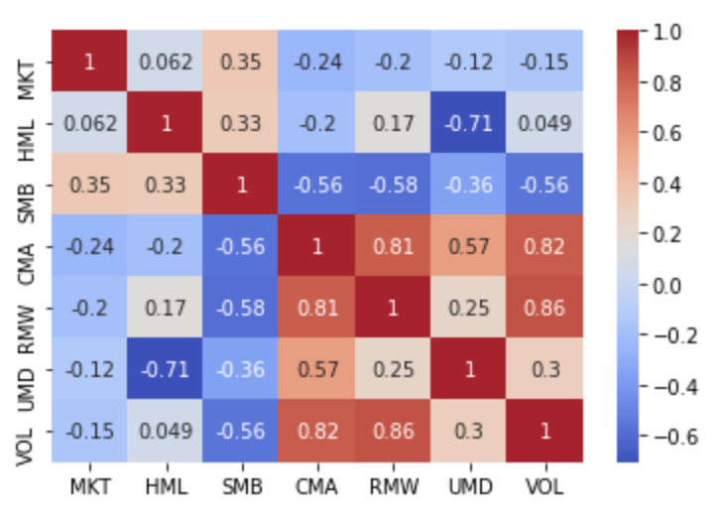

1. Methodology

This section will discuss the models that are used, as well as how each is fitted and validated. Section 4.1 outlines the different models that are to be compared, while sections 4.2 and 4.3 outline the method via which these models are fitted, and their tuning parameters chosen.

The models summarised in section 2.2 are used as the foundation upon which this thesis builds.

* 1. Models Estimated

The goal of this paper is to evaluate if models that allow for nonlinearity in the relationship between common equity factor returns and security returns improve upon the standard linear regression. As a result, a variety of models are considered, and their specifications summarised in this section.

* + 1. Linear Regression

Before investigating the performance of non-linear models, it is necessary to first estimate the linear model in order to provide a benchmark for their performance. The Ordinary Least Squares (OLS) model aims to minimise the sum of squared residuals (SSR) as defined in equation [x].

Given that all residuals are weighted the same, large outliers can have a disproportionate effect on the performance of the model and its predictions.

* + 1. Polynomial Regression

The first nonlinear model implemented is the polynomial regression, which builds on the linear regression by allowing for quadratic and cubic polynomials of variables to be used as predictors.

Firstly, a cubic polynomial predictor set is created from the existing data simply by raising all variables up to the third power. Each model specified above is expanded to include all predictors up to a cubic power, hence permitting a nonlinear relationship.

why is ^3 polynomial used instead of ^2 or ^4?

The goal of the cubic polynomial regression is the same as that of the linear regression, namely, to minimise the sum of squared residuals. Hence outliers are just as important in this scenario, however the idea is that by permitting a nonlinear relationship between predictors and returns the model will be a better fit.

* + 1. Lasso Regression

The lasso regression is a form of penalised regression in which a shrinkage factor attempts to limit the number of predictors incorporated into the model. The same predictor set is used as the polynomial regression, ensuring that this model can incorporate nonlinearities as well. The lasso regression implements L1 regularisation, which means that it includes a penalisation term which applies to the sum of the absolute values of predictor coefficients. Mathematically, instead of minimising the SSR, the optimisation aims to minimise equation [x].

The shrinkage term, , determines the severity with which additional predictors are penalised. A higher value of will limit the size of the predictor set more strongly than lower values, and so the choice of is important.

* + 1. Ridge Regression

The ridge regression also falls into the category of penalised regressions. It is similar to the lasso, but instead of using L1 regularisation to constrain the number of predictors it implements L2 regularisation. L2 regularisation means that instead of considering the sum of the absolute values of coefficients, the Ridge regression penalises the sum of the squared coefficients. This results in an optimisation problem which aims to minimise equation [x].

* + 1. Regression Tree

The final model used is a regression tree. The main difference between regression trees and the rest of the models implemented is that they are nonparametric, meaning that no functional form is implied in the relationship between predictors and outcomes when training the model.

explain how a regression tree works

do something like this (hyperparameter analysis)

* 1. Model Training

Traditionally, a process of k-fold cross validation would be used to train the model and evaluate its true performance. K-fold cross validation involves dividing the dataset into segments, or “folds”. One by one each fold is temporarily removed from the dataset. The model is then trained on the other folds and tested on the fold that was left out. Once each fold has been tested, an average performance can be taken over all folds and a fair evaluation of the model’s performance made.

This approach is commonly used in situations where the ordering of data does not matter. However, it can cause issues when applied to time series data given that it does not account for the intertemporal relation between different folds. Consider trying to predict the past given what happened in the future.

Consequently, in addition to k-fold cross validation, a process of rolling origin (or “walk forward”) evaluation (Tashman, 2000) is also used. This involves

When evaluating each model, is used as a measure of performance. is defined as the percentage variation in the dependent variable that is explained by the model and is specified by equation [x].

* 1. Hyperparameter Tuning

explain how you choose the tuning parameters of the models (lambda, alpha, tree depth etc)

1. Results
   1. Model Performance

results from k-fold cross validation

The results from training the models using k-fold cross validation method are shown below in table [x]. Out of sample values are low due to the high degree of noise present in financial market data.

The FF five-factor model appears to be particularly effective, with both linear and non-linear models performing well.

Regression tree models appear to be particularly effective in return prediction as opposed to return decomposition.

In addition to evaluating the extent to which nonlinear models improve the decomposition of returns, the same models are also evaluated in terms of their predictive capabilities. Understandably the performance here is weaker, as any significant results are likely to be arbitraged away by the millions of market participants looking for trading opportunities each day.

When used in prediction the factor returns cannot be regressed on as these variables are contemporaneous with the security returns that are being predicted. Consequently, the underlying variables to construct factor returns are regressed on instead.

results from other evaluation methods (walk forward cv)

comparison of linear to non-linear

discussion of regression coefficients

As well as a discussion of model performance, the coefficients from polynomial regressions are worth investigating.

mean squared error (mse)

distribution of residuals

size and significance of intercept

In addition to measuring model performance using , the extent to which a factor model captures all return variation can be evaluated via a brief investigation of the regression intercept and residuals.

* 1. Limitations of Results

There are however certain limitations to the results of this thesis. Firstly, data covering the UK market is not as rich or lengthy as that of the US, which is where most research on risk premia lies. Despite this issue, a motivation for this thesis is to investigate what information can be extracted from the data that is available, while acknowledging its limitations.

Secondly, the results presented may not be of the highest economic significance given that the models fitted do not account for practical issues such as that of trading costs. Hence it is admitted that it may not be practically possible to act on the positive performance of the fitted models, and in fact this could be a reason for a positive in the first place.

Finally, it is true that machine learning methods and other nonlinear statistical models are easier to overfit. The validation processes implemented aim at solving this but one must still be aware of the bias-variance trade-off, specifically when using nonlinear models.

1. Conclusion

could extend to more data and factors: illiquidity, value weight factors, try more ml models (neural networks)

how significant are these results in the field of equity risk premia

nobody has done this before, so it does show to an extent how the data in the uk can be used

also provides the basis for a uk equity factor model, of which there are also fewer

you may lose more in interpretability than you gain in predictability

Overall, this thesis has investigated the extent to which nonlinear statistical methods add value to an equity factor model in the UK. Results are compared in terms of both contemporaneous return decomposition models as well as predictive models.

Bibliography

Sharpe, W., 1964. Capital Asset Prices: A Theory of Market Equilibrium under Conditions of Risk. *The Journal of Finance*, 19(3), p.425.

Lintner, J., 1965. The Valuation of Risk Assets and the Selection of Risky Investments in Stock Portfolios and Capital Budgets. *The Review of Economics and Statistics*, 47(1), p.13.

Fama, E. and French, K., 1993. Common risk factors in the returns on stocks and bonds. *Journal of Financial Economics*, 33(1), pp.3-56.

Gu, S., Kelly, B. and Xiu, D., 2018. Empirical Asset Pricing Via Machine Learning. *SSRN Electronic Journal*.

Fama, E. and French, K., 2015. Dissecting Anomalies with a Five-Factor Model. *Review of Financial Studies*, 29(1), pp.69-103.

Carhart, M., 1997. On Persistence in Mutual Fund Performance. *The Journal of Finance*, 52(1), pp.57-82.

Ang, A., Hodrick, R., Xing, Y. and Zhang, X., 2006. The Cross-Section of Volatility and Expected Returns. *The Journal of Finance*, 61(1), pp.259-299.

Fama, E., 1970. Efficient Capital Markets: A Review of Theory and Empirical Work. The Journal of Finance, 25(2), p.383.

Pioch, A., 2018. *How market frictions live in harmony with persistent factor premia*. [online] Macromatters.lgim.com. Available from: https://macromatters.lgim.com/categories/portfolio-thinking/how-market-frictions-live-in-harmony-with-persistent-factor-premia [Accessed 25 Feb. 2020].

Jegadeesh, N., 1990. Evidence of Predictable Behavior of Security Returns. The Journal of Finance, 45(3), pp.881-898.

JEGADEESH, N. and TITMAN, S., 1993. Returns to Buying Winners and Selling Losers: Implications for Stock Market Efficiency. *The Journal of Finance*, 48(1), pp.65-91.

Gu, S., Kelly, B. and Xiu, D., 2018. Empirical Asset Pricing Via Machine Learning. *SSRN Electronic Journal*.

Tashman, L., 2000. Out-of-sample tests of forecasting accuracy: an analysis and review. *International Journal of Forecasting*, 16(4), pp.437-450.

Anon, 2020. *Size factor definition - Risk.net*. [online] Risk.net. Available from: https://www.risk.net/definition/size-factor [Accessed 18 Mar. 2020].

Carlson, B., 2020. *The Momentum Factor: Why Momentum Investing Works*. [online] See It Market. Available from: https://www.seeitmarket.com/the-momentum-factor-why-momentum-investing-works-14544/ [Accessed 18 Mar. 2020].

Miller, M. and Modigliani, F., 1961. Dividend Policy, Growth, and the Valuation of Shares. *The Journal of Business*, 34(4), p.411.

Anon, 2020. *What is Low Volatility and Why Does It Matter? - Invesco*. [online] Invesco.com. Available from: https://www.invesco.com/us2/factor-investing/low-volatility-factor-101/ [Accessed 18 Mar. 2020].

Appendix

Python Code

The code used to run the regression models and machine learning models. Programmed in Jupyter notebook.

Variables

The following variables are sourced directly from Thomson Reuters DataStream.

|  |  |
| --- | --- |
| **Name** | **Description** |
| *ret* | 1-month price return in excess of risk free rate |
| *mv* | Market value |
| *allshare* | Monthly price return of FTSE All Share |

The following variables were calculated using the data in the above table.

|  |  |
| --- | --- |
| **Name** | **Description** |
| *ret_12m* | 3-month price return in excess of risk free rate (gilt3m) |
| *gilt3m* | The annualised interest rate on 3-month UK government bonds. Used as risk free rate |
|  |  |