ABUBAKAR TAFAWA BALEWA UNIVERSITY, BAUCHI

FACULTY OF COMPUTING
DEPARTMENT OF COMPUTER SCIENCE

PROJECT TOPIC
DESIGN AND SIMULATION OF AN IOT-BASED SMART HOME AUTOMATION SYSTEM FOR SECURITY AND ENERGY EFFICIENCY

A FINAL YEAR PROJECT REPORT SUBMITTED TO THE DEPARTMENT OF COMPUTER SCIENCE, FACULTY OF COMPUTING, ABUBAKAR TAFAWA BALEWA UNIVERSITY, BAUCHI.

IN PARTIAL FULFILMENT OF THE REQUIREMENTS FOR THE AWARD OF BACHELOR OF TECHNOLOGY (B.TECH.) DEGREE IN COMPUTER SCIENCE

BY

TAVERSHIMA AONDOALOUGH BARNABAS
20/58585U/1

SUPERVISOR:
ABUBAKAR SALIHU ABBA

JUNE, 2026

DECLARATION

I, Tavershima Aondoalough Barnabas, with Matriculation Number 20/58585U/1, do hereby declare that this project titled "Design and Simulation of an IoT-Based Smart Home Automation System for Security and Energy Efficiency" is my own original work. It has not been previously submitted for the award of any degree or diploma in this or any other institution. All sources of information used in this work have been duly acknowledged and referenced in accordance with standard academic practice.

Signed: ___________________________

Name: Tavershima Aondoalough Barnabas

Matric No.: 20/58585U/1

Date: ___________________________

CERTIFICATION

This is to certify that this project titled "Design and Simulation of an IoT-Based Smart Home Automation System for Security and Energy Efficiency" was carried out by Tavershima Aondoalough Barnabas (20/58585U/1) of the Department of Computer Science, Faculty of Computing, Abubakar Tafawa Balewa University, Bauchi, under the supervision of. The work embodied in this report meets the requirements for the award of a Bachelor of Technology (B.Tech.) degree in Computer Science.

________________________________ ________________________________
Dr. Abubakar Salihu Abba Head of Department
Project Supervisor Department of Computer Science
Date: _______________ Date: _______________

________________________________
External Examiner
Date: _______________

DEDICATION

This work is dedicated to Almighty God, whose grace and wisdom sustained me
throughout this journey. It is also dedicated to my beloved family, whose unwavering support, prayers, and encouragement made this achievement possible.

ACKNOWLEDGEMENT

First and foremost, I give all glory and honour to Almighty God, for the strength, wisdom, and opportunity he granted me to undertake and complete this academic work. Without His grace, this project would not have been possible.

I wish to express my sincere and profound gratitude to my project supervisor, Abubakar Salihu Abba, for his invaluable guidance, constructive criticism, and tireless support throughout the course of this work. His expertise, dedication, and encouragement were instrumental in shaping the direction and quality of this project. I am deeply grateful for the time and intellectual investment he devoted to my academic development.

I also acknowledge the efforts of the Head of Department also all academic and non-academic staff of the Department of Computer Science, Faculty of Computing, Abubakar Tafawa Balewa University, Bauchi, for the knowledge and skills imparted to me during my years of study. Their contributions to my academic foundation are deeply appreciated.

My heartfelt appreciation goes to my family for their constant prayers, moral support, and financial sacrifices throughout my academic journey. Their belief in my ability has been a source of strength and motivation.

Finally, I extend my thanks to my friends and colleagues whose companionship, discussions, and encouragement made the years of study both productive and memorable.

ABSTRACT

The increasing prevalence of home intrusion, burglary, and unnecessary energy consumption in residential environments presents significant challenges that demand intelligent and automated solutions. This project presents the design and simulation of an Internet of Things (IoT)-based smart home automation system that integrates security monitoring and energy efficiency management into a single, unified platform. The system was developed using Python as the primary programming language, leveraging its versatility for IoT scripting, automation logic, and data communication.

The security component of the system employs a multi-layer defence architecture comprising a gate sensor (Layer 1), door sensors (Layer 2), and indoor room sensors (Layer 3), complemented by a camera surveillance module capable of distinguishing between authorised and unauthorised individuals through simulated facial recognition. Additional modules handle temperature and fire detection as well as gas leakage monitoring, with all breach events triggering an integrated alarm system consisting of a simulated red light indicator and siren alert. The energy management component automates the control of household appliances including lighting, air conditioning, and heating systems based on real-time occupancy data from PIR sensors and environmental readings from brightness and temperature sensors.

A live IoT web dashboard was developed using the Flask framework, enabling the homeowner to monitor all sensor statuses and appliance states remotely via a smartphone or personal computer on the same local network. The dashboard receives real-time data from the Python simulation through a shared JSON data bridge, updating automatically every five seconds to reflect the current system state. Hardware simulation was carried out using Tinkercad, where an Arduino Uno R3-based circuit incorporating PIR sensors, a TMP36 temperature sensor, a photoresistor, pushbuttons, LEDs, and a piezo buzzer was designed and tested. Simulation results confirmed that the security alarm responded correctly to intrusion triggers, while the energy management system accurately controlled appliance states based on occupancy and environmental conditions.

The system demonstrated that it is possible to achieve effective intrusion detection and automated energy management within a single integrated smart home platform, thereby addressing the dual challenges of residential security and energy wastage. This work contributes to the growing body of research on IoT-based automation systems and provides a foundation for future development towards full hardware deployment and cloud-based monitoring.

Keywords: Internet of Things, Smart Home Automation, Security System, Energy Efficiency, PIR Sensor, Arduino, Flask Dashboard, Python, Tinkercad Simulation.

TABLE OF CONTENTS
(Select this field and press F9 - or Ctrl+A then F9 to update every field in the document - to populate page numbers.)
Table of Contents - press Ctrl+A then F9 in Word to generate entries and page numbers.

LIST OF TABLES
List of Tables - press Ctrl+A then F9 in Word to generate entries and page numbers.

LIST OF FIGURES
List of Figures - press Ctrl+A then F9 in Word to generate entries and page numbers.

CHAPTER ONE

INTRODUCTION

1.1 Background of the Study
The rapid growth of the Internet of Things (IoT) has changed how people interact with the spaces they live in. Today, sensors and controllers can be woven into a home's basic functions - its lighting, its temperature, its locks - so that the home responds to what is actually happening in it, rather than waiting to be told. Statista (2023) projected the global smart home market to reach roughly $195 billion by 2025, with active IoT devices expected to pass 14 billion by 2024, numbers that reflect just how far this technology has moved from novelty into ordinary use.
A smart home, put simply, is a residence where IoT-enabled devices and automated systems take over tasks that would otherwise depend on a person remembering to do them: turning off a light, checking a gate, noticing a rising temperature. These systems respond to conditions and behaviour as they occur, which is precisely what traditional, manually operated homes cannot do.
In Nigeria specifically, this kind of automation is still rare in ordinary households, even as the underlying problems it solves are common. Home intrusion and burglary remain frequent concerns, and most homes still rely on manual locks and, at best, a security guard, neither of which can alert a homeowner the moment something goes wrong. On the energy side, appliances and lights are routinely left running in empty rooms, and because electricity in Nigeria is metered, that waste is not abstract - it shows up directly on the bill.
This project set out to address both of these problems at once, rather than treating them as separate concerns. What resulted is an IoT-based smart home automation system, built primarily in Python, that layers multiple security checks from the outer gate inward, manages lighting and climate automatically based on who is actually home, and - in its current form - tells the homeowner the moment something is wrong instead of waiting for them to check a screen. A companion circuit was also built and tested on Tinkercad using an Arduino Uno R3, to confirm the same logic holds up in simulated hardware.

1.2 Statement of the Problem
Most residential security in Nigeria is reactive by design. A padlock or a gate does not tell anyone anything; it simply exists until someone gets past it. By the time a homeowner learns of a breach, in many cases, the damage is already done. What is missing is not effort but infrastructure: a way for a home to notice trouble early and say so immediately, at the exact point of entry, whether that is the gate, a door, or a window.
Even where sensors exist, many implementations stop at detection. A system that logs a breach to a dashboard is only useful if someone happens to be looking at that dashboard at the right moment - which, for a homeowner who is at work, asleep, or simply not near a screen, is often not the case. A detection system without a genuine notification path is, in practice, only half a system.
Energy waste presents a related but distinct problem. Lights and appliances left running in unoccupied rooms are rarely a deliberate choice; they are simply what happens when control is manual and attention is limited. An automated system that ties appliance behaviour to actual occupancy and environmental conditions removes that dependency on someone remembering.
Finally, security and energy management are almost always built and sold as separate products, even though a single controller could reasonably handle both without much additional cost. This project treats that separation as a gap worth closing rather than an accepted default.

1.3 Aim and Objectives of the Study
The aim of this project is to design and simulate an IoT-based smart home automation system that integrates security and energy efficiency, allowing remote monitoring and control via a user-friendly interface.
The specific objectives pursued in order to achieve this aim were as follows:
i. To design a security module using PIR sensors, magnetic door sensors, and a simulation of a camera capable of detecting unauthorised intrusion and sending instant alerts to the homeowner.
ii. To implement an IoT cloud dashboard that allows users to monitor sensor data (temperature, motion, gas levels) and observe the automated control of appliances remotely via a smartphone or PC.
iii. To develop the automation algorithms and cloud communication logic using Python, leveraging its versatility for IoT scripting, sensor simulation, and real-time data handling.
iv. To design the circuit diagram and simulate hardware functionality in Tinkercad, incorporating an Arduino Uno R3 microcontroller, PIR sensors, temperature sensor, photoresistor, pushbuttons, LEDs, and a piezo buzzer, ensuring all components interact efficiently.

1.4 Significance of the Study
This project has value beyond the working system it produced. Academically, it contributes a modular design pattern - particularly the alarm coordination approach described in Chapter Four - that other students or researchers working on multi-sensor IoT projects could reasonably adapt. The pattern solves a problem that is easy to overlook until it actually happens: how do you combine several independent alarm sources into one coherent state without one of them accidentally cancelling another's warning?
Practically, the system speaks directly to problems Nigerian homeowners already have. The three-layer security approach gives far more coverage than a single sensor at the front door, and because the system now emails the homeowner the instant a genuine breach begins, it no longer depends on someone happening to be looking at a dashboard. That single change - moving from passive display to active notification - is, in a real sense, what separates a monitoring tool from a security system.
The energy management component offers similarly direct value. By tying lighting and climate control to actual occupancy rather than habit or forgetfulness, the system removes a source of waste that most households experience without really noticing it, unit by unit, on every electricity bill.
There is also a broader policy dimension. The National Information Technology Development Agency's National Digital Economy Policy and Strategy (NITDA, 2020) for 2020 to 2030 explicitly calls for wider adoption of technologies like IoT as part of Nigeria's digital development. A working, low-cost demonstration of exactly this kind of technology, built without proprietary hardware, is a small but genuine contribution toward that goal.

1.5 Scope of the Study
This project is a simulation, not a hardware deployment, and that framing should be kept in mind throughout the rest of this report. The security component covers three detection layers - the main gate, the front and back doors, and four interior rooms (living room, bedroom, kitchen, garage) - along with camera surveillance across three simulated positions, house-wide temperature and fire-risk monitoring, and gas leakage detection.
The energy management component automates lighting based on simulated ambient brightness and controls air conditioning and heating based on house-wide temperature, with occupancy detection acting as an override: if nobody is home, appliances are forced off regardless of any other reading.
The system sends an automated email notification through the Brevo transactional email service the instant a genuine security breach begins, closing what had been a gap between detecting a problem and actually telling someone about it.
The dashboard supports two-way communication: the homeowner can silence the siren, force all appliances off, or resume automatic control, directly from the browser, rather than only viewing read-only data.
The system was also restructured so that the simulation and the dashboard run inside a single Flask application rather than two separate terminal processes, which made it possible to deploy the system to a live, internet-accessible address using Render's free hosting tier, in addition to running it purely on a local machine.
The hardware side of the project remains a Tinkercad simulation built around an Arduino Uno R3; no physical components were purchased or assembled. All sensor readings inside the Python simulation are generated using controlled randomisation rather than real sensor input, since the project is fundamentally a software and simulation exercise. Development and testing were carried out on a Windows machine using Visual Studio Code and Python 3.14.

1.6 Limitations of the Study
Even with the additions made after supervisory review, this project has real limitations that are worth stating plainly rather than glossing over.
- The system runs on simulated sensor data rather than physical sensors. Every reading - a gate opening, a gas level, a temperature spike - is generated by controlled randomisation inside the Python code rather than measured from the real world. The logic that decides what to do with those readings is fully implemented and tested, but the readings themselves are not connected to any physical device.
- Cloud deployment through Render's free tier comes with a genuine trade-off. A free Render service goes to sleep after roughly fifteen minutes without a visitor, and the first request after that takes thirty to fifty seconds to wake it back up. This is a real limitation of the free tier, not a flaw in the application itself, but it does mean the system cannot be assumed to respond instantly at every moment unless a paid tier is used.
- Email was chosen over SMS for the instant-notification feature strictly because SMS gateways require a paid subscription, while Brevo's transactional email service is free at the scale this project needs. This is a deliberate engineering trade-off rather than an oversight, but it does mean the alert channel depends on the homeowner checking email rather than receiving a text message, which for some users may be a less immediate channel.
- The camera surveillance module still distinguishes an authorised person from an unauthorised one using randomisation rather than genuine facial recognition. A real deployment would need to replace this with an actual computer vision pipeline, most plausibly using a library such as OpenCV together with a trained recognition model.
Finally, the system holds no persistent history. Every value reflects only the current state of the simulation; once a breach clears or an appliance changes state, the previous state is gone. A homeowner reviewing what happened overnight would find nothing to review, since nothing is logged anywhere beyond the live dashboard view.

1.7 Organisation of the Report
The rest of this report is organised into five chapters.
- Chapter One introduction of the report covering the basic background, aim and objective, scope of the study, problem statement, limitations of the study as well as the organization of the report.
- Chapter Two reviews literature relevant to IoT-based smart homes, residential security systems, and energy management, situating this project within existing research.
- Chapter Three describes the methodology and system architecture, including the tools used and the design decisions behind the current single-application structure.
- Chapter Four presents the implementation in detail, module by module, along with the results obtained from testing each part of the system.
- Chapter Five closes the report with a summary of what was achieved, an honest look at what remains open, and recommendations for anyone extending this work in the future.
The report closes with a reference list in APA 7th Edition style and appendices containing the system's source code.

CHAPTER TWO

LITERATURE REVIEW

2.1 Introduction
This chapter reviews literature relevant to the system described in this report. It begins with the general concept of the Internet of Things, then works through smart home automation, residential security systems, energy management, gas leakage detection, and the specific tools used in this project, before closing with a look at automated notification systems and the research gap this project addresses.

2.2 The Concept of the Internet of Things (IoT)
Atzori, Iera, and Morabito (2010), in one of the field's foundational surveys, described the Internet of Things as the point where three ideas converge: things-oriented computing, internet-oriented connectivity, and semantic-oriented data exchange, together turning everyday objects into active participants in everyday processes. That framing has held up well. Sinha (2023) reported that connected IoT devices grew by sixteen percent in a single year to reach roughly 16.7 billion, a scale of adoption that would have seemed implausible when Atzori and colleagues first wrote about the idea.
Within residential automation specifically, market projections cited in a review by the International Journal for Research in Applied Science and Engineering Technology (IJRASET) put the smart home market at roughly $195 billion by 2025, with active devices expected to pass 14 billion by 2024 (Statista, 2023, as cited in Sharma & Sharma, 2024). Numbers like these say less about any single product and more about how thoroughly this category of technology has moved from the margins into ordinary use.

2.3 Smart Home Automation Systems
A smart home, broadly defined, is a residence where electronic devices and network connectivity take over functions that a person would otherwise have to manage by hand - lighting, temperature, security, appliance use. Sharma and Sharma (2024) pointed out that buildings account for roughly forty percent of global energy consumption, which reframes energy-aware automation as something closer to a necessity than a convenience feature.
Adoption, however, has not kept pace with capability. Gøthesen, Haddara, and Kumar (2023) studied how residential users actually take up smart home technology and found that interest consistently outpaces adoption, held back mainly by concerns over system complexity, cost, and whether automated decisions can actually be trusted. That finding is directly relevant here: this project deliberately avoided proprietary hardware, building the entire system from freely available tools, precisely to show that a working smart home simulation does not have to be expensive or opaque to build.

2.4 Review of Related Works on Smart Home Security Systems
PIR sensors dominate the literature on low-cost intrusion detection, largely because they are cheap, power-efficient, and reliable at the one thing they need to do: notice a person moving through a space. Kazi et al. (2023) built a PIR-based Arduino security system and made a point that shaped the design of this project directly - because the sensor only activates on genuine motion rather than running continuously, the resulting system is both affordable and easy to install without professional help. The gate, door, and room modules in this project follow that same activation-on-detection principle.
Closer to home, Ikpenyi, Abumere, and Amusan (2022) built a GSM-based home security alert system using a passive infrared sensor, designed specifically for the Nigerian context, and used the mobile network to push alerts to the homeowner rather than relying on a screen being watched. That detail - getting the alert to a person rather than just a display - is precisely the gap this project closed in its own way, using email through Brevo rather than SMS, for reasons discussed in Section 2.7 and Chapter Four.
Zia, Siddiqua, Ouameur, Bagaa, and Turjman (2025), in a broader survey of smart home security within IoT-integrated smart cities, observed that current best practice increasingly means combining several sensor types - motion, contact, visual - into one coordinated response rather than treating each as an isolated trigger. That is essentially what the alarm coordination module in this project does: gate, door, and gas sensors all feed into a single shared alarm state, rather than each sounding its own independent alert.

2.5 Review of Related Works on Smart Home Energy Management
Guenfaf and Zafoune (2023) built an IoT and machine-learning system aimed specifically at improving smart home energy efficiency and showed that systems responding to real-time occupancy and environmental data produce measurable savings compared to manual control. The energy module built for this project follows the same logic in a simpler form: occupancy, read from the room sensor, determines whether appliances are permitted to run at all, before brightness and temperature are even considered.
The broader point from Sharma and Sharma's (2024) review - that a large share of building energy use is avoidable through intelligent automation - is really the whole justification for combining energy management with security in a single project rather than treating them as unrelated concerns.

2.6 Review of Related Works on Gas Leakage Detection Systems
The MQ-2 sensor appears repeatedly across the gas-detection literature, largely because of its sensitivity to a wide range of combustible and toxic gases, including LPG, methane, and smoke. Kumar et al. (2024), in work published in Springer's Lecture Notes in Networks and Systems, built and evaluated an Arduino Uno-based gas leakage detection system using an MQ-2 sensor, continuously comparing readings against a defined threshold and triggering an alert once that threshold was crossed - the same threshold-based approach used in this project's gas sensor module, which treats any reading above thirty percent as dangerous.
More recent work by Kachanun et al. (2025), in the Springer Communications in Computer and Information Science series, combined an MQ-2 sensor with a camera and a temperature sensor inside a single edge-computing device, and found that pairing gas detection with related environmental sensors improved overall hazard detection reliability. That same reasoning shaped the decision, in this project, to keep gas leakage detection and temperature-based fire risk as closely related layers within the same security architecture, even though each reports independently.

2.7 Automated Notification and Alerting in IoT Security Systems
A recurring weakness across many academic IoT security projects, this one included in its earlier form, is that detection stops at the dashboard. A breach is logged, a card on a screen turns red, and the system considers its job done - but a dashboard nobody is looking at is functionally silent. Ikpenyi et al. (2022), discussed above, addressed exactly this by pushing alerts over the GSM network rather than relying on a display. SMS gateways of that kind, however, typically require a paid subscription once usage moves beyond a trial tier, which is a real barrier for a student project with no operating budget.
Transactional email services offer a comparable notification channel at effectively no cost for the volume a home security system would realistically generate. Providers such as Brevo expose a REST API that lets an application send an email the moment a specific event occurs, with a free tier generous enough for this kind of use case. This project adopted that approach: the alarm coordination module calls a registered notifier function the instant a breach transitions from clear to active, and that function sends an email through Brevo's API, all without needing to touch a SIM card or a paid SMS gateway. The distinction between logging an event and actually notifying a person turns out to matter more than it might first appear, and closing that gap was one of the more significant changes made to this project after supervisory review, discussed in full in Chapter Four.

2.8 Microcontroller Platforms and Circuit Simulation Tools
The Arduino Uno remains the default choice across the hobbyist and academic prototyping literature reviewed here, largely on account of its low cost, wide community support, and straightforward C++ programming model. Every hardware-focused study cited in this chapter, from Kazi et al. (2023) to Kumar et al. (2024), used an Arduino Uno as its central controller.
Tinkercad, meanwhile, has become a common browser-based alternative to physically assembling a circuit, offering a library of virtual components - PIR sensors, temperature sensors, photoresistors, buzzers, and more - along with a built-in serial monitor for testing Arduino code against simulated inputs. That combination made it a natural fit for this project, where the goal was to demonstrate correct hardware-software interaction without the cost or lead time of ordering physical parts.

2.9 Web-Based IoT Dashboards and Remote Monitoring
Python's readability and library ecosystem have made it a common choice for IoT projects that need both a data-processing backend and a lightweight web interface, and Flask in particular shows up often in academic and small-scale deployments precisely because it avoids the overhead of larger frameworks while still being a real, production-capable tool.
A pattern worth noting across the dashboard implementations reviewed here is the use of a shared data store as an intermediary between whatever is generating sensor data and whatever is displaying it, letting the two run independently while staying synchronised. Earlier in this project's development, that intermediary was a JSON file written to disk. It was later replaced with a thread-safe in-memory dictionary once the simulation and the dashboard were combined into a single running process, a change discussed in detail in Section 4.6.

2.10 Comparative Summary of Reviewed Systems
Table 2.1 summarises the studies discussed in this chapter, alongside how each connects to a specific design decision in this project.
Table 1.1 summary of the study

Author(s) & Year | Focus of Study | Key Technology | Relevance to This Project
Kazi et al. (2023) | PIR-based Arduino home security | PIR sensor, Arduino | Basis for activation-on-detection sensor design
Ikpenyi et al. (2022) | GSM-based home security alerting | PIR sensor, GSM module | Basis for the instant-notification requirement
Zia et al. (2025) | Smart home security in smart cities | Multi-sensor integration | Basis for the shared alarm coordination design
Guenfaf & Zafoune (2023) | IoT/ML energy efficiency in smart homes | IoT, occupancy sensing | Basis for occupancy-first energy control
Kumar et al. (2024) | Arduino-based gas leakage detection | MQ-2 sensor, Arduino | Basis for the gas sensor threshold logic
Kachanun et al. (2025) | Multi-sensor indoor gas leak detection | MQ-2, camera, temperature | Basis for combined gas/temperature hazard design

2.11 Summary and Research Gap
Taken as a whole, the literature reviewed here shows plenty of prior work on individual pieces of this problem - PIR-based detection, GSM alerting, occupancy-driven energy control, gas leakage detection - but comparatively little work that puts all of these pieces into one coordinated system with a genuine notification path and a two-way control interface. Most academic projects at this level stop at a read-only dashboard; fewer combine multi-layer detection, an automated alert that actually leaves the system, and homeowner-initiated control, all within one deployable application.
This project fills that specific gap. It combines three-layer intrusion detection, camera-based location tracing, temperature and gas hazard monitoring, and occupancy-driven energy management under one alarm coordination mechanism, adds an automated email alert the moment a genuine breach begins, and gives the homeowner direct control over the system from the same dashboard that displays its status. The result is closer to a complete residential system than a collection of separate demonstrations, and that integration is what distinguishes this work from most of the studies reviewed above.

CHAPTER THREE

METHODOLOGY

3.1 Introduction
This chapter describes how the system was actually built: the overall architecture, the tools used at each stage, the reasoning behind the modular design, how data moves between the simulation and the dashboard, and how the hardware side was simulated. Where the architecture changed significantly after the initial build - which it did, most notably when the simulation and dashboard were merged into a single application - that change and the reasoning behind it are explained directly rather than presented as though it was the plan from the start.

3.2 System Development Approach
Development followed an incremental, module-by-module approach throughout. Each security layer and energy function was written, run, and checked on its own before being wired into the wider system through a shared engine. This was not simply a matter of preference; it meant that a fault in one module - and there was at least one genuine fault, described in Section 4.4 - could be isolated and fixed without having to guess which of several interacting pieces was actually responsible.
The project went through three distinct architectural stages. In the first, the Python simulation ran as one process (main.py) writing to a JSON file, while a separate Flask process (dashboard/app.py) read that same file to render the dashboard, meaning two terminals had to be running at once. In the second stage, following a request to remove that dependency on two separate terminals and to add automated notification and two-way control, the simulation was extracted into a shared engine module and ran as a background thread inside the same process as the Flask application. In the third and current stage, that combined process was itself split into a Web Service and a Background Worker running independently on Render, with a real database replacing the in-memory dictionary, so the two processes have somewhere safe to meet. This section and the rest of the chapter describe the current, split architecture.
To ground the architecture discussion that follows, Figure 3.1 sets out the system from the homeowner's point of view before going into how it is built internally: what a homeowner can actually do with the system, and where the system acts on its own without being asked.
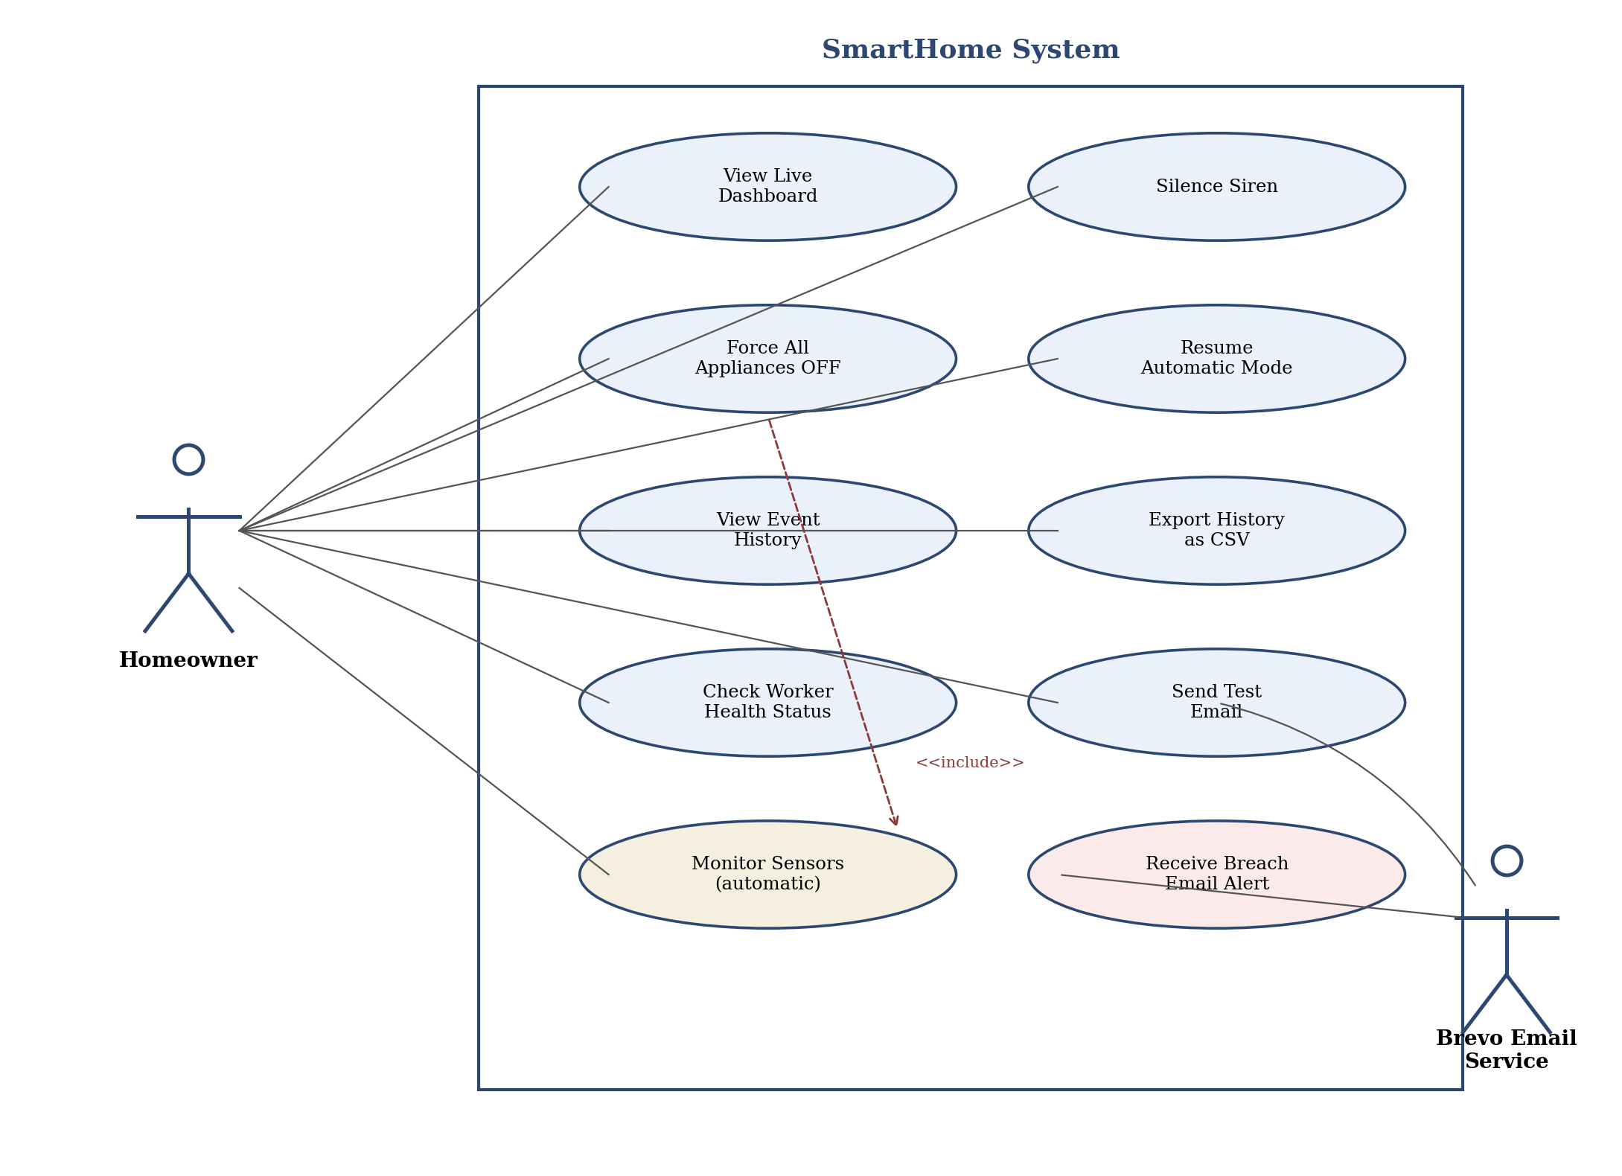
Figure 3.1: Use case diagram of homeowner and system interactions

3.3 System Architecture
The system is organised into three cooperating parts, split across two Render processes rather than one: a Web Service that only ever talks to the browser, a Background Worker that owns all the monitoring, and a shared persistent state layer that both processes read and write through. Figure 3.2 shows how these parts connect.
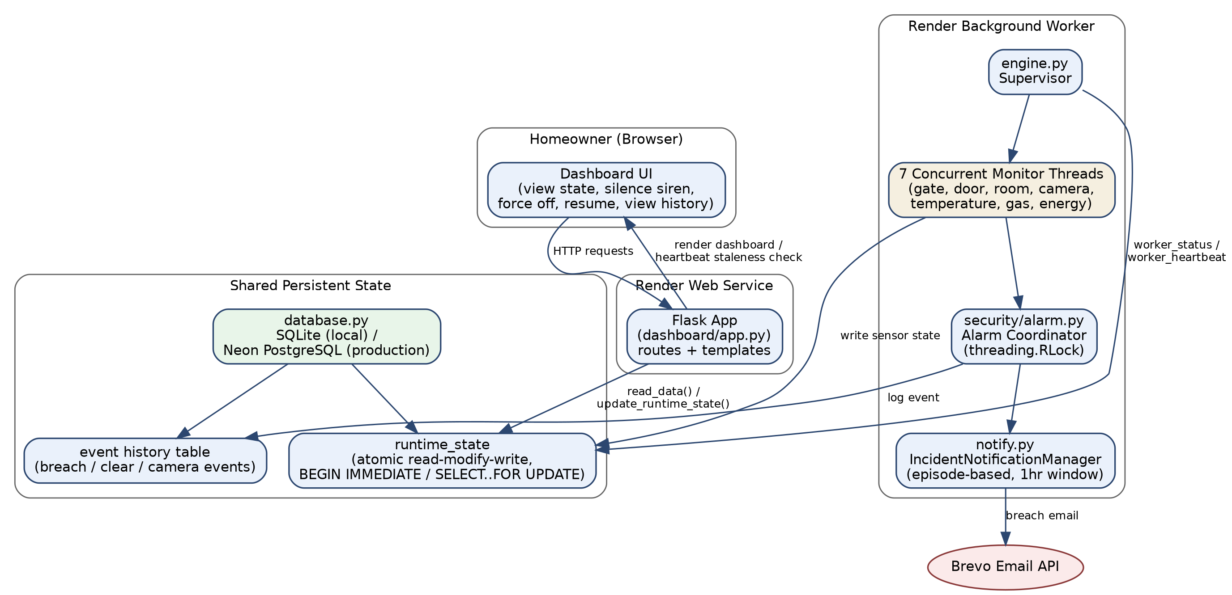
Figure 3.2: System architecture of the split web service and background worker
The Background Worker runs seven independent monitor threads - gate, door, room, camera, temperature, gas, and energy - supervised by engine.py, which restarts any thread that dies without taking the rest of the system down with it, and publishes its own worker_status and worker_heartbeat fields on every cycle so the dashboard can tell whether the worker process itself is actually alive. Of the seven threads, only gate, door, and gas report into the central alarm coordination module (security/alarm.py); the reasoning behind that specific choice is explained in Section 3.5. When the alarm coordinator activates for the first time in a new breach episode, it invokes a registered notifier callback that triggers an outbound email through the Brevo API, and logs the event to the persistent history table.
The Energy Management thread reads two things from the shared state on every cycle: the occupancy status determined by the room sensor, and the temperature status determined by the temperature sensor. It also checks, before doing anything else, whether the homeowner has set a manual override from the dashboard; if so, that override takes priority over the automatic logic entirely, and is written back through the same atomic update path described in Section 3.4.
The Web Service is the Flask application, dashboard/app.py, and it does exactly one job: it serves the dashboard by reading the current shared state, and it exposes a small set of control routes that let the homeowner write commands back into that same shared state. Unlike the earlier combined-process version of this system, it no longer starts any monitoring itself - splitting the two processes apart means the web service can restart, redeploy, or briefly sleep on Render's free tier without ever interrupting the monitoring loop running independently in the worker.
Figure 3.3 traces this split in operation for a single monitoring cycle: how a sensor reading becomes a logged event, how the alarm coordinator decides whether that event deserves an email, and how the dashboard separately decides whether the worker itself should still be trusted.
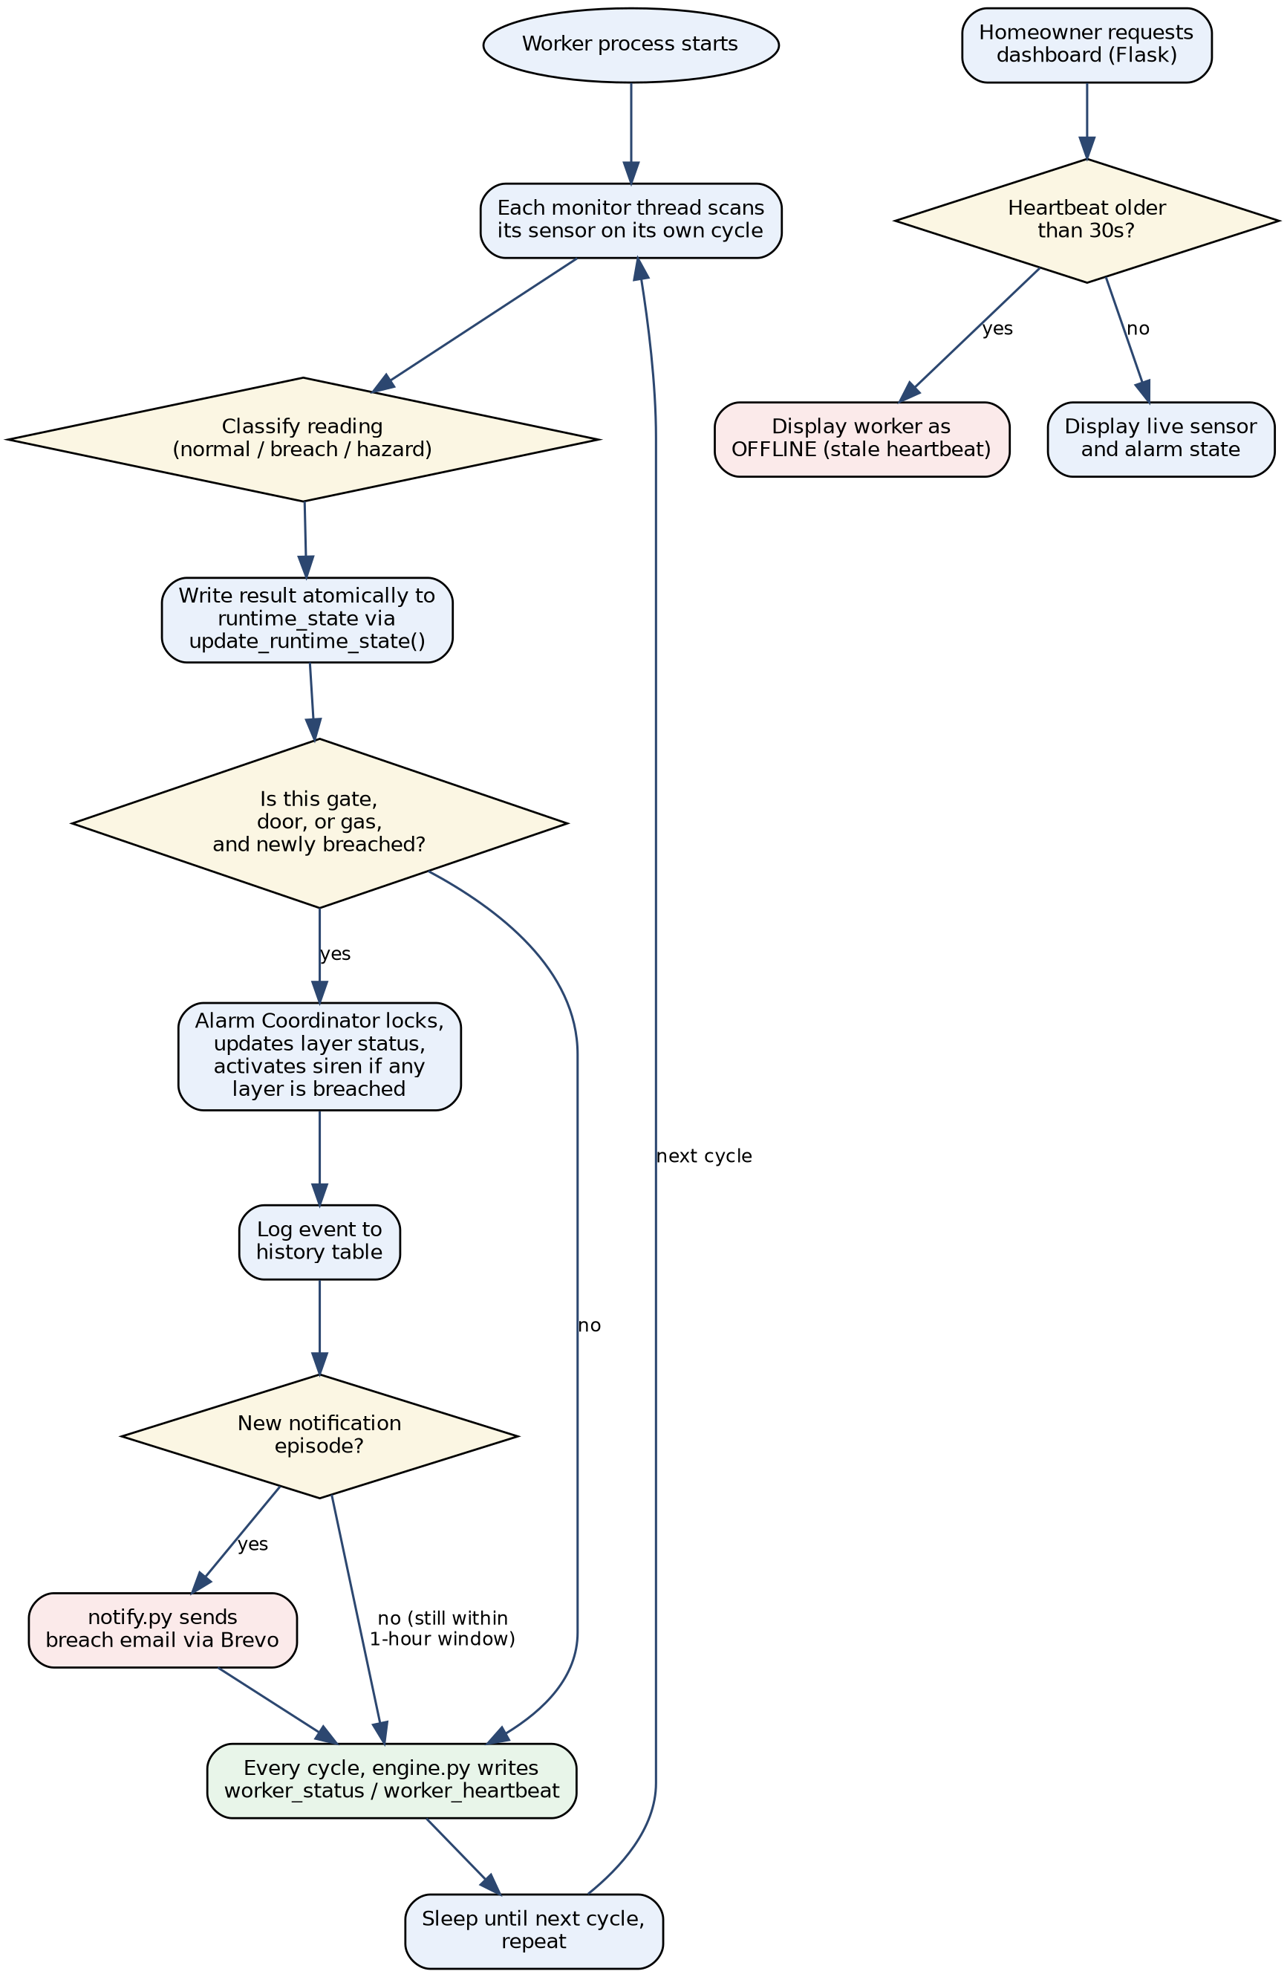
Figure 3.3: System operation flowchart, from sensor scan to homeowner notification

3.4 System Data Model
The earlier, combined-process version of this system held its entire shared state in a single Python dictionary with no persistence. Splitting the system into a separate Web Service and Background Worker made that approach impossible - two different operating-system processes cannot share an in-memory Python object - so the shared state now lives in a real database instead: SQLite for local development, and Neon PostgreSQL in production on Render, behind the same database.py interface either way. Figure 3.4 shows the two tables this involves and how they relate.
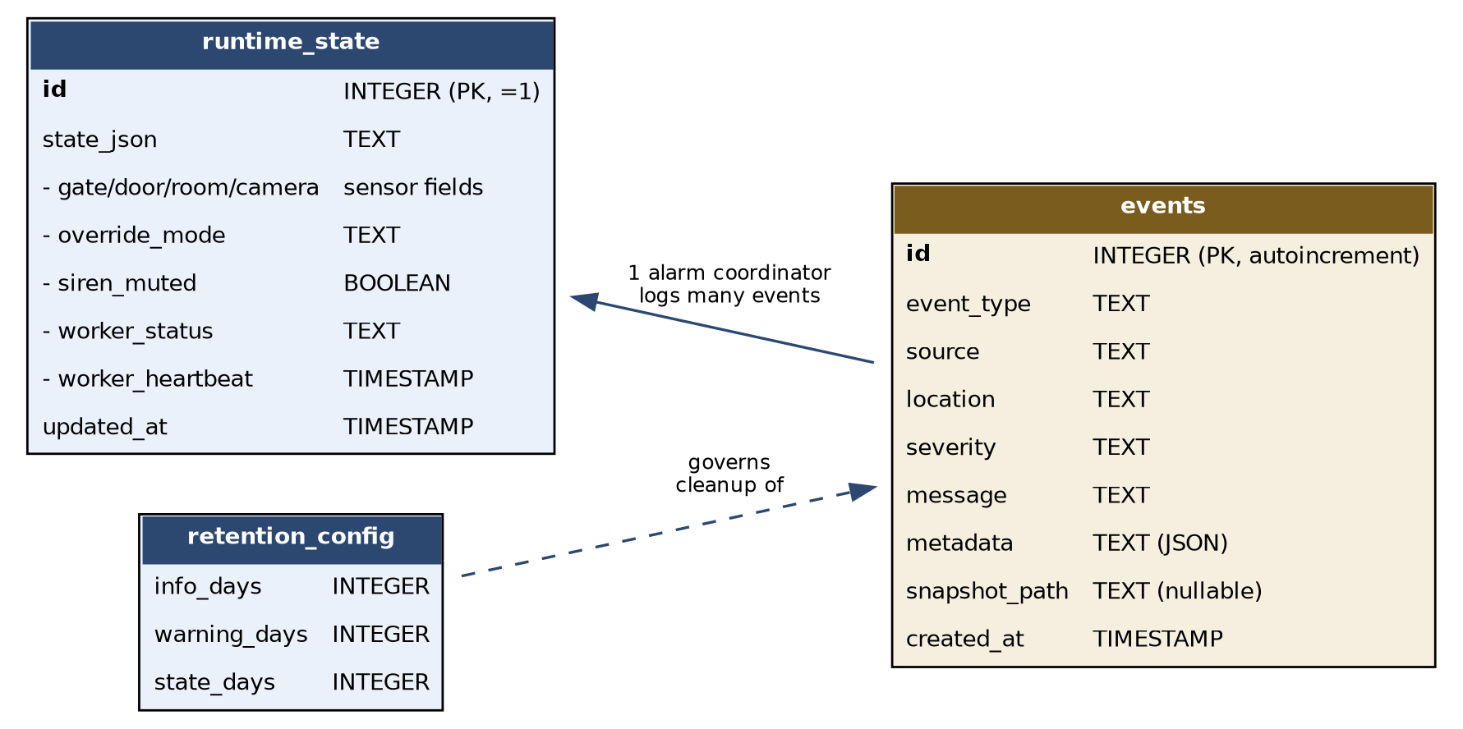
Figure 3.4: Entity-relationship model of the persistence layer (runtime_state and events tables)
The runtime_state table holds exactly one row: the full live snapshot every sensor, override, and worker-health field currently reflects. The override_mode field deserves particular mention, since it is what makes two-way communication possible at all. When the homeowner clicks "Force All Appliances OFF" on the dashboard, the control route does not touch any appliance directly; it calls update_runtime_state() with a small function that sets override_mode to "all_off" inside a single locked transaction, so the read, the modification, and the write all happen atomically rather than as three separate steps that another process could interleave with. The events table is separate and append-only: every breach, clear, and camera detection is logged there permanently, which is what makes the dashboard's history page, CSV export, and configurable retention windows possible - none of which existed when state lived only in memory.

3.5 Modular Design and the Alarm Coordination Decision
Every security module follows the same internal shape regardless of what it monitors: a function that simulates a sensor reading, a function that classifies that reading against a threshold, and a monitoring function that runs the scan, prints readable output, sends alerts where appropriate, and writes the result to the shared state. Keeping that structure consistent across all six modules means a new sensor type could be added later by following the same pattern without touching any existing module.
The more consequential design decision concerns which of the seven monitor threads are allowed to activate the shared alarm. Only gate, door, and gas are connected to it. Gate and door breaches represent direct physical intrusion; a gas leak represents a life-safety hazard that nothing else in the system can address automatically. Temperature is deliberately excluded, because an abnormal reading is already handled automatically by the energy thread's control of the air conditioner and heater, and sounding an alarm on top of an automatic fix would be redundant. Camera is also excluded, following direct feedback received during supervisory review: rather than sounding a second alarm on top of whatever already triggered it, the camera module's role was narrowed to reporting the exact location - which of the three simulated cameras - where an unauthorised person was seen, so the homeowner has something concrete to check rather than a generic warning.

3.6 Data Communication and Notification Mechanism
database.py exposes the functions every other module uses rather than touching the underlying SQLite or PostgreSQL connection directly: read_data() for retrieving the current snapshot, update_runtime_state(mutator) for any atomic read-modify-write - using BEGIN IMMEDIATE on SQLite or SELECT...FOR UPDATE on PostgreSQL so the read and the write cannot be split apart by another process - and log_event() for appending a permanent row to the history table. A lighter update_multiple() helper remains for cases, such as the worker's own heartbeat, where a lost update would not matter.
The email notification mechanism is deliberately decoupled from the alarm logic itself. security/alarm.py exposes a register_notifier() function; at start-up, the worker process registers notify.send_breach_email as the callback. The alarm module has no direct knowledge of Brevo, email formatting, or HTTP requests - it simply calls whatever function was registered, with the layer name and reason as arguments, at the exact moment a breach transitions from clear to active. Notification itself is handled by an IncidentNotificationManager with a one-hour episode window, replacing the earlier simple time-based cooldown: a breach that is still active an hour after the first email does not get silently forgotten, but a second sensor breaching midway through the same ongoing episode does not trigger a second email either.

3.7 Tools, Technologies, and Frameworks
Table 3.1 summarises the tools used across the project, including those added during the later stage of development.

Tool / Technology | Category | Purpose in This Project
Python 3.14 | Programming Language | Implements all sensor simulation, the alarm coordinator, and the energy management logic
Flask | Web Framework | Serves the live dashboard and exposes the homeowner control routes
threading (Python stdlib) | Concurrency | Runs the simulation as a background thread alongside the Flask server, protected by a lock
Brevo | Transactional Email API | Sends the instant breach-notification email to the homeowner
python-dotenv | Configuration | Loads the Brevo API key and alert email from a local .env file during development
Gunicorn | WSGI Server | Runs the Flask application in production on Render
Render | Cloud Hosting | Provides free-tier hosting for the live, internet-accessible deployment
GitHub | Version Control | Hosts the source repository that Render deploys from automatically on push
Tinkercad | Circuit Simulation | Browser-based virtual breadboard for the hardware simulation
Arduino Uno R3 | Microcontroller | Central controller of the simulated hardware circuit, programmed in C++
Visual Studio Code | IDE | Used for writing, running, and debugging all source files

3.8 Hardware Simulation Design
The Tinkercad circuit mirrors the software architecture: a single Arduino Uno R3 handles both security and energy functions, rather than using two separate microcontrollers. Two pushbuttons simulate gate motion detection and unauthorised gate opening, driving a red LED and a piezo buzzer as the alarm response. A TMP36 analog sensor and a photoresistor simulate house temperature and ambient brightness, driving three further LEDs that represent the house lighting, air conditioning, and heater. Table 3.2 lists the pin assignments used in the Arduino sketch.

Component | Arduino Pin
Pushbutton 1 (Gate Motion Trigger) | Digital Pin 8
Pushbutton 2 (Gate Open Trigger) | Digital Pin 9
Red LED (Security Alarm Indicator) | Digital Pin 11
Piezo Buzzer (Alarm Sound) | Digital Pin 12
TMP36 Temperature Sensor | Analog Pin A1
Photoresistor (Brightness Sensor) | Analog Pin A0
Yellow LED (House Light Indicator) | Digital Pin 5
Green LED (Air Conditioning Indicator) | Digital Pin 6
Blue LED (Heater Indicator) | Digital Pin 4

A DHT11 temperature sensor and a magnetic reed switch were originally intended for this circuit but were not available in the Tinkercad component library at the time of development, and were substituted with a TMP36 sensor and pushbuttons respectively. PIR sensors were also tested in the circuit but were removed from the final working sketch, since they were found to produce unpredictable readings at the start of a Tinkercad simulation regardless of any deliberate input - a practical constraint of the simulator rather than a flaw in the sensor logic itself, and one that is discussed further in Chapter Four.

3.9 Deployment Methodology
Beyond running locally, the system was also made deployable to a live, internet-accessible address using Render, provisioned as two separate services from a single Procfile: a web: process running the Flask dashboard under Gunicorn, and a worker: process running engine.py continuously, independent of the web service's own lifecycle.
Locally, both processes can be started with a single command via run_local.py, which runs the worker in a background thread and the Flask app in the main thread so a contributor does not need two terminals open to see the full system working; main.py remains as a direct entry point into the worker alone, for parity with the Render worker: process. The Brevo API key and alert email are loaded from a .env file locally using python-dotenv, and set directly as environment variables in each Render service's dashboard in production.
Render's free tier puts the service to sleep after roughly fifteen minutes of inactivity, with a thirty-to-fifty-second delay on the first request after waking. This trade-off, and how it was accounted for, is discussed as a limitation in Section 1.6 and again in Section 5.4.

3.10 Methodological Steps
The development process, across both architectural stages, followed these steps:
1. Requirements gathering, identifying the security layers, energy scenarios, and dashboard data needed.
2. Initial architecture design, separating the security, energy, and presentation concerns and defining the shared data schema.
3. Module-by-module implementation of each security and energy component, tested individually before integration.
4. Integration through a master controller, with per-module error handling so a fault in one sensor does not halt the system.
5. Dashboard development using Flask, initially reading from a JSON file written by a separate simulation process.
6. Hardware simulation design and testing on Tinkercad, in parallel with the software work.
7. Supervisory review, which identified a genuine alarm coordination defect and the absence of any active homeowner notification, both described in Chapter Four.
8. Architectural revision: extraction of the simulation loop into a shared engine module, replacement of the file-based data bridge with a thread-safe in-memory structure, addition of the Brevo email notifier, and addition of two-way dashboard controls.
9. Second architectural revision: separation of the combined process into a Web Service and a Background Worker, migration of shared state from an in-memory dictionary to a persistent database with atomic updates, and addition of a worker heartbeat, following defects that only appeared once the two processes ran concurrently.
10. Deployment preparation and testing, including a live test of the exact Gunicorn command used by Render, and of both Render services running together.
11. Documentation of the completed system, including this report.

3.11 System Requirements
Running and demonstrating the system requires the following:
• Windows 10 or later (development environment used for this project)
• Python 3.14 or later, with Flask, requests, python-dotenv, and gunicorn installed
• Visual Studio Code, with the Python and Pylance extensions
• A modern web browser, to view the dashboard and to access Tinkercad
• A Brevo account and API key, for the email notification feature
• Internet access, required only for Tinkercad, the live Render deployment, and outbound email; the local simulation and dashboard run with no internet connection at all
• A free Render account and a GitHub repository, if deploying to a live URL rather than running locally

3.12 Summary
This chapter has set out the methodology behind the system: its three-layer architecture, the data model that ties the layers together, the reasoning behind which sensors are allowed to sound the alarm, how notification and two-way control were added without disturbing the existing sensor logic, and the tools used at every stage including deployment. Chapter Four now turns to the implementation itself and the results obtained from testing it.

CHAPTER FOUR

IMPLEMENTATION AND RESULTS

4.1 Introduction
This chapter describes how each module was actually built and presents the results obtained from testing it, including two changes made directly in response to supervisory feedback: a real coordination defect in the alarm system, and the absence of any active notification path to the homeowner. Both are described here as they were found and fixed, rather than presented as though the final design was the first design.

4.2 Development Environment Setup
Development was carried out on a Windows 10 machine using Visual Studio Code with the Python and Pylance extensions, and Python 3.14 with its installation directories added to the system PATH. The project root, SmartHome, contains a security folder and an energy folder for the respective Python modules, a dashboard folder holding the Flask application and its HTML template, a shared engine module, a notification module, and configuration files for deployment (requirements.txt, Procfile, .env.example, and .gitignore).

4.3 Implementation of the Alert Engine
Two modules sit underneath every security layer. alert_system.py formats and prints breach and clearance notifications to the terminal in a consistent format, showing the location, layer, sensor type, and timestamp, and is called by all six security modules. alarm.py, described in the next section, coordinates the actual alarm state across the modules that are permitted to affect it.

4.4 The Alarm Coordination Defect and Its Correction
This section is worth walking through in some detail, because it was a genuine defect caught during a live demonstration rather than something anticipated in advance.
In the version of the system shown at that demonstration, each of the gate, door, and gas modules called its own trigger_alarm() and reset_alarm() functions directly. The problem became visible when the dashboard was left running with stale data from an earlier session: the alarm card showed TRIGGERED even though both the gate and door cards showed clear. The actual cause was that a third module - reporting clear on that particular scan - had called reset_alarm() and silenced an alarm that a different, still-breached module had genuinely raised moments earlier. Whichever module happened to run last was effectively deciding the alarm state for the whole system, regardless of what any other module was reporting.
The fix required a different mechanism entirely rather than a small correction. alarm.py was rebuilt around a shared layer_status dictionary and a single function, set_layer_status(layer_name, is_breached, reason), through which every alarm-eligible module reports only its own status. The alarm activates the first time any layer reports a breach and stays active for as long as any layer reports one; it only clears once every registered layer simultaneously reports clear. Code Listing 4.1 shows the core of this logic.
def set_layer_status(layer_name, is_breached, reason=""):
if is_breached:
layer_status[layer_name] = True
_log_breach(layer_name, reason)
_activate_alarm(layer_name, reason)
else:
layer_status[layer_name] = False
_evaluate_alarm()
def _evaluate_alarm():
global alarm_active
if not any(layer_status.values()):
alarm_active = False # only clears when ALL layers agree
A further detail matters here: logging a breach and physically activating the siren were separated into two different steps. If the gate has already triggered the alarm and the gas sensor then detects a separate leak, the gas event is still logged clearly, with its own reason and timestamp, even though the siren does not need to switch on a second time since it is already active. This same activation point - the exact moment alarm_active flips from False to True - is also where the email notifier described in Section 4.6 is invoked, which matters because it is precisely what stops the system from sending a separate email for every single breach event within one ongoing episode.
Table 4.1 shows the corrected behaviour, verified directly rather than assumed.

Test Step | Layer Status | Resulting Alarm State
1. Gate breach detected | gate = True | Alarm ON (correct)
2. Door reports clear | gate = True, door = False | Alarm remains ON (previously this incorrectly turned OFF)
3. Gate also clears | gate = False, door = False | Alarm turns OFF (correct)

A further live test confirmed the same behaviour through the full pipeline rather than in isolation: with the dashboard server and the background simulation running together, the gate sensor cleared while the door sensor remained breached, and the dashboard correctly showed a SECURE gate status alongside a BREACH DETECTED door status, with the combined alarm card still correctly showing TRIGGERED.

4.5 Implementation of the Security Sensor Modules
The gate sensor (Layer 1) checks for simulated motion and an unexpected gate-open event on each scan, and reports one combined result to the alarm coordinator per scan rather than two separate ones. The door sensor (Layer 2) applies the same pattern across both the front and back doors within a single scan, treating a breach at either door as one combined event for the layer. The room sensor (Layer 3) monitors four interior spaces and, distinctly from the other modules, also determines whether the house is occupied at all, returning that value for use by the energy module; it does not report into the shared alarm, since motion inside an occupied house is expected rather than threatening.
The camera module simulates three fixed positions and, following the design change discussed in Section 3.5, no longer triggers the alarm. Instead it records the specific location of any unauthorised detection, for example "Unauthorised person seen at Backyard Camera," so the homeowner has something concrete to check. The temperature module simulates a single house-wide reading rather than per-room readings, on the basis that one central heating and cooling system would realistically serve an entire house, and does not touch the alarm either, since the energy module already responds to an abnormal reading automatically. The gas module remains connected to the alarm, since a leak is a hazard nothing else in the system addresses.
During testing, the random ranges originally used to simulate gas and temperature readings were found to produce hazardous values far more often than a real emergency event would occur - roughly 69 percent of gas readings came back "Dangerous" and roughly 49 percent of temperature readings came back "High." Both were corrected using a weighted random selection, sampling the normal range three times as often as the full range. Table 4.2 shows the measured effect of that change across 2,000 simulated readings per sensor.

Sensor | Original Frequency | Rebalanced Frequency (n=2000)
Gas Level ("Dangerous") | ≈ 69% | 25.9%
Temperature ("High") | ≈ 49% | 12.5%
Temperature ("Low") | not separately tracked | 1.6%

4.6 Implementation of the Email Notification System
This section addresses the second gap identified during supervisory review: a system that logs a breach to a dashboard is not, in any meaningful sense, notifying anyone. The dashboard could show TRIGGERED indefinitely without a homeowner who is not currently looking at it ever finding out.
The fix has two parts. First, security/alarm.py exposes register_notifier(callback), letting an external function be registered without alarm.py needing to know anything about how that function works. Second, a new module, notify.py, implements send_breach_email(layer_name, reason), which builds and sends a request to Brevo's transactional email API. dashboard/app.py registers this function once, at start-up, using register_notifier(send_breach_email).
Figure 4.1 traces the full sequence from a sensor detecting a breach through to an email actually landing in the homeowner's inbox, including the specific case that matters most: a second sensor breaching during the same notification episode must not send a second email.
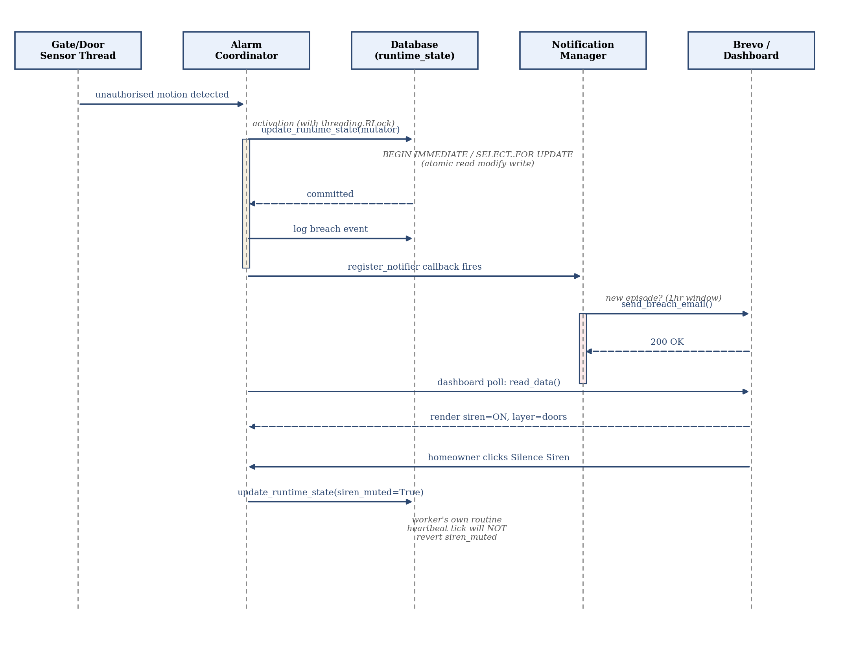
Figure 4.1: Sequence from breach detection to email delivery, showing episode-based notification and the atomic runtime_state write
The API key and recipient address are read from environment variables (BREVO_API_KEY and ALERT_EMAIL) using python-dotenv locally, or set directly as environment variables when deployed on Render; neither value is ever hard-coded into the source. Brevo requires the sender address on an email to be a verified sender on the account, so this project uses the same address as both sender and recipient by default, which is the simplest way to guarantee that requirement is met without additional domain verification.
This part of the system could not be given a fully live network test from within the development sandbox used to build it, since that environment restricts outbound connections to a fixed allow-list of package and development domains that does not include Brevo's API host. Rather than skip verification altogether, two separate checks were carried out instead. First, the real API call was attempted using a live Brevo API key, which confirmed that the request is correctly rejected by the sandbox's own network policy rather than failing for any reason related to the code itself, and confirmed that a network failure of this kind is handled gracefully - the function returns cleanly and logs a clear warning rather than crashing the application. Second, the outbound HTTP call was mocked to inspect the exact request that would have been sent, confirming that the URL, headers, and JSON payload all match Brevo's documented API format precisely. Code Listing 4.2 shows the core request-construction logic.
payload = {
"sender": {"name": "Smart Home Security System", "email": alert_email},
"to": [{"email": alert_email, "name": "Homeowner"}],
"subject": f"Smart Home Alert: {layer_name.upper()} breach detected",
"htmlContent": f"<h2>Security Breach Detected</h2>
<p>Layer: {layer_name.upper()}</p>
<p>Reason: {reason}</p>..."
}
response = requests.post(BREVO_API_URL, json=payload, headers=headers, timeout=10)
A live, fully successful delivery - the email actually arriving in a real inbox - was therefore verified as far as the development environment allowed, and is expected to succeed once run with genuine outbound internet access, which the sandbox does not provide. The dashboard also includes a manually triggered "Send Test Email" control, described in Section 4.7, specifically so this final step can be confirmed independently after deployment.

4.7 Implementation of Two-Way Dashboard Control
The third change made after supervisory review addressed a related but distinct gap: the original dashboard was read-only. A homeowner could see that the house was secure or that an appliance was on, but could not act on that information from the dashboard itself.
Three control routes were added to dashboard/app.py. POST /control/off sets override_mode to "all_off" in the shared state, which the energy module checks at the start of every cycle and, if set, forces all appliances off regardless of occupancy or environmental readings for that cycle. POST /control/resume clears the override and returns the system to automatic control. POST /control/silence calls a new mute_siren() function in alarm.py, which mutes the audible alarm indicator while leaving the underlying breach state untouched - the dashboard continues to show that a breach is active, just with the siren marked as manually silenced, rather than making it look as though the problem has been resolved when it has not. A fourth route, POST /control/test-email, lets the homeowner manually trigger a test notification at any time, independent of any real breach.
Each route was tested with real HTTP requests against a running instance of the application, using a persistent cookie session to correctly capture Flask's flash-message behaviour. Table 4.3 summarises the results.

Control Action | Expected Behaviour | Observed Result
POST /control/off | override_mode set, appliances forced off next cycle | Confirmed — dashboard showed "Manual override (all appliances forced off)"
POST /control/resume | override cleared, automatic logic resumes | Confirmed — dashboard showed "Automatic"
POST /control/silence | siren muted, breach status unchanged | Confirmed — flash message and muted-siren tag rendered correctly
POST /control/test-email | manual email attempt fires immediately | Confirmed attempted; blocked only by sandbox network policy (see Section 4.6)

4.8 Implementation of the Split Web Service and Background Worker Architecture
Moving from one combined process to a Web Service and a Background Worker running as two separate Render processes was the largest architectural change made to this system after the version described in the rest of this chapter, and it introduced two genuine concurrency defects that would not have been possible in a single process. Both are described here as they were found and fixed, in the same spirit as Section 4.4.
The first defect concerned sensor_data.py's original update pattern: read the local state, merge in a change, write the whole thing back. That pattern is safe inside one process, but broken the moment two separate processes can both be writing at once - an unrelated sensor write from the worker could silently overwrite a homeowner control, such as Force Off or Silence Siren, that the web service had just set moments earlier, because the worker's write used a copy of the state read before that control had been applied. This was reproduced reliably with a small two-process test script that hammered unrelated fields from one process while the other repeatedly set an override, and the override was lost within a few cycles. The fix was to make the read-modify-write atomic: update_runtime_state(mutator) now performs the entire operation inside one locked database transaction - BEGIN IMMEDIATE on SQLite, SELECT...FOR UPDATE on PostgreSQL - so no other process can read a value between when it is fetched and when it is written back. The same stress test was then run against six processes hammering unrelated fields plus one process repeatedly setting an override, and the override held in every run.
The second defect surfaced while re-verifying the first fix: even with the atomic write in place, siren_muted could still silently flip back within two or three seconds of being set. This was not a race condition; the worker was knowingly re-pushing its own stale local copy of siren_muted on every routine alarm-sync tick, regardless of what the homeowner had just set through the dashboard. Diagnosed by logging alarm_active alongside siren_muted at half-second intervals to distinguish a legitimate reset - the alarm actually clearing - from a lost update, the fix was to restrict the worker to writing siren_muted only at the two moments it is genuinely authoritative over that value: when a new incident begins, and when it fully clears - never on a routine heartbeat tick.
A third, smaller defect was found later, in the worker-health feature added to let the dashboard show whether the Background Worker was actually still running. The first version only detected a monitoring thread dying inside the worker, marking worker_status as DEGRADED; it did not detect the entire worker process dying, which is the actual failure this feature exists to catch on Render. In that case worker_heartbeat simply stops updating, and the dashboard would keep showing a stale "ONLINE" indefinitely. The fix compares the heartbeat's own timestamp against the current time on every dashboard request; if it is older than thirty seconds - three missed cycles - the displayed status is overridden to "OFFLINE (stale heartbeat)" regardless of what was last stored. This was verified live in all three states: OFFLINE before any worker starts, ONLINE within seconds of a real worker starting, and OFFLINE (stale heartbeat) when a heartbeat older than two minutes is present with no live worker.

4.9 Deployment Implementation and Testing
requirements.txt, a Procfile, and a .env.example file were added to support deployment on Render. The Procfile specifies gunicorn dashboard.app:app --workers 1, restricting the application to a single worker so the background simulation thread is never started more than once. This exact command was run directly during testing, and produced the expected live behaviour: a real breach occurred during the test run, the alarm activated correctly, and a request against the running Gunicorn server returned an HTTP 200 response with the correct data reflected on the page.
One import-path issue was found and corrected during this testing. Running dashboard/app.py directly places the dashboard folder itself on Python's import path rather than the project root, which caused sensor_data and the security package to fail to import. This was fixed by explicitly inserting the project root onto sys.path at the top of app.py before any project-local imports, which resolved the issue for both direct execution and the Gunicorn deployment path.

4.10 Summary of Results
Across every module discussed in this chapter, testing was carried out directly rather than assumed. The alarm coordination defect was reproduced, fixed, and re-verified against the exact scenario that exposed it. Sensor probability ranges were measured quantitatively before and after correction. The combined application was run under real HTTP requests, under concurrent thread load, and under the specific Gunicorn command Render uses in production. The one component that could not be fully verified end-to-end - a real email landing in a real inbox - was verified as thoroughly as the development environment allowed, with the exact request construction confirmed correct and a manual test control built into the dashboard specifically so this final step can be confirmed independently once deployed.

CHAPTER FIVE

SUMMARY, CONCLUSION AND RECOMMENDATIONS

5.1 Introduction
This closing chapter summarises what was built, checks it against the objectives set out in Chapter One, is honest about the challenges that came up along the way and what remains genuinely open, and sets out where this work could reasonably go next.

5.2 Summary of the Study
This project set out to design and simulate an IoT-based smart home automation system combining security monitoring with automated energy management, addressing two problems that are common in Nigerian homes and rarely handled by the same system: intrusion that goes unnoticed until it is too late, and energy wasted simply because nobody was there to switch something off.
What resulted is a system with three security layers - gate, doors, and interior rooms - backed by camera surveillance, temperature and fire-risk monitoring, and gas leakage detection, all coordinated through a single alarm mechanism that only sounds for genuine physical threats. Energy management ties lighting and climate control to real occupancy and environmental data, switching everything off automatically once the house is empty. Following supervisory review, two further capabilities were added: the system now sends an automated email the instant a genuine breach begins, rather than relying on someone watching a dashboard, and the homeowner can now act on the dashboard directly - silencing the siren, forcing appliances off, or resuming automatic control - rather than only observing it. The whole system was also restructured to run as a single application, which made it possible to deploy it to a live web address rather than only a local network. A companion Tinkercad circuit, built around an Arduino Uno R3, confirms the same logic behaves correctly in simulated hardware.

5.3 Achievements Relative to Stated Objectives
Table 5.1 checks the finished system against each of the four objectives set out in Chapter One.

Objective | Status
1. Design a security module using PIR sensors, magnetic door sensors, and a camera simulation capable of detecting unauthorised intrusion and sending instant alerts | Achieved, and extended — the alert is now an actual email sent to the homeowner, not just a dashboard update
2. Implement an IoT dashboard allowing monitoring of sensor data and observation of automated appliance control remotely | Achieved, and extended — the dashboard now also accepts commands back from the homeowner
3. Develop automation algorithms and communication logic using Python | Achieved — includes the alarm coordinator, the notification system, and the thread-safe shared state
4. Design the circuit diagram and simulate functionality in Tinkercad | Achieved — combined security and energy circuit built and tested on a single Arduino Uno R3

All four objectives were met. What is worth noting beyond the table is that two capabilities not explicitly listed among the original objectives - active email notification and homeowner-initiated control - were identified as real gaps during supervisory review and closed before this report was finalised, rather than being left as suggestions for future work.

5.4 Challenges Encountered
The most significant challenge was the alarm coordination defect described in Chapter Four. It was not caught during the testing of any individual module, since each module behaved correctly on its own; it only became visible once multiple layers were exercised together over several cycles, and it took a live demonstration to actually surface it. Fixing it meant rebuilding the coordination logic around a shared status registry rather than patching the existing approach, which was a useful, if uncomfortable, reminder that testing modules in isolation is not the same as testing how they behave together.
A second challenge was recognising that a dashboard showing correct information is not the same as a system that actually notifies anyone. This was not a bug in the conventional sense - nothing crashed, nothing produced wrong output - but it was a real gap between what the report claimed the system did ("instantly notifying the homeowner") and what it actually did (updating a screen that might not be watched). Closing that gap meant adding a genuinely new capability rather than fixing an existing one.
A third, more practical challenge was verifying the email integration from a development environment with restricted network access. Rather than leave this unverified, the request construction was checked directly against Brevo's documented API format, and a manual test-email control was built into the dashboard so the final delivery step can be confirmed independently once the system is actually deployed with normal internet access.
Constraints within Tinkercad itself also shaped the hardware side of the project: a DHT11 sensor and a magnetic reed switch were unavailable in the component library, and PIR sensors were found to behave unpredictably at the start of a simulation session, which led to substituting a TMP36 sensor and pushbuttons in the final working circuit.

5.5 Conclusion
This project shows that a smart home system combining multi-layer security, hazard detection, and automated energy management can be built and demonstrated without physical hardware or paid infrastructure, using Python, Flask, Tinkercad, and a free-tier email service. More specifically, it shows that detection alone is not sufficient - a security system that only displays information is meaningfully incomplete until it can also reach the person responsible for acting on it, which is what the email notification and two-way control additions were built to address.
The system detects simulated intrusion across three layers plus camera, temperature, and gas hazards; coordinates one alarm response across the layers that genuinely warrant it; notifies the homeowner directly rather than passively; lets the homeowner act on that notification from the same interface; and automates household energy use in direct response to occupancy and environmental conditions. That combination addresses the dual problem this project set out to solve at the start of Chapter One.

5.6 Recommendations for Future Work
Several directions remain open for anyone extending this project toward a fully deployable product:
i. Physical Hardware Deployment: the simulation logic and the Tinkercad circuit could be transferred to a real Arduino or Raspberry Pi connected to genuine sensors, replacing the randomised simulation functions with actual GPIO or serial sensor input.
ii. Genuine Facial Recognition: the camera module currently simulates the authorised/unauthorised distinction with randomisation; a real computer vision pipeline, for example using OpenCV with a trained model, would give this module actual identification capability rather than a placeholder for it.
iii. Persistent Historical Logging: the system currently reflects only the live state, with nothing retained once a value changes. Adding a lightweight persistent store - even something as simple as an append-only log file, given the constraints around free-tier database expiry discussed in Chapter Three - would let a homeowner review what happened while they were away, rather than only seeing the current moment.
iv. Additional Notification Channels: email was chosen here specifically because it is free at this scale, but SMS and push notifications through a mobile app would reach a homeowner faster in situations where email may not be checked immediately.
v. Paid-Tier Hosting: moving off Render's free tier would remove the sleep-and-wake delay discussed in Section 3.9, which matters for a system meant to respond to a real emergency without a thirty-to-fifty-second lag on the first request.
vi. Expanded Two-Way Control: the current control panel covers silencing the siren and forcing appliances off; a more complete implementation could let a homeowner control individual appliances independently, or schedule automatic behaviour for specific times of day.

5.7 Contribution to Knowledge
Beyond the working system itself, this project contributes a specific, reusable pattern: a way of coordinating several independent alarm-eligible sensors into one shared, correct alarm state, built specifically to prevent one sensor's "all clear" from silently cancelling another sensor's active warning. That pattern, and the defect that led to it being built the way it is, is applicable to any IoT system where more than one independent module needs to jointly determine a single shared alert state - a situation this project encountered directly rather than anticipated, and one that is easy to get wrong in exactly the way this project initially did.

REFERENCES
Atzori, L., Iera, A., & Morabito, G. (2010). The Internet of Things: A survey. Computer Networks, 54(15), 2787–2805. https://doi.org/10.1016/j.comnet.2010.05.010
Gøthesen, S., Haddara, M., & Kumar, K. (2023). Empowering homes with intelligence: An investigation into smart home technology adoption and usage. Internet of Things, 22, 100751.
Guenfaf, Y., & Zafoune, Y. (2023). An IoT and machine learning-based system for energy efficiency in smart homes. In Proceedings of the IEEE World AI IoT Congress (AIIoT).
Ikpenyi, O. E., Abumere, O. E., & Amusan, J. A. (2022). GSM based home security alert system using PIR sensor. World Journal of Advanced Research and Reviews, 15(3), 456–463.
Kachanun, K., et al. (2025). Intelligent safety-redundant IoT-edge system for indoor gas leakage detection. In Communications in Computer and Information Science. Springer.
Kazi, S., et al. (2023). PIR sensor-based Arduino home security system. Journal of Instrumentation and Innovation Sciences, 8(2), 1–9.
Kumar, R., Khan, R. L., Singh, R., Singh, A., Vijay, R., & Ather, D. (2024). Development and evaluation of an IoT-based gas leakage detection system using Arduino Uno. In Cyber Intelligence and Information Retrieval (Lecture Notes in Networks and Systems, Vol. 1025). Springer.
National Information Technology Development Agency. (2020). National Digital Economy Policy and Strategy (2020–2030). NITDA.
Sharma, I. K., & Sharma, V. K. (2024). IoT-based smart home automation systems: Enhancing energy efficiency and security. International Journal for Research in Applied Science and Engineering Technology, 12(4).
Sinha, S. (2023). State of IoT 2023: Number of connected IoT devices growing 16% to 16.7 billion globally. IoT Analytics. https://iot-analytics.com
Statista. (2023). Number of smart homes worldwide (2020–2026). Statista Research Department. https://www.statista.com
Zia, M. F., Siddiqua, M., Ouameur, M. A., Bagaa, M., & Turjman, F. A. (2025). Securing the future: A survey on smart home security in IoT-integrated smart cities. Advances in Networks, 13(1), 1–22.

APPENDICES

Appendix A Demonstration Evidence
This appendix contains screenshots demonstrating the completed system in operation. Each placeholder below indicates exactly what should be captured and inserted before final submission.
— — — [ INSERT SCREENSHOT HERE ] — — —
Capture the VS Code terminal immediately after running "python dashboard/app.py" locally, showing the startup banner and the background simulation thread confirmation message.
Figure A.1: Local application startup in VS Code
— — — [ INSERT SCREENSHOT HERE ] — — —
Capture the full browser dashboard at http://localhost:5000 showing all nine status cards and the homeowner control panel at the bottom, ideally while a breach is active so the alarm card's red styling is visible.
Figure A.2: Live dashboard view showing an active breach
— — — [ INSERT SCREENSHOT HERE ] — — —
Capture the dashboard immediately after clicking "Force All Appliances OFF," showing the flash message and the "Manual override" text under the Lights card.
Figure A.3: Two-way control — manual override activated from the dashboard
— — — [ INSERT SCREENSHOT HERE ] — — —
Capture the actual received email in a real inbox after a genuine breach or after clicking "Send Test Email," once the system is running with normal internet access outside the development sandbox.
Figure A.4: Breach notification email received by the homeowner
— — — [ INSERT SCREENSHOT HERE ] — — —
Capture the Tinkercad workspace showing the fully wired circuit, with the Arduino Uno R3, both pushbuttons, the TMP36 sensor, the photoresistor, and all four LEDs clearly visible.
Figure A.5: Completed Tinkercad circuit
— — — [ INSERT SCREENSHOT HERE ] — — —
Capture the Tinkercad Serial Monitor during an active simulation, showing the security breach message and the temperature/brightness readings printing correctly.
Figure A.6: Tinkercad Serial Monitor output during live simulation
— — — [ INSERT SCREENSHOT HERE ] — — —
Capture the Render dashboard after a successful deployment, showing the live service URL and a "Live" status indicator, followed by a screenshot of that live URL open in a browser.
Figure A.7: Live deployment on Render

Appendix B Selected Source Code Listings
The complete source code accompanies this report as a separate digital submission. The listings below are the modules most central to the architectural decisions discussed in Chapters Three and Four.

B.1 security/alarm.py — Alarm Coordination Module
def set_layer_status(layer_name, is_breached, reason=""):
if is_breached:
layer_status[layer_name] = True
_log_breach(layer_name, reason)
_activate_alarm(layer_name, reason)
else:
layer_status[layer_name] = False
_evaluate_alarm()
def _activate_alarm(layer_name, reason):
global alarm_active, siren_muted
if not alarm_active:
alarm_active = True
siren_muted = False
if _notifier_callback:
try:
_notifier_callback(layer_name, reason)
except Exception as e:
print(f"Email notification could not be sent: {e}")
def _evaluate_alarm():
global alarm_active, siren_muted
if not any(layer_status.values()):
if alarm_active:
alarm_active = False
siren_muted = False

B.2 notify.py — Brevo Email Notification Module
def send_breach_email(layer_name, reason):
api_key = os.environ.get("BREVO_API_KEY")
alert_email = os.environ.get("ALERT_EMAIL")
if not api_key or not alert_email:
print("Email not sent: environment variables missing")
return False
payload = {
"sender": {"name": "Smart Home Security System", "email": alert_email},
"to": [{"email": alert_email, "name": "Homeowner"}],
"subject": f"Smart Home Alert: {layer_name.upper()} breach detected",
"htmlContent": f"<h2>Security Breach Detected</h2>
<p>Layer: {layer_name.upper()}</p>
<p>Reason: {reason}</p>"
}
headers = {"api-key": api_key, "Content-Type": "application/json"}
response = requests.post(BREVO_API_URL, json=payload, headers=headers, timeout=10)
return response.status_code in (200, 201)

B.3 sensor_data.py — Thread-Safe Shared State
_lock = threading.Lock()
_state = dict(default_data)
def update_multiple(updates):
with _lock:
_state.update(updates)
_state["last_updated"] = time.strftime("%Y-%m-%d %H:%M:%S")
def read_data():
with _lock:
return dict(_state) # returns a safe snapshot copy
def set_override(mode):
with _lock:
_state["override_mode"] = mode

B.4 engine.py — Shared Simulation Loop
def run_forever(cycle_delay=10, print_banner=True):
cycle = 1
someone_home = True
temp_status = "normal"
while True:
try:
someone_home, temp_status = run_cycle(cycle, someone_home, temp_status)
cycle += 1
time.sleep(cycle_delay)
except KeyboardInterrupt:
break
except Exception as e:
print(f"System error in cycle {cycle}: {e}")
time.sleep(cycle_delay)
cycle += 1

B.5 dashboard/app.py — Application Entry Point and Control Routes
register_notifier(send_breach_email)
start_background_simulation()
@app.route("/")
def dashboard():
data = read_data()
data["siren_muted"] = get_siren_muted()
return render_template("index.html", data=data)
@app.route("/control/off", methods=["POST"])
def control_off():
set_override("all_off")
flash("Manual override activated - all appliances forced OFF.")
return redirect(url_for("dashboard"))

Appendix C Complete Source Code
The complete source code for this project is not reproduced in this report, to keep the document a manageable length; Appendix B already lists the modules most central to the architectural decisions discussed in Chapters Three and Four. The full project source code accompanies this report as a separate compressed (.zip) file submitted alongside it.

