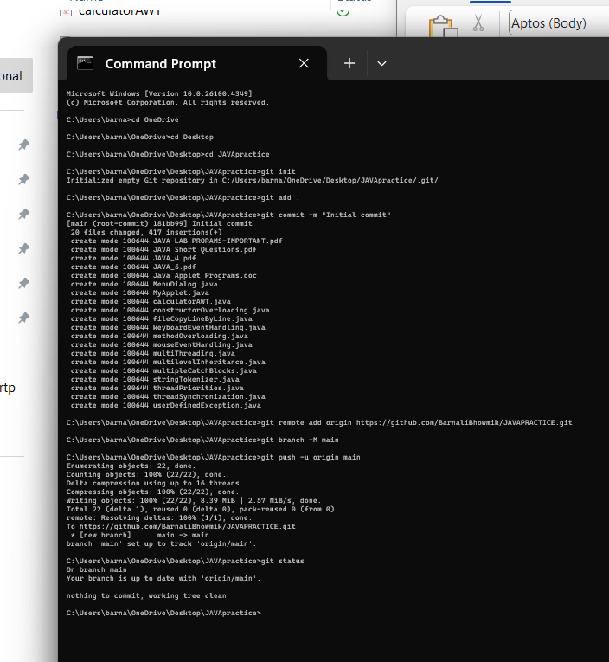

SO, this is the demo for those who r trying to upload their existing projects from “File Manager” or “Folder” into their GitHub account.

FOLLOW THE BELLOW STEPS FOR BETTER UNDERSTANDING ✌🏻:

1. Go to GitHub → Click on New repository → Name it (e.g., my-project) → Do **NOT** initialize with a README → Click Create repository.
2. Open Command Prompt and Navigate to your project folder.

cd “path\to\your\project”

1. git init (Initialize the Git repository)
2. git add . (Add all files to staging)
3. git commit -m “Initial commit”
4. git remote add origin <https://github.com/your-username/my-project.git>
5. If your GitHub repo is empty and uses the main branch, run:

git branch -M main

git push -u origin main

(if your GitHub repo uses “master”, use “git push -u origin master”

Pre-requisites-

1. Make sure you’ve installed **Git.**
2. To check what’s staged or committed in your GitHub account folder use “**git status**”.
3. You’ll have a different remote URL if you are using GitHub CLI or SSH instead of HTTPS so use accordingly.

**COMMON LOOSE CASES FACED BY BEGINNER’s**

1. Missing .git initialization

* If u don’t initialize then Git commands wont work. So run “git init” in the project folder.

1. Remote origin isn’t set

* You will face git push error: “No configured push destination”.

Run “git remote add origin <repo-url>” and “git push -u origin main”.

1. Wrong branch name

* GitHub default repo is **main** but u r working in local(vice versa). Do “git branch -M main” or “git push origin master”.

1. Size limit exceeded

* Git push fails because file/repo size >100MB. So, use “.gitignore” or “[Git Large File Storage | Git Large File Storage (LFS) replaces large files such as audio samples, videos, datasets, and graphics with text pointers inside Git, while storing the file contents on a remote server like GitHub.com or GitHub Enterprise.](https://git-lfs.com/)”.

1. If .gitignore not used

* __pycache__ , node_modules and other unwanted files get pushed. So add git then add .gitignore file

1. Untracked files

* Files are not uploaded. Use “git add .” before committing.

1. Authentication failed

* push fails due to wrong GitHub credentials. So, setup SSH keys

1. No commit

* If in case git push shows as “nothing to push” then do “git commit -m “message” then push.