WIT Services

Saoirse O’Donovan

Ian Barnes

Corey Shanahan

2022

Contents

Overall Introduction to Project 2

Product Vision 2

Features 2

Personas 2

What is a Persona? 2

Persona 1 2

Persona 2 2

Persona 3 2

Scenarios 2

What is a Scenario? 2

Scenario 1 2

Scenario 2 2

Scenario 3 2

User Stories 2

What is a User Story? 2

User Story 1 2

User Story 2 2

User Story 3 2

User Story 4 2

User Story 5 2

User Story 6 2

Prototype 2

What is a Prototype? 2

The tool used to create Prototype (say if you found it easy to use or not briefly!!!) 2

URL or Screen Shots (not all some) 2

# Overall Introduction to Project

## Product Vision

Following the research conducted into various apps and features related to apps documenting the variation in educational facilities and services for similar scenarios to this particular app, various features were analysed, and it became clear which of such enhanced the user experience and ability to navigational structure of the app and which prohibited the overall experience.

As a means to research applications of a similar nature, we downloaded the NUI Galway and Iowa Wesleyan apps. Viewing these applications from a national and international level seemed like a good idea to acknowledge potential differences and a broader variety of features that could influence elements we wish to add to our application.

Below are some of the features observed that made the navigational flow and aesthetics of the applications seem more attractive from our perspectives. The interactive map that provided details regarding all services available and legible labelling of all room numbers and names was very well made and is something that would’ve been very useful as a first year getting to know the campus. The calendar providing details of upcoming events and times associated was an informative touch that would help for not only academic deadlines but also student events and special weeks on campus. The breakdown of specific categories concerning clubs, societies and sports seemed like a necessary addition as it is relatively difficult to get information regarding these topics and it was represented nicely on the NUI Galway app. (see below)

Specific features of each made the user experience less enjoyable, such as an incredibly busy homepage filled with a plethora of images that made it difficult to know where specific information was. On the NUI Galway application, there was an absence of a menu bar which made the navigation of the application unnecessarily complex. On the NUI Galway application, there was also limited means to go back to the home page of the app after clicking on the menu or profile options which opened new windows, these features also negatively impacted the usability.

1. Our target customers would be WIT students, perhaps staff and young people around Ireland who may be considering attending WIT in the future and wish to learn more about the activities and resources offered to students at WIT.
2. There is currently no application available to WIT students providing information on services, resources, events etc. All this information is scattered amongst various areas, such as the WIT website, Moodle and multiple social media sites. Having all of this information compiled in one convenient application would be especially beneficial and improve the communication throughout the institute and keep all students updated and informed on upcoming changes, events, schedules and more.
3. The WIT Viking app is a generic application of services students can use every day to help with studying and socialising at WIT.
4. The application will aid the welfare of students by encouraging them to expand their social circles through active involvement in clubs and societies that will take away from the pressure of their academic studies. It will generally help in the spreading of information and all essential updates.
5. There is no prime competitor as WIT does not offer an app for all-inclusive services and the services that are available to share information are scattered and sources differ.
6. Our product aims to be uniquely tailored towards the students of WIT which will differ from potential competitors who will have a staggering target audience for their application. The services it provides will be exclusively for currently enrolled WIT students and what is available to them, hopefully in a manner that provides enhanced usability in comparison to any provided by competitors.

# Features

Following the product visualization, there are various ways in which our application can be constructed depending on the areas we wish for it to specialize in. The process required significant thought that allowed all team members to share ideas on what might be essential to us as students who wish to have an application providing details on services regarding college.

Some relevant features that we found compelling enough to wish to expand on further are:

1. A section exclusively for perhaps, Erasmus students or simply new students such as first years or those new to the Waterford area, which provides them with student-written posts regarding topics that will aid them in their socialization to ensure that they are confident and motivated to make new friends. These posts may contain a wide variety of data, for example, a student could write a post on what are the best cafes to visit in Waterford and another could write about all the different sporting facilities in Waterford and general training times and locations.
2. Timetables available for students to view, both study timetables, exam timetables and general academic calendar with assessment schedules.
3. The ability to add assignment due dates, with notification of upcoming deadlines.
4. Notifications of any timetable changes.
5. Grade calculator, to keep track of how much percentage of a module you have.
6. Interactive map with all the room numbers on it, where you can search for a room, and it will locate it.

# Personas

## What is a Persona?

Personas are essentially made-up entities that represent potential users of our application. They allow for the development of a character portrait that aids us in considering what features might be significant in our work by looking at the services being provided from an external perspective.

## Persona 1

Shauna, WIT Applied Computing student,

Shauna, age 22, is a student at WIT studying Applied Computing and is currently in her third year. She is originally from Kildare but currently lives in Tramore with her grandparents where is much closer to Waterford. Shauna currently works part-time at the surfing school on Tramore Strand, teaching young teens to surf on her free evenings, twice a week. She is also a member of the WIT surf society and plays an active role in promotions. She is also a qualified lifeguard and is hoping to soon be trained in diving. This hobby allows for her to take her eyes away from the screen often and she likes to have all her college content available to her on her phone for when she is out and about.

Shauna has a passion for travelling and often goes on short road trips with her roommates on the weekend when she doesn’t have too much assignment work taking up her time. After college, she hopes to work for Intel in Kildare as it is close to home and allows her to continue building her understanding and appreciation for software development in a work environment that is satisfactory and allows to produce rewarding work.

## Persona 2:

Thomas, a Mature Student studying at WIT,

Thomas, age 25, is a mature student who is studying business at WIT who is from Offaly. Thomas comes from a traditional farming family in the countryside of the county. His family run a dairy farm while also running a big shop in the local village. He is studying to one day take over the family business of the shop.

Thomas likes to play golf with his friends from home when he gets time but since he has been living in student accommodation in Waterford he rarely gets home to play. Thomas has been looking for a way to join societies or clubs through WIT to see if he can make new friends while playing golf or if there is a society for mature students.

## Persona 3

Alex, a student studying at WIT,

Alex, age 18, is a first-year student studying in Social Care in WIT who is from Wexford. She hopes to become a Youth Worker when she finishes her course. Alex volunteers in her local Youth centre during the week and has a part-time job working in a Supervalu in her hometown on the weekends.

Alex commutes into college by bus and isn’t familiar with Waterford city. One of Alex’s hobbies is to play video games and would like to join an esports team in Rocket League and meet new people. She would also like to know events that are happening on college campus and in the city.

# Scenarios

## What is a Scenario?

A scenario describes how a user or group of users may use the system, it’s a description of a user using a feature of the product that they want to use.

## Scenario 1

Shauna has found that since moving from Kildare to Tramore that she is missing out on social outings and having a break away from her studies by going to meet friends. She joined the surfing society to combat this and to build her social networks. She wishes that there was an application that provided her with a feature that allowed for announcements regarding her own society to be published and viewed with ease and even a way to post photos or comments on her progression and experience in the surfing society so that it might encourage other students to join or inspire others to take up a new hobby.

## Scenario 2

Thomas has been very busy with his assignments and studying that he needs to blow off some steam and go out with his friends. He and his friends are planning on going out for R&G week but don’t know what events are being planned on campus and on the nights out. They can go onto Instagram to see any posts regarding R&G week but don’t like using that social media platform and also can't go to WITSU to purchase tickets because they are so busy. They want an app that they can check out the different events happening on campus throughout the year and for R&G week and purchase tickets for events.

## Scenario 3

Alex is a first year studying social care, she has been finding it difficult navigating the campus and has not been able to find the office of the Humanities Department. There is currently a map on the website but that only shows where lecture halls are. Alex wants to make new friends and would like to join a club or society; her main hobby is playing video games. She would like to join an esports team but does not know how to join one.

# User Stories

## What is a User Story?

A user story is used to added significant detail to a previously discussed scenario and add some additional information regarding stated features. User stories can be used by teams in relation to consider what should be of priority and distributing the hierarchy within the project structure.

## User Story 1

Shauna is so busy with her academic studies and commitment to her clubs and societies that when she goes to use the software, she expects it to be reliable and stable in nature so that its use does not seem unjustified.

## User Story 2

Shauna hopes that in the click of a button, she can successfully share a post with other WIT students so that her progress can be documented and fuel the motivation others may need to get involved in a society.

## User Story 3

Thomas is very busy with assignments that when he wants to receive regular updates of events or news from the student union as easily as possible.

## User Story 4

Thomas expects that updates and events will be posted regularly and be reliable so that he can stay on top of what is coming out from the Student Union.

## User Story 5

Alex does not know her way around the campus and expects to have a map that should be able to search the room number and it shows where on the campus it is and an image of the building.

## User Story 6

Alex expects to have a calendar in the app where her timetable can be displayed alongside any assignments that are due and that she would be notified if her timetable changes.

# Revised Features List

Following the development and assortment of our initial features list, three noteworthy features were chosen and focused on in terms of further exploration.

1. A WITSU page that provides users with upcoming events and general updates on a regular basis. All WITSU officers are visible with means of contacting them for issues or concerns. Users can purchase tickets for upcoming events, for example, collaborations during Rag Week with bars in Waterford, if they wish to.
2. A map that allows a user to input a classroom ID or the name of a building on Campus and then direct the individual to the stated location.
3. The ability to search and view all active clubs and societies, where all users have a profile allowing them to post updates and general experiences within the society that they are active in. These posts are visible to all users and provide students with a realistic idea of the atmosphere surrounding societies from a first-hand perspective.

# Prototype

## What is a Prototype?

A prototype is a preliminary draft or version of some variation of an application.

## Canva

The tool used to create our prototype was a website called Canva. We found it easy to use and navigate as our team members have experience using it in the past. However, a downside to the site is that there are limited resources available when using the free version and a lot of helpful and customizable features are only available to premium users who pay a subscription.

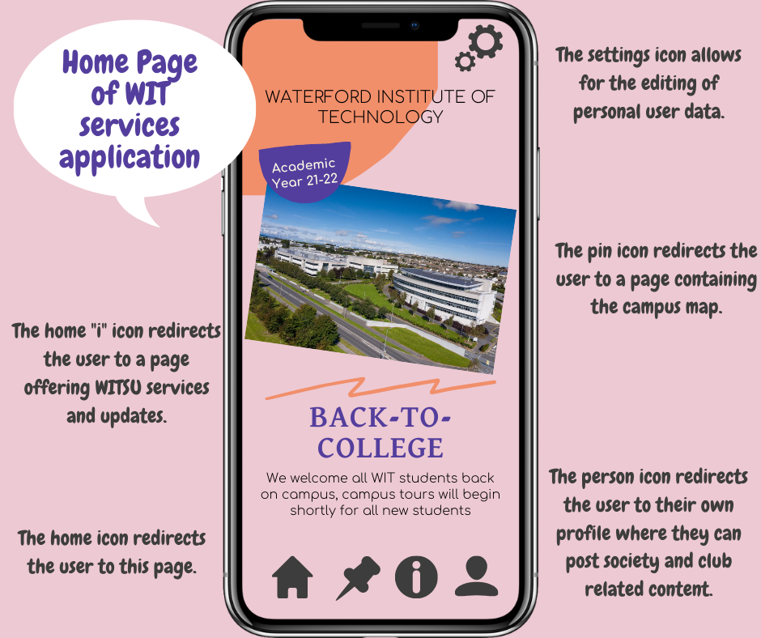

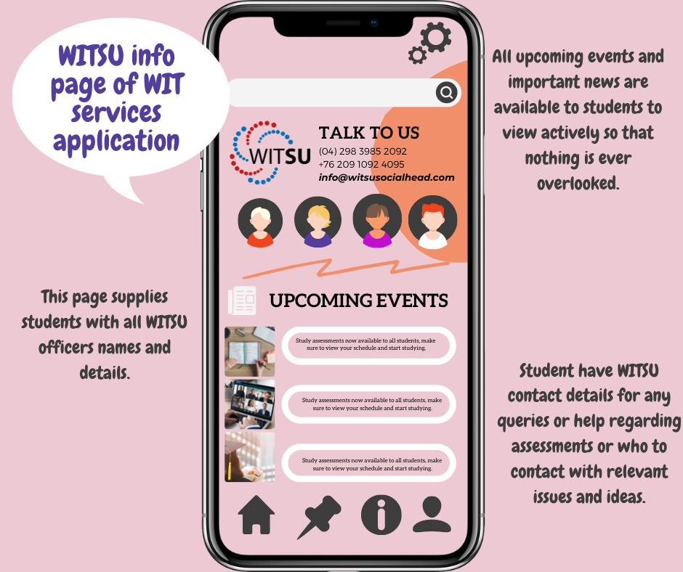

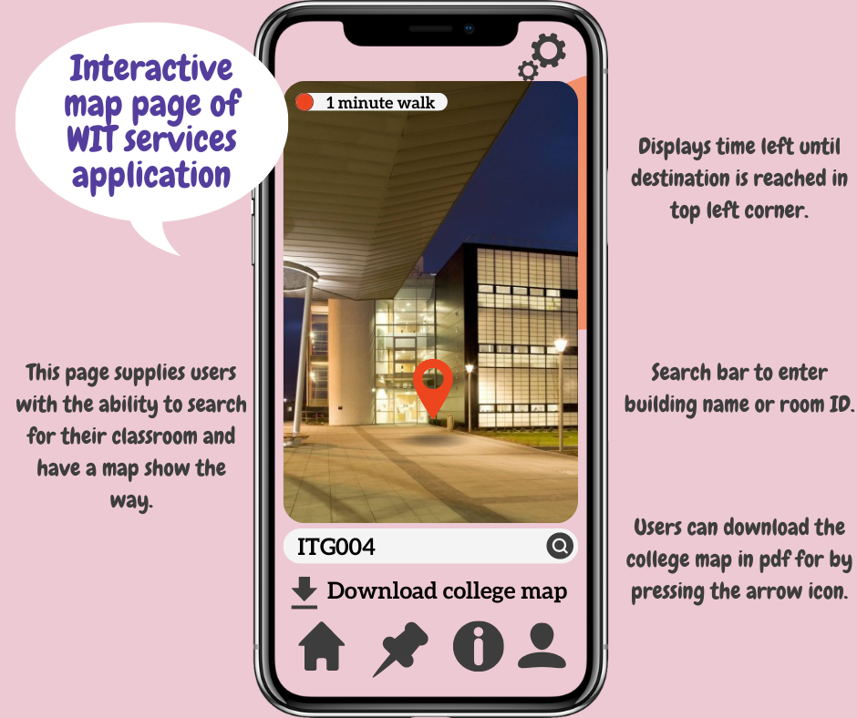

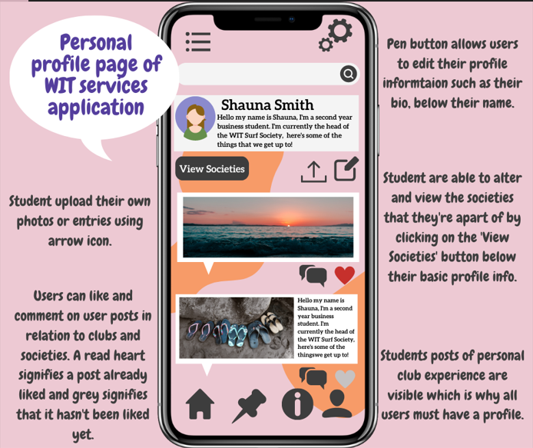

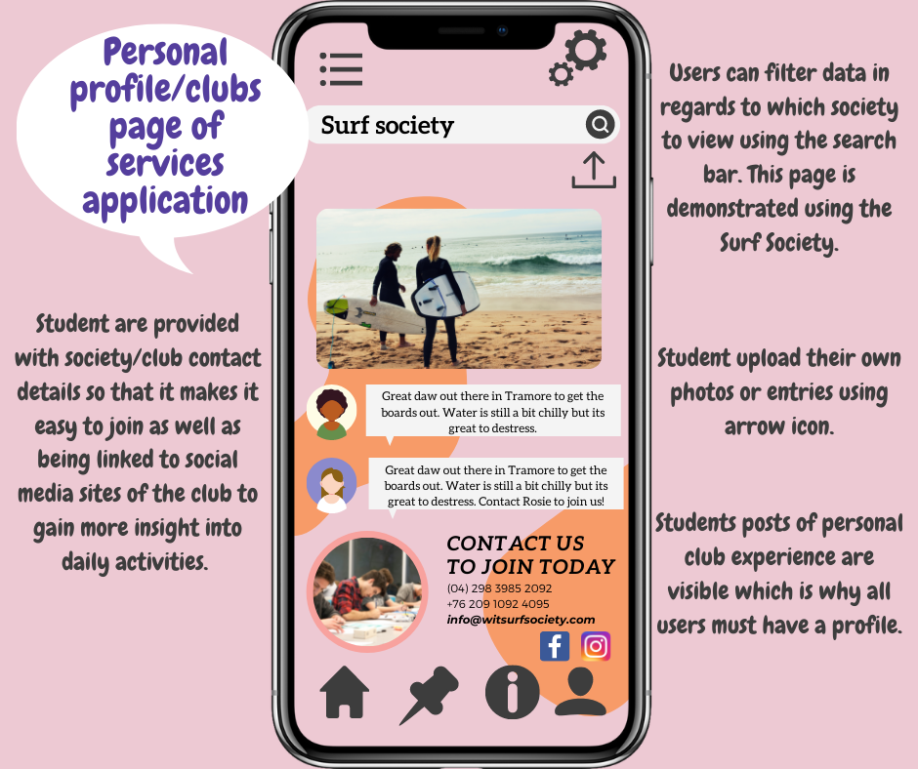

# Use Case Diagram

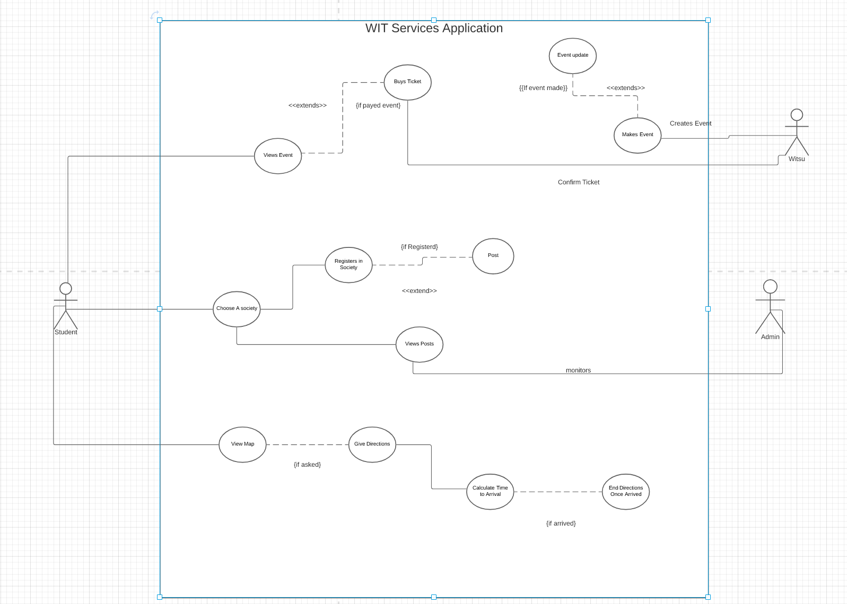

Activity Diagram 01

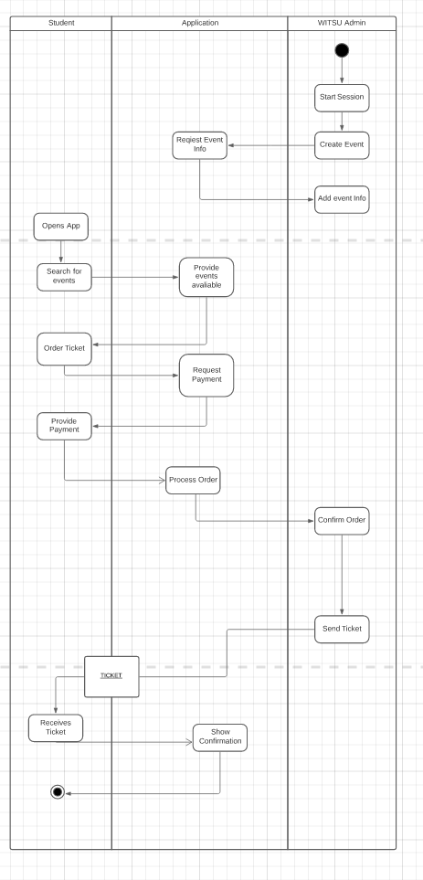

Activity Diagram 02

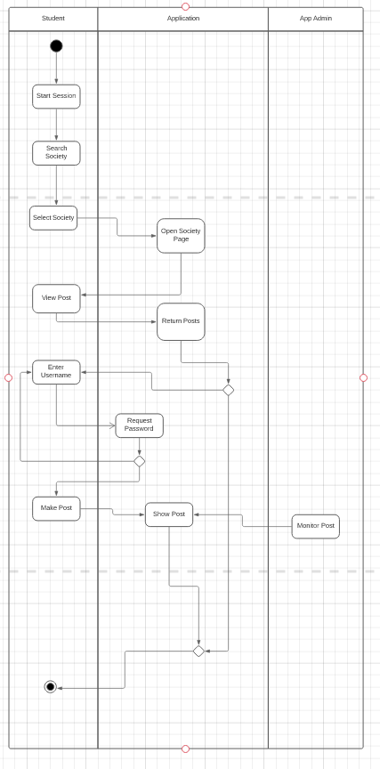

Class Diagram 01

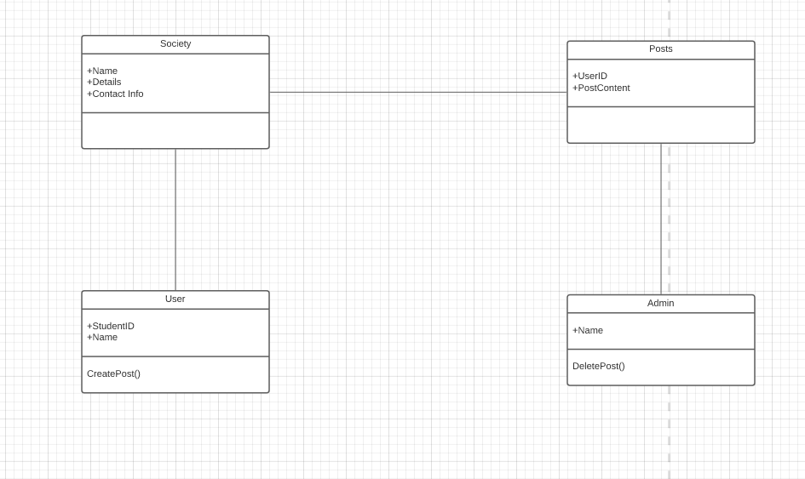

Class Diagram 02

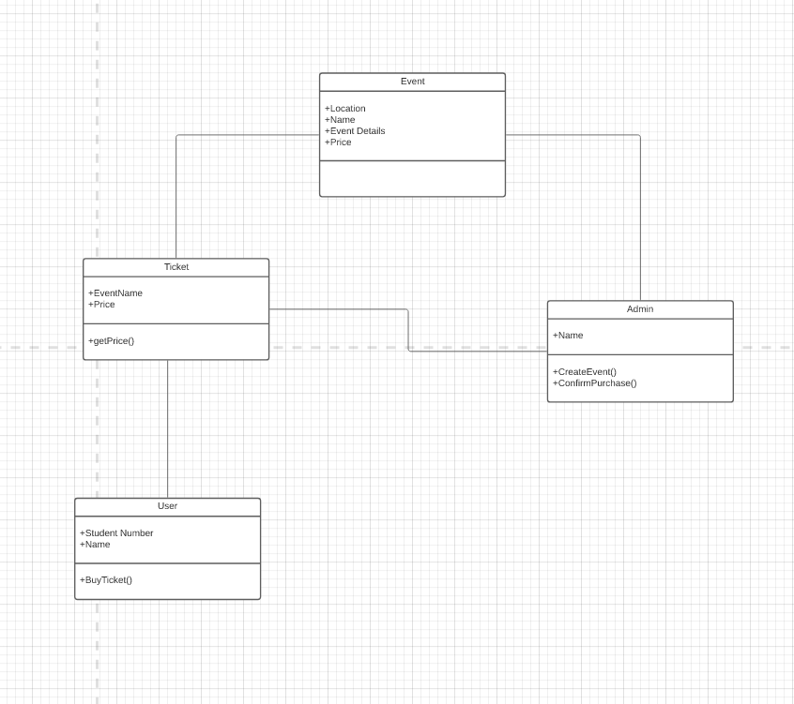

# Junit Tests

## Admin Test

import org.junit.jupiter.api.AfterEach;  
import org.junit.jupiter.api.BeforeEach;  
import org.junit.jupiter.api.Test;  
  
import static org.junit.jupiter.api.Assertions.*;  
  
class AdminTest {  
  
 Admin admin1, admin2, admin3;  
 Post post1, post2;  
  
 @BeforeEach  
 void setUp() {  
 admin1 = new Admin("Corey Shanahan");  
 admin2 = new Admin("Saoirse O'Donavan");  
 admin3 = new Admin("Ian Barnes");  
 post1 = new Post("20093473", "See you all at the ball");  
 }  
  
 @AfterEach  
 void tearDown() {  
 admin1 = null;  
 admin2 = null;  
 admin3 = null;  
 post1 = null;  
 }  
  
 @Test  
 void deletePost() {  
 *assertTrue*(admin1.deletePost(post1));  
 *assertFalse*(admin1.deletePost(post2));  
 }  
  
  
 @Test  
 void setName() {  
 *assertEquals*("Corey Shanahan", admin1.getName());  
 admin1.setName("");  
 *assertEquals*("Corey Shanahan", admin1.getName());  
 }  
}

## User Test

import org.junit.jupiter.api.AfterEach;  
import org.junit.jupiter.api.BeforeEach;  
import org.junit.jupiter.api.Test;  
  
import static org.junit.jupiter.api.Assertions.*;  
  
class UserTest {  
  
 User user1, user2, user3;  
  
 @BeforeEach  
 void setUp() {  
 user1 = new User("20093473", "Corey Shanahan");  
 user2 = new User("20093474", "Saoirse O'Donavan");  
 user3 = new User("20093475", "Ian Barnes");  
 }  
  
 @AfterEach  
 void tearDown() {  
 user1 = null;  
 user2 = null;  
 user3 = null;  
 }  
  
 @Test  
 void createPost() {  
 *assertTrue*(user1.createPost("Society Meeting at 8pm"));  
 *assertFalse*(user2.createPost(""));  
 *assertTrue*(user3.createPost("Can't wait to see ye all at the ball"));  
 }  
  
  
 @Test  
 void setStudentID() {  
 *assertEquals*("20093473", user1.getStudentID());  
 user1.setStudentID("200q3473");  
 *assertEquals*("20093473", user1.getStudentID());  
 user1.setStudentID("20093472");  
 *assertEquals*("20093472", user1.getStudentID());  
 }  
  
 @Test  
 void setName() {  
 *assertEquals*("Ian Barnes", user3.getName());  
 user3.setName("");  
 *assertEquals*("Ian Barnes", user3.getName());  
 user3.setName("AAAAAAAAAAAAAAAAAAAAAAAAAAAAAAAAAAAAAAAAAAAAAAAAAAAAAAAAAAAAAAAAAAAAAAAAAAAAAAAAAAAAAAAAAAAAAAAAAAAAAAAAAA");  
 *assertEquals*("Ian Barnes", user3.getName());  
 }  
}