**COMP3322 Modern Technologies on World Wide Web**

**Lab 8: React**

# Introduction

In this lab exercise, we will use React to implement a simple web page, as shown below. The web page allows retrieving, displaying and adding commodities from/to a MongoDB database through the web service that we built using the node.js/express.js environment in lab 6 (and used in both lab 6 and lab 7).

Upon initial load, you will see a page as shown in Fig. 1. A number of existing commodities from the MongoDB database will be loaded and displayed in a table. If you enter some string in the “Search…” box, the displayed commodity table changes and only the commodities whose name starts with the entered string will be displayed (e.g., Fig. 2). If you click the “Hide Out-of-Stock Commodity” button, the commodities whose status is “out of stock” will no longer be displayed in the table, and the text on the button changes to “Show Out-of-Stock Commodity” (Fig. 3); and then if you click the “Show Out-of-Stock Commodity” button, the page view goes back to Fig. 1. If you enter a new commodity’s name and category in the respective input text boxes (at the lower part of the page), select the status in the select dropdown list (e.g., Fig. 4), and then click the “Submit” button, the new commodity’s information will be sent to the server side to store in the MongoDB database, and the page view becomes Fig. 5, i.e., the newly added commodity is displayed in the commodity table.

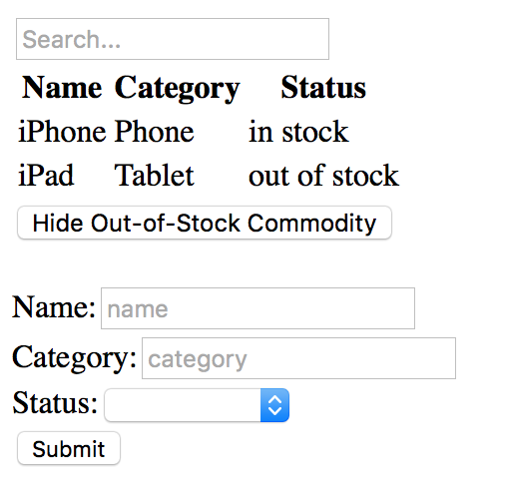 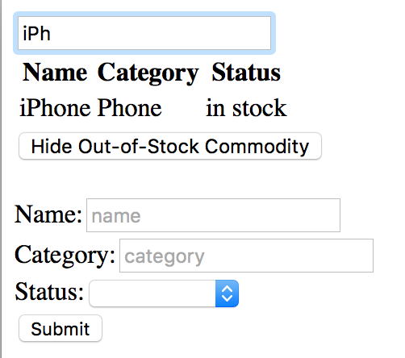

Fig. 1 Fig. 2

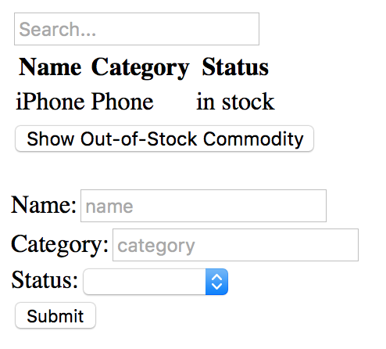

Fig. 3

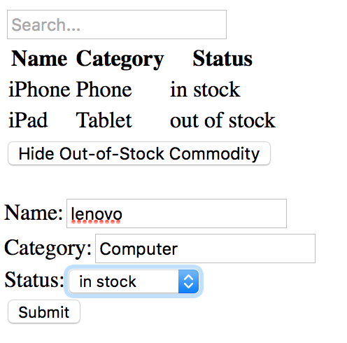 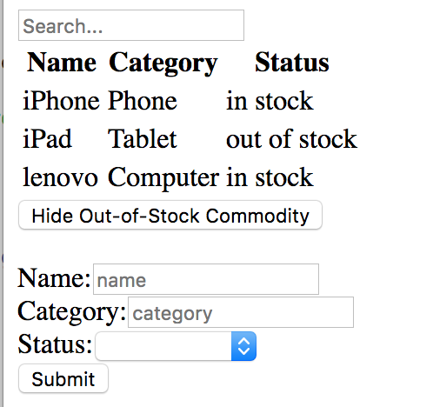

Fig. 4 Fig. 5

# Prepare the Web Service

Create a folder “**lab8**”. Inside the “**lab8**” folder, make a copy of your **lab6** project folder, and rename the folder name to “**serverapp**”. In this lab, we are going to run the app you built in lab 6 as the server side, and allow our React app (client side) to make use of the web services it provides. We are going to run this server app on your localhost on the port of 3001 (instead of 3000), since we are going to run our React app on the port of 3000.

Open **app.js** in the “**serverapp**” folder. At the end of app.js, replace “module.exports = app;” by the following code:

|  |
| --- |
| //module.exports = app;  var server = app.listen(3001, function () {  var host = server.address().address  var port = server.address().port  console.log("Example app listening at http://%s:%s", host, port)  }) |

Open **users.js** in “**serverapp/routes/**” directory, and change the middleware handling HTTP GET requests for “/commodities” as follows:

|  |
| --- |
| router.get('/commodities', function(req, res) {  var db = req.db;  var collection = db.get('commodities'); collection.find({},{},function(err,docs){  res.set({  "Access-Control-Allow-Origin": "http://localhost:3000"  });    if (err === null)  res.json(docs);  else res.send({msg: err });  });  }); |

And change the middleware handling HTTP POST requests for “/addcommodity” as follows:

|  |
| --- |
| router.post('/addcommodity', function (req, res) {  var db = req.db;  var collection = db.get('commodities');    res.set({  "Access-Control-Allow-Origin": "http://localhost:3000",  });    //insert new commodity document  collection.insert(req.body, function (err, result) {  res.send(  (err === null) ? { msg: '' } : { msg: err }  );  });  }); |

Especially, in the above two middlewares, we set Access-Control-Allow-Origin header into the response message, in order to allow our react app which will be running at http://localhost:3000/ to access this web service running at http://localhost:3001/ (i.e., resolve the cross-domain reference issue; see more at <https://developer.mozilla.org/en-US/docs/Web/HTTP/CORS> ).

Note that our React app will only make use of the web service implemented by app.js and user.js, but not any other modules in the app you built in Lab 6, and you can leave all other files as they are in the “**serverapp**” folder.

Launch the server app as follows (as what you did in Lab 6):

**Step 1**: Launch a terminal and switch to the directory where MongoDB is installed. Start MongoDB server using the “**data**” directory in the “**serverapp**” folder as the database location, as follows: (replace “**YourPath**” by the actual path on your computer that leads to “lab8” directory)

If you use a 64-bit MongoDB on your own computer, please use the following command：

|  |
| --- |
| ./bin/mongod --dbpath **YourPath**/lab8/serverapp/data |

If you use a 32-bit MongoDB, please use the following command instead:

|  |
| --- |
| ./bin/mongod --storageEngine=mmapv1 --dbpath **YourPath**/lab8/serverapp/data |

In this way, you can reuse the “lab6” database you used in Lab 6.

**Leave this terminal open and do not close it during your entire lab practice session,** in order to allow connections to the database from your server app.

Launch another terminal and switch to the directory where MongoDB is installed. Then you can use the following commands to add commodities into the database, if you need them for testing purpose. (If there are still commodities in your “lab6” database as you inserted before, you do not have to do this.)

|  |
| --- |
| ./bin/mongo  use lab6  db.commodities.insert({'category':'Computer', 'name':'lenovo', 'status':'in stock'}) |

**Step 2**: Launch another terminal and switch to the “**serverapp**” directory, and run the following command to launch your server app (**NOT** “npm start”!):

|  |
| --- |
| node app.js |

In this way, your server app will be running on the port of 3001, as specified by code at the end of **app.js**.  **Leave this terminal open and do not close it during your entire lab practice session,** in order to allow connections to the server app from your React app.

# Create a New React App

Launch a terminal. Go to your “**lab8**” directory and create a React app named “myreactapp” using the following commands:

|  |
| --- |
| cd **YourPath**/lab8  npm install -g create-react-app  create-react-app myreactapp |

Go inside the “**myreactapp**” folder just created. Since we are going to use the jQuery library when implementing our own React app, install the jQuery module in the React app as follows:

|  |
| --- |
| cd myreactapp  npm install jquery |

Then launch the React App as follows:

|  |
| --- |
| npm start |

After successfully launching the app, you should see prompts like the following in your terminal:

|  |
| --- |
| Compiled successfully!  You can now view **test** in the browser.  http://localhost:**3000**/  Note that the development build is not optimized.  To create a production build, use npm run build. |

And a web page should be loaded automatically in your browser, as follows:

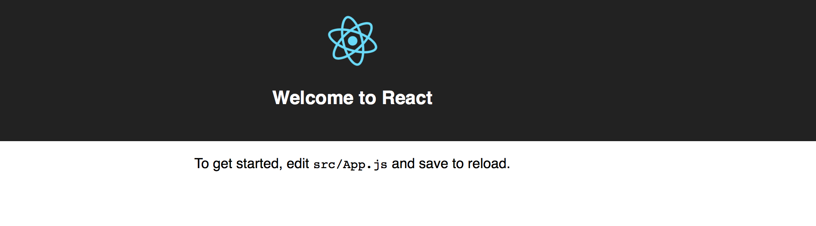

Fig. 6

Using the command “npm start”, we are running a development build (not optimized), rather than a production build (optimized build which can be created using “npm run build” instead).

Note that with the above steps, we have created a new React app. If you wish to add React into an existing app, refer to steps here: <https://reactjs.org/docs/add-react-to-an-existing-app.html>.

# Lab Exercise 1: Understand the Project File Structure

**Step 1**: The HTML file loaded after you launched the app using “npm start” is **index.html** under myreactapp/public/, together with image and configuration files. In **index.html**, a <div> element with id “root” is created as follows, in which React elements will be rendered:

|  |
| --- |
| <div id="root"></div> |

**Step 2**: The JavaScript files to render React elements are located under myreactapp/src/. Find **index.js** and **App.js** in this directory and open them in a text editor.

**Step 3**: In **index.js**, it first loads **React** and **ReactDOM** modules:

|  |
| --- |
| import React from 'react';  import ReactDOM from 'react-dom'; |

and css file:

|  |
| --- |
| import './index.css'; |

and exported components from other JavaScript files (**App.js** and **registerServiceWorker.js**):

|  |
| --- |
| import App from './App';  import registerServiceWorker from './registerServiceWorker'; |

**index.js** mainly renders the **App** component in the 'root' <div> element (in **index.html**). registerServiceWorker() is used in production environment to register a service worker to serve assets from local cache (i.e., to allow the app to load faster on subsequent visits in production environment — see <https://goo.gl/KwvDNy>).

|  |
| --- |
| ReactDOM.render(<App />, document.getElementById('root'));  registerServiceWorker(); |

**Step 4:** In **App.js**, it creates a class component **App**:

|  |
| --- |
| class App extends Component {  render() {  return (  <div className="App">  <header className="App-header">  <img src={logo} className="App-logo" alt="logo" />  <h1 className="App-title">Welcome to React</h1>  </header>  <p className="App-intro">  To get started, edit <code>src/App.js</code> and save to reload.  </p>  </div>  );  }  } |

The component returns a <div> element of class “App”, and the styling rules on this class (given in **App.css**) are applied to this <div> element. Note that the class attribute becomes className in React. The <div> element contains a <header> element of class "App-header" and a <p> element of class "App-intro". Within the header, there is an <img> element and a <h1> element. All these elements render the page view in Fig. 6.

At last, **App.js** exposes the App component to other modules using the following statement:

|  |
| --- |
| export default App; |

# Lab Exercise 2: Create our Web Page Using React

We are going to modify **index.js** and **App.js** to create the page as shown in Figures 1-5.

**Step 1**: In **index.js**, replace the content by the following code:

|  |
| --- |
| import React from 'react';  import ReactDOM from 'react-dom';  import CommodityPage from './App';  ReactDOM.render(  <CommodityPage/>,  document.getElementById('root')  ); |

With the above code, we render the element returned by the CommodityPage component (to be implemented in **App.js**) in the “root” <div> (in myreactapp/public/index.html).

CommodityPage is the component to render the entire view in Fig. 1, enclosing other components to implement different parts in the view. Note that the component exported from **App.js** will be CommodityPage (instead of App as in the default React app you studied in Lab Exercise 1); and hence we use import CommodityPage from './App'; at the beginning of **index.js.**

**Step 2**: In **App.js** , replace the content by the following code, which creates the CommodityPage component:

|  |
| --- |
| import React from 'react';  import ReactDOM from 'react-dom';  import $ from 'jquery';  class CommodityPage extends React.Component {  constructor(props) {  super(props);  this.state = {  commodities: [],  filterText: '',  showOutOfStockCommodity: true  };    this.handleFilterTextChange = this.handleFilterTextChange.bind(this);  this.handleButtonClick = this.handleButtonClick.bind(this);  }  handleFilterTextChange(filterText) {  this.setState({  filterText: filterText  });  }    handleButtonClick() {  this.setState({  showOutOfStockCommodity: !this.state.showOutOfStockCommodity  })  }    componentDidMount() {  this.loadCommodities();  }    loadCommodities() {  $.ajax({  url: "http://localhost:3001/users/commodities",  dataType: 'json',  cache: false,  success: function(data) {  this.setState({  commodities: data  });  }.bind(this),  error: function (xhr, ajaxOptions, thrownError) {  alert(xhr.status);  alert(thrownError);  }.bind(this)  });  }    render() {  return (  <div>  <SearchBar  filterText={this.state.filterText}  onFilterTextChange={this.handleFilterTextChange}  />  <CommodityTable  commodities={this.state.commodities}  filterText={this.state.filterText} showOutOfStockCommodity={this.state.showOutOfStockCommodity}  />  <ShowHideButton showOutOfStockCommodity={this.state.showOutOfStockCommodity} onButtonClick={this.handleButtonClick}/>  </div>  );  }  }  export default CommodityPage; |

The component returns a <div> element as the container, containing a SearchBar component, a CommodityTable component, and a ShowHideButton component, corresponding to the search bar, the commodity table and the “Show/Hide Out-of-Stock Commodity” button in the view respectively (see Fig. 7). We will implement the component AddCommodityForm in Lab Exercise 3.

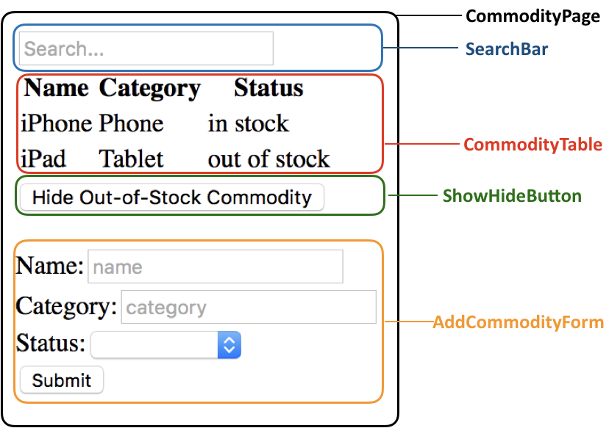

Fig. 7

There are currently three states commodities, filterText and showOutOfStockCommodity in the CommodityPage component, maintaining the commodities to be displayed in the table, text that user enters in the search box and the status of the “Show/Hide Out-of-Stock Commodity” button. Value of the commodities state is used in the CommodityTable component (and the AddCommodityForm component to be implemented); value of the filterText state is used in both the SearchBar component and the CommodityTable component; and value of the showOutOfStockCommodity is used in both the CommodityTable component and the ShowHideButton component. That’s why we maintain them in the parent component CommodityPage. The two event handler functions handleFilterTextChange and handleButtonClick set the values of filterText and showOutOfStockCommodity states upon change event on the search box and click event on the button, respectively.

The componentDidMount() function is a function defined in the React.Component abstract class, and is invoked immediately after the component is mounted (refer to <https://reactjs.org/docs/react-component.html#componentdidmount>). Inside this function, we call a jQuery AJAX API to create an HTTP GET AJAX request, for retrieving the commodities from the web service, which we have launched in “Prepare the Web Service”. Especially, in order to use jQuery APIs in React, we have imported the jQuery module as “import $ from 'jquery';" at the beginning of **App.js**. Refer to <http://api.jquery.com/jquery.ajax/> to learn about our settings in the $.ajax function call. To make “this” accessible inside the success and error callback functions, we bind “this” to both functions using .bind(this) in the code.

**Step 3**: In **App.js** , add the following code to create the SearchBar component:

|  |
| --- |
| class SearchBar extends React.Component {  constructor(props) {  super(props);  this.handleFilterTextChange = this.handleFilterTextChange.bind(this);  }    handleFilterTextChange(e) {  this.props.onFilterTextChange(e.target.value);  }    render() {  return (  <form>  <input  type="text"  placeholder="Search..."  value={this.props.filterText}  onChange={this.handleFilterTextChange}  />  </form>  );  }  } |

The component returns a <form> element, containing a search input text box. The value displayed in the search box is decided by filterText contained in the **props** passed into the component, which is value of the state filterText in the CommodityPage component. The event handler handleFilterTextChange in the SearchBar component passes user input value in the search box to the event handler handleFilterTextChange in the CommodityPage component, through its props.onFilterTextChange.

**Step 4**: In **App.js** , add the following code to create the CommodityTable component:

|  |
| --- |
| class CommodityTable extends React.Component {  render() {  const filterText = this.props.filterText;  const showOutOfStockCommodity = this.props.showOutOfStockCommodity;  const rows = [];  this.props.commodities.map((commodity) => {  if (commodity.name.indexOf(filterText) === -1) {  return;  }    if (showOutOfStockCommodity || commodity.status === "in stock") {  rows.push(  <CommodityRow  commodity={commodity}  key={commodity.name}  />  );  }  });  return (  <table>  <thead>  <tr>  <th>Name</th>  <th>Category</th>  <th>Status</th>  </tr>  </thead>  <tbody>{rows}</tbody>  </table>  );  }  } |

The component displays commodities in a table as follows:

1. The commodities displayed should match the search string, if a search string has been entered in the “Search…” box;
2. Out-of-stock commodities are displayed, if props.showOutOfStockCommodity received from the parent CommodityPage component is true (when the button element we are going to implement in **Step 6** displays “Hide Out-of-Stock Commodity”).
3. A CommodityRow component is used to return the table row showing each commodity.

**Step 5**: In **App.js** , add the following code to create the CommodityRow component:

|  |
| --- |
| class CommodityRow extends React.Component {  render() {  const commodity = this.props.commodity;  return (  <tr>  <td>{commodity.name}</td>  <td>{commodity.category}</td>  <td>{commodity.status}</td>  </tr>  );  }  } |

**Step 6**: In **App.js** , add the following code to create the ShowHideButton component:

|  |
| --- |
| class ShowHideButton extends React.Component {  constructor(props) {  super(props);  this.handleButtonClick = this.handleButtonClick.bind(this);  }  handleButtonClick() {  this.props.onButtonClick();  }  render() {  return (  <button onClick={this.handleButtonClick}>  {this.props.showOutOfStockCommodity ? 'Hide Out-of-Stock Commodity' : 'Show Out-of-Stock Commodity'}  </button>  );  }  } |

The component returns a <button> element. The text displayed on the button is decided by showOutOfStockCommodity contained in the **props** passed into the component, which is value of the state showOutOfStockCommodity in the CommodityPage component. The event handler handleButtonClick in the ShowHideButton component invokes the event handler handleButtonClick in the CommodityPage component, through its props.onButtonClick.

**Step 7**: Now launch the app using “npm start” and browse the web page at <http://localhost:3000/>. You should see a page as shown below. You can test typing search string and clicking the button to see the effectiveness.

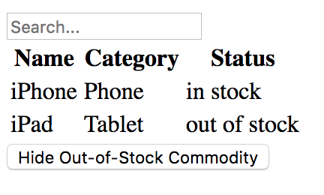

Fig. 8

# Lab Exercise 3: Adding to the Web Page a Component for Adding New Commodity

Next, we will add code in **App.js** to implement the following functionality: a form is displayed underneath the ShowHideButton component, which includes two text input boxes for entering name and category, a select element for selecting status, and a “Submit” button (see Fig. 7). After you have typed name and category, selected status, and clicked the “Submit” button, an HTTP POST AJAX request is sent to the web service, which stores the new commodity into the MongoDB database, and the newly added commodity should be added into the commodity table (see Figures 4-5).

To implement the above functionality, we need to add a component AddCommodityForm, and render it in the CommodityPage component.

**Step 1**: In the CommodityPage component, add three additional states as follows:

|  |
| --- |
| newCommodityName: '',  newCommodityCategory: '',  newCommodityStatus: '' |

Then add three event handlers as follows to handle the change events on the name input text box, category input text box and status select element (in the AddCommodityForm component which we are going to implement in **Step 2**), respectively. These event handlers change the respective state values in the CommodityPage component according to user input values in the AddCommodityForm. In addition, you should add code to bind “this” to the three functions.

|  |
| --- |
| handleNameChange(name) {  this.setState({  newCommodityName: name  })  }    handleCategoryChange(category) {  this.setState({  newCommodityCategory: category  })  }    handleStatusChange(status) {  this.setState({  newCommodityStatus: status  })  } |

Add another event handler as follows to handle the submit event on the form in the AddCommodityForm component. Again, you should add code to bind “this” to this function in the CommodityPage component

|  |
| --- |
| handleAddFormSubmit(e) {  $.post("http://localhost:3001/users/addcommodity",  {  "category" : this.state.newCommodityCategory,  "name" : this.state.newCommodityName,  "status" : this.state.newCommodityStatus  },  function(data, status){  if (data.msg ==''){  let newcommodities=this.state.commodities;  newcommodities.push({  "category" : this.state.newCommodityCategory,  "name" : this.state.newCommodityName,  "status" : this.state.newCommodityStatus  });  this.setState({  commodities: newcommodities,  newCommodityName: '',  newCommodityCategory: '',  newCommodityStatus: ''  });  } else  alert(data.msg);  }.bind(this)  );    e.preventDefault();  } |

In this event handler, we produce an AJAX POST request using jQuery’s $.post API. When a success response is received from the server side, the new commodity is added into the state commodities array. The value of commodities is used by the CommodityTable component to decide the table rows to display, and hence the new commodity is to be displayed in the CommodityTable.

Next, in the CommodityPage component, you should add code for rendering the AddCommodityForm component after the ShowHideButton component, passing in the following **props**:

* the value of newCommodityName state
* the value of newCommodityCategory state
* the value of newCommodityStatus state
* the event handler to handle the change event on the name input text box
* the event handler to handle the change event on the category input text box
* the event handler to handle the change event on the select element
* the event handler to handle the submit event on the form

**Step 2**: Implement the AddCommodityForm component returning a <form> element, which includes a name input text box, a category input text box, a status select element, and a submit button. The view should be like Fig. 1. The select element can have the following options:

|  |
| --- |
| <option value="0"></option>  <option value="in stock">in stock</option>  <option value="out of stock">out of stock</option> |

You should associate values of the name, category and status input elements with respective states in the CommodityPage component (i.e., newCommodityName, newCommodityCategory, and newCommodityStatus) through the **props** that the AddCommodityForm component receives (similar to how the value of the search box in the SearchBar component is associated with the state filterText in the CommodityPage component).

In addition, in the AddCommodityForm component, you should implement the code for passing the handling of the change events on the input elements and the submit event on the form to event handlers handleNameChange, handleCategoryChange, handleStatusChange, and handleAddFormSubmit in the CommodityPage component (similar to how handling of change event on the search box in the SearchBar component is passed to handleFilterTextChange in the CommodityPage component).

Launch the React app using “npm start” and browse the web page at <http://localhost:3000/>. You should see the complete page as shown in Fig. 1. Try adding a new commodity to test your code.

**Submission:**

Create a .zip file named **lab8.zip** which should contain two subfolders “**serverapp**” and “**myreactapp**”. The “**serverapp**” folder should contain **app.js** and **user.js** from your serverapp project and the “**myreactapp**” folder should contain **index.js** and **App.js** from your myreactapp project. No other files in the two projects should be submitted. Please upload lab8.zip to i.cs.hku.hk web server before **23:59 Sunday April 29**, such that it can be accessed at the following URL:

**http://i.cs.hku.hk/~[your CSID]/lab8.zip.**