

Forecasting and path construction
Documentation

Ihor Kulynych, Valentyn Bondarenko

version 1.0

15.10.2025

Table of Contents
1 Abstract 3
1.1 History of changes 3
2 Vocabulary 4
3 Specification 5
3.1 Executive summary 5
3.2 Functional requirements 5
3.3 Non-functional requirements 7
4 Project schedule 8
5 Risk Analysis 10
6 Bibliography 11

Abstract
This project focuses on developing web application for unmanned aerial vehicles(UAVs) consisting of two modules.
The Forecasting module predicts UAV parameters depending on various conditions(TODO”Valentyn Part”).
The Routing module constructs the optimal scouting paths using genetic algorithm or another metaheuristic optimization method. Path generation is governed by both internal and external environmental constraints to ensure efficient UAV navigation

History of changes

Date | Author | Description | Version
15.10.2025 | Ihor Kulynych,  Valentyn Bondarenko | First version | 1.0

Vocabulary

UAV - Unmanned Aerial Vehicles, commonly known as drones, are aircraft that operate without a human pilot onboard and are used in various applications ranging from military to commercial purposes.
Genetic Algorithm(GA) - metaheuristic optimization method inspired by the process of natural selection, used to find optimal or near-optimal solutions to complex problems.
Metaheuristic optimization - class of algorithms designed to solve complex optimization problems by exploring solution spaces intelligently rather than exhaustively.
Environmental constraints - external factors such as wind speed, obstacles, or weather conditions that affect UAV navigation and path planning.
Internal parameters - UAV-specific properties such as battery level, maximum speed, or payload weight that influence operational decisions.

Specification

Executive summary
The project presents an integrated web application designed for UAV operation and analysis.
It consists of two complementary modules: Forecasting module, responsible for predicting parameters under various constraints and Routing module, focused on generating optimal paths conditioned by internal parameters and environmental constraints using Genetic Algorithm or another metaheuristic optimization method.
Both modules aim to support efficient UAV mission planning -- the Forecasting module gives predictive data on flight conditions, while the Routing module uses this information to optimize flight trajectories.
The system is implemented as web application utilizing Fast API and PostgreSQL to develop Python-based backend and JavaScript frontend using Leaflet library visualization of interactive map and paths.

Functional requirements
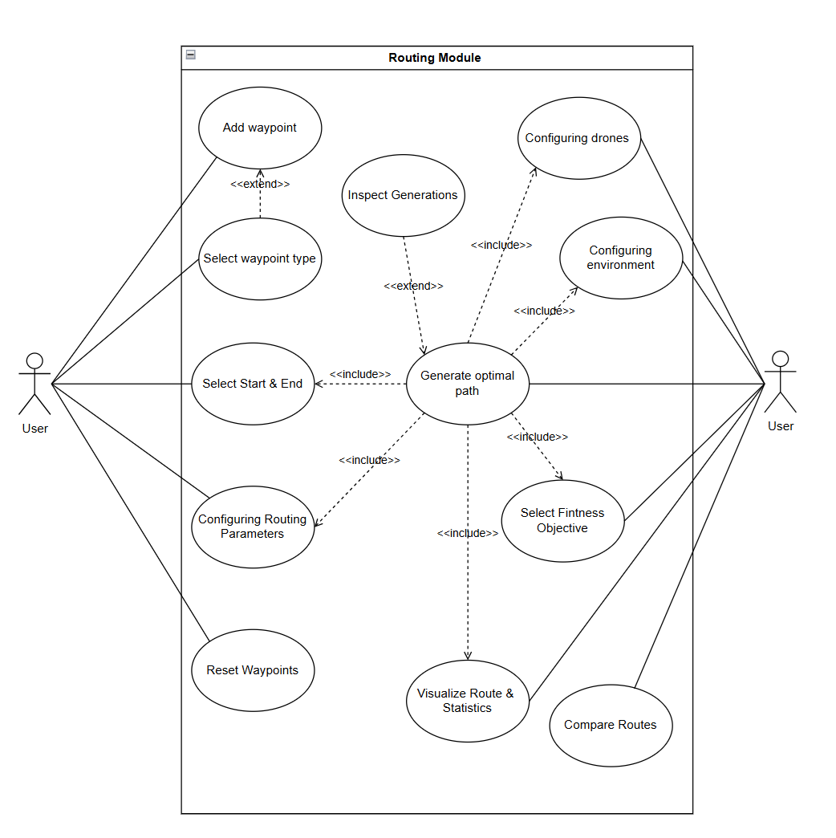
Figure 1 Use cases showing interaction of User with the Routing module

ID | Actor | Name | Description | System response
UAV | User | Adding waypoint | The user adds a new waypoint by clicking on the interactive map. | A circular marker appears on the map with a popup showing waypoint information.
UAV | User | Select waypoint type | The user chooses a waypoint type (required, optional, or station) in the “Scouting Options” panel. | The marker’s color changes according to its selected type
UAV | User | Select Start & End | The user defines the start and end waypoints for the scouting route. | The selected markers turn black to indicate their roles
UAV | User | Configuring Routing parameters | The user sets Genetic Algorithm (GA) parameters such as the number of generations and population size. | The system updates configuration values for the GA.
UAV | User | Generate Optimal Path | The system computes the optimal UAV path based on defined parameters and constraints. | An ordered list of waypoints (best path) is returned and stored.
UAV | User | Inspect Generations | The user views intermediate routes from each GA generation. | The system displays waypoints and paths computed for every generation.
UAV | User | Reset Waypoints | The user clears all waypoints and related data. | All markers disappear from the map, and stored waypoint data is deleted.
UAV | User | Compare Routes | The user selects two saved routes to compare their metrics (distance, fitness cost, etc.). | The system calculates and displays differences between the selected routes.
UAV | User | Visualize Route & Statistics | The system visualizes the computed route and summary statistics. | Polylines representing the path are drawn on the map along with distance and cost data
UAV | User | Configuring drones | The user sets drone-specific parameters such as state of charge | The system updates and stores the new drone state parameters.
UAV | User | Configuring environment | The user specifies external conditions including wind speed / direction | Chnaging waypoint information about location
UAV | User | Select Fitness Objective | The user selects the fitness function used for path optimization | The system records the chosen objective and uses it in GA evaluation.
Table 1 Description of use cases for actors and Routing system

User Stories
- Forecasting module
  - Usage 1 description
  - Usage 2 description
- Routing module
  - As a user, I want to add a waypoint on the interactive map so that it can be used as part of the drone’s scouting route.
  - As a user, I want to set a waypoint type (required, optional, or station) so that the system can prioritize points during path computation.
  - As a user, I want to choose which waypoints are the start and end of the route so that the algorithm can compute a valid path between them.
  - As a user, I want to set drone parameters (state of charge, speed) so that optimization can include drone capabilities and limits.
  - As a user, I want to define environmental constraints such as wind, rain so that computing of path accounting for weather and authorities conditions.
  - As a user, I want to specify Genetic Algorithm settings (number of generations, population size) so that I can control the optimization process.
  - As a user, I want to select a fitness objective (shortest distance, energy, weather) so that the route is optimized according to my mission goals.
  - As a user, I want to generate the optimal path based on current waypoints, drone, and environment parameters so that I can plan an efficient scouting mission.
  - As a user, I want to view the best path for each generation so that I can understand the algorithm’s convergence process.
  - As a user, I want to see the computed route and related metrics so that I can analyze the efficiency of the generated path.
  - As a user, I want to compare two previously generated routes so that I can identify which configuration or generation produces better results
  - As a user, I want to remove all waypoints and clear the map so that I can start planning a new route from scratch.

Non-functional requirements
Table 1 List of non-functional requirements for a remote repository of document records

Requirements area | Requirement No. | Description
Utility  ( Usability ) | 1 | All main functions should be accessible within two clicks from each page.
Utility  ( Usability ) | 2 | The map visualization must clearly distinguish waypoint types (colors) and routes (polylines).
Utility  ( Usability ) | 3 | The web interface must be intuitive and easy to use.
Utility  ( Usability ) | 4 | User must be informed when invalid input is detected
Utility  ( Usability ) | 5 | // Forecsting//
Reliability  ( Reliability ) | 6 | Application is accessible 24x7, when technical issues happens, user is informed.
Reliability  ( Reliability ) | 7 | The system must process 300 waypoints to compute route without crashes and  Data corruption
Reliability  ( Reliability ) | 8 | // Forecsting//
Performance  ( Performance ) | 9 | Path computation using the Genetic Algorithm must complete within 8 seconds for less than 100 waypoints on standard hardware.
Performance  ( Performance ) | 10 | The application should render map updates (add/remove markers, draw path) in less than second
Performance  ( Performance ) | 11 | // Forecsting//
Maintenance  ( Supportability ) | 12 | All system parameters are stored in structured form for reproducibility
Maintenance  ( Supportability ) | 13 | The system should include developer documentation for API endpoints and configuration parameters
Maintenance  ( Supportability ) | 14 | The system backend and frontend must be modular and easily extensible.

The project is planned to be implemented in accordance with the following schedule:

Project schedule
The project is planned to be implemented in accordance with the following schedule:

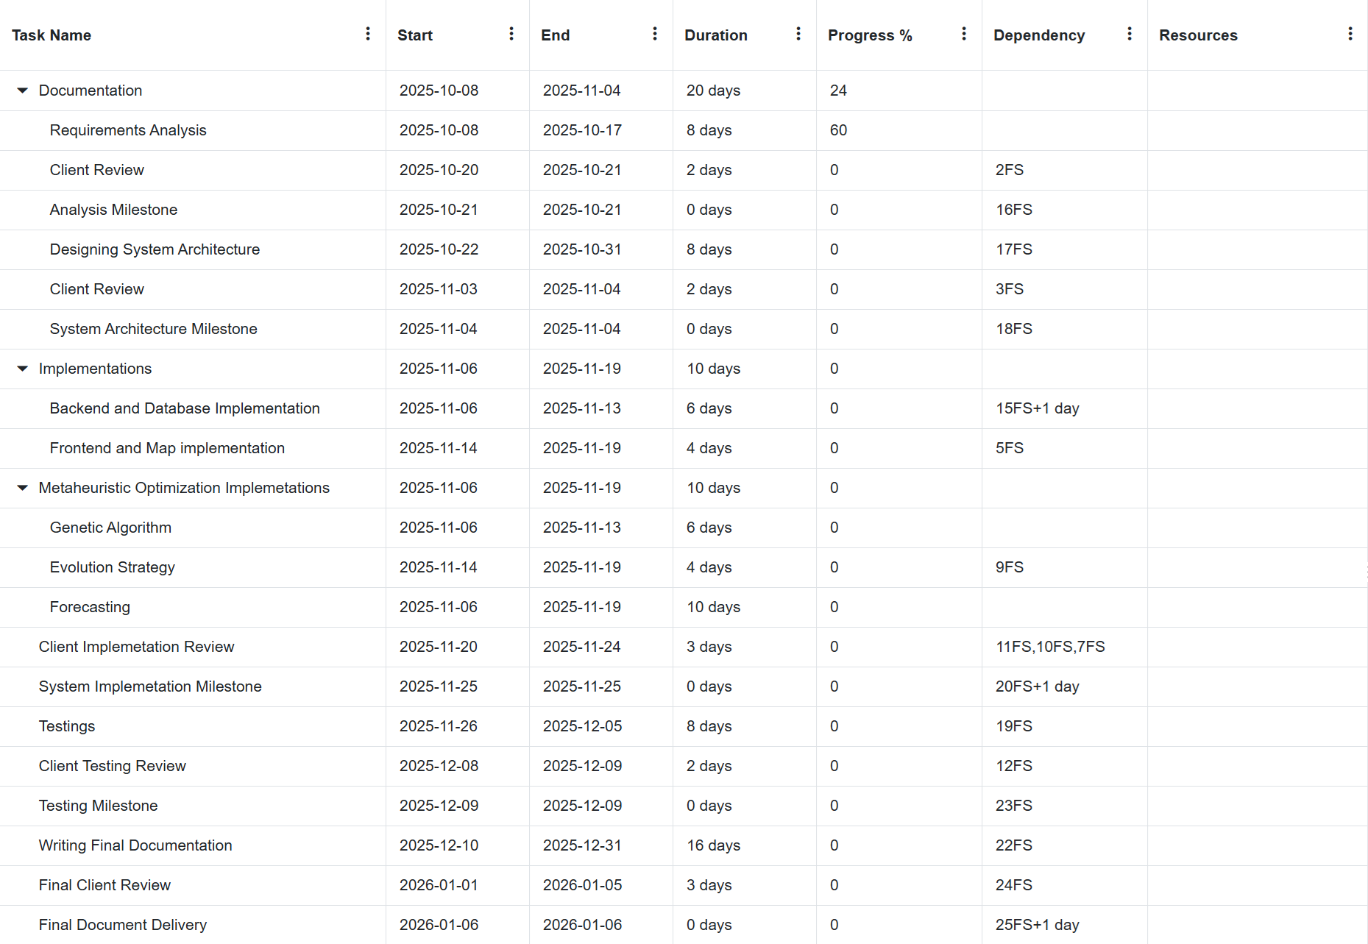

Figure 1 Project schedule.
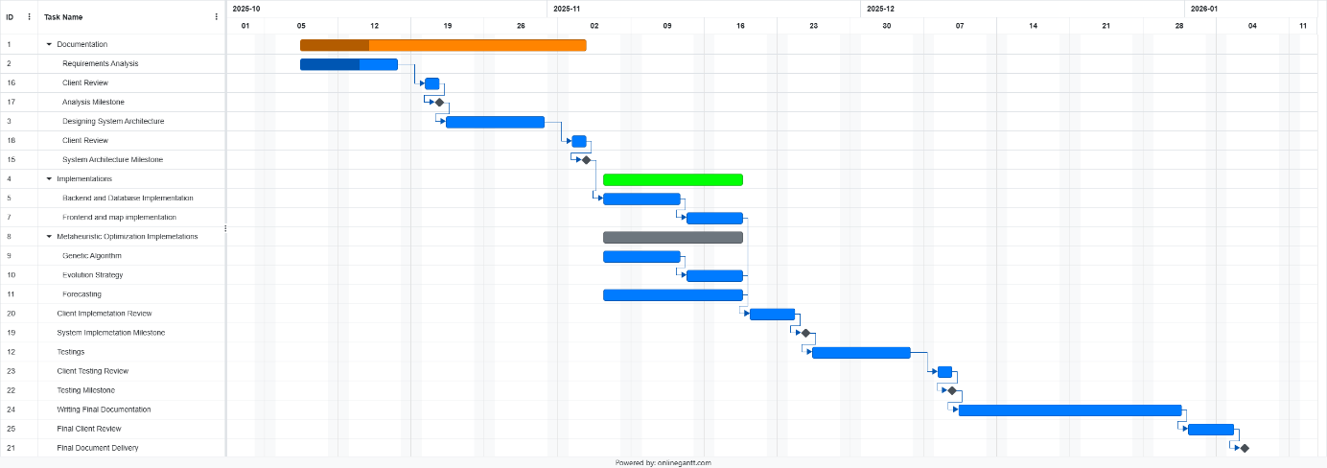

Figure 1 Project schedule, Gantt diagram.

Risk Analysis
Obligatory chapter
Describe the points according to the SWOT methodology (Strengths, Weaknesses, Opportunities.Threats) The hazard points should be given a coarse evaluation of their likelihood and actions to counteract their occurrence.
Sample:
SWOT | Threats | Opportunities
Internal | 1. Not enough time due to other projects  2  ... | 1.  2.  ...
External | 3.  4.  ... | 3.  4.  ...

Threat 1 : Very probable (Longer description of the sources of this threat).
Activities to minimize chances of occurrence.
Value of the threat.

Bibliography
Sample content
- Instalacja Tomcat 6.0 na CentOS 7.0 http://www.howtoforge.com/how-to-install-tomcat-on-centos-7 [15.10.2015]
- Instalacja Tomcat 6 z JDK 7 na CentOS RHEL Fedora Debian Ubuntu http://linuxdrops.com/install-tomcat-6-with-jdk-7-on-centos-rhel-fedora-debian-ubuntu/ [15.10.2015]
- Instalacja Tomcat 6 na CentOS lub RHEL http://www.davidghedini.com/pg/entry/install_tomcat_6_on_centos [15.10.2015]
- Portal CKAN http://ckan.org/ [30.10.2014]
- Portal The Open Knowledge Foundation https://okfn.org/ [30.10.2014]

