Badminton database design

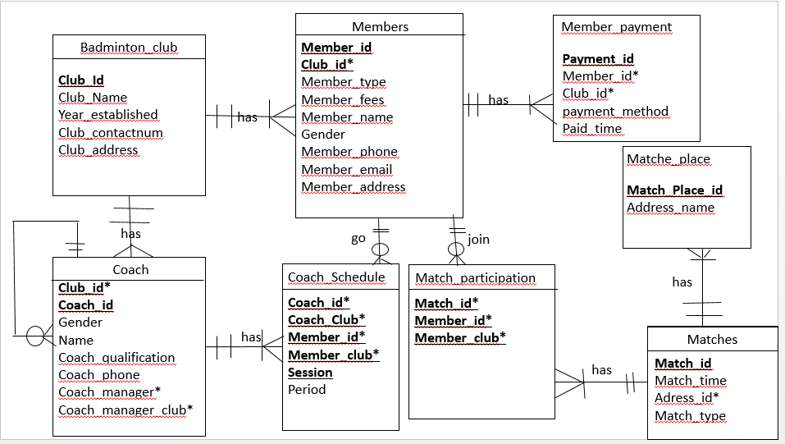

Name: renhui zhou

Student ID:12454892: