Predicted Against Measured
Module 6 • Assignment 6.2 | Temperature comparison
Student: ___________________________ Date: __________________

Evidence summary
Metric | Result
Paired source rows | 1,800 predicted and 1,800 measured
Comparable observations | 1,747 (OK with finite accepted measurement)
Mean signed difference | +1.734865 °C
Mean absolute difference | 1.734865 °C
Largest absolute difference | 2.603 °C
Excluded source rows | 53 (33 missing; 14 rejected; 6 suspicious)

1. Prediction
The supplied deterministic prediction CSV contains 1,800 predicted temperatures (°C) with sample numbers and UTC timestamps. These values are treated as original prediction output and are never modified. The source does not identify the Module 1–4 function or model parameters that generated them; this lineage must be supplied separately if a strict earlier-tool provenance requirement is enforced.

2. Measurement
The paired classroom virtual sensor CSV contains measured_temperature_c, accepted_temperature_c, sensor_status, status_reason, and a nominal two-second sample interval. It does not identify a specific instrument, its calibration, location, or physical environment. The variables and units in both files agree (temperature, °C).

3. Alignment and filtering
All 1,800 pairs match exactly by both sample number and timezone-aware timestamp. Signed differences are calculated only for sensor_status = OK with a finite accepted value. All non-OK records remain in the 1,800-row comparison table, with their residual cells blank rather than filled or invented. No timestamp or temperature conversion is needed.

4. Comparison results
The signed residual is measured minus predicted; absolute residual is its magnitude. All 1,747 comparable residuals are positive. Mean and median signed residuals are +1.734865 °C and +1.745 °C, respectively. The smallest signed residual is +0.539 °C; the largest absolute residual is 2.603 °C. The positive pattern is evidence of disagreement, not proof of its physical cause.

Figure 1. Paired predictions and accepted sensor measurements. Pink bands mark missing timestamp intervals.
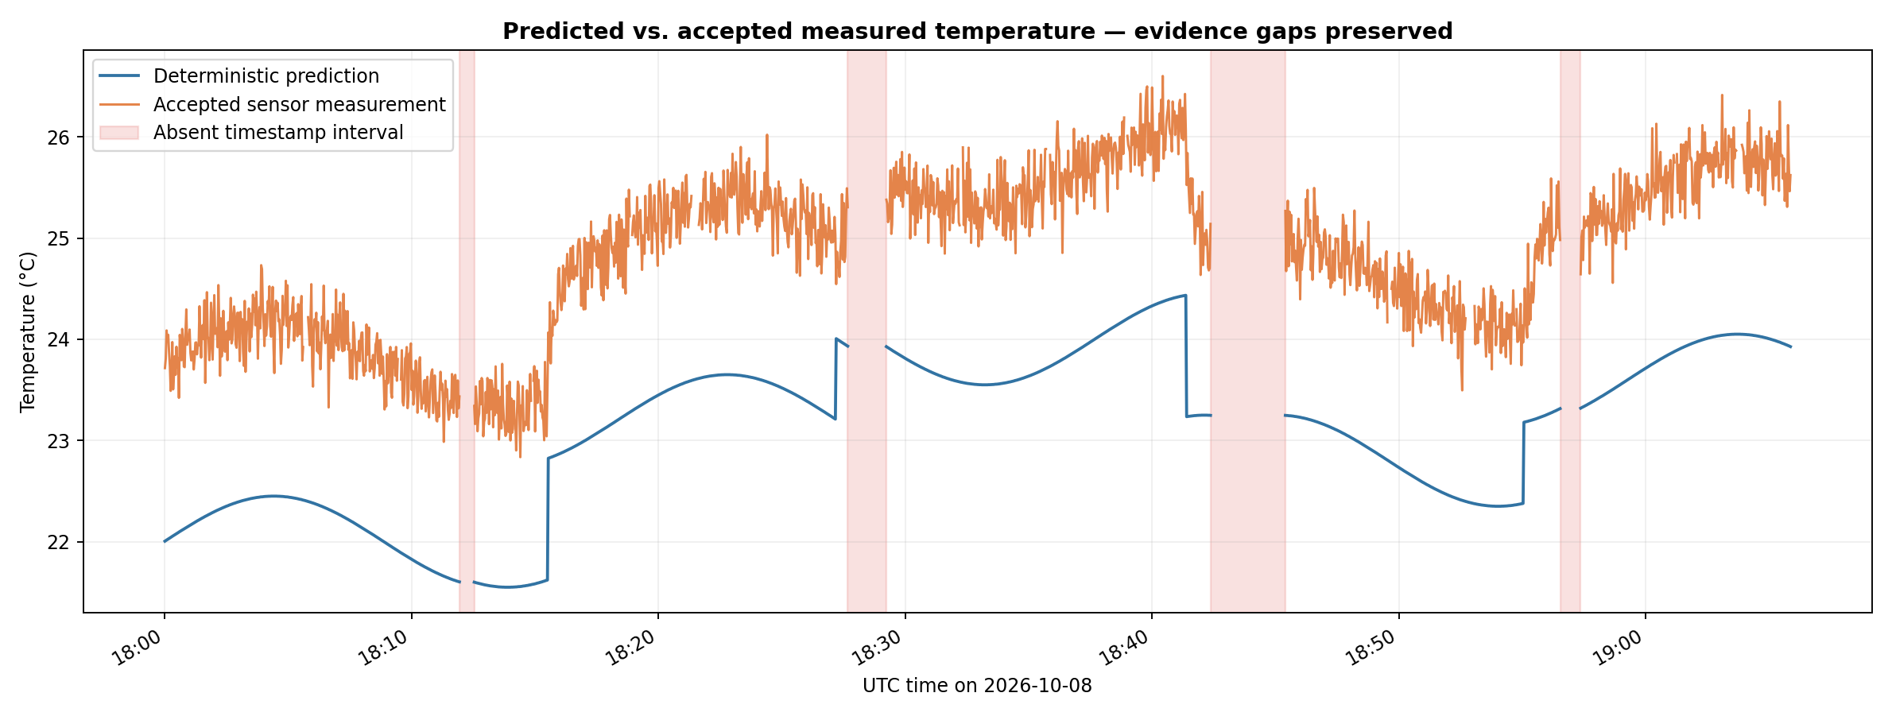

5. Residual pattern
The difference persists across the observation rather than alternating around zero. Mean signed differences in five sample regions range from approximately +1.708 °C to +1.771 °C. A stable offset is consistent with more than one explanation. Both curves have discontinuities, and no evidence is available during missing time windows.
Figure 2. Signed residual (accepted measured − predicted). Unavailable periods remain discontinuous.
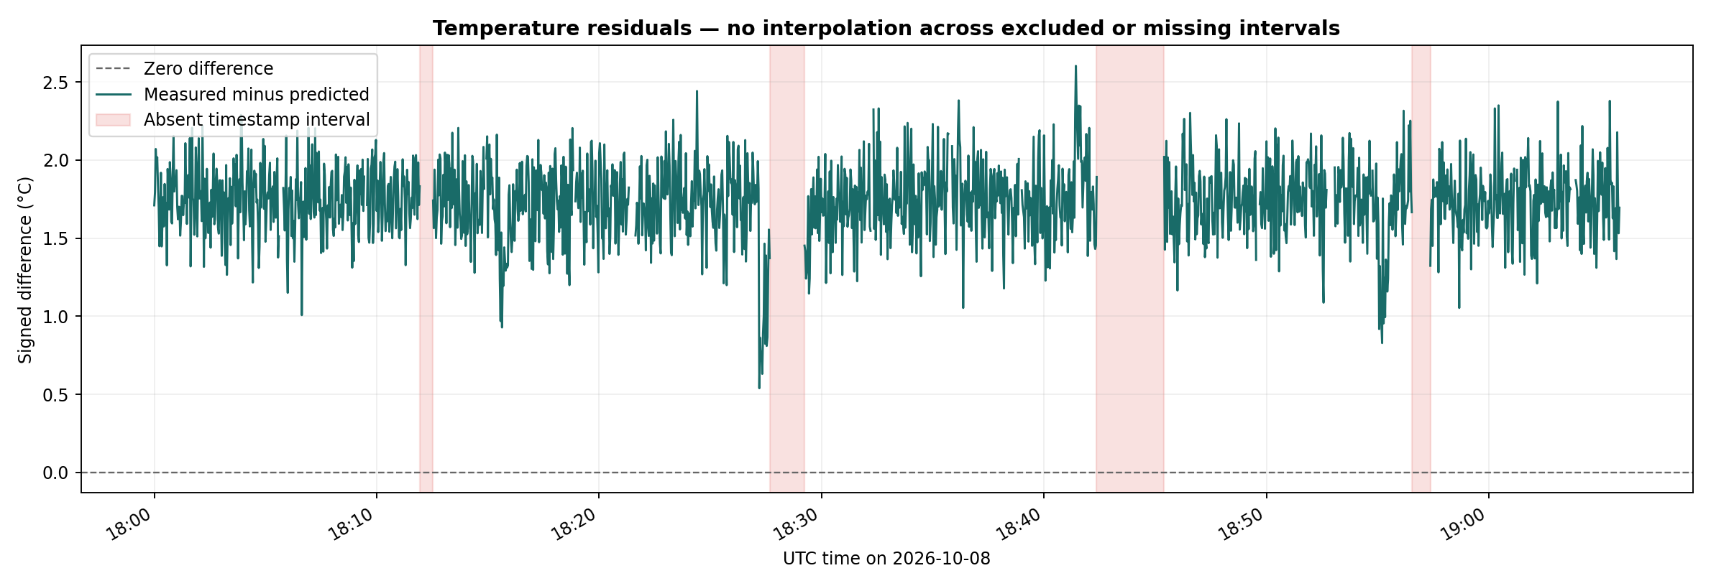

6. Plausible cause 1 — Sensor calibration or reference offset
Evidence: All comparable measurements exceed predictions and the mean residual is fairly stable across sample regions. Missing evidence: a calibrated reference measurement, sensor specifications, calibration history, and controlled repeated setpoints. Verification: measure at several stabilized reference temperatures with a calibrated independent thermometer alongside the sensor. A reproducible sensor–reference offset would support calibration bias; agreement would weaken it.

7. Plausible cause 2 — Simplified model or unrecorded local conditions
Evidence: The recorded measured curve follows the broad prediction pattern but remains consistently higher. The files do not provide model parameters, environmental heating/cooling conditions, airflow, or sensor location. Missing evidence: original prediction equation, actual local conditions, and sensor placement. Verification: log model inputs and use synchronized, co-located sensors under controlled conditions. Re-run predictions after verifying the environment or position. Reduced disagreement would support a model-assumption/placement hypothesis.

8. Timing gaps, filtering, and limits
Four gaps separate timestamps by 36, 94, 182, and 50 seconds, implying 17 + 46 + 90 + 24 = 177 absent two-second slots. Separately, 53 existing records lack trusted accepted sensor values. The 1,977-slot period therefore contains only 1,747 comparable points. Both plots preserve the gaps instead of connecting or smoothing across them. Matching UTC timestamps rule out a simple pairing error at recorded samples, but actual sensor response delay, placement, units metadata quality, and simplifications remain uncertain.
Last reading (UTC) | Next reading (UTC) | Absent slots
18:11:56 | 18:12:32 | 17
18:27:40 | 18:29:14 | 46
18:42:22 | 18:45:24 | 90
18:56:32 | 18:57:22 | 24

9. Conclusion and use of AI
The defensible conclusion is that, for 1,747 accepted paired observations, recorded measurements average 1.735 °C higher than the supplied deterministic predictions. The data cannot demonstrate whether this arises from sensor calibration, model simplification, placement, environment, or another factor. Original model provenance and controlled comparative testing are still needed. ChatGPT assisted with reproducible analysis code, report drafting, and verification-test ideas. Python calculations and the supplied CSVs, not AI-generated explanations, establish the numerical evidence. No Ollama run was performed.

