CPE301 – SPRING 2019

Design Assignment 3A

Student Name: Chris Barr

Student #: 2000682859

Student Email: barrc1@unlv.nevada.edu

Primary Github address: https://github.com/BarrChris

Directory: https://github.com/BarrChris/submission_da.git

Submit the following for all Labs:

1. In the document, for each task submit the modified or included code (only) with highlights and justifications of the modifications. Also, include the comments.
2. Use the previously create a Github repository with a random name (no CPE/301, Lastname, Firstname). Place all labs under the root folder ESD301/DA, sub-folder named LABXX, with one document and one video link file for each lab, place modified asm/c files named as LabXX-TYY.asm/c.
3. If multiple asm/c files or other libraries are used, create a folder LabXX-TYY and place these files inside the folder.
4. The folder should have a) Word document (see template), b) source code file(s) and other include files, c) text file with youtube video links (see template).

1. **COMPONENTS LIST AND CONNECTION BLOCK DIAGRAM w/ PINS**

List of Components used

* Atmega328P
* Multi-Function Shield
* FTDI Basic
* 4 M-M wires

Block diagram with pins used in the Atmega328P

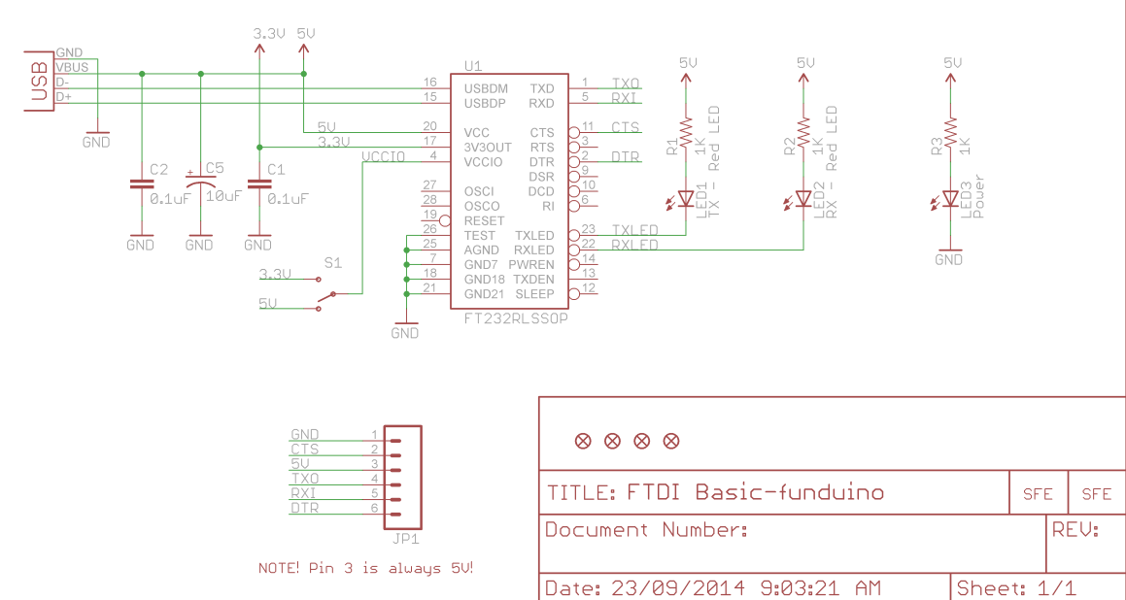

This is the diagram for the FTDI

1. **INITIAL/MODIFIED/DEVELOPED CODE OF TASK 1/A**

/*

* DA3A.c

*

* Created: 3/26/2019 3:16:08 PM

* Author : Chris

*/

#define BAUD 9600

#define F_CPU 16000000UL

#include <avr/io.h>

#include <stdio.h>

#include <util/delay.h>

#include <avr/interrupt.h>

void USART_send**(**char data**);** // Used to send integer to terminal

void USART_putstring**(**char**\*** StringPtr**);** // Used to take in every character in the string and sends it to the terminal

void USART_init**(**void**);** // Initializes the analog to digital functions, as well as OVF interrupt

char stringtype**[]** **=** "String: "**;** // Declaring the string value on screen

char inttype**[]** **=** "Integer: "**;** // Declaring the integer value on screen

char floattype**[]** **=** "Floating Point: "**;** // Declaring the floating point value on screen

char Space**[]** **=** "\n"**;** // Used to create the next line

char String**[]** **=** "This is my DA3A"**;** //String[] is the variable to output into terminal

char outs**[**20**];** // Allocating memory space to contain the float value

volatile float adc_temp **=** 74.744**;** // Sets the float value

int main**(**void**)**

**{**

USART_init**();** // Initializes the analog to digital functions as well as OVF interrupt

**while(**1**)**

**{**

// main loop

**}**

**}**

ISR **(**TIMER1_OVF_vect**)**

**{**

USART_putstring**(**Space**);** // creates next line

USART_putstring**(**stringtype**);** // LABEL PRINT "String: "

USART_putstring**(**String**);** // prints string "This is my DA3A"

USART_putstring**(**Space**);** // creates next line

USART_putstring**(**inttype**);** // LABEL PRINT "Integer: "

USART_send**(**'5'**);** // prints value 5

USART_putstring**(**Space**);** // creates next line

USART_putstring**(**floattype**);** // LABEL PRINT "FLoating Point: "

snprintf**(**outs**,** **sizeof(**outs**),** "%f\r\n"**,** adc_temp**);** // the floating point characters are stored in outs

USART_putstring**(**outs**);** // transmits outs to UART

USART_putstring**(**Space**);** // creates next line

TCNT1 **=** 49911**;** // Reset timer

**}**

void USART_init**(** void **)**

**{**

UBRR0H **=** 0**;**

UBRR0L **=** F_CPU**/**16**/**BAUD **-** 1**;** // Used for the BAUD prescaler

UCSR0C **=** _BV**(**UCSZ01**)** **|** _BV**(**UCSZ00**);** /* 8-bit data */

UCSR0B **=** _BV**(**RXEN0**)** **|** _BV**(**TXEN0**);** /* Enable RX and TX */

TCCR1B **|=** 5**;** //(1 << CS12) | (1 << CS10); // Sets prescaler to 1024

TIMSK1 **=** **(**1 **<<** TOIE1**);** // Enables overflow flag

TCNT1 **=** 49911**;** // 1 second delay = (0xFFFF) - TCNT = 65535 - 15624 = 49911

sei**();**

**}**

void USART_send**(**char data**)**

**{**

**while** **(!(**UCSR0A **&** **(**1 **<<** UDRE0**)));** // Until UDRE0 goes high, it will keep looping

UDR0 **=** data**;** // UDR0 register grabs the value given from the parameter

**}**

void USART_putstring**(**char **\***StringPtr**)**

**{**

**while** **((\***StringPtr **!=** '\0'**)){** // Until it reaches the end of the line, it will keep looping

**while** **(!(**UCSR0A **&** **(**1 **<<** UDRE0**)));** // Until UDRE0 goes high, it will keep looping

UDR0 **=** **\***StringPtr**;** // UDR0 register grabs the value given from the parameter

StringPtr**++;** // but it does it by every character as shown here

**}**

**}**

1. **DEVELOPED MODIFIED CODE OF TASK 2/A from TASK 1/A**

None modified

1. **SCHEMATICS**

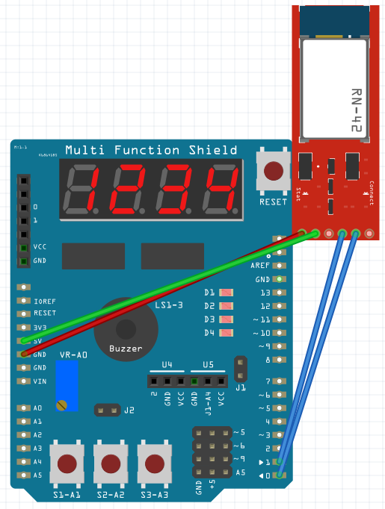

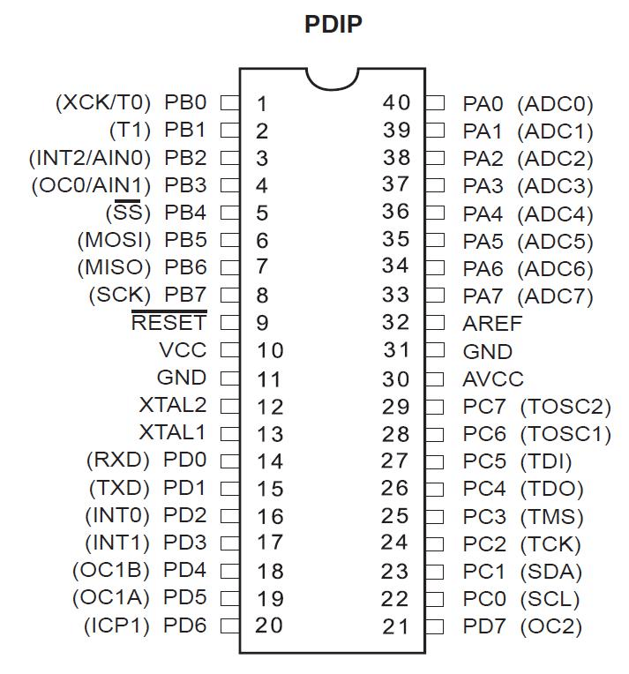

PD0 uses RX

PD1 uses TX

5V to 5V

GND to GND

1. **SCREENSHOTS OF EACH TASK OUTPUT (ATMEL STUDIO OUTPUT)**

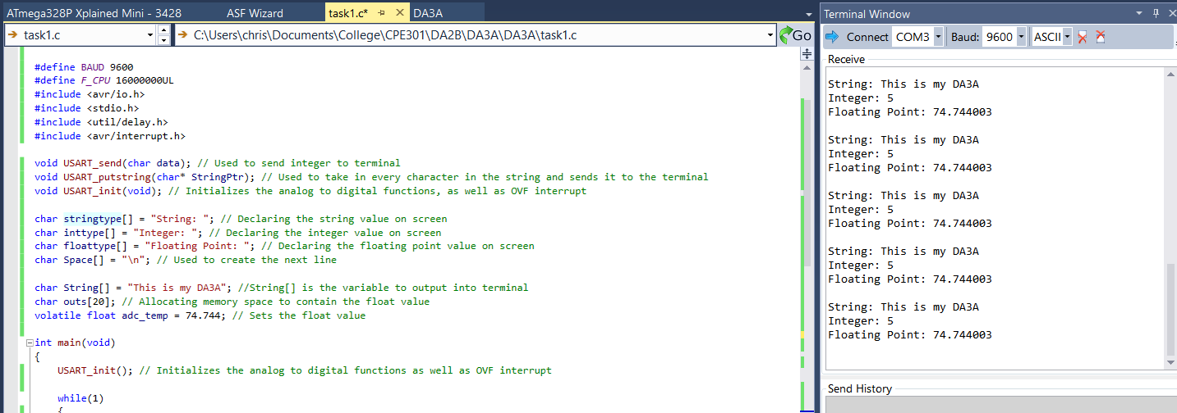

After every second, it will output the string, integer, and float point values

1. **SCREENSHOT OF EACH DEMO (BOARD SETUP)**

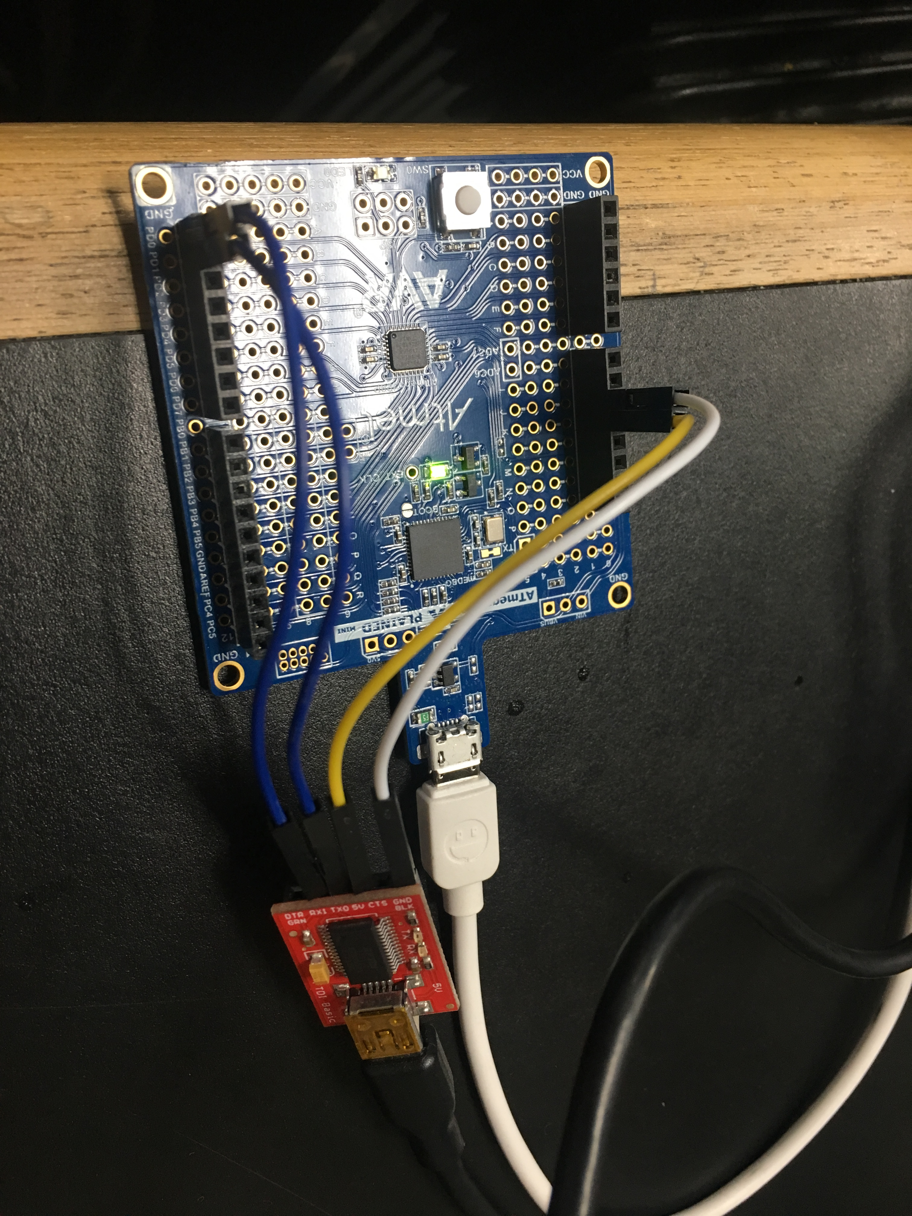

1. **VIDEO LINKS OF EACH DEMO**

<https://www.youtube.com/watch?v=zUFWhA-y1yY>

1. **GITHUB LINK OF THIS DA**

<https://github.com/BarrChris/submission_da/tree/master/DesignAssignments/DA3A>

**Student Academic Misconduct Policy**

<http://studentconduct.unlv.edu/misconduct/policy.html>

“This assignment submission is my own, original work”.

Chris Barr