**Date Submitted: 12/06/19**

**Task 00:**

**Partner: Darryl Derico (Sensor)**

**Me: Chris Barr (Collector)**

Task ID:

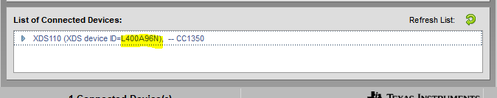

**------------------------------------------------------------------------------------**

**Task 01:**

Youtube Link: N/A

**Building and loading the collector example:**

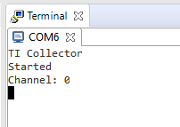

**------------------------------------------------------------------------------------**

**Task 02:**

Youtube Link: N/A

**Building and loading the sensor example:**

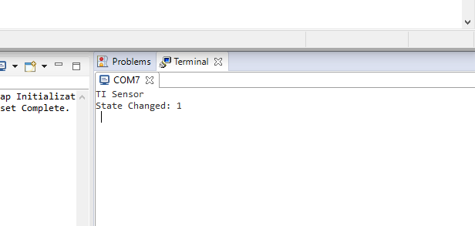

**------------------------------------------------------------------------------------**

**Task 03:**

Youtube Link: N/A

**Modified Code:**

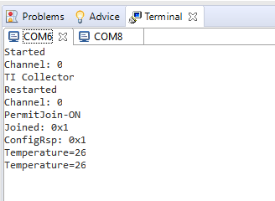 **Terminal of the Collector**

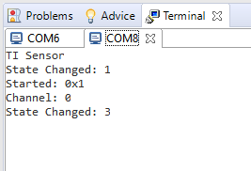 **Terminal of the Sensor**

**------------------------------------------------------------------------------------**

**Task 04:**

Youtube Link: <https://www.youtube.com/watch?v=s9qJeNVDSPw&list=PLLbVEP8QAFUHcIy4811PDGN9a2DgT_SmS&index=1>

**Modified Code:**

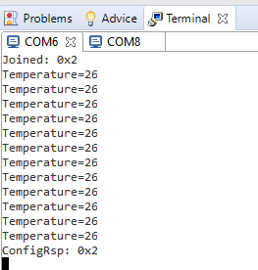 **Collectors temperature reading with quicker succession**

**------------------------------------------------------------------------------------**

**Using TI 15.4-Stack and portable app to create a remote sensor**

**Task 01:**

Youtube Link:

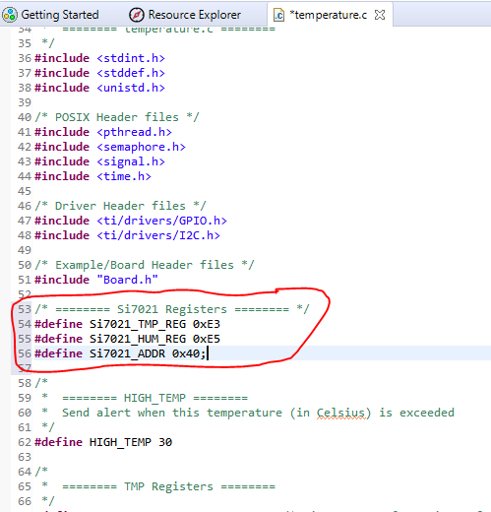 **Modifying the code for the si7021**

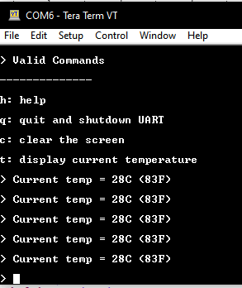 **Temperature UART Display**

**------------------------------------------------------------------------------------**

**Task 02:**

Youtube Link: N/A

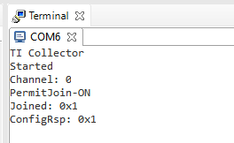 **Collector started on Channel 0**

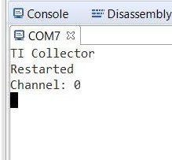 **Sensor joined (incorrect UART name at the top) using the portable method**

**------------------------------------------------------------------------------------**

**Task 03:**

Youtube Link: <https://www.youtube.com/watch?v=gLR4aZdcpk4&list=PLLbVEP8QAFUHcIy4811PDGN9a2DgT_SmS&index=2>

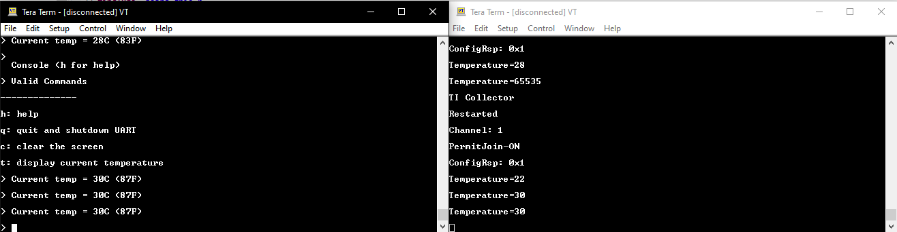 **Temperature sensor on the left communicating portably to the collector on the right**

**Note: don’t mind the “Temperature=65535” glitch. Also, the collector is trying to read internal temperature (22 as seen in the figure above), but the rest shows it reading from the sensor on the other.**

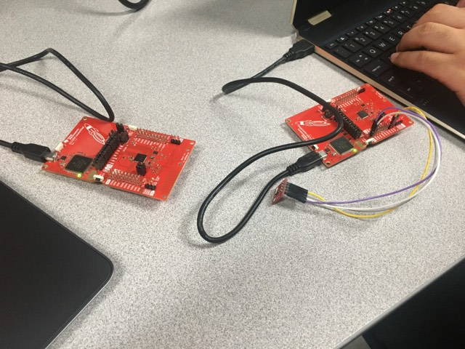

**------------------------------------------------------------------------------------**

**This assignment was a follow along assignment. No code was modified, nor created. Pictures of each task was taken to show completion. Videos included.**