Linked List Node
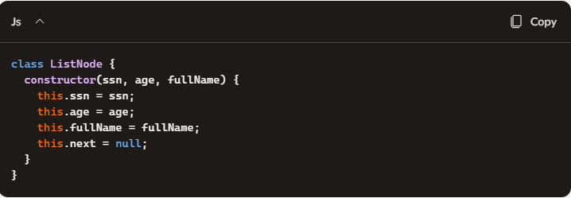
Merge Function
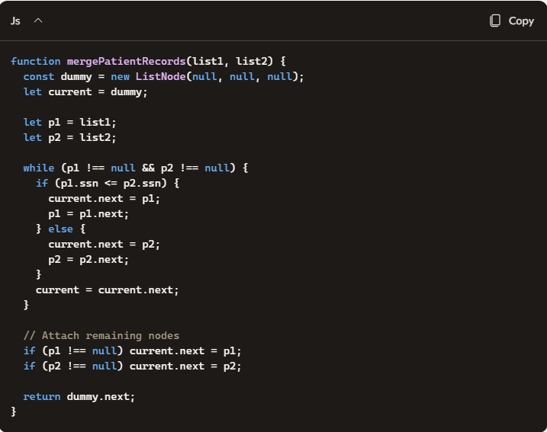

PART 2 — Clarifying Questions (required for repo)
- Include these in your README:
- Are SSNs guaranteed to be valid 9-digit numbers?
- Can either list be empty?
- Should duplicates be preserved or removed?
- Are the lists always sorted in ascending order?
- Is the merge required to be in-place (O(1) space)?

⭐ PART 3 — Test Cases (Jest)
Create a file: mergePatientRecords.test.js

Normal Case 1 — Interleaving SSNs
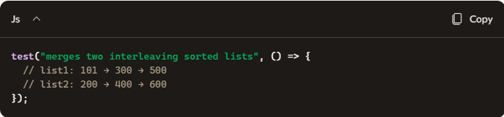
Normal Case 2 — One list entirely smaller
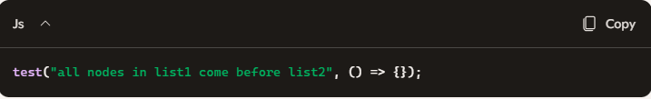
Normal Case 3 — Duplicate SSNs
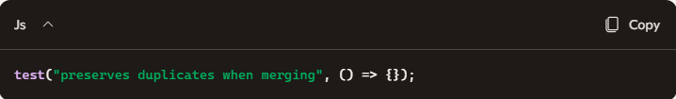
Edge Case 1 — list1 is empty
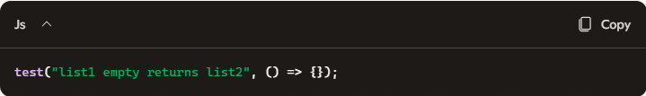
Edge Case 2 — list2 is empty
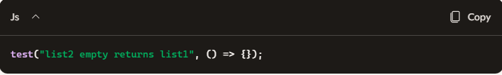
Edge Case 3 — both lists empty
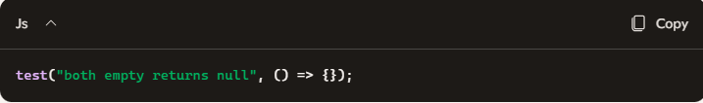

⭐ PART 4 — Time & Space Complexity
Time Complexity: O(n + m)
You traverse each list once.
Space Complexity: O(1)
You reuse existing nodes — no new allocations except the dummy head.

⭐ PART 5 — Diagram (include in README)

Before Merge
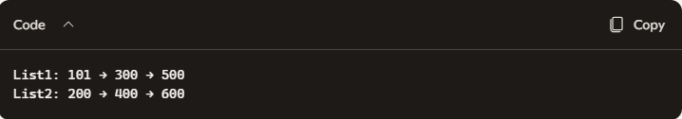

Pointer Movement
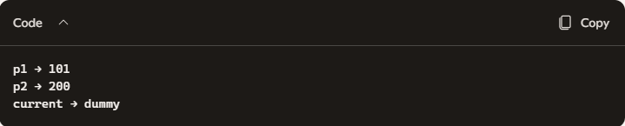

After Merge


